1. [JavaScript Basics](https://www.geeksforgeeks.org/javascript/" \l "javascript-basics)

9. [JavaScript First Program Hello world](https://www.geeksforgeeks.org/javascript-course-printing-hello-world-in-javascript/)

Involves displaying the phrase “Hello World” using simple methods like console.log(), document.write(), or alert(), introducing beginners to fundamental JavaScript syntax and output techniques.

**Using console.log() method**

The [console.log() method](https://www.geeksforgeeks.org/javascript-console-log-method/) prints the message to the browser console. This approach is mainly used for debugging purposes and checking outputs while developing code.

**Example:** In this example, we will print the legendary “Hello World” in the window console.

// Using console.log

console.log('Hello World');

**Output**

Hello World

**Note** To see the output in browser open file .html file -> right click in webpage -> inspect element or F12 -> go to console tab – here you will find the output “Hello World”.

**Using document.write() Method**

Using the [document.write() method](https://www.geeksforgeeks.org/html-dom-write-method/" \t "_blank) in JavaScript allows you to display “Hello World” directly on the webpage. This method is straightforward and places the text within the HTML document. However, it’s generally only suitable for simple demos or initial page load.

**Example:** In this example, we will print the “Hello World” in the HTML document.

// Using document.write

document.write('Hello World');

**Output:**

Hello world

**Using alert() Method**

The [alert() method](https://www.geeksforgeeks.org/html-dom-window-alert-method/) displays a popup alert box with the message. It’s useful for simple notifications or warnings but should be used sparingly as it disrupts user interaction.

**Example: I**n this example, we will print the “Hello World” on the browser window with some message or warning.

// Using alert

alert("Hello World, This is going to be Pro-Developer");

**Output:**

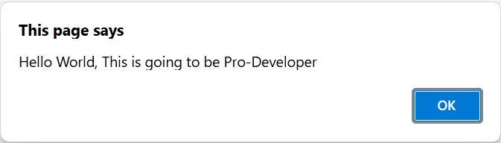

Each of the above methods has different ways of outputting the content. Though ‘document.write()’ is used when we want to print the content onto the document which is the HTML Document. Also ‘console.log()’ is mainly used when we are debugging JavaScript code and the ‘alert()’ is used to show an alert box on the browser window with some message or warning.

**10. JavaScript Data Types:**

JavaScript supports multiple data types. JavaScript data types are broadly categorized into **primitive and non-primitive types. The primitive data types include Number, String, Boolean, Null, Undefined, and Symbol. Non-primitive types include Object, Array, and Function.**

The latest ECMAScript standard defines eight data types Out of which seven data types are **Primitive(predefined)** and one **complex or Non-Primitive**.

**Primitive Data Types**

The predefined data types provided by JavaScript language are known as primitive data types. Primitive data types are also known as in-built data types.

|  |  |
| --- | --- |
| **Type** | **Description** |
| **Number** | JavaScript numbers are always stored in double-precision 64-bit binary format IEEE 754. |
| **String** | JavaScript Strings are made up of a list of characters, essentially an array of characters. |
| **Boolean** | Represents a logical entity and can have two values: true or false. |
| **Null** | This type has only one value: null. |
| **Undefined** | A variable that has not been assigned a value is undefined. |
| **Symbol** | Symbols return unique identifiers that can be used as property keys in objects without colliding with other keys. |
| **BigInt** | BigInt is a built-in object providing a way to represent whole numbers larger than 253-1. |

This table summarizes the basic data types in JavaScript along with their descriptions.

**Non-Primitive Data Types:**

The data types that are derived from primitive data types of the JavaScript language are known as non-primitive data types. It is also known as derived data types or reference data types.

* [**Object:**](https://www.geeksforgeeks.org/objects-in-javascript) It is the most important data type and forms the building blocks for modern JavaScript.

**JavaScript Primitive Data Types Examples:**

**Number:**

The number type in JavaScript contains both integer and floating-point numbers. Besides these numbers, we also have some ‘special-numbers’ in javascript that are: **‘Infinity’, ‘-Infinity’, and ‘NaN’. Infinity basically represents the mathematical ‘?’. The ‘NaN’ denotes a computational error.**

let num = 2; **// Integer**

let num2 = 1.3; **// Floating point number**

let num3 = Infinity; **// Infinity**

let num4 = 'something here too'/2; **// NaN**

**String:**

**A String in JavaScript is basically a series of characters that are surrounded by quotes.** There are three types of quotes in JavaScript, which are:

let str = **"Hello There";**

let str2 = **'Single quotes works fine';**

let phrase = **`can embed ${str}`;**

There’s no difference between ‘single’ and “double” quotes in JavaScript.

Backticks provide extra functionality as with their help of them we can embed variables inside them.

let name = **"Mukul";**

// embed a variable

alert( **`Hello, ${name}!`** ); // Hello, Mukul!

**Boolean:**

**The Boolean type has only two values: true and false.** This data type is used to store yes/no type of values: True means “Yes, Correct”, and False means “No, Incorrect”.

let isCoding = True; // yes

let isOld = False; // no

**NULL:**

The special NULL value does not belong to any of the default data types. It forms a separate type of its own which contains only the null value:

let age = null;

The ‘null’ data type basically defines a special value that represents ‘nothing’, ’empty’, or ‘value unknown’.

**Undefined** Just like null, Undefined makes its own type. The meaning of undefined is ‘value is not assigned’.

let x;

console.log(x); // undefined

|  |  |
| --- | --- |
| **NULL** | **UNDEFINED** |
| Null is an assignment value, meaning that a variable has been declared and given the value of null. | Undefined means a variable has been declared but has not yet been assigned a value. |
| **let** y = null;  console.**log**(y); *// logs 'null'* | **let** x;  console.**log**(x); *// logs 'undefined'* |
| console.log(typeof a); *//****logs 'object'*** | console.log(typeof z);*//****logs 'undefined'*** |
| Explicitly we need to assign to null. | Automatically assigned to undefined. |
| null values are preserved during JSON serialization (e.g., {“key”: null} ). | undefined values are omitted during serialization. |

**Symbol:**

**Symbols are new primitive built-in object types introduced as part of ES6.** Symbols return unique identifiers that can be used to add unique property keys to an object that won’t collide with keys of any other code that might add to the object. They are used as object properties that cannot be recreated. It basically helps us to enable encapsulation or information hiding.

let symbol1 = Symbol("Geeks")

let symbol2 = Symbol("Geeks")

// Each time Symbol() method

// is used to create new global Symbol

console.log(symbol1 == symbol2); // False

**BigInt:**

BigInt is a built-in object in JavaScript that provides a way to represent whole numbers larger than 253-1. The largest number that JavaScript can reliably represent with the Number primitive is 253-1, which is represented by the MAX\_SAFE\_INTEGER constant.

let bigBin = BigInt("0b1010101001010101001111111111111111");

// 11430854655n

console.log(bigBin);

**JavaScript Non-Primitive Data Types Examples:**

**Object:**

JavaScript objects are fundamental data structures used to store collections of data. They consist of key-value pairs and can be created using curly braces {} or the new keyword. Understanding objects is crucial, as everything in JavaScript is essentially an object.

**Object creation:**

**Using the “object constructor” syntax:**

let person = new Object();

**Using the “object literal” syntax:**

let person = {}; //

Both these methods are correct, though it’s totally your call what to choose. We can also put properties inside an Object.

**11. JavaScript Variables**

**Variables**are used to store data in JavaScript. Variables are used to store reusable values. The values of the variables are allocated using the assignment operator(“=”).

JavaScript assignment operator is equal (=) which assigns the value of the right-hand operand to its left-hand operand.

y = "Hello"

**JavaScript Identifiers**

JavaScript variables must have unique names. These names are called Identifiers.

**Basic rules to declare a variable in JavaScript:**

* These are case-sensitive
* Can only begin with a letter, underscore(“\_”) or “$” symbol
* It can contain letters, numbers, underscore, or “$” symbol
* A variable name cannot be a reserved keyword.

**Operators in JavaScript with Example:**

**1. Arithmetic Operators**

* **Addition (+)**:

let a = 5;

let b = 10;

let sum = a + b; // 15

* **Subtraction (-)**:

let diff = b - a; // 5

* **Multiplication (\*)**:

let product = a \* b; // 50

* **Division (/)**:

let quotient = b / a; // 2

* **Modulus (%)**:

let remainder = b % a; // 0

* **Increment (++)**:

let x = 5;

x++; // x becomes 6

* **Decrement (--)**:

x--; // x becomes 5 again

* **Exponentiation (\*\*)**:

let power = 2 \*\* 3; // 8

**2. Assignment Operators**

* **Assign (=)**:

let c = 5;

* **Add and assign (+=)**:

c += 5; // c becomes 10

* **Subtract and assign (-=)**:

c -= 2; // c becomes 8

* **Multiply and assign (\*=)**:

c \*= 2; // c becomes 16

* **Divide and assign (/=)**:

c /= 4; // c becomes 4

* **Modulus and assign (%=)**:

c %= 3; // c becomes 1

* **Exponentiation and assign (\*\*=)**:

c \*\*= 3; // c becomes 1 (because 1 raised to any power is still 1)

**3. Comparison Operators**

* **Equal to (==)**:

let isEqual = (5 == "5"); // true (type coercion happens)

* **Strict equal to (===)**:

let isStrictEqual = (5 === "5"); // false (no type coercion)

* **Not equal to (!=)**:

let isNotEqual = (5 != "5"); // false

* **Strict not equal to (!==)**:

let isStrictNotEqual = (5 !== "5"); // true

* **Greater than (>)**:

let isGreater = (10 > 5); // true

* **Less than (<)**:

let isLess = (10 < 5); // false

* **Greater than or equal to (>=)**:

let isGreaterOrEqual = (10 >= 10); // true

* **Less than or equal to (<=)**:

let isLessOrEqual = (10 <= 5); // false

**4. Logical Operators**

* **Logical AND (&&)**:

let andResult = (true && false); // false

* **Logical OR (||)**:

let orResult = (true || false); // true

* **Logical NOT (!)**:

let notResult = !true; // false

**5. Bitwise Operators**

* **Bitwise AND (&)**:

let andBitwise = 5 & 1; // 1 (binary: 0101 & 0001 = 0001)

* **Bitwise OR (|)**:

let orBitwise = 5 | 1; // 5 (binary: 0101 | 0001 = 0101)

* **Bitwise XOR (^)**:

let xorBitwise = 5 ^ 1; // 4 (binary: 0101 ^ 0001 = 0100)

* **Bitwise NOT (~)**:

let notBitwise = ~5; // -6 (binary: ~0101 = 1010, which is -6 in two's complement)

* **Left shift (<<)**:

let leftShift = 5 << 1; // 10 (binary: 0101 << 1 = 1010)

* **Right shift (>>)**:

let rightShift = 5 >> 1; // 2 (binary: 0101 >> 1 = 0010)

* **Unsigned right shift (>>>)**:

let unsignedRightShift = -5 >>> 1; // 2147483645 (shifts the bits to the right and fills with zeros)

**6. String Operators**

* **Concatenation (+)**:

let str1 = "Hello";

let str2 = "World";

let greeting = str1 + " " + str2; // "Hello World"

**7. Ternary Operator**

* **Ternary (? :)**:

let age = 18;

let canVote = (age >= 18) ? "Yes" : "No"; // "Yes"

**8. Type Operators**

* **typeof**:

let type = typeof 123; // "number"

* **instanceof**:

let date = new Date();

let isDate = date instanceof Date; // true

**9. Unary Operators**

* **Unary Plus (+)**:

let num = +"123"; // Converts the string "123" to the number 123

* **Unary Negation (-)**:

let neg = -123; // -123

* **Logical NOT (!)**:

let isFalse = !true; // false

* **Bitwise NOT (~)**:

let complement = ~5; // -6

* **delete**:

let obj = {name: "Alice"};

delete obj.name; // Deletes the "name" property from obj

* **void**:

void 0; // Returns undefined

**10. Relational Operators**

* **in**:

let obj = {name: "Alice"};

let hasName = "name" in obj; // true

* **instanceof**:

let arr = [];

let isArray = arr instanceof Array; // true

**11. Comma Operator**

* **Comma (,)**:

let result = (5, 10, 15); // 15 (returns the last value)

These examples demonstrate the various operators in JavaScript and how they can be used in code.

**12. Nullish Coalescing Assignment (??=)**

This operator is represented by **x ??= y**and it is called Logical nullish assignment operator. Only if the value of **x** is **nullish** then the value of y will be assigned to **x**thatmeansif the value of x is **null**or**undefined**then the value of y will be assigned to x.

logical nullish assignment is represented as **x ??= y**, this is derived by two operators nullish coalescing operator and assignment operator we can also write it as **x ?? (x = y)**. Now javascript checks the **x**first, if it is **nullish** then the value of **y** will be assigned to **x**.

**Syntax :**

x ??= y // Means : x ?? (x = y)

**Example 1 :**

let x = 12;

let y = null;

let z = 13;

// The value of x will become

// unchanged because x is not nullish.

x ??= z;

// The value of y will be

// changed because y is nullish.

y ??= z;

console.log(x) // 12

console.log(y) // 13

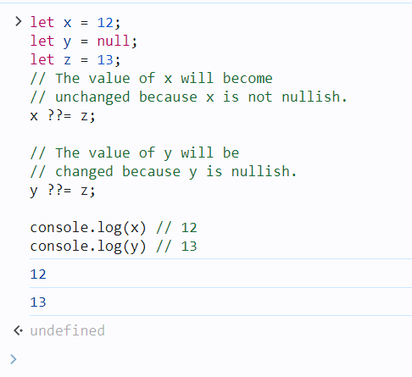

**Example 2:**

let x = {

name : "Ram"

}

// The value of name will remain

// unchanged because x.name is not nullish

x.name ??= "Shyam";

// There is no any property named age in object x .

// So the value of x.age will be

// undefined and undefined means nullish.

// that's why the value of age will be assigned.

x.age ??= 18;

console.log(x.name) // Ram

console.log(x.age) // 18

**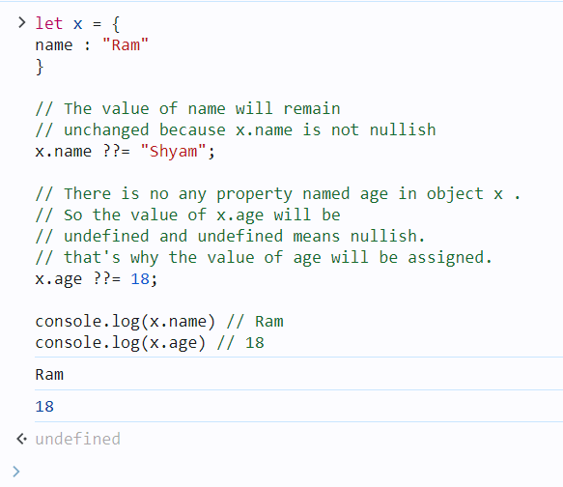**

**Example 3:**

<h1>Hello Coalescing</h1>

<p id="print\_arr"></p>

<script>

    let arr = [1, 2, "apple", null, undefined, []]

    // Replace each nullish values with "RAM"

    arr.forEach((item, index)=>{

    arr[index] ??= "RAM"

        })

        document.getElementById("print\_arr")

    .innerText = arr.toString();

        //console.log(arr)

</script>

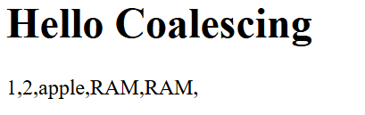

**Variable Declaration:**

**Var :**

The var keyword in JavaScript is used to declare a variable. It was the primary way to declare variables before the introduction of let and const in ES6. Variables declared with var have some unique characteristics that distinguish them from let and const.

**Characteristics of var:**

1. **Function Scope**: var is function-scoped, meaning that if a variable is declared inside a function, it is only accessible within that function. However, it is not block-scoped (i.e., var ignores block scopes such as loops and if statements).
2. **Hoisting**: Variables declared with var are hoisted to the top of their scope. This means the declaration is moved to the top of its scope, but the initialization stays in place.
3. **Redeclaration**: You can redeclare a variable with var without causing an error.
4. **Global Object Property**: In the global scope, var declarations create properties on the global object (e.g., window in browsers).

**Syntax:**

var variableName = value;

**Examples:**

**1. Basic Declaration and Assignment:**

var x = 10; // Declare and initialize a variable

console.log(x); // 10

**2. Function Scope:**

function testVar() {

var y = 20;

console.log(y); // 20 (accessible within the function)

}

testVar();

console.log(y); // Error: y is not defined (y is not accessible outside the function)

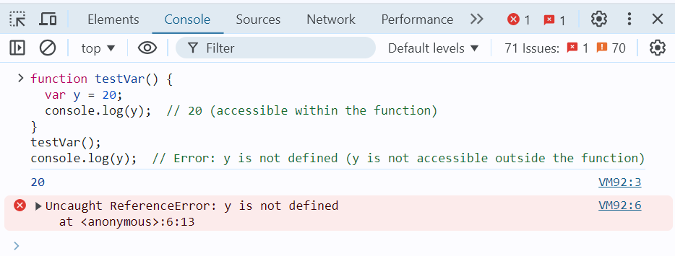

**3. Hoisting:**

console.log(a); // undefined (the declaration is hoisted, but not the assignment)

var a = 5;

console.log(a); // 5

This code behaves as though it was written like this:

var a;

console.log(a); // undefined

a = 5;

console.log(a); // 5

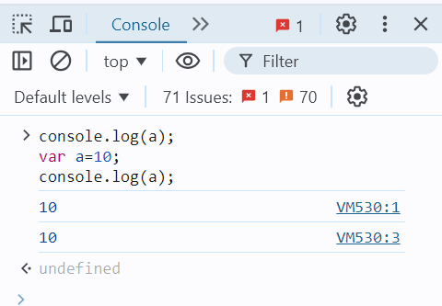

**4. Ignoring Block Scope:**

if (true) {

var z = 30;

}

console.log(z); // 30 (accessible outside the block, because var is not block-scoped)

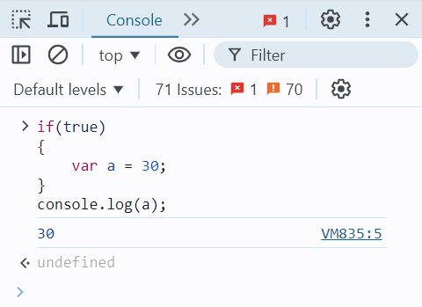

**5. Redeclaration:**

var message = "Hello";

var message = "World";

console.log(message); // "World" (no error on redeclaration)

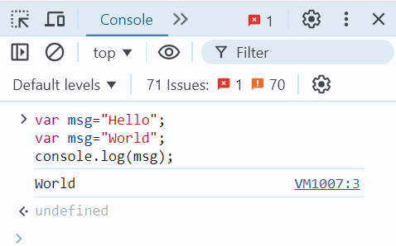

**Let:**

The let keyword in JavaScript was introduced in ES6 (ECMAScript 2015) and is used to declare variables. Unlike var, let provides block-scoping, which makes it a more predictable and safer way to declare variables in modern JavaScript.

**Characteristics of let:**

1. **Block Scope**: Variables declared with let are confined to the block in which they are defined. A block is typically defined by {} (e.g., within an if, for, or function).
2. **No Hoisting with Initialization**: Although let variables are hoisted to the top of their block, they are not initialized until their declaration is encountered in the code. This leads to a **"Temporal Dead Zone (TDZ)"** where accessing the variable before its declaration results in an error.
3. **No Redeclaration**: Variables declared with let cannot be redeclared within the same scope. This helps prevent accidental overwriting of variables.

**Syntax:**

let variableName = value;

**Examples:**

**1. Basic Declaration and Assignment:**

let x = 10; // Declare and initialize a variable

console.log(x); // 10

**2. Block Scope:**

if (true) {

let y = 20;

console.log(y); // 20 (accessible within the block)

}

console.log(y); // Error: y is not defined (y is not accessible outside the block)

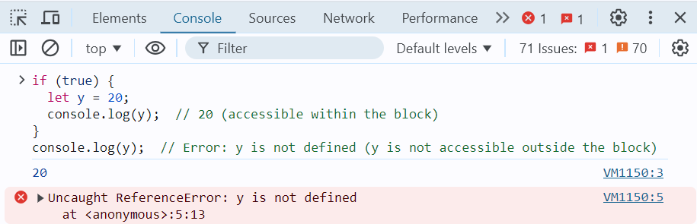

**3. No Hoisting with Initialization:**

Unlike var, let variables are hoisted but not initialized, leading to a temporal dead zone (TDZ).

console.log(z); // Error: Cannot access 'z' before initialization

let z = 30;

The above code throws an error because z is in the temporal dead zone until the let z = 30; line is executed.

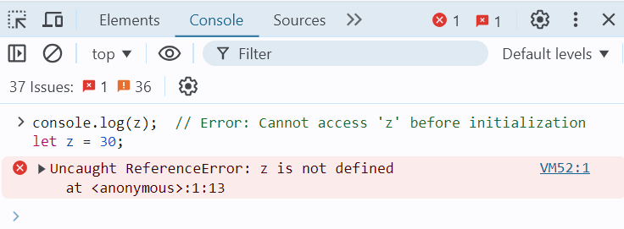

**4. No Redeclaration:**

let message = "Hello";

// let message = "World"; // Error: Identifier 'message' has already been declared

message = "World"; // This is allowed (reassigning the value)

console.log(message); // "World"

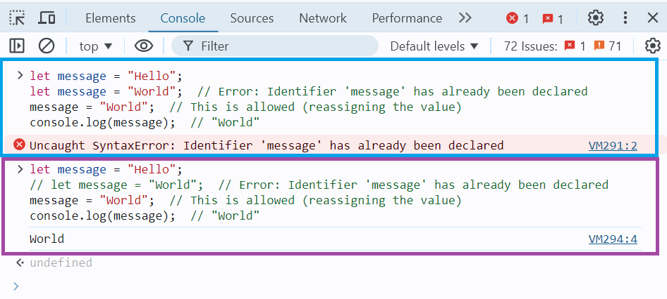

**5. Using let in Loops:**

let is commonly used in loops, especially in scenarios where each iteration needs its own scope.

for (let i = 0; i < 5; i++) {

console.log(i); // Prints 0, 1, 2, 3, 4

}

console.log(i); // Error: i is not defined (i is block-scoped to the loop)

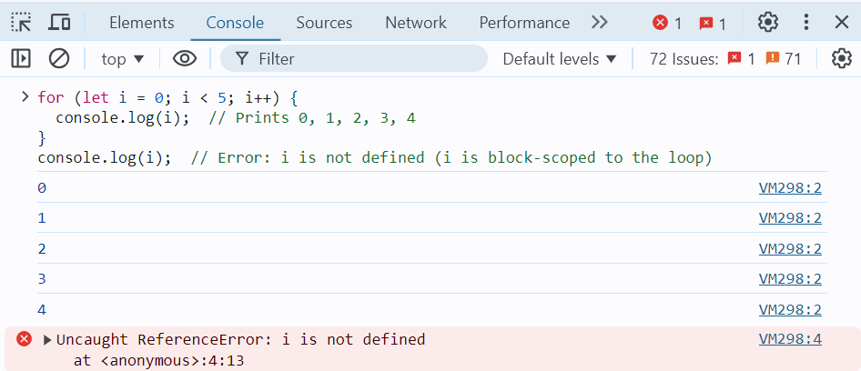

The let keyword is generally preferred over var in modern JavaScript because of its block-scoping behaviour, lack of redeclaration, and safer hoisting. It reduces the risk of errors in code by limiting the scope of variables and ensuring that they are not accidentally redeclared. This makes let a more predictable and reliable way to declare variables.

**Const:**

The const keyword in JavaScript, introduced in ES6 (ECMAScript 2015), is used to declare variables that are **constant**. Once a variable is assigned a value with const, it cannot be reassigned. const is typically used to declare variables that should not change throughout the program, such as constants or configuration values.

**Characteristics of const:**

1. **Block Scope**: Similar to let, const is block-scoped, meaning it is only accessible within the block in which it is declared.
2. **No Reassignment**: Variables declared with const cannot be reassigned a new value after they are initialized.
3. **Must be Initialized**: A const variable must be initialized at the time of declaration. Unlike let, you cannot declare a const variable without assigning a value.
4. **Mutable Objects**: While you cannot reassign a const variable, if the variable holds an object (including arrays), the contents of the object or array can still be modified.

**Syntax:**

const variableName = value;

**Examples:**

**1. Basic Declaration and Assignment:**

const x = 10;

console.log(x); // 10

// x = 20; // Error: Assignment to constant variable.

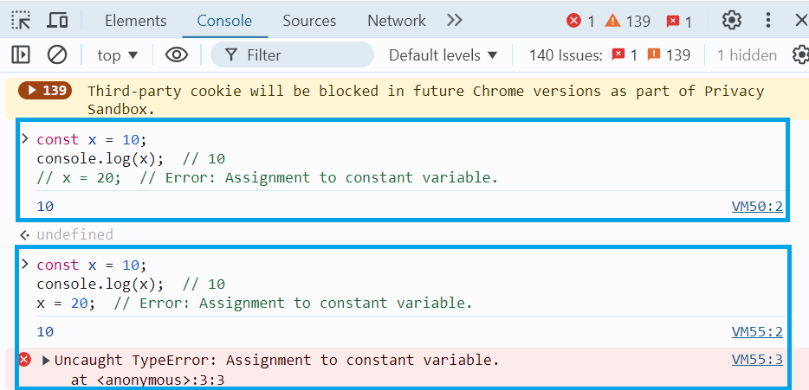

**2. Block Scope:**

if (true) {

const y = 20;

console.log(y); // 20 (accessible within the block)

}

console.log(y); // Error: y is not defined (y is not accessible outside the block)

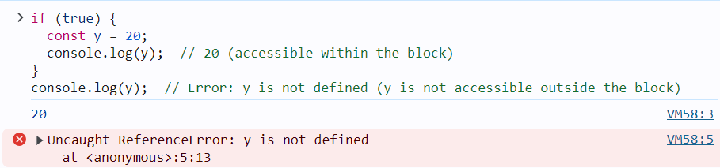

**3. Mutable Objects and Arrays:**

Even though const prevents reassignment, the contents of objects and arrays can still be modified:

* **Array Example**:

const arr = [1, 2, 3];

arr.push(4); // This is allowed

console.log(arr); // [1, 2, 3, 4]

// arr = [5, 6, 7]; // Error: Assignment to constant variable

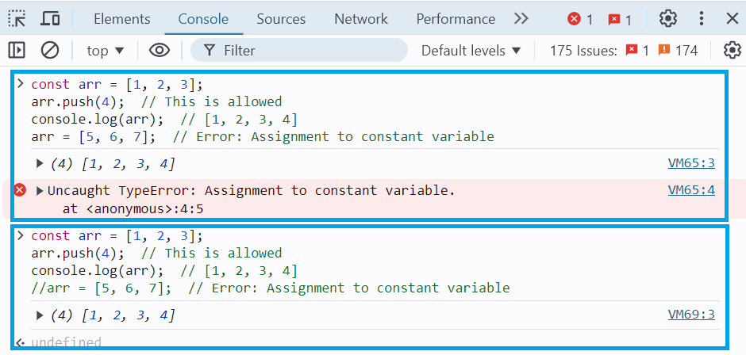

* **Object Example**:

const person = { name: "John", age: 30 };

person.age = 31; // This is allowed

console.log(person); // { name: "John", age: 31 }

// person = { name: "Jane", age: 25 }; // Error: Assignment to constant variable

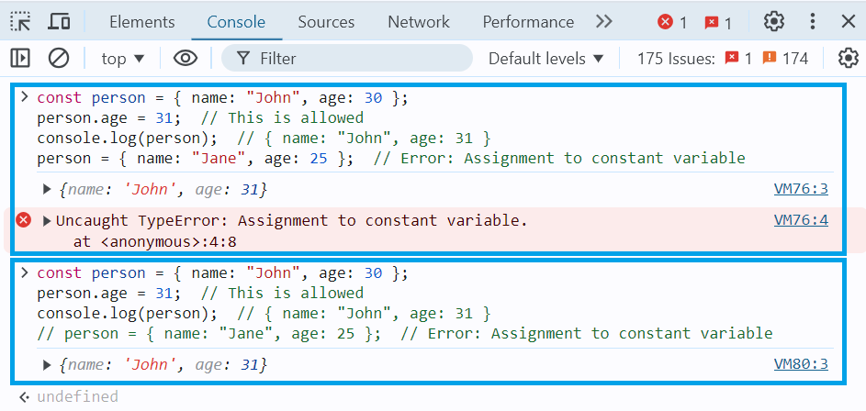

**4. Const in Loops:**

You can use const in loops, but only if the variable does not need to be reassigned. For example, const can be used inside a loop for iteration variables in a for...of loop:

const arr = [10, 20, 30];

for (const num of arr) {

console.log(num); // Prints 10, 20, 30

}

However, const is not suitable for traditional for loops where the loop counter is expected to change:

// This will throw an error because i is being reassigned in every iteration

// for (const i = 0; i < 5; i++) {

// console.log(i);

// }

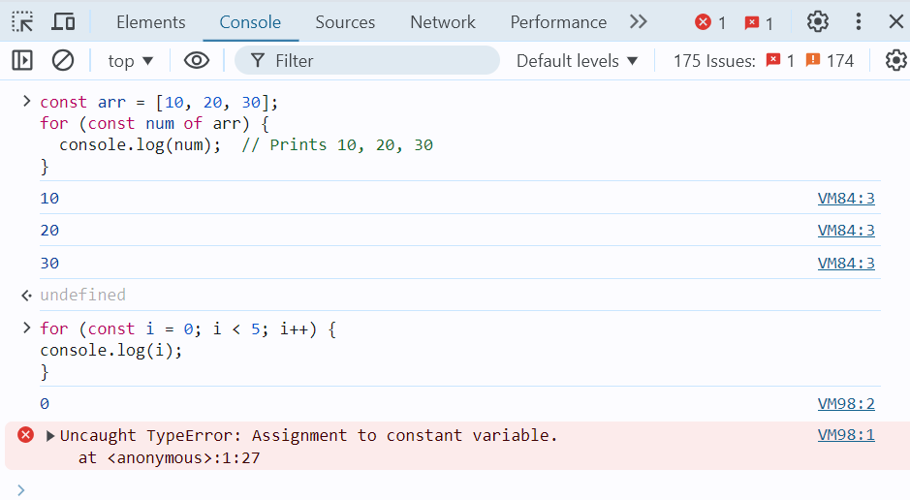

The const keyword is ideal for declaring variables that should not be reassigned. However, it does not make the variable itself immutable if it holds an object or an array — only the reference to the variable is constant. For values that need to remain constant throughout the program, const is the best choice, and it is generally preferred for readability and clarity in modern JavaScript.

1. JavaScript Control Flow Statements
2. [JS return Statement](https://www.geeksforgeeks.org/javascript-return-statement/)

The return statement is used to exit a function and optionally pass a value back to the caller. Once a return statement is executed, the function stops executing, and the control is returned to the calling code.

**Example 1: Basic return statement**

function add(a, b) {

return a + b; // The function returns the sum of a and b

}

let result = add(3, 4); // Calls the function and stores the result

console.log(result); // Output: 7

In this example, the add function adds two numbers and returns the result using the return statement.

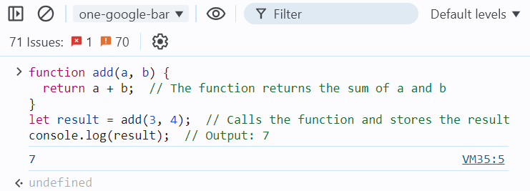

**Example 2: return without a value**

function greet(name) {

if (!name) {

return; // If no name is provided, return (undefined)

}

console.log("Hello, " + name);

}

greet("Alice"); // Output: Hello, Alice

greet(); // No output, as the function returned early

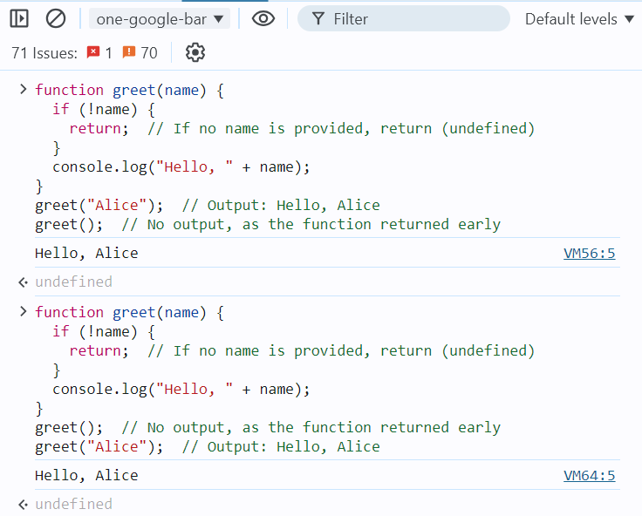

Here, the function returns early without any value if no name is provided. When return is used without a value, the function returns undefined by default.

**Example 3: Returning an object**

function createPerson(firstName, lastName) {

return {

firstName: firstName,

lastName: lastName,

};

}

let person = createPerson("John", "Doe");

console.log(person); // Output: { firstName: "John", lastName: "Doe" }

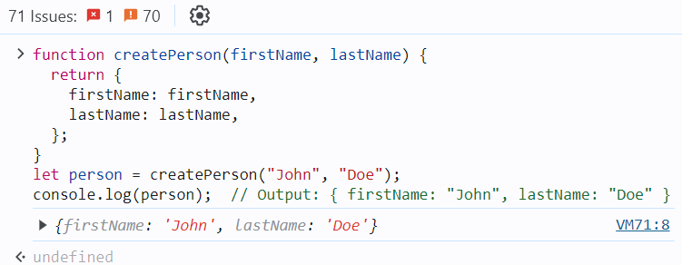

In this example, the function createPerson returns an object containing the provided firstName and lastName.

**Example 4: Returning an object**

The code defines a function Language() that returns an object containing three properties: first, second, and Third, each storing a string value. Then, it uses object destructuring to assign these properties to variables first, second, and Third. Finally, it logs the values of these variables.

function Language() {

let first = 'HTML',

second = 'CSS',

Third = 'Javascript'

return {

first,

second,

Third

};

}

let { first, second, Third } = Language();

console.log(first+ " " + second + " " + Third);

**I.Q.:**

Can a JavaScript function have multiple return statements?

What happens if there is no return statement in a function?

Can you return multiple values from a function?

What is the difference between return and console.log?

Does the return statement exit the function?

Can you use return outside a function in JavaScript?

*No, the return statement can only be used inside functions. Using it outside a function will result in a syntax error.*

1. [JS break Statement](https://www.geeksforgeeks.org/javascript-break-statement/)

The break statement is used to terminate a loop or switch statement. When a break is encountered, the program immediately exits the loop or switch block, and the control moves to the statement following the loop or switch.

**Example 1: Using break in a loop**

for (let i = 0; i < 10; i++) {

if (i === 5) {

break; // Exit the loop when i is 5

}

console.log(i);

}

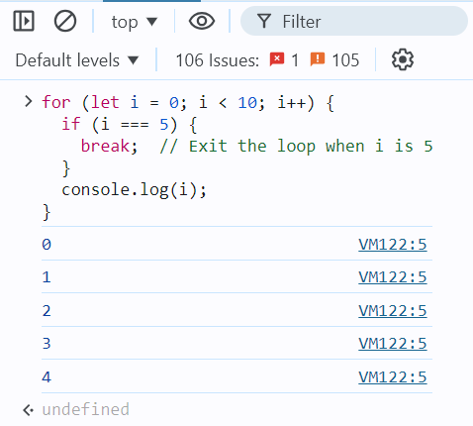

In this example, the loop iterates from 0 to 9, but when i reaches 5, the break statement is executed, causing the loop to terminate early.

**Example 2: Using break in a while loop**

let i = 0;

while (i < 10) {

console.log(i);

i++;

if (i === 3) {

break; // Exit the loop when i is 3

}

}

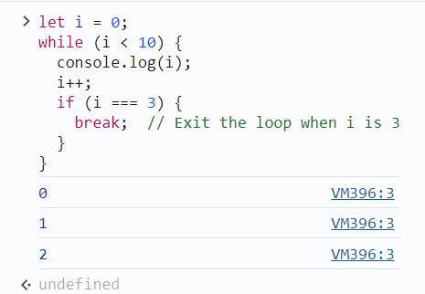

Here, the while loop runs until i equals 3, at which point the break statement is encountered, terminating the loop.

**Example 3: Using break in a switch statement**

let fruit = "apple";

switch (fruit) {

case "apple":

console.log("This is an apple.");

break;

case "banana":

console.log("This is a banana.");

break;

default:

console.log("Unknown fruit.");

}

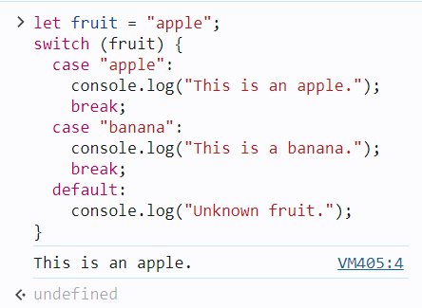

In this switch statement, the break statement prevents the execution from "falling through" to the next case. Without the break, all subsequent cases would be executed regardless of the match.

**Important Notes:**

* In a for, while, or do...while loop, break immediately exits the loop.
* In a switch statement, break stops the execution of further cases and exits the switch block.

1. [JS continue Statement](https://www.geeksforgeeks.org/javascript-continue-statement/)

Continue statement is used to skip the current iteration of a loop and move to the next iteration. Unlike the break statement, which completely exits the loop, continue only skips the current iteration and resumes execution at the next iteration of the loop.

**Example 1: Using continue in a for loop**

for (let i = 0; i < 5; i++) {

if (i === 2) {

continue; // Skip the iteration when i is 2

}

console.log(i);

}

**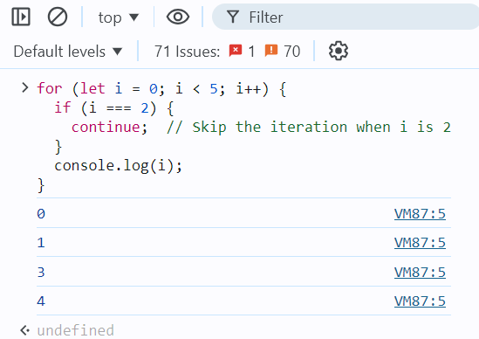**

In this example, when i is 2, the continue statement is executed, which skips that iteration. Therefore, 2 is not printed, but the loop continues with the next iteration.

**Example 2: Using continue in a while loop**

let i = 0;

while (i < 5) {

i++;

if (i === 3) {

continue; // Skip the iteration when i is 3

}

console.log(i);

}

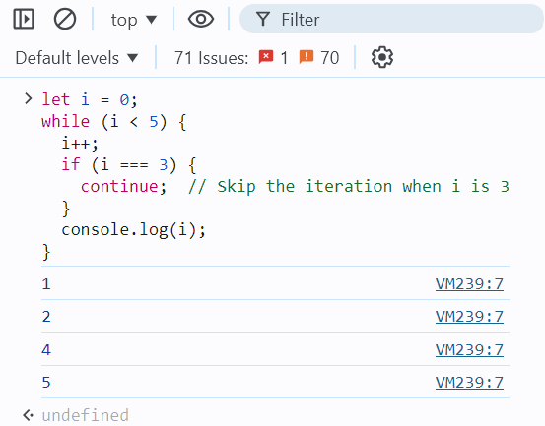

Here, when i equals 3, the continue statement causes the loop to skip that iteration, so 3 is not printed. The loop then continues with the next value of i.

**Example 3: Using continue in a nested loop**

for (let i = 0; i < 3; i++) {

for (let j = 0; j < 3; j++) {

if (j === 1) {

continue; // Skip the inner loop iteration when j is 1

}

console.log(`i: ${i}, j: ${j}`);

}

}

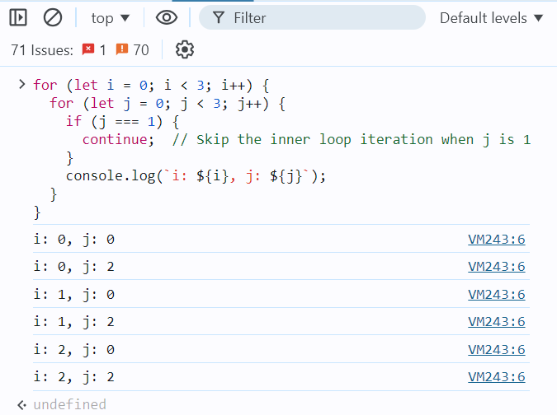

In this example, the continue statement inside the inner loop skips the iteration when j equals 1. The loop continues with the next value of j, but j = 1 is skipped for each value of i.

**Important Notes:**

* The continue statement is useful when you want to skip certain iterations of a loop based on a condition.
* It can be used in any type of loop: for, while, do...while.

1. [JS throw Statement](https://www.geeksforgeeks.org/javascript-errors-throw-and-try-to-catch/)

In JavaScript, handling errors is an essential part of writing robust code. JavaScript provides the throw statement to raise an error and the try...catch block to handle it.

**1. Throwing Errors**

You can use the throw statement to create custom errors in your code. When you throw an error, the normal flow of execution stops, and control is passed to the nearest catch block that can handle the error.

Here's how you can use the throw statement:

function divide(a, b) {

if (b === 0) {

throw new Error("Division by zero is not allowed.");

}

return a / b;

}

console.log(divide(4, 2)); // Outputs: 2

console.log(divide(4, 0)); // Throws an error: "Division by zero is not allowed."

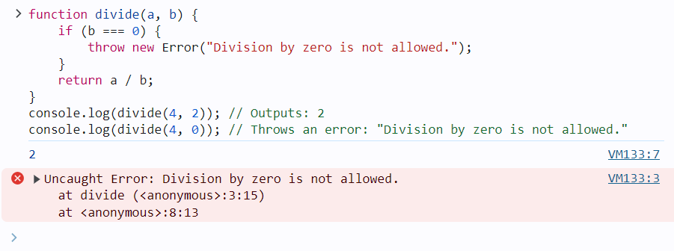

**2. Handling Errors with Try...Catch**

To handle errors that might occur during execution, you use the try...catch statement. This block allows you to "try" to execute code that might throw an error, and if an error occurs, the control is passed to the catch block.

Here’s an example:

function divide(a, b) {

if (b === 0) {

throw new Error("Division by zero is not allowed.");

}

return a / b;

}

try {

console.log(divide(4, 2)); // Outputs: 2

console.log(divide(4, 0)); // This line throws an error

} catch (error) {

console.error("An error occurred: " + error.message); // Handles the error

}

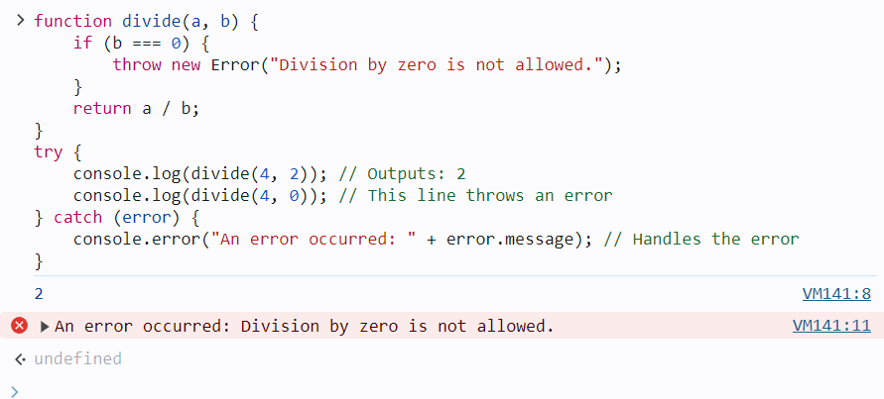

**3. The finally Block**

You can also include a finally block after the try...catch blocks. The code inside the finally block will run regardless of whether an error was thrown or not.

function divide(a, b) {

if (b === 0) {

throw new Error("Division by zero is not allowed.");

}

return a / b;

}

try {

console.log(divide(4, 2)); // Outputs: 2

console.log(divide(4, 0)); // Throws an error

} catch (error) {

console.error("An error occurred: " + error.message); // Handles the error

} finally {

console.log("This will run regardless of what happens.");

}

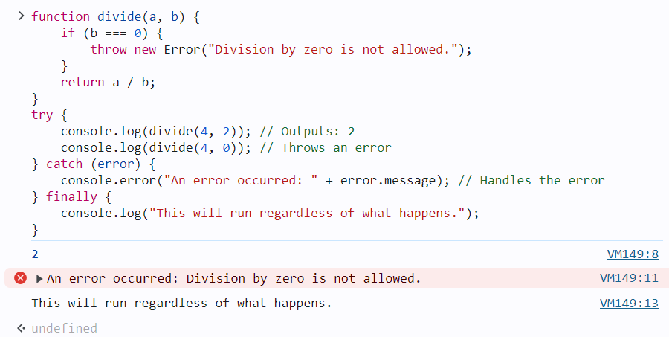

In this example, the message inside the finally block will always be printed, whether or not an error occurred.

**4. Custom Error Types**

You can also create your own custom error types by extending the Error class. This is useful when you want to throw and catch specific types of errors.

class DivisionByZeroError extends Error {

constructor(message) {

super(message);

this.name = "DivisionByZeroError";

}

}

function divide(a, b) {

if (b === 0) {

throw new DivisionByZeroError("Division by zero is not allowed.");

}

return a / b;

}

try {

console.log(divide(4, 0)); // Throws a DivisionByZeroError

} catch (error) {

if (error instanceof DivisionByZeroError) {

console.error("Custom error caught: " + error.message);

} else {

console.error("An unexpected error occurred: " + error.message);

}

}

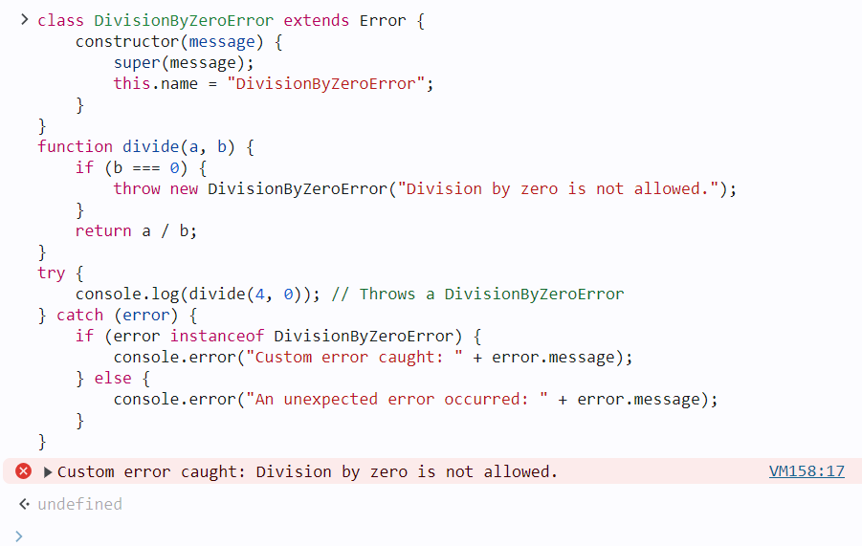

This example shows how to create and handle custom error types, allowing for more fine-grained error handling.

**Summary:**

* **throw**: Used to create and throw an error.
* **try...catch**: Used to handle errors that occur within the try block.
* **finally**: Code inside this block runs whether an error is thrown or not.
* **Custom Errors**: Extend the Error class to create specific error types for better error handling.

This approach helps to manage exceptions in your code effectively, ensuring that errors are caught and handled appropriately.

1. [JS if…else Statement](https://www.geeksforgeeks.org/conditional-statements-in-javascript/)

JavaScript conditional statements allow you to execute specific blocks of code based on conditions. If the condition is met, a particular block of code will run; otherwise, another block of code will execute based on the condition.

|  |  |
| --- | --- |
| **Conditional Statement** | **Description** |
| if statement | Executes a block of code if a specified condition is true. |
| else statement | Executes a block of code if the same condition of the preceding if statement is false. |
| else if statement | Adds more conditions to the if statement, allowing for multiple alternative conditions to be tested. |
| switch statement | Evaluates an expression, then executes the case statement that matches the expression’s value. |
| ternary operator | Provides a concise way to write if-else statements in a single line. |
| Nested if else statement | Allows for multiple conditions to be checked in a hierarchical manner. |

**Conditional Statements Examples:**

**1. Using if Statement**

The if statement is used to evaluate a particular condition. If the condition holds true, the associated code block is executed.

**Syntax:**

if ( condition ) {

// If the condition is met,

//code will get executed.

}

**Example:**This JavaScript code determines if the variable `num` is even or odd using the modulo operator `%`. If `num` is divisible by 2 without a remainder, it logs “Given number is even number.” Otherwise, it logs “Given number is odd number.”

let num = 20;

if (num % 2 === 0) {

console.log("Given number is even number.");

}

if (num % 2 !== 0) {

console.log("Given number is odd number.");

};

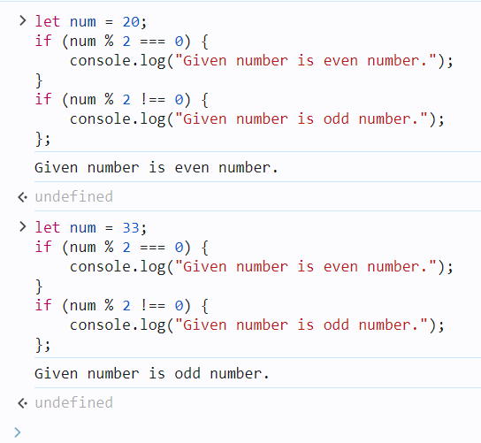

**2. Using if-else Statement**

The if-else statement will perform some action for a specific condition. Here we are using the else statement in which the else statement is written after the if statement and it has no condition in their code block.

**Syntax:**

if (condition1) {

// Executes when condition1 is true

if (condition2) {

// Executes when condition2 is true

}

}

**Example:**This JavaScript code checks if the variable `age` is greater than or equal to 18. If true, it logs “You are eligible for a driving license.” Otherwise, it logs “You are not eligible for a driving license.” This indicates eligibility for driving based on age.

let age = 25;

if (age >= 18) {

console.log("You are eligible of driving licence")

} else {

console.log("You are not eligible for driving licence")

};

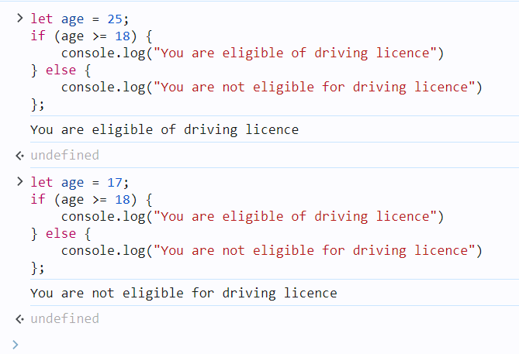

**3. else if Statement**

The else if statement in JavaScript allows handling multiple possible conditions and outputs, evaluating more than two options based on whether the conditions are true or false.

**Syntax:**

if (1st condition) {

// Code for 1st condition

} else if (2nd condition) {

// ode for 2nd condition

} else if (3rd condition) {

// Code for 3rd condition

} else {

// ode that will execute if all

// above conditions are false

}

**Example:**This JavaScript code determines whether the constant `num` is positive, negative, or zero. If `num` is greater than 0, it logs “Given number is positive.” If `num` is less than 0, it logs “Given number is negative.” If neither condition is met (i.e., `num` is zero), it logs “Given number is zero”.

const num = 33;

if (num > 0) {

console.log("Given number is positive.");

} else if (num < 0) {

console.log("Given number is negative.");

} else {

console.log("Given number is zero.");

};

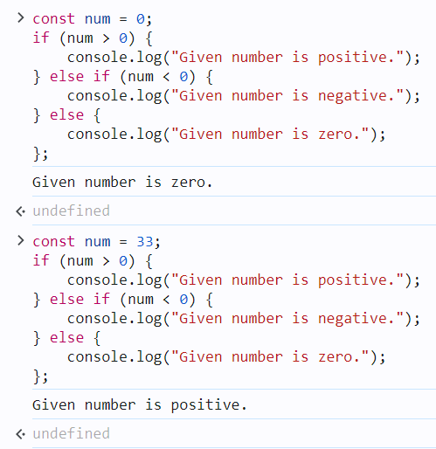

**4. Using Switch Statement (JavaScript Switch Case)**

As the number of conditions increases, you can use multiple else-if statements in JavaScript. but when we dealing with many conditions, the switch statement may be a more preferred option.

**Syntax:**

switch (expression) {

case value1:

statement1;

break;

case value2:

statement2;

break;

. . .

case valueN:

statementN;

break;

default:

statementDefault;

};

**Example:**This JavaScript code assigns a branch of engineering to a student based on their marks. It uses a switch statement with cases for different mark ranges. The student’s branch is determined according to their marks and logged to the console.

**const** marks = 93;

**let** Branch;

**switch** (**true**) {

**case** marks >= 90:

Branch = "Computer science engineering";

**break**;

**case** marks >= 80:

Branch = "Mechanical engineering";

**break**;

**case** marks >= 70:

Branch = "Chemical engineering";

**break**;

**case** marks >= 60:

Branch = "Electronics and communication";

**break**;

**case** marks >= 50:

Branch = "Civil engineering";

**break**;

**default**:

Branch = "Bio technology";

**break**;

}

console.log(`Student Branch name is : **${**Branch**}**`);

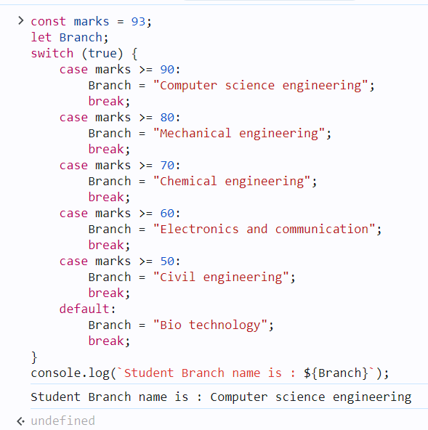

**5. Using Ternary Operator ( ?: )**

The conditional operator, also referred to as the ternary operator (?:), is a shortcut for expressing conditional statements in JavaScript.

**Syntax:**

condition ? value if true : value if false

**Example:**This JavaScript code checks if the variable `age` is greater than or equal to 18. If true, it assigns the string “You are eligible to vote.” to the variable `result`. Otherwise, it assigns “You are not eligible to vote.” The value of `result` is then logged to the console.

let age = 21;

const result =

(age >= 18) ? "You are eligible to vote."

: "You are not eligible to vote.";

console.log(result);  
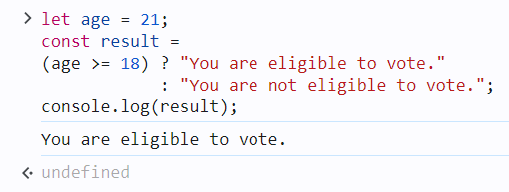

**6. Nested if…else**

Nested if…else statements in JavaScript allow us to create complex conditional logic by checking multiple conditions in a hierarchical manner. Each if statement can have an associated else block, and within each if or else block, you can nest another if…else statement. This nesting can continue to multiple levels, but it’s important to maintain readability and avoid excessive complexity.

**Syntax:**

if (condition1) {

// Code block 1

if (condition2) {

// Code block 2

} else {

// Code block 3

}

} else {

// Code block 4

}

**Example:**In this example, the outer if statement checks the weather variable. If it’s “sunny,” it further checks the temperature variable to determine the type of day it is (hot, warm, or cool). Depending on the values of weather and temperature, different messages will be logged to the console.

**let** weather = "sunny";

**let** temperature = 25;

**if** (weather === "sunny") {

**if** (temperature > 30) {

console.log("It's a hot day!");

} **else** **if** (temperature > 20) {

console.log("It's a warm day.");

} **else** {

console.log("It's a bit cool today.");

}

} **else** **if** (weather === "rainy") {

console.log("Don't forget your umbrella!");

} **else** {

console.log("Check the weather forecast!");

};

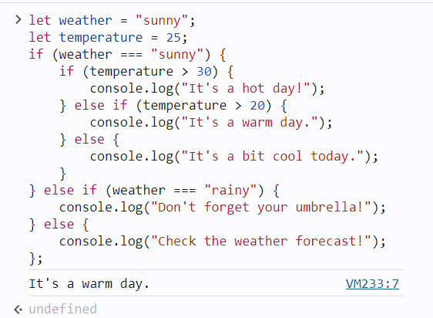

1. [JS switch Statement](https://www.geeksforgeeks.org/switch-case-in-javascript/)

The switch statement in JavaScript is used to perform different actions based on different conditions. It is an alternative to using multiple if...else if statements when you need to compare a value against multiple possible outcomes.

**Syntax**

switch(expression) {

case value1:

// Code to run if expression === value1

break;

case value2:

// Code to run if expression === value2

break;

// Add more cases as needed

default:

// Code to run if no case matches

}

**How It Works**

* The expression is evaluated once and compared with each case.
* If a match is found, the code block corresponding to that case is executed.
* The break statement prevents the code from running into the next case. Without break, the execution will continue to the next case, even if it doesn't match.
* The default case is optional but will execute if no matching case is found.

**Example: Days of the Week**

let day = 3;

let dayName;

switch (day) {

case 1:

dayName = "Monday";

break;

case 2:

dayName = "Tuesday";

break;

case 3:

dayName = "Wednesday"; // This case matches, so this block runs

break;

case 4:

dayName = "Thursday";

break;

case 5:

dayName = "Friday";

break;

case 6:

dayName = "Saturday";

break;

case 7:

dayName = "Sunday";

break;

default:

dayName = "Invalid day"; // Runs if none of the above cases match

}

console.log(dayName); // Outputs: Wednesday

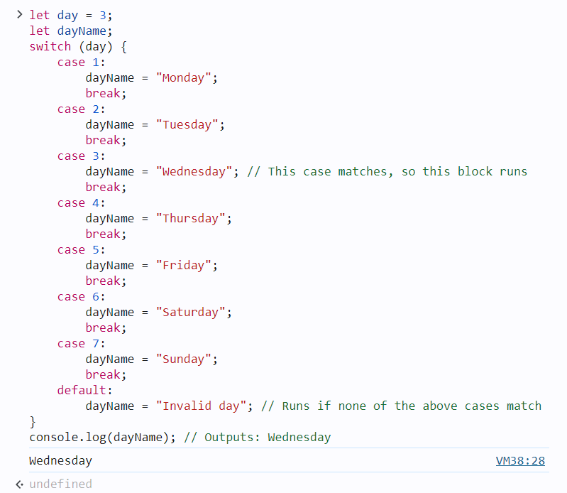

**Example: Grading System**

Here’s another example that assigns grades based on a score:

let score = 90;

let grade;

switch (true) {

case (score >= 90):

grade = "A";

break;

case (score >= 80):

grade = "B"; // This case matches, so this block runs

break;

case (score >= 70):

grade = "C";

break;

case (score >= 60):

grade = "D";

break;

default:

grade = "F"; // Runs if score is below 60

}

console.log(grade); // Outputs: A

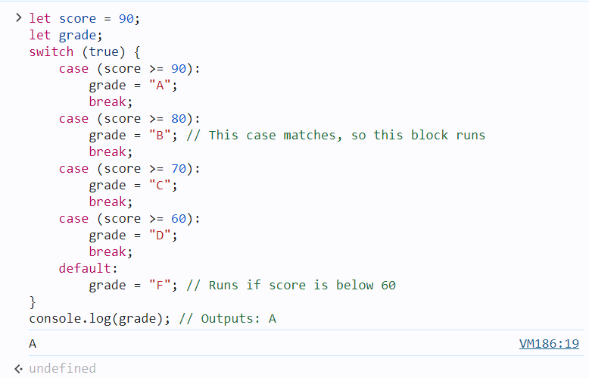

**Key Points**

* **switch** is useful when you need to compare a single expression against multiple possible values.
* **break** is important to prevent fall-through, where multiple cases might be executed unintentionally.
* **default** is optional but provides a fallback when no case matches.

The switch statement makes code easier to read and manage, especially when dealing with multiple possible outcomes for a single expression.

1. [JS try…catch Statement](https://www.geeksforgeeks.org/javascript-errors-throw-and-try-to-catch/)
2. [JavaScript Loops](https://www.geeksforgeeks.org/javascript/#javascript-loops)
3. [JS for Loop](https://www.geeksforgeeks.org/javascript-for-loop/)

The for loop in JavaScript is used to repeatedly execute a block of code a certain number of times. It's one of the most commonly used loops in programming for iterating over arrays, performing repetitive tasks, and more.

**Syntax**

for (initialization; condition; update) {

// Code to execute in each iteration

}

**Explanation**

* **Initialization**: This step is executed only once before the loop starts. It typically initializes one or more loop counters.
* **Condition**: Before each iteration, the loop checks this condition. If it evaluates to true, the loop continues. If false, the loop stops.
* **Update**: This step is executed after each iteration. It typically increments or decrements the loop counter(s).

**Example: Basic for Loop**

Here’s a simple example of a for loop that prints numbers from 1 to 5:

for (let i = 1; i <= 5; i++) {

console.log(i);

}

**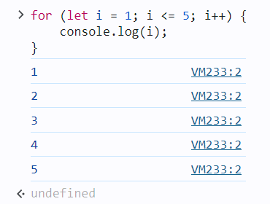**

**Example: Iterating Over an Array**

You can also use a for loop to iterate over the elements of an array:

let fruits = ["Apple", "Banana", "Cherry", "Date", "Elderberry"];

for (let i = 0; i < fruits.length; i++) {

console.log(fruits[i]);

}

**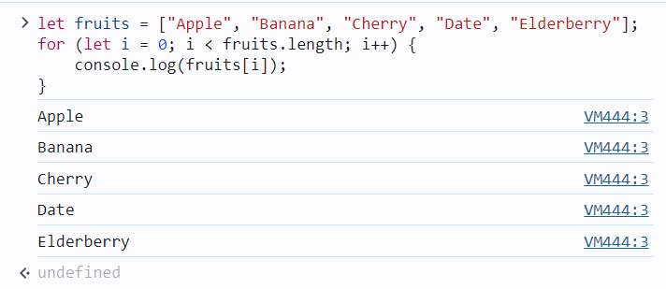**

**Example: Summing Numbers**

Here’s an example where a for loop is used to calculate the sum of numbers from 1 to 10:

let sum = 0;

for (let i = 1; i <= 10; i++) {

sum += i; // sum = sum + i

}

console.log("Sum:", sum);

**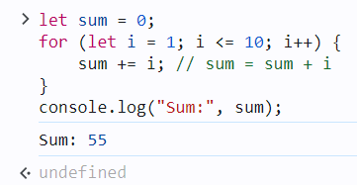**

**Example: Nested for Loop**

You can also use nested for loops, which are loops inside other loops. This is useful when working with multi-dimensional arrays or performing operations on grid-like structures.

for (let i = 1; i <= 3; i++) {

for (let j = 1; j <= 3; j++) {

console.log(`i = ${i}, j = ${j}`);

}

}

**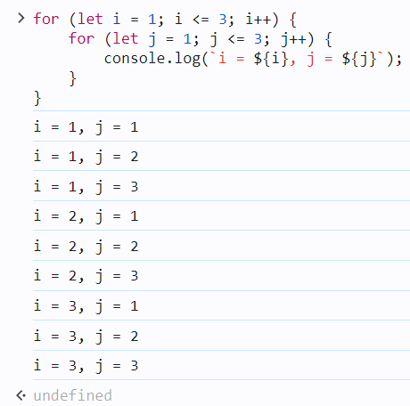**

**Summary**

* The for loop is used to repeat a block of code a specified number of times.
* **Initialization** is done once at the start.
* **Condition** is checked before each iteration, and the loop runs as long as this condition is true.
* **Update** happens after each iteration, typically used to modify the loop counter.
* It’s commonly used for iterating over arrays, summing values, and performing repetitive tasks.

1. [JS do…while Loop](https://www.geeksforgeeks.org/javascript-do-while-loop/)

The **do...while** loop in JavaScript is a control flow statement that executes a block of code **at least once**, and then continues to execute the block as long as a specified condition is true. The condition is evaluated **after** the code block is executed, which ensures that the code block runs at least once, regardless of the condition's value.

**Syntax:**

do {

// Code block to execute

} while (condition);

**Key Points:**

* The code inside the do block will run **at least once**.
* After the code block runs, the condition is checked.
* If the condition is true, the loop repeats; if false, the loop terminates.

**Example 1: Basic do...while Loop**

let i = 0;

do {

console.log("The value of i is: " + i);

i++;

} while (i < 5);

**Output:**

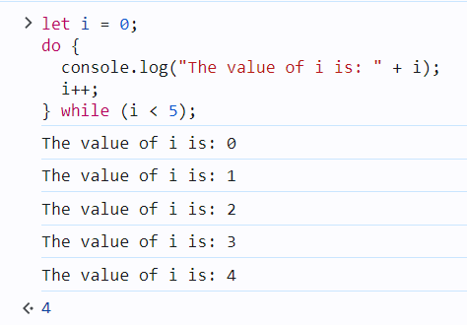

**Explanation:**

* Initially, i is 0.
* The loop prints the value of i, then increments it by 1.
* The loop continues as long as i < 5.

**Example 2: Loop that Runs Once Even if Condition is false**

let count = 10;

do {

console.log("This will run at least once. Current count: " + count);

count++;

} while (count < 5);

**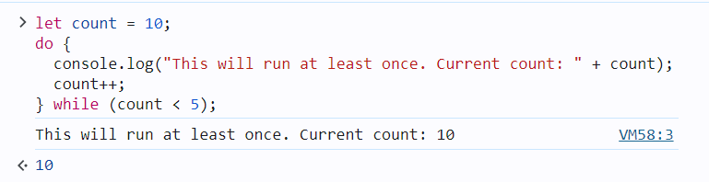**

**Explanation:**

* Although the condition count < 5 is false from the beginning, the code inside the do block still runs **once** because the condition is checked only after the code block is executed.

**Example 3: Using do...while for User Input Validation**

let password;

do {

password = prompt("Enter your password (must be 8 characters long):");

} while (password.length < 8);

console.log("Password accepted.");

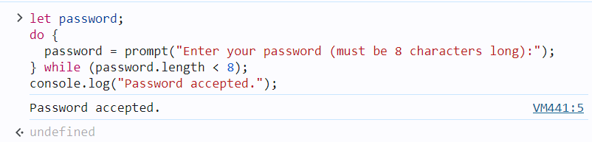

**Explanation:**

* The loop prompts the user for a password and repeats until a password of at least 8 characters is entered.

In summary, the do...while loop guarantees that the code inside the loop will execute at least once, regardless of the condition. This is useful in scenarios where you need to ensure an action is performed before a condition is checked, such as input validation or ensuring initialization steps are executed.

1. [JS while Loop](https://www.geeksforgeeks.org/javascript-while-loop/)

The**while loop**executes a block of code as long as a specified condition is true. In JavaScript, this loop evaluates the condition before each iteration and continues running as long as the condition remains true. The loop terminates when the condition becomes false, enabling dynamic and repeated operations based on changing conditions.

**Syntax**

while (condition) {  
 Code block to be executed  
}

Example: Here’s an example of a while loop that counts from 1 to 5.

**let** count = 1;

**while** (count <= 5) {

console.log(count);

count++;

}

**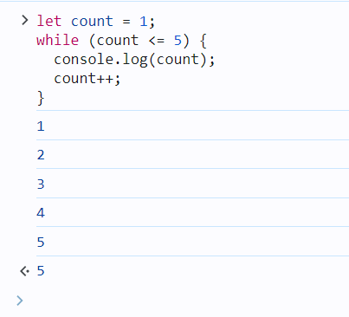**

**Do-While loop**

A [**Do-While loop**](https://www.geeksforgeeks.org/javascript-do-while-loop)is another type of loop in JavaScript that is similar to the while loop, but with one key difference: the do-while loop guarantees that the block of code inside the loop will be executed at least once, regardless of whether the condition is initially true or false .

**Syntax**

do {   
 // code block to be executed   
 } while (condition);

**Example**: Here’s an example of a do-while loop that counts from 1 to 5.

**let** count = 1;

**do** {

console.log(count);

count++;

} **while** (count <= 5);

**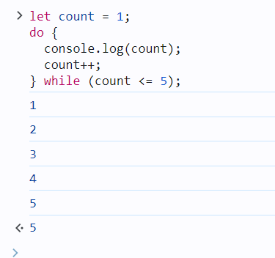**

**Comparison between the while and do-while loop:**

The do-while loop executes the content of the loop once before checking the condition of the while loop. While the while loop will check the condition first before executing the content.

|  |  |
| --- | --- |
| **While Loop** | **Do-While Loop** |
| It is an entry condition looping structure. | It is an exit condition looping structure. |
| The number of iterations depends on the condition mentioned in the while block. | Irrespective of the condition mentioned in the do-while block, there will a minimum of 1 iteration. |
| The block control condition is available at the starting point of the loop. | The block control condition is available at the endpoint of the loop. |

1. [JS for…in Loop](https://www.geeksforgeeks.org/javascript-for-in-loop/)

The for...in loop in JavaScript is used to iterate over the **enumerable properties** of an object. It allows you to loop through the keys (or property names) of an object or the indices of an array.

**Syntax:**

for (variable in object) {

// code block to execute

}

* variable: The variable that will be assigned the current property/key name on each iteration.
* object: The object or array whose properties/indices will be iterated over.

**Example with an Object:**

const person = {

name: "John",

age: 30,

city: "New York"

};

for (let key in person) {

console.log(key + ": " + person[key]);

}

**Output:**

name: John

age: 30

city: New York

**Explanation:**

* for (let key in person): Loops through each key of the person object.
* person[key]: Accesses the value associated with the current key.

**Example with an Array:**

const fruits = ["Apple", "Banana", "Mango"];

for (let index in fruits) {

console.log(index + ": " + fruits[index]);

}

**Output:**

0: Apple

1: Banana

2: Mango

**Explanation:**

* for (let index in fruits): Loops through each index of the fruits array.
* fruits[index]: Accesses the value at the current index.

**Important Notes:**

* The for...in loop is designed for **objects**, but it can also iterate over arrays. However, for arrays, it is generally recommended to use a for loop or for...of loop to avoid potential issues with inherited properties.
* If the object has properties inherited from its prototype, for...in will also iterate over those properties. To avoid this, you can use the hasOwnProperty() method.

**Example using hasOwnProperty():**

const person = {

name: "John",

age: 30

};

Object.prototype.gender = "male"; // Adding a property to the prototype

for (let key in person) {

if (person.hasOwnProperty(key)) {

console.log(key + ": " + person[key]);

}

}

**Output:**

name: John

age: 30

In this case, we prevent the prototype property gender from being printed.

Example :

For-in loop iterates over the properties of an object and its prototype chain’s properties. If we want to display both properties of the “student1” object which belongs to that object only and the prototype chain, then we can perform it by for in loop.

const courses = {

// Declaring a courses object

firstCourse: "C++ STL",

secondCourse: "DSA Self Paced",

thirdCourse: "CS Core Subjects"

};

// Creating a new empty object with

// prototype set to courses object

const student1 = Object.create(courses);

// Defining student1 properties and methods

student1.id = 123;

student1.firstName = "Prakhar";

student1.showEnrolledCourses = function () {

console.log(courses);

}

// Iterating over all properties of

// student1 object

for (let prop in student1) {

console.log(prop + " -> "

+ student1[prop]);

}

**Output**

id -> 123

firstName -> Prakhar

showEnrolledCourses -> function () {

console.log(courses);

}

firstCourse -> C++ STL

secondCourse -> DSA Self Paced

thirdCourse -> CS Core Subjects

1. [JS for…of Loop](https://www.geeksforgeeks.org/javascript-for-of-loop/)

The for...of loop in JavaScript is used to iterate over **iterable objects**, such as arrays, strings, maps, sets, and more. It allows you to loop through the **values** of an iterable object rather than its property names or indices.

**Syntax:**

for (variable of iterable) {

// code block to execute

}

* variable: A variable that holds the value of each iteration.
* iterable: An iterable object (such as an array, string, map, set, etc.).

**Example with an Array:**

const fruits = ["Apple", "Banana", "Mango"];

for (let fruit of fruits) {

console.log(fruit);

}

**Output:**

Apple

Banana

Mango

**Explanation:**

* for (let fruit of fruits): Loops through each element (value) in the fruits array.
* Each iteration assigns the value of the current element to fruit and logs it.

**Example with a String:**

const word = "Hello";

for (let char of word) {

console.log(char);

}

**Output:**

H

e

l

l

o

**Explanation:**

* for (let char of word): Loops through each character in the string "Hello".
* Each iteration assigns the current character to char and logs it.

**Example with a Set:**

const uniqueNumbers = new Set([1, 2, 3, 4]);

for (let number of uniqueNumbers) {

console.log(number);

}

**Output:**

1

2

3

4

**Example with a Map:**

const map = new Map();

map.set("name", "John");

map.set("age", 30);

for (let [key, value] of map) {

console.log(key + ": " + value);

}

**Output:**

name: John

age: 30

**Difference between for...in and for...of:**

* **for...in**: Iterates over **enumerable property names** (keys) of an object or array.
* **for...of**: Iterates over **values** of an iterable object.

**Example to demonstrate the difference:**

const arr = ["a", "b", "c"];

console.log("for...in:");

for (let index in arr) {

console.log(index); // Logs index

}

console.log("for...of:");

for (let value of arr) {

console.log(value); // Logs value

}

**Output:**

for...in:

0

1

2

for...of:

a

b

c

**Conclusion:**

* Use for...of when you want to iterate through the **values** of an iterable (arrays, strings, maps, sets).
* Use for...in when you want to iterate over the **keys** of an object or array.

Example:

**Iterating Over a Map using for…of Loop**

Maps are a new data structure in ES6 that store key-value pairs. The for…of loop can be used to iterate over the entries of a map.

const map = new Map([

["name", "Akash"],

["age", 25],

["city", "Noida"]

]);

for (let [key, value] of map) {

console.log(`${key}: ${value}`);

}

**Output**

name: Akash

age: 25

city: Noida

**Code Explanation**

* First, we create a Map object where we want to iterate over.
* Initiates the for...of loop, where [key, value] represents each key-value pair in the Map during each iteration.
* Inside the loop, console.log(`${key}: ${value}`); prints each key-value pair to the console during each iteration of the loop.

1. [JS labeled Statement](https://www.geeksforgeeks.org/javascript-label-statement/)

JavaScript **label statement**is used to label a block of code. A labeled statement can be used with loops and control flow statements to provide a target for the break and continue statements.

**Syntax:**

Label: statement (loop or block of code)

**Keywords to be used:**

* **Label:**Aunique string that is Used to define the name of the block or loop.
* **Statement:**It can be a loop or block.
* **Break:**Used to terminate the loop or block of code.
* **Continue:**Used to terminate or jump from the current iteration of the loop.

**Label statement with for loops:**In this section, the user will learn to assign a unique label to multiple loops. Also, we will use the break and continue keywords with the multiple loops. The below examples will demonstrate the use of labels using loops.

**Example 1:**Using the break keyword with labeled loops. Users can terminate the outer loop from the inner loop using the label.

JavaScript

**let** sum = 0, a = 1;

*// Label for outer loop*

outerloop: **while** (**true**) {

a = 1;

*// Label for inner loop*

innerloop: **while** (a < 3) {

sum += a;

**if** (sum > 12) {

*// Break outer loop from inner loop*

**break** outerloop;

}

console.log("sum = " + sum);

a++;

}

}

**Output**

sum = 1

sum = 3

sum = 4

sum = 6

sum = 7

sum = 9

sum = 10

sum = 12

**Example 2:**Using the continue keyword with labeled loops. Users can jump to the outer loop from the inner loop using the label. When the ‘ a=2 and sum < 12’ condition executes true, it doesn’t print the sum as we are terminating that iteration of the inner loop using the ‘continue’ keyword. When condition inside if statement executes true, it will jump to the outer loop.

JavaScript

**let** sum = 0, a = 1;

*// Label for outerloop*

outerloop: **while** (sum < 12) {

a = 1;

*// Label for inner loop*

innerloop: **while** (a < 3) {

sum += a;

**if** (a === 2 && sum < 12) {

*// Jump to outer loop from inner loop*

**continue** outerloop;

}

console.log("sum = " + sum + " a = " + a);

a++;

}

}

**Output**

sum = 1 a = 1

sum = 4 a = 1

sum = 7 a = 1

sum = 10 a = 1

sum = 12 a = 2

**Example 3:**Using the label statement with a block of code. Users can terminate the execution of a labeled block using the break keyword. You can observe that code after the break keyword is not executed

JavaScript

blockOfCode: {

console.log('This part will be executed');

**break** blockOfCode;

console.log('this part will not be executed');

}

console.log('out of the block');

**Output**

This part will be executed

out of the block

**Example 4:**labeled function declaration. myLabel is the label assigned to the function declaration. myLabeledFunction is the name of the function.

JavaScript

myLabel: **function** myLabeledFunction() {

console.log("This is a labeled function.");

}

*// Calling the labeled function*

myLabeledFunction();

**Output**

This is a labeled function.

1. [JS break Statement](https://www.geeksforgeeks.org/javascript-break-statement/)

JavaScript **break statement** is used to terminate the execution of the loop or the switch statement when the condition is true.

* In a switch, code breaks out and the execution of code is stopped.
* In a loop, it breaks out to the loop but the code after the loop is executed.

**Syntax:**

break;

**Using Labels**

A label reference can be used by the break statement to exit any JavaScript code block. Only a loop or a switch can be used with the break in the absence of a label.

break labelName;

**Example 1:**In this example, the switch case is executed if the condition is true then it breaks out and the next case is not checked.

* JavaScript

const fruit = "Mango";

**switch** (fruit) {

**case** "Apple":

        console.log("Apple is healthy for our body");

**break**;

**case** "Mango":

        console.log("Mango is a National fruit of India");

**break**;

**default**:

        console.log("I don't like fruits.");

}

**Output**

Mango is a National fruit of India

**Example 2:** In this example, the fruit name is apple but the given output is for the two cases. This is because of the break statement. In the case of Apple, we are not using a break statement which means the block will run for the next case also till the break statement not appear.

* JavaScript

const fruit = "Apple";

**switch** (fruit) {

**case** "Apple":

        console.log("Apple is healthy for our body");

**case** "Mango":

        console.log("Mango is a National fruit of India");

**break**;

**default**:

        console.log("I don't like fruits.");

}

**Output**

Apple is healthy for our body

Mango is a National fruit of India

**Example 3:**In this example, the loop iterate from 1 to 6 when it is equal to 4 then the condition becomes true, and code breaks out to the loop.

* Javascript

**for** (let i = 1; i < 6; i++) {

**if** (i == 4) **break**;

    console.log(i);

}

**Output**

1

2

3

**Example 4:** In this example, break statement can is used with while and do-while loop.

* JavaScript

// Using break in a while loop

let i = 1;

**while** (i <= 5) {

    console.log(i);

**if** (i === 3) {

**break**;

    }

    i++;

}

// Using break in a do-while loop

let j = 1;

**do** {

    console.log(j);

**if** (j === 3) {

**break**;

    }

    j++;

} **while** (j <= 5);

**Output**

1

2

3

1

2

3

1. [JS continue Statement](https://www.geeksforgeeks.org/javascript-continue-statement/)

The **continue statement**in Javascript is used to break the iteration of the loop and follow with the next iteration. The break in the iteration is possible only when the specified condition going to occur.

The major difference between the continue and break statement is that the break statement breaks out of the loop completely while continue is used to break one statement and iterate to the next statement.

**How does the continue statement work for different loops?**

* In a For loop, iteration goes to an updated expression which means the increment expression is first updated.
* In a While loop, it again executes the condition.

**Syntax:**

continue;

**Example 1:**In this example, we will use the continue statement in the *for loop*.

* Javascript

**for** (let i = 0; i < 11; i++) {

**if** (i % 2 == 0) **continue**;

    console.log(i);

}

**Output:**In the above example, the first increment condition is evaluated and then the condition is checked for the next iteration.

1  
3  
5  
7  
9

**Example 2:**In this example, we will use the continue statement in the while loop.

* Javascript

let i = 0;

**while** (i < 11) {

    i++;

**if** (i % 2 == 0) **continue**;

    console.log(i);

}

**Output:**In the above example, the first condition is checked, and if the condition is true then the while loop is again executed.

1  
3  
5  
7  
9  
11

1. [JS Expression and Operators](https://www.geeksforgeeks.org/javascript/#js-expression-and-operators) : The topic already coverd
   1. [JS Assignment operators](https://www.geeksforgeeks.org/javascript-assignment-operators/)
   2. [JS Comparison operators](https://www.geeksforgeeks.org/javascript-comparison-operators/)
   3. [JS Arithmetic operators](https://www.geeksforgeeks.org/javascript-arithmetic-operators/)
   4. [JS Bitwise operators](https://www.geeksforgeeks.org/javascript-bitwise-operators/)
   5. [JS Logical operators](https://www.geeksforgeeks.org/javascript-logical-operators/)
   6. [JS BigInt Operators](https://www.geeksforgeeks.org/javascript-bigint/)
   7. [JS String operators](https://www.geeksforgeeks.org/javascript-string-operators/)
   8. [JS Ternary operator](https://www.geeksforgeeks.org/javascript-ternary-operator/)
   9. [JS Comma operator](https://www.geeksforgeeks.org/javascript-comma-operator/)
   10. [JS Unary operators](https://www.geeksforgeeks.org/javascript-unary-operators/)
   11. [JS Relational operators](https://www.geeksforgeeks.org/javascript-relational-operators/)
2. [JavaScript Objects](https://www.geeksforgeeks.org/javascript/#javascript-objects)
   1. [JS Array](https://www.geeksforgeeks.org/javascript-arrays/)

An array in JavaScript is a data structure used to store multiple values in a single variable. It can hold various data types and allows for dynamic resizing. Elements are accessed by their index, starting from 0.

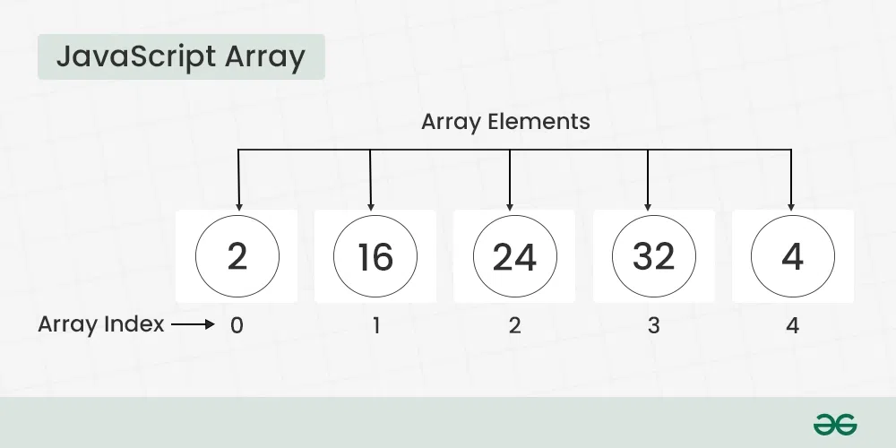

You have two ways to create JavaScript Arrays: **using the Array constructor**or the **shorthand array literal syntax**, which is just square brackets. Arrays are flexible in size, so they can grow or shrink as you add or remove elements.

**Table of Content**

* [Basic Terminologies of JavaScript Array](https://www.geeksforgeeks.org/javascript-arrays/#basic-terminologies-of-javascript-array)
* [Declaration of an Array](https://www.geeksforgeeks.org/javascript-arrays/#declaration-of-an-array)
* [Basic Operations on JavaScript Arrays](https://www.geeksforgeeks.org/javascript-arrays/#basic-operations-on-javascript-arrays)
* [Difference Between JavaScript Arrays and Objects](https://www.geeksforgeeks.org/javascript-arrays/#difference-between-javascript-arrays-and-objects)
* [When to use JavaScript Arrays and Objects?](https://www.geeksforgeeks.org/javascript-arrays/#when-to-use-javascript-arrays-and-objects)
* [Recognizing a JavaScript Array](https://www.geeksforgeeks.org/javascript-arrays/#recognizing-a-javascript-array)
* [JavaScript Array Complete Reference](https://www.geeksforgeeks.org/javascript-arrays/#javascript-array-complete-reference)
* [JavaScript Array Examples](https://www.geeksforgeeks.org/javascript-arrays/#javascript-array-examples)
* [JavaScript CheatSheet](https://www.geeksforgeeks.org/javascript-arrays/#javascript-cheatsheet)

**Basic Terminologies of JavaScript Array**

* **Array:** A data structure in JavaScript that allows you to store multiple values in a single variable.
* **Array Element:** Each value within an array is called an element. Elements are accessed by their index.
* **Array Index:** A numeric representation that indicates the position of an element in the array. JavaScript arrays are zero-indexed, meaning the first element is at index 0.
* **Array Length:** The number of elements in an array. It can be retrieved using the length property.

**Declaration of an Array**

There are basically two ways to declare an array i.e. Array Literal and Array Constructor.

**1. Creating an Array using Array Literal**

Creating an array using array literal involves using square brackets [] to define and initialize the array. This method is concise and widely preferred for its simplicity.

**Syntax:**

let arrayName = [value1, value2, ...];

**Example:**

JavaScript

*// Creating an Empty Array*

**let** names = [];

console.log(names);

*// Creating an Array and Initializing with Values*

**let** courses = ["HTML", "CSS", "Javascript", "React"];

console.log(courses);

**Output**

[]

[ 'HTML', 'CSS', 'Javascript', 'React' ]

**2. Creating an Array using JavaScript new Keyword (Array Constructor)**

The “**Array Constructor**” refers to a method of creating arrays by invoking the Array constructor function. This approach allows for dynamic initialization and can be used to create arrays with a specified length or elements.

**Syntax:**

let arrayName = new Array();

**Example:**

javascript

*// Creating and Initializing an array with values*

**let** courses = **new** Array("HTML", "CSS", "Javascript", "React");

console.log(courses);

**Output**

[ 'HTML', 'CSS', 'Javascript', 'React' ]

***Note:****Both the above methods do exactly the same. Use the array literal method for efficiency, readability, and speed.*

**Basic Operations on JavaScript Arrays**

**1. Accessing Elements of an Array**

Any element in the array can be accessed using the index number. The index in the arrays starts with 0.

JavaScript

*// Creating an Array and Initializing with Values*

**let** courses = ["HTML", "CSS", "Javascript", "React"];

*// Accessing Array Elements*

console.log(courses[0]);

console.log(courses[1]);

**Output**

HTML

CSS

**2. Accessing the First Element of an Array**

The array indexing starts from 0, so we can access first element of array using the index number.

JavaScript

*// Creating an Array and Initializing with Values*

**let** courses = ["HTML", "CSS", "JavaScript", "React"];

*// Accessing First Array Elements*

**let** firstItem = courses[0];

console.log("First Item: ", firstItem);

**Output**

First Item: HTML

**3. Accessing the Last Element of an Array**

We can access the last array element using [array.length – 1] index number.

JavaScript

*// Creating an Array and Initializing with Values*

**let** courses = ["HTML", "CSS", "JavaScript", "React"];

*// Accessing Last Array Elements*

**let** lastItem = courses[courses.length - 1];

console.log("First Item: ", lastItem);

**Output**

First Item: React

**4. Modifying the Array Elements**

Elements in an array can be modified by assigning a new value to their corresponding index.

JavaScript

*// Creating an Array and Initializing with Values*

**let** courses = ["HTML", "CSS", "Javascript", "React"];

console.log(courses);

courses[1]= "Bootstrap";

console.log(courses);

**Output**

[ 'HTML', 'CSS', 'Javascript', 'React' ]

[ 'HTML', 'Bootstrap', 'Javascript', 'React' ]

**5. Adding Elements to the Array**

Elements can be added to the array using methods like [push()](https://www.geeksforgeeks.org/javascript-array-push-method/) and [unshift()](https://www.geeksforgeeks.org/javascript-array-unshift-method/).

* The push() method add the element to the end of the array.
* The unshift() method add the element to the starting of the array.

JavaScript

*// Creating an Array and Initializing with Values*

**let** courses = ["HTML", "CSS", "Javascript", "React"];

*// Add Element to the end of Array*

courses.push("Node.js");

*// Add Element to the beginning*

courses.unshift("Web Development");

console.log(courses);

**Output**

[ 'Web Development', 'HTML', 'CSS', 'Javascript', 'React', 'Node.js' ]

**6. Removing Elements from an Array**

To remove the elements from an array we have different methods like [pop()](https://www.geeksforgeeks.org/javascript-array-pop-method/), [shift()](https://www.geeksforgeeks.org/javascript-array-shift-method/), or [splice()](https://www.geeksforgeeks.org/javascript-array-splice-method/).

* The pop() method removes an element from the last index of the array.
* The shift() method removes the element from the first index of the array.
* The splice() method removes or replaces the element from the array.

JavaScript

*// Creating an Array and Initializing with Values*

**let** courses = ["HTML", "CSS", "Javascript", "React", "Node.js"];

console.log("Original Array: " + courses);

*// Removes and returns the last element*

**let** lastElement = courses.pop();

console.log("After Removing the last elements: " + courses);

*// Removes and returns the first element*

**let** firstElement = courses.shift();

console.log("After Removing the First elements: " + courses);

*// Removes 2 elements starting from index 1*

courses.splice(1, 2);

console.log("After Removing 2 elements starting from index 1: " + courses);

**Output**

Original Array: HTML,CSS,Javascript,React,Node.js

After Removing the last elements: HTML,CSS,Javascript,React

After Removing the First elements: CSS,Javascript,React

After Removing 2 elements starting from index 1: CSS

**7. Array Length**

We can get the length of the array using the [array length property](https://www.geeksforgeeks.org/javascript-array-length-property/).

JavaScript

*// Creating an Array and Initializing with Values*

**let** courses = ["HTML", "CSS", "Javascript", "React", "Node.js"];

**let** len = courses.length;

console.log("Array Length: " + len);

**Output**

Array Length: 5

**8. Increase and Decrease the Array Length**

We can increase and decrease the array length using the JavaScript length property.

JavaScript

*// Creating an Array and Initializing with Values*

**let** courses = ["HTML", "CSS", "Javascript", "React", "Node.js"];

*// Increase the array length to 7*

courses.length = 7;

console.log("Array After Increase the Length: ", courses);

*// Decrease the array length to 2*

courses.length = 2;

console.log("Array After Decrease the Length: ", courses)

**Output**

Array After Increase the Length: [ 'HTML', 'CSS', 'Javascript', 'React', 'Node.js', <2 empty items> ]

Array After Decrease the Length: [ 'HTML', 'CSS' ]

**9. Iterating Through Array Elements**

We can iterate array and access array elements using [for loop](https://www.geeksforgeeks.org/javascript-for-loop/) and forEach loop.

**Example:** It is an example of for loop.

JavaScript

*// Creating an Array and Initializing with Values*

**let** courses = ["HTML", "CSS", "JavaScript", "React"];

*// Iterating through for loop*

**for** (**let** i = 0; i < courses.length; i++) {

console.log(courses[i])

}

**Output**

HTML

CSS

JavaScript

React

**Example:** It is the example of [Array.forEach()](https://www.geeksforgeeks.org/javascript-array-foreach-method/" \t "_blank)loop.

JavaScript

*// Creating an Array and Initializing with Values*

**let** courses = ["HTML", "CSS", "JavaScript", "React"];

*// Iterating through forEach loop*

courses.forEach(**function** myfunc(elements) {

console.log(elements);

});

**Output**

HTML

CSS

JavaScript

React

**10. Array Concatenation**

Combine two or more arrays using the concat() method. It returns new array containing joined arrays elements.

JavaScript

*// Creating an Array and Initializing with Values*

**let** courses = ["HTML", "CSS", "JavaScript", "React"];

**let** otherCourses = ["Node.js", "Expess.js"];

*// Concatenate both arrays*

**let** concateArray = courses.concat(otherCourses);

console.log("Concatenated Array: ", concateArray);

**Output**

Concatenated Array: [ 'HTML', 'CSS', 'JavaScript', 'React', 'Node.js', 'Expess.js' ]

**11. Conversion of an Array to String**

We have a builtin method **[toString()](https://www.geeksforgeeks.org/javascript-array-tostring-method/" \t "_blank)**to converts an array to a string.

JavaScript

*// Creating an Array and Initializing with Values*

**let** courses = ["HTML", "CSS", "JavaScript", "React"];

*// Convert array ot String*

console.log(courses.toString());

**Output**

HTML,CSS,JavaScript,React

**12. Check the Type of an Arrays**

The JavaScript [typeof](https://www.geeksforgeeks.org/javascript-typeof-operator/" \t "_blank) operator is used ot check the type of an array. It returns “object” for arrays.

JavaScript

*// Creating an Array and Initializing with Values*

**let** courses = ["HTML", "CSS", "JavaScript", "React"];

*// Check type of array*

console.log(**typeof** courses);

**Output**

object

**Difference Between JavaScript Arrays and Objects**

|  |  |  |
| --- | --- | --- |
| **Feature** | **JavaScript Arrays** | **JavaScript Objects** |
| **Index Type** | Numeric indexes (0, 1, 2, …) | Named keys (strings or symbols) |
| **Order** | Ordered collection | Unordered collection |
| **Use Case** | Storing lists, sequences, ordered data | Storing data with key-value pairs, attributes |
| **Accessing Elements** | Accessed by index (e.g., arr[0]) | Accessed by key (e.g., obj[“key”]) |
| **Iteration** | Typically iterated using loops like for or forEach | Iterated using for…in, Object.keys(), or Object.entries() |
| **Size Flexibility** | Dynamic, can grow or shrink in size | Dynamic, can add or remove key-value pairs |

**When to use JavaScript Arrays and Objects?**

* Use arrays when you need numeric indexing and order matters.
* Use objects when you need named keys and the relationship between keys and values is important.

**Recognizing a JavaScript Array**

There are two methods by which we can recognize a JavaScript array:

* **By using [Array.isArray()](https://www.geeksforgeeks.org/javascript-array-isarray-method/" \t "_blank) method**
* **By using [instanceof](https://www.geeksforgeeks.org/instanceof-operator-in-javascript/" \t "_blank) method**

Below is an example showing both approaches:

JavaScript

**const** courses = ["HTML", "CSS", "Javascript"];

console.log("Using Array.isArray() method: ", Array.isArray(courses))

console.log("Using instanceof method: ", courses **instanceof** Array)

**Output**

Using Array.isArray() method: true

Using instanceof method: true

**Note:** A common error is faced while writing the arrays:

const numbers = [5]

// and

const numbers = new Array(5)

JavaScript

**const** numbers = [5]

console.log(numbers)

The above two statements are not the same.

**Output:** This statement creates an array with an element ” [5] “.

[5]

JavaScript

**const** numbers = **new** Array(5)

console.log(numbers)

**Output**

[ <5 empty items> ]

**JavaScript Arrays – FAQs**

**What is an array in JavaScript?**

*An array is a special type of object used to store multiple values in a single variable. Arrays can hold any combination of data types, including numbers, strings, objects, and even other arrays.*

**How do you create an array?**

*You can create an array using the array literal syntax or the Array constructor.*

**What is the array literal syntax?**

*The array literal syntax uses square brackets to enclose a comma-separated list of values.*

*Example: const fruits = [“apple”, “banana”, “cherry”];*

**What is the Array constructor?**

*The Array constructor creates an array by using the new Array() syntax.*

*Example: const fruits = new Array(“apple”, “banana”, “cherry”);*

**How do you access array elements?**

*You can access array elements using their index, which starts at 0 for the first element.*

*Example: const firstFruit = fruits[0];*

**How do you modify array elements?**

*You can modify array elements by assigning a new value to a specific index.*

*Example: fruits[0] = “orange”;*

* 1. [JS String](https://www.geeksforgeeks.org/javascript-string/)

**What is String in JavaScript?**

**JavaScript String** is a sequence of characters, typically used to represent text. It is enclosed in single or double quotes and supports various methods for text manipulation.

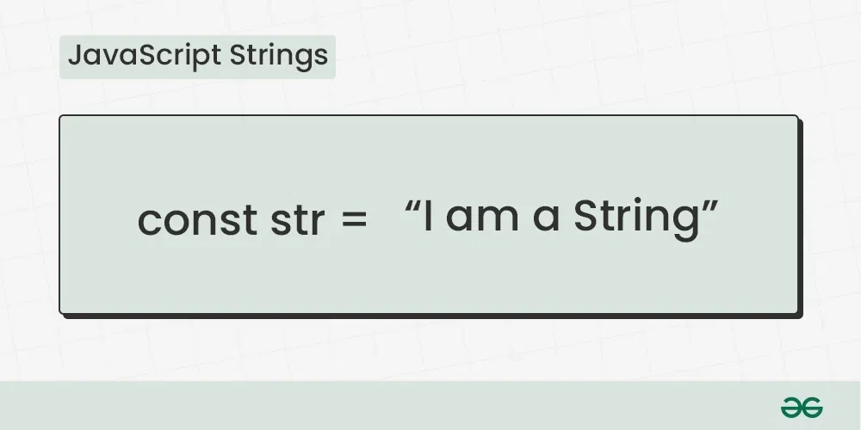

JavaScript strings can be created by enclosing text within either single or double quotes. You have options for creating strings using string literals or the String constructor. Strings offer flexibility for dynamic manipulation, allowing you to easily modify or extract elements as required.

**Table of Content**

* [What is String in JavaScript?](https://www.geeksforgeeks.org/javascript-strings/#what-is-string-in-javascript)
* [Basic Terminologies of JavaScript String](https://www.geeksforgeeks.org/javascript-strings/#basic-terminologies-of-javascript-string)
* [Declaration of a String](https://www.geeksforgeeks.org/javascript-strings/#declaration-of-a-string)
* [Basic Operations on JavaScript Strings](https://www.geeksforgeeks.org/javascript-strings/#basic-operations-on-javascript-strings)
* [Are the strings created by the new keyword is same as normal strings?](https://www.geeksforgeeks.org/javascript-strings/#are-the-strings-created-by-the-new-keyword-is-same-as-normal-strings)
* [JavaScript String Complete Reference](https://www.geeksforgeeks.org/javascript-strings/#javascript-string-complete-reference)

**Basic Terminologies of JavaScript String**

* **String:** A sequence of characters enclosed in single (‘ ‘) or double (” “) quotes.
* **Length:** The number of characters in a string, obtained using the length property.
* **Index:** The position of a character within a string, starting from 0.
* **Concatenation:** The process of combining two or more strings to create a new one.
* **Substring:** A portion of a string, obtained by extracting characters between specified indices.

**Declaration of a String**

**1. Using Single Quotes**

Single Quotes can be used to create a string in JavaScript. Simply enclose your text within single quotes to declare a string.

**Syntax:**

let str = 'String with single quote';

**Example:**

JavaScript

**let** str = 'Create String with Single Quote';

console.log(str);

**Output**

Create String with Single Quote

**2. Using Double Quotes**

Double Quotes can also be used to create a string in JavaScript. Simply enclose your text within double quotes to declare a string.

**Syntax:**

let str = “String with double quote”;

**Example:**

JavaScript

**let** str = "Create String with Double Quote";

console.log(str);

**Output**

Create String with Double Quote

**3. String Constructor**

You can create a string using the String Constructor. The String Constructor is less common for direct string creation, it provides additional methods for manipulating strings. Generally, using string literals is preferred for simplicity.

JavaScript

**let** str = **new** String('Create String with String Constructor');

console.log(str);

**Output**

[String: 'Create String with String Constructor']

**4. Using Template Literals (String Interpolation)**

You can create strings using Template Literals. Template literals allow you to embed expressions within backticks (`) for dynamic string creation, making it more readable and versatile.

**Syntax:**

let str = 'Template Litral String';  
let newStr = `String created using ${str}`;

**Example:**

JavaScript

**let** str = 'Template Litral String';

**let** newStr = `String created using **${**str**}**`;

console.log(newStr);

**Output**

String created using Template Litral String

**5. Empty String**

You can create an empty string by assigning either single or double quotes with no characters in between.

**Syntax:**

// Create Empty Strign with Single Quotes  
let str1 = '';  
// Create Empty Strign with Double Quotes  
let str2 = "";

**Example:**

JavaScript

**let** str1 = '';

**let** str2 = "";

console.log("Empty String with Single Quotes: " + str1);

console.log("Empty String with Double Quotes: " + str2);

**Output**

Empty String with Single Quotes:

Empty String with Double Quotes:

**6. Multiline Strings (ES6 and later)**

You can create a multiline string using backticks (“) with template literals. The backticks allows you to span the string across multiple lines, preserving the line breaks within the string.

**Syntax:**

let str = `  
 This is a  
 multiline  
 string`;

**Example:**

JavaScript

**let** str = `

This is a

multiline

string`;

console.log(str);

**Output**

This is a

multiline

string

**Basic Operations on JavaScript Strings**

**1. Finding the length of a String**

You can find the length of a string using the [length property](https://www.geeksforgeeks.org/javascript-string-length-property).

**Example:**Finding the length of a string.

JavaScript

**let** str = 'JavaScript';

**let** len = str.length;

console.log("String Length: " + len);

**Output**

String Length: 10

**2. String Concatenation**

You can combine two or more strings using [+ Operator](https://www.geeksforgeeks.org/addition-arithmetic-operator-in-javascript).

**Example:**

JavaScript

**let** str1 = 'Java';

**let** str2 = 'Script';

**let** result = str1 + str2;

console.log("Concatenated String: " + result);

**Output**

Concatenated String: JavaScript

**3. Escape Characters**

We can use escape characters in string to add single quotes, dual quotes, and backslash.

**Syntax:**

\' - Inserts a single quote  
\" - Inserts a double quote   
\\ - Inserts a backslash

**Example:**In this example we are using escape characters

JavaScript

**const** str1 = "\'GfG\' is a learning portal";

**const** str2 = "\"GfG\" is a learning portal";

**const** str3 = "\\GfG\\ is a learning portal";

console.log(str1);

console.log(str2);

console.log(str3);

**Output**

'GfG' is a learning portal

"GfG" is a learning portal

\GfG\ is a learning portal

**4. Breaking Long Strings**

We will use a backslash to break a long string in multiple lines of code.

JavaScript

**const** str = "'GeeksforGeeks' is \

a learning portal";

console.log(str);

**Output**

'GeeksforGeeks' is a learning portal

**Note:** This method might not be supported on all browsers.

**Example:** The better way to break a string is by using the string addition.

JavaScript

**const** str = "'GeeksforGeeks' is a"

+ " learning portal";

console.log(str);

**Output**

'GeeksforGeeks' is a learning portal

**5. Find Substring of a String**

We can extract a portion of a string using the [substring() method](https://www.geeksforgeeks.org/javascript-string-substring-method).

JavaScript

**let** str = 'JavaScript Tutorial';

**let** substr = str.substring(0, 10);

console.log(substr);

**Output**

JavaScript

**6. Convert String to Uppercase and Lowercase**

Convert a string to uppercase and lowercase using [toUpperCase()](https://www.geeksforgeeks.org/javascript-string-touppercase-method" \t "_blank) and [toLowerCase()](https://www.geeksforgeeks.org/javascript-string-tolowercase-method" \t "_blank) methods.

JavaScript

**let** str = 'JavaScript';

**let** upperCase = str.toUpperCase();

**let** lowerCase = str.toLowerCase();

console.log(upperCase);

console.log(lowerCase);

**Output**

JAVASCRIPT

javascript

**7. String Search in JavaScript**

Find the index of a substring within a string using [indexOf() method](https://www.geeksforgeeks.org/javascript-string-indexof-method" \t "_blank).

JavaScript

**let** str = 'Learn JavaScript at GfG';

**let** searchStr = str.indexOf('JavaScript');

console.log(searchStr);

**Output**

6

**8. String Replace in JavaScript**

Replace occurrences of a substring with another using [replace() method](https://www.geeksforgeeks.org/javascript-string-replace-method).

JavaScript

**let** str = 'Learn HTML at GfG';

**let** newStr = str.replace('HTML', 'JavaScript');

console.log(newStr);

**Output**

Learn JavaScript at GfG

**9. Trimming Whitespace from String**

Remove leading and trailing whitespaces using [trim() method](https://www.geeksforgeeks.org/javascript-string-trim-method).

JavaScript

**let** str = ' Learn JavaScript ';

**let** newStr = str.trim();

console.log(newStr);

**Output**

Learn JavaScript

**10. Access Characters from String**

Access individual characters in a string using bracket notation and [charAt() method](https://www.geeksforgeeks.org/javascript-string-charat-method" \t "_blank).

JavaScript

**let** str = 'Learn JavaScript';

**let** charAtIndex = str[6];

console.log(charAtIndex);

charAtIndex = str.charAt(6);

console.log(charAtIndex);

**Output**

J

J

**11. String Comparison in JavaScript**

There are some inbuilt methods that can be used to compare strings such as the equality operator and another like [localeCompare() method](https://www.geeksforgeeks.org/javascript-string-localecompare-method" \t "_blank).

JavaScript

**let** str1 = "John";

**let** str2 = **new** String("John");

console.log(str1 == str2);

console.log(str1.localeCompare(str2));

**Output**

true

0

**Note:**The Equality operator returns true, whereas the localeCompare method returns the difference of ASCII values.

**12. Passing JavaScript String as Objects**

We can create a JavaScript string using the new keyword.

JavaScript

**const** str = **new** String("GeeksforGeeks");

console.log(str);

**Output**

[String: 'GeeksforGeeks']

**Are the strings created by the new keyword is same as normal strings?**

**No**, the string created by the new keyword is an object and is not the same as normal strings.

JavaScript

**const** str1 = **new** String("GeeksforGeeks");

**const** str2 = "GeeksforGeeks";

console.log(str1 == str2);

console.log(str1 === str2);

**Output**

true

false

**JavaScript Strings – FAQs**

**What is a string in JavaScript?**

*A string is a sequence of characters used to represent text. Strings are one of the fundamental data types in JavaScript and are enclosed in single quotes (‘), double quotes (“), or backticks (`).*

**How do you create a string?**

*You can create a string by enclosing characters in single quotes, double quotes, or backticks.*

***Examples:***

* *‘Hello’*
* *“World”*
* *`Hello World`*

**What are template literals?**

*Template literals are strings enclosed in backticks (`) and allow for embedded expressions using ${expression}. They can span multiple lines and include interpolated variables and expressions.*

*Example: `Hello, ${name}!`*

**How do you access characters in a string?**

*You can access characters in a string using bracket notation and the index of the character. The index starts at 0 for the first character.*

*Example: str[0]*

**How do you find the length of a string?**

*You can find the length of a string using the length property.*

*Example: str.length*

**How do you concatenate strings?**

*You can concatenate strings using the + operator or the concat() method.*

*Example: str1 + str2 or str1.concat(str2)*

* 1. [JS Date](https://www.geeksforgeeks.org/javascript-date/)

The**JavaScript Date** object represents a single moment in time in a platform-independent format, encapsulating milliseconds since January 1, 1970, 00:00:00 UTC. It is fundamental for managing date and time in applications, providing methods for date arithmetic, formatting, and manipulation, essential for handling temporal data in web development.

**Understanding the Date Object**

The time value in a JavaScript Date object is measured in milliseconds since January 1, 1970, 00:00:00 UTC. The new Date() constructor initializes it, supporting parameters to specify year, month, day, hour, minute, second, and milliseconds.

**Table of Content**

* [Creating a Date Object](https://www.geeksforgeeks.org/javascript-date/#creating-a-date-object)
* [Getting Date Components](https://www.geeksforgeeks.org/javascript-date/#getting-date-components)
* [Formatting Dates](https://www.geeksforgeeks.org/javascript-date/#formatting-dates)
* [Manipulating Dates](https://www.geeksforgeeks.org/javascript-date/#manipulating-dates)

**Creating a Date Object**

Creating a Date object involves invoking the new Date() constructor, which initializes the object with the current date and time based on the system’s local time zone. The Date constructor supports various parameter options to specify a specific date and time, including year, month, day, hour, minute, second, and milliseconds.

You can create a Date object in several ways:

**Syntax**

new Date();  
new Date(value);  
new Date(dateString);  
new Date(year, month, day, hours, minutes, seconds, milliseconds);

**Parameters**

|  |  |
| --- | --- |
| **Field** | **Description** |
| value | The number of milliseconds since January 1, 1970, 00:00:00 UTC. |
| dateString | Represents a date format. |
| year | An integer representing the year, ranging from 1900 to 1999. |
| month | An integer representing the month, ranging from 0 for January to 11 for December. |
| day | An optional integer representing the day of the month. |
| hours | An optional integer representing the hour of the day. |
| minutes | An optional integer representing the minute of the time. |
| seconds | An optional integer representing the second of the time. |
| milliseconds | An optional integer representing the millisecond of the time. |

**Return Values**

It returns the present date and time if nothing as the parameter is given otherwise it returns the date format and time in which the parameter is given.

**Getting Date Components**

You can get various components of a date (such as year, month, day, hour, minute, second, etc.) using methods provided by the Date object:

**Example:** The code initializes a Date object representing the current date and time. It then retrieves various components such as year, month (zero-based), day of the month, hours, minutes, and seconds from this object. These components are stored in separate variables for further use or display.

JavaScript

**let** date = **new** Date();

**let** year = date.getFullYear();

**let** month = date.getMonth(); *// Note: Month is zero-based (0 for January, 11 for December)*

**let** day = date.getDate();

**let** hours = date.getHours();

**let** minutes = date.getMinutes();

**let** seconds = date.getSeconds();

**Formatting Dates**

Formatting dates in JavaScript can be done manually, or by using libraries like moment.js. However, with modern JavaScript, you can also achieve formatting using Intl.DateTimeFormat:

**Example:**The code initializes a `Date` object representing the current date. It then formats this date using the Intl.DateTimeFormat constructor with the locale set to ‘en-US’, displaying it in the format ‘month/day/year’.

JavaScript

**let** date = **new** Date();

**let** formattedDate = **new** Intl.DateTimeFormat('en-US').format(date);

console.log(formattedDate); *// Output: "2/23/2024" (assuming today's date is Feb 23, 2024)*

**Output**

7/8/2024

**Manipulating Dates**

You can manipulate dates using various methods provided by the Date object.

**Example:**The code initializes a Date object representing the current date. It then increments the date by 7 days using setDate(). Finally, it logs the modified date to the console.

JavaScript

**let** date = **new** Date();

date.setDate(date.getDate() + 7); *// Adds 7 days to the current date*

console.log(date);

**Output**

2024-07-15T10:25:17.602Z

**Example:** The code initializes a `Date` object with the provided parameters: year (1996), month (10 for November), day (13), hours (5), minutes (30), seconds (22), and milliseconds (0 by default). It then logs this date to the console.

javascript

*// When some numbers are taken as the parameter*

*// then they are considered as year, month, day,*

*// hours, minutes, seconds, milliseconds*

*// respectively.*

**let** A = **new** Date(1996, 10, 13, 5, 30, 22);

console.log(A);

**Output**

1996-11-13T05:30:22.000Z

Furthermore, the Date object provides a range of methods for retrieving and manipulating date and time components, such as **getFullYear(), getMonth(), getDate(), getHours(), getMinutes(), getSeconds(), and getMilliseconds()**.

The JavaScript Date object is essential for managing date and time in web applications, offering methods for arithmetic, formatting, and manipulation. It supports various parameters and provides extensive functionalities. For a complete reference, see the JavaScript Date Object Complete Reference article. Supported by all major browsers.

We have a complete list of Javascript Date object methods, to check those please go through this [JavaScript Date Object Complete Reference](https://www.geeksforgeeks.org/javascript-date-object-complete-reference/) article.

**Supported Browsers**

The browsers supported by JavaScript Date are listed below:

* [Google Chrome](https://www.geeksforgeeks.org/how-to-install-and-use-metamask-on-google-chrome/) 5.0
* [Edge](https://www.geeksforgeeks.org/microsoft-edge-browser/)12
* [Mozilla](https://www.geeksforgeeks.org/mozilla-firefox-browser/) 4.0
* [Safari](https://www.geeksforgeeks.org/apple-safari-browser/)5.0
* [Opera](https://www.geeksforgeeks.org/opera-browser/)11.1

**JavaScript Date – FAQs**

**What is the Date object in JavaScript?**

*The Date object in JavaScript is used to work with dates and times. It provides methods for creating, formatting, and manipulating dates and times.*

**How do you get the current date and time?**

*You can get the current date and time by creating a new Date object with no arguments: const now = new Date();*

**How do you get individual date and time components?**

*You can get individual date and time components using methods like getFullYear(), getMonth(), getDate(), getDay(), getHours(), getMinutes(), getSeconds(), and getMilliseconds().*

* 1. [JS Number](https://www.geeksforgeeks.org/javascript-numbers/)

JavaScript numbers are primitive data types and, unlike other programming languages, you don’t need to declare different numeric types like int, float, etc. JavaScript numbers are always stored in double-precision 64-bit binary format IEEE 754. This format stores numbers in 64 bits:

* 0-51 bits store the value (fraction)
* 52-62 bits store the exponent
* 63rd bit stores the sign

**Numeric Types in JavaScript**

In JavaScript, numbers play an important role, and understanding their behavior is essential for effective programming. Let’s explore the various aspects of numeric types in JavaScript.

**1. The Only Numeric Type**

As we know JavaScript has only one numeric type: the **double-precision 64-bit binary format IEEE 754**means that it doesn’t differentiate between integers and floating-point numbers explicitly. Instead, it uses a unified approach for all numeric values.

* Integers and floating-point numbers are both represented using this format.
* The numeric precision is **53 bits**, allowing for an accurate representation of integer values ranging from **-2^53 + 1** to **2^53 – 1**.

**2. Scientific Notation**

JavaScript allows writing extra-large or extra-small numbers using scientific (exponent) notation.

**Example:**

JavaScript

**let** a = 156e5;

**let** b = 156e-5;

console.log(a);

console.log(b);

**Output**

15600000

0.00156

**3. Integer Precision:**

Integers (numbers without a period or exponent notation) are accurate up to 15 digits.

**Example:**

JavaScript

**let** a = 999999999999999;

**let** b = 9999999999999999;

console.log(a);

console.log(b);

**Output**

999999999999999

10000000000000000

**4. Floating Point Precision:**

Floating point arithmetic is **not always 100% accurate** due to binary representation limitations.

**Example:**

let x = 0.22 + 0.12; //x will be **0.33999999999999997**

**To solve this problem, multiply and divide:**

let x = (0.22 \* 10 + 0.12 \* 10) / 10; // x will be **0.34**

JavaScript

**let** x = 0.22 + 0.12;

**let** y = (0.22 \* 10 + 0.12 \* 10) / 10;

console.log(x);

console.log(y);

**Output**

0.33999999999999997

0.34

**5. Adding Numbers and Strings:**

* JavaScript uses the `**+**` operator for both addition and concatenation.
* Numbers are added, when strings are concatenated.

**Example:**

JavaScript

*// Adding two numbers*

**let** x = 10;

**let** y = 15;

**let** z = x + y;

console.log(z);

*// Concatenating two strings:*

**let** a = "10";

**let** b = "30";

**let** c = a + b;

console.log(c);

**Output**

25

1030

**6. Numeric Strings:**

JavaScript automatically converts the numeric strings to numbers in most operations like.

Example:

JavaScript

**let** x = "100" / "10";

**let** y = "100" \* "10";

**let** z = "100" - "10";

console.log(x);

console.log(y);

console.log(z);

**Output**

10

1000

90

**Number Literals:**

**The types of number literals You can use decimal, binary, octal, and hexadecimal.**

**1. Decimal Numbers:**

JavaScript Numbers does not have different types of numbers(ex: int, float, long, short) which other programming languages do. It has only one type of number and it can hold both with or without decimal values.

JavaScript

**let** a=33;

**let** b=3.3;

console.log(a);

console.log(b);

**Output**

33

3.3

**2. Octal Number:**

If the number starts with 0 and the following number is smaller than 8. It will be parsed as an Octal Number.

JavaScript

**let** x = 0562;

console.log(x);

**Output**

370

**3. Binary Numbers:**

They start with 0b or 0B followed by 0’s and 1’s.

JavaScript

**let** x = 0b11;

**let** y = 0B0111;

console.log(x);

console.log(y);

**Output**

3

7

**4. Hexadecimal Numbers:**

They start with 0x or 0X followed by any digit belonging (0123456789ABCDEF)

JavaScript

**let** x = 0xfff;

console.log(x);

**Output**

4095

**Number Coercion in JavaScript**

In JavaScript, **coercion** refers to the automatic or implicit conversion of values from one data type to another. When different types of operators are applied to values, JavaScript performs type coercion to ensure that the operation can proceed. Let’s explore some common examples of coercion:

**1. Undefined to NaN:**

When you perform an operation involving **undefined**, JavaScript returns **NaN**(Not-a-Number).

JavaScript

**const** result = **undefined** + 10;

console.log(result); *// NaN*

**Output**

NaN

**2. Null to 0:**

The value **null**is **coerced to 0**when used in arithmetic operations.

JavaScript

**const** total = **null** + 5;

console.log(total); *// 5*

**Output**

5

**3. Boolean to Number:**

Boolean values (true and false) are converted to numbers**: 1 for true** and**0 for false**.

JavaScript

**const** num1 = **true** + 10;

**const** num2 = **false** + 10;

console.log(num1);

console.log(num2);

**Output**

11

10

**4. String to Number**

When performing arithmetic operations, JavaScript converts strings to numbers. If the string cannot be parsed as a valid number, it returns **NaN**.

JavaScript

**const** str1 = '42';

**const** str2 = 'hello';

**const** numFromString1 = Number(str1);

**const** numFromString2 = Number(str2);

console.log(numFromString1);

console.log(numFromString2);

**Output**

42

NaN

**5. BigInts and Symbols**

Attempting to coerce **Symbol** values to numbers results in a TypeError.

JavaScript

**const** symbolValue = Symbol('mySymbol');

**const** numFromSymbol = Number(symbolValue); *// TypeError*

console.log(numFromSymbol);

**Output:**

TypeError: Cannot convert a Symbol value to a number

**Integer conversion**

Some operations such as those which work with an array, string indexes, or date/time expect integers. After performing the coercion if the number is greater than 0 it is returned as the same and if the number NaN or -0, it is returned as 0. The result is always an integer.

**Fixed-width number Conversion**

In Javascript, there are some functions that deal with the binary encoding of integers such as bitwise operators and typedArray objects. The bitwise operators always convert the operands to 32-bit integers.

**JavaScript Number Methods**

Now, we will use Number methods such as [toString()](https://www.geeksforgeeks.org/javascript-tostring-function/), [toExponential()](https://www.geeksforgeeks.org/javascript-toexponential-function/), [toPrecision()](https://www.geeksforgeeks.org/javascript-toprecision-function/), [isInteger()](https://www.geeksforgeeks.org/javascript-number-isinteger-function/), and [toLocaleString()](https://www.geeksforgeeks.org/javascript-number-tolocalestring-method/) method. Let’s see the examples of these Number methods.

JavaScript

**let** x = 21

console.log(x.toString());

console.log(x.toExponential());

console.log(x.toPrecision(4));

console.log(Number.isInteger(x));

console.log(x.toLocaleString("bn-BD"));

**Output:**

21  
2.1e+1  
21.00  
true  
২১

**Some Facts About Numbers in JavaScript**

* **String Concatenation with Numbers**: When you add a string and a number in JavaScript, the result will be a string concatenation.
* Javascript numbers which are primarily primitive values can also be defined as objects using a new keyword.
* Constants preceded by 0x are interpreted as hexadecimal in JavaScript.
* Javascript numbers are of base 10 by default, but we can use the toString() method to get output in the required base from base 2 to base 36.
* Apart from regular numbers, Javascript has BigInt numbers which are integers of arbitrary length.

*We have a complete list of Javascript Number Objects methods, to check those please go through this [Javascript Number Complete Reference](https://www.geeksforgeeks.org/javascript-number-complete-reference/) article.*

**JavaScript Numbers – FAQs**

**What are numbers in JavaScript?**

*Numbers in JavaScript are a data type used to represent both integer and floating-point values. JavaScript uses a 64-bit floating-point representation (IEEE 754) for all numeric values.*

**How do you create a number in JavaScript?**

*You can create a number by simply assigning a numeric value to a variable.*

*Example: let num = 42; or let pi = 3.14;*

**What is the difference between integers and floating-point numbers?**

* *Integers: Whole numbers without a decimal point, such as 1, 42, or -7.*
* *Floating-point numbers: Numbers with a decimal point, such as 3.14, -0.001, or 2.71828.*

**How do you round numbers?**

*You can round numbers using the methods provided by the Math object:*

* *Math.round(): Rounds to the nearest integer.*
* *Math.ceil(): Rounds up to the nearest integer.*
* *Math.floor(): Rounds down to the nearest integer.*
* *Math.trunc(): Truncates the decimal part and returns the integer part.*

**How do you generate random numbers?**

*You can generate random numbers using Math.random(), which returns a floating-point number between 0 (inclusive) and 1 (exclusive). To get a number in a specific range, you can scale and shift the value.*

* 1. [JS Math](https://www.geeksforgeeks.org/javascript-math-object/)

JavaScript **Math object** is used to perform mathematical operations on numbers. All the properties of Math are static and unlike other objects, it does not have a constructor.

We use Math only on [Number](https://www.geeksforgeeks.org/javascript-numbers/) data type and not on [BigInt](https://www.geeksforgeeks.org/bigint-in-javascript/)

**Example 1:** This example uses math object properties to return their values.

JavaScript

console.log("Math.LN10: " + Math.LN10);

console.log("Math.LOG2E: " + Math.LOG2E);

console.log("Math.Log10E: " + Math.LOG10E);

console.log("Math.SQRT2: " + Math.SQRT2);

console.log("Math.SQRT1\_2: " + Math.SQRT1\_2);

console.log("Math.LN2: " + Math.LN2);

console.log("Math.E: " + Math.E);

console.log("Math.PI: " + Math.PI);

**Output**

Math.LN10: 2.302585092994046

Math.LOG2E: 1.4426950408889634

Math.Log10E: 0.4342944819032518

Math.SQRT2: 1.4142135623730951

Math.SQRT1\_2: 0.7071067811865476

Math.LN2: 0.6931471805599453

Math.E: 2.71828...

**Example 2:** Math object methods are used in this example.

JavaScript

console.log("Math.abs(-4.7): " + Math.abs(-4.7));

console.log("Math.ceil(4.4): " + Math.ceil(4.4));

console.log("Math.floor(4.7): " + Math.floor(4.7));

console.log("Math.sin(90 \* Math.PI / 180): " +

Math.sin(90 \* Math.PI / 180));

console.log("Math.min(0, 150, 30, 20, -8, -200): " +

Math.min(0, 150, 30, 20, -8, -200));

console.log("Math.random(): " + Math.random());

**Output**

Math.abs(-4.7): 4.7

Math.ceil(4.4): 5

Math.floor(4.7): 4

Math.sin(90 \* Math.PI / 180): 1

Math.min(0, 150, 30, 20, -8, -200): -200

Math.random(): 0.7416861489868538

**Supported Browsers:**

* Chrome
* Edge
* Firefox
* Opera
* Safari

We have a complete list of JavaScript Math Object methods, to check those please go through the [JavaScript Math Complete Reference](https://www.geeksforgeeks.org/javascript-math-complete-reference/) article

**JavaScript Math Object – FAQs**

**What is the Math object in JavaScript?**

*The Math object is a built-in object that provides properties and methods for mathematical constants and functions. It is not a constructor, so all its properties and methods are static and can be called without creating a Math object instance.*

**How do you use the Math object?**

*You use the Math object by calling its properties and methods directly. For example, Math.PI for the value of π or Math.sqrt() for calculating the square root.*

**How do you generate random numbers using the Math object?**

*You can generate random numbers using Math.random(), which returns a floating-point number between 0 (inclusive) and 1 (exclusive). To generate a random number within a specific range, you can scale and shift the result.*

**How do you find the maximum or minimum of a set of numbers?**

*You can find the maximum or minimum of a set of numbers using Math.max() and Math.min() respectively. Both methods accept zero or more arguments.*

* 1. [JS Object](https://www.geeksforgeeks.org/javascript-objects/)

In our previous article on [Introduction to Object Oriented Programming in JavaScript](https://www.geeksforgeeks.org/introduction-object-oriented-programming-javascript/) we have seen all the common OOP terminology and got to know how they do or don’t exist in JavaScript. In this article, objects are discussed in detail.

**Creating Objects:**

In JavaScript, Objects can be created using two different methodologies namely Literal Form and Constructed Form.

* **Literal Form:** The literal form uses the construction of **object literals** that can be said as a collection of key-value pairs enclosed within a pair of curly braces. The syntaxial form is shown below.

let obj = {  
 key1: value1,  
 key2: value2,  
 ...  
};

* **Constructed Form:** The Constructed form uses either an object constructor function or the new keyword to create an empty object ad then adds properties to the object one by one. The syntaxial forms are shown below.
  + **Object Constructor Function:** In this methodology, the user creates an explicit function to take required values as parameters and assign them as the properties of the desired object.

function obj(value1, value2, ...) {  
 this.key1 = value1;  
 this.key2 = value2;  
 ...  
}

* **Using**[**New Keyword**](https://www.geeksforgeeks.org/javascript-new-keyword/)**:** This methodology uses the New keyword in front of any constructor method or any built-in constructor method ( such as Object, Date, String, etc) and creates a new instance of the following object by mounting it on memory.

let obj = new Object();  
obj.key1 = value1;  
obj.key2 = value2;  
...

**Differences between using Object Literals and the Constructed Form:** Both the constructed form and literal form result in creating exactly the same sort of object i.e. the end result is the same for both methodologies. The only difference between the both is that object literals can take care of several key-value pairs at once and thus is more convenient while on the other hand with the constructed-form objects, we must add the properties one-by-one in separate statements.

**Note:** It is highly uncommon to use the Constructed Form over the Object Literals for creating objects, hence for any further illustrations we will be using the object literals on most occasions.

**Built-In Objects:**

JavaScript consists of a bunch of Built-In Objects, the following list explores most of them. Although these built-ins have the appearance of being actual types or classes like in any other OOP, in JavaScript these are only functions that can be used as constructors to create objects of the particular sub-type.

* [String](https://www.geeksforgeeks.org/javascript-strings/)
* [Number](https://www.geeksforgeeks.org/javascript-numbers/)
* [Boolean](https://www.geeksforgeeks.org/javascript-boolean/)
* [Object](https://www.geeksforgeeks.org/objects-in-javascript/)
* [Function](https://www.geeksforgeeks.org/functions-in-javascript/)
* [Array](https://www.geeksforgeeks.org/arrays-in-javascript/)
* [Date](https://www.geeksforgeeks.org/javascript-date/)
* [RegExp](https://www.geeksforgeeks.org/javascript-regular-expressions/)
* Error

Now let us take an example to differentiate between Objects and Primitives.

javascript

*// Create string primitive.*

**let** strPrimitive = "GeeksforGeeks";

**typeof** strPrimitive; *// "string"*

strPrimitive **instanceof** String; *// false*

*// Use the Built-in String Function as Constructor.*

**let** strObject = **new** String( "GeeksforGeeks" );

**typeof** strObject; *// "object"*

strObject **instanceof** String; *// true*

*// inspect the object sub-type*

Object.prototype.toString.call( strObject ); *// [object String]*

In the above example, we saw that creating a string primitive didn’t create an object or an instance of a String. Primitives are literal and immutable values, to perform tasks like calculating the length or changing any character at any position we must use the Object of type String. But JavaScript is a dynamic language and luckily for the developers, JavaScript coerces a string primitive to a String class whenever any operation needs it to be. It is to be noted, that **due to internal coercion it is vastly preferred to use primitives as much as possible instead of objects**.

**Content of Objects:**

JavaScript objects consist of a set of key-value pairs, which are known as Properties. All Properties are named in JavaScript objects and the key part represents the Property name, while the value part represents the property Value. The Property Value can be of the primitive data type or an object or even a function. The property can also be globally accessible in spite of being owned by an object. The general syntax of defining an object property is as shown below,

objectName.objectProperty = propertyValue;

The following program will clear the concepts we discussed above,

javascript

**let** myObj = {

*// Integer Property.*

int\_prop: 5,

*// String Property.*

str\_prop: "GeeksforGeeks",

*// Object Property (Date).*

obj\_prop: **new** Date(),

*// Object Property.*

inner\_obj: {

int\_prop: 6

},

*// Function Property.*

func\_prop: **function**() {

console.log("Welcome to GeeksforGeeks!");

}

};

console.log(myObj.int\_prop);

console.log(myObj.str\_prop);

console.log(myObj.obj\_prop.toLocaleTimeString());

console.log(myObj.inner\_obj.int\_prop);

myObj.func\_prop();

**Output:**

5  
GeeksforGeeks  
5:47:55 PM  
6  
Welcome to GeeksforGeeks!

As per conventions, functions associated with an object are known as **methods**. This is considered to be a small difference between a function and a method. A function is an independent sequence of a bunch of statements whereas a method is associated with an object and is generally referenced by [**this keyword**](https://www.geeksforgeeks.org/javascript-this-identifier/).

**Defining Global Variables to be owned by Objects:**This is mostly done on methods, the process is fairly simple we will define our function as we are used to, and while defining the function to be a member of the object properties we will just give the name of the function as the value of one key. Let us see the example given below.

javascript

*// Define Function Explicitly.*

**function** toGreet() {

console.log("Hello There!");

}

**let** myObj = {

*// Mention Function-Name as Value.*

greet: toGreet,

*// Define Function implicitly.*

byWhom: **function**() {

console.log(" - GeeksforGeeks.org");

}

}

myObj.greet();

myObj.byWhom();

**Output:**

Hello There!  
 - GeeksforGeeks.org

**Note:**The **‘with’** keyword can be used to reference an object’s properties. The object specified as an argument to with becomes the default object for the duration of the block that follows. This is generally recommended not to be used by developers. The use of **with**is not allowed in **JavaScript strict mode.**

**Important Points:**

* Date values can only be created with their constructed object form, as they have no literal form.
* Objects, Arrays, Functions, and RegExps (regular expressions) are all objects regardless of their creation methodologies i.e. whether the literal or constructed form was used to create them.
* The constructed form may offer more customization while creating an object, this is the sole advantage over using the literal form.

With this, we can end this discussion about Objects in JavaScript and can start walking on the Path of defining and describing important topics related to objects.

**JavaScript Objects – FAQs**

**What is an object in JavaScript?**

*An object is a complex data structure that allows you to store collections of data. It is used to group related data and functionality together, consisting of properties (key-value pairs) and methods (functions).*

**How do you create an object in JavaScript?**

*You can create an object using object literals, the new Object() syntax, or by using constructor functions and classes.*

**What is an object literal?**

*An object literal is a comma-separated list of key-value pairs wrapped in curly braces. It is the most common way to create objects.*

**How do you access object properties?**

*You can access object properties using dot notation or bracket notation. Dot notation is typically used when you know the exact name of the property, while bracket notation is useful when the property name is dynamic or not a valid identifier.*

**How do you add or modify properties in an object?**

*You can add or modify properties using dot notation or bracket notation. Assign the new value to the property, whether it exists or not.*

**How do you delete properties from an object?**

*You can delete properties using the delete operator, which removes the property from the object.*

* 1. [JS Boolean](https://www.geeksforgeeks.org/javascript-boolean/)

**JavaScript Boolean** represents true or false values. It’s used for logical operations, condition testing, and variable assignments based on conditions. Values like 0, NaN, empty strings, undefined, and null are false; non-empty strings, numbers other than 0, objects, and arrays are true.

**Note:** A variable or object which has a value is treated as a **true** boolean value. ‘**0**‘, ‘NaN’, empty string, ‘undefined’, and ‘null’ is treated as **false** boolean values.

Here a1 and a2 store the boolean value i.e. true and false respectively.

let a1 = true;

let a2 = false;

**Note:** The below variables are initialized with strings, not boolean values.

let a1 ="true";

let a2 ="false";

**Boolean() function in JavaScript**

The Boolean() function in JavaScript converts any value to its corresponding Boolean representation: truthy values become true, and falsy values become false.

**Syntax:**

Boolean(variable/expression)

**Example 1:** The below program will give *true* values as output.

javascript

**function** gfg() {

console.log(Boolean(12));

}

gfg();

**Output**

true

**Example 2:** Below program will give *true* values as output.

JavaScript

console.log('Boolean(10) is ' + Boolean(10));

console.log('Boolean("GeeksforGeeks") is '+ Boolean("GeeksforGeeks"));

console.log('Boolean(2.74) is ' + Boolean(2.74));

console.log('Boolean(-1) is ' + Boolean(-1));

console.log("Boolean('true') is " + Boolean('true'));

console.log("Boolean('false') is " + Boolean('false'));

console.log('Boolean(3 \* 2 + 1.11) is '+ Boolean(3 \* 2 + 1.11));

console.log('Boolean(1<2) is ' + Boolean(1 < 2));

**Output**

Boolean(10) is true

Boolean("GeeksforGeeks") is true

Boolean(2.74) is true

Boolean(-1) is true

Boolean('true') is true

Boolean('false') is true

Boolean(3 \* 2 + 1.11) is true

Boolean(1<2) is true

**Example 3:** Below program will give *false* values as output.

javascript

**let** e; *//undefined*

console.log('Boolean(0) is ' + Boolean(0));

console.log('Boolean("") is ' + Boolean(""));

console.log('Boolean(e) undefined is '+ Boolean(e));

console.log('Boolean(-0) is ' + Boolean(-0));

console.log('Boolean(false) is ' + Boolean(**false**));

console.log('Boolean(NaN) is ' + Boolean(**NaN**));

console.log('Boolean(null) is ' + Boolean(**null**));

console.log('Boolean(1>2) is ' + Boolean(1 > 2));

**Output**

Boolean(0) is false

Boolean("") is false

Boolean(e) undefined is false

Boolean(-0) is false

Boolean(false) is false

Boolean(NaN) is false

Boolean(null) is false

Boolean(1>2) is false

**JavaScript Boolean object:**

The boolean object in javascript is an object wrapper for boolean values. Booleans in JavaScript can also be defined using the new keyword.

**Syntax:**

new Boolean(value)

Below are examples of the **JavaScript Boolean** method.

**Example 1:** Below program will give *false* values for the first 4 variables & *true* for last 2 values as output.

javascript

**let** v1 = **false**;

**let** v2 = **new** Boolean(**false**);

**let** v3 = **new** Boolean("");

**let** v4 = **new** Boolean(0);

**let** v5 = **new** Boolean(**true**);

**let** v6 = **new** Boolean("GeeksforGeeks");

console.log('v1 = ' + v1);

console.log('v2 = ' + v2);

console.log('v3 = ' + v3);

console.log('v4 = ' + v4);

console.log('v5 = ' + v5);

console.log('v6 = ' + v6);

**Output**

v1 = false

v2 = false

v3 = false

v4 = false

v5 = true

v6 = true

**Example 2:** Below program will give *true* for the first value & *false* for the second value as output.

javascript

**let** v1 = **true**;

**let** v2 = **new** Boolean(**true**);

console.log('v1 = = v2 is ' + (v1 == v2));

console.log('v1 = = = v2 is ' + (v1 === v2));

**Output**

v1 = = v2 is true

v1 = = = v2 is false

**Note:** *v1 = = = v2* is not true as the type of v1 and v2(object) is not the same.

**Supported Browsers**

* [Google Chrome](https://www.geeksforgeeks.org/how-to-install-and-use-metamask-on-google-chrome/) 5.0
* [Edge](https://www.geeksforgeeks.org/microsoft-edge-browser/)12
* [Mozilla](https://www.geeksforgeeks.org/mozilla-firefox-browser/) 4.0
* [Safari](https://www.geeksforgeeks.org/apple-safari-browser/)5.0
* [Opera](https://www.geeksforgeeks.org/opera-browser/)11.1

*We have a Cheat Sheet on Javascript where we covered all the important topics of Javascript to check those please go through [Javascript Cheat Sheet-A Basic guide to JavaScript](https://www.geeksforgeeks.org/javascript-cheat-sheet-a-basic-guide-to-javascript/).*

**JavaScript Boolean – FAQs**

**What is a Boolean in JavaScript?**

*A Boolean is a primitive data type in JavaScript that can have one of two values: true or false. It is used to represent logical values and control the flow of the program.*

**What values are considered truthy or falsy in JavaScript?**

* *Falsy values: false, 0, -0, 0n, “” (empty string), null, undefined, NaN.*
* *Truthy values: All values that are not falsy, including objects, non-zero numbers, non-empty strings, and arrays.*

**How do you use Booleans in conditional statements?**

*Booleans are commonly used in conditional statements like if, else, while, and for loops to control the flow of the program.*

**How do you compare Boolean values?**

*You can compare Boolean values using standard comparison operators (==, !=, ===, !==). The strict equality operators (===, !==) are recommended to avoid type coercion.*

**How do Boolean objects differ from Boolean primitives?**

*Boolean objects are created using the Boolean constructor and are objects, while Boolean primitives are simply true or false. Boolean objects are always truthy, even if they represent false.*

* 1. [JS JSON](https://www.geeksforgeeks.org/javascript-json/)

JSON, short for***JavaScript Object Notation***, is a way to organize data. It’s similar to XML in that it structures information, but it’s more lightweight and easier for humans to read and write. Web applications commonly use JSON to exchange data between each other.

**What is JSON?**

JSON *(JavaScript Object Notation*) is a lightweight data interchange format that is easy for humans to read and write and easy for machines to parse and generate. JSON is built on two structures:

1. A collection of name/value pairs. In various languages, this is realized as an object, record, struct, dictionary, hash table, keyed list, or associative array.
2. An ordered list of values. In most languages, this is realized as an array, vector, list, or sequence.

**Why JSON?**

The fact that whenever we declare a variable and assign a value to it, it’s not the variable that holds the value but rather the variable just holds an address in the memory where the initialized value is stored. Further explaining, take for example:

let age=21;

when we use age, it gets replaced with 21, but that does not mean that age contains 21, rather what it means is that the variable age contains the address of the memory location where 21 is stored.

**How is JSON helpful?**

Well, yes, you are right! it is fine here till now but imagine you have to transfer the data and use it somewhere else (like an API maybe), so how will we share this?

One way could be to send your computer’s entire memory along with the address of the locations that are required, as you might have understood now this is not at all a good way to do it, it is risky to send your entire computer memory.

Here comes JSON to the rescue, JSON serializes the data and converts it into a human-readable and understandable format, which also makes it transferal and to be able to communicate.

**Characteristics of JSON**

* **Human-readable and writable**: JSON is easy to read and write.
* **Lightweight text-based data interchange format**: JSON is simpler to read and write when compared to XML.
* **Widely used**: JSON is a common format for data storage and communication on the web.
* **Language-independent**: Although derived from JavaScript, JSON can be used with many programming languages.

**JSON Syntax Rules**

JSON syntax is derived from JavaScript object notation syntax:

* Data is in name/value pairs Example:

{ "name":"Thanos" }

***Types of Values****:*

***Array:****An associative array of values.*

***Boolean:****True or false.*

***Number:****An integer.*

***Object:****An associative array of key/value pairs.*

***String:****Several plain text characters which usually form a word.*

Data is separated by commas Example:

{ "name":"Thanos", "Occupation":"Destroying half of humanity" }

* Curly braces hold objects Example:

let person={ "name":"Thanos", "Occupation":"Destroying half of humanity" }

* Square brackets hold arrays Example:

let person={ "name":"Thanos", "Occupation":"Destroying half of humanity", "powers": ["Can destroy anything with snap of his fingers", "Damage resistance", "Superhuman reflexes"] }

**JSON Objects**

A JSON object is a collection of key/value pairs. The keys are strings, and the values can be strings, numbers, objects, arrays, true, false, or null.

**JSON Arrays**

A JSON array is an ordered collection of values. The values can be strings, numbers, objects, arrays, true, false, or null.

**Example:**This example shows the JSON text.

javascript

{

"Avengers": [

{

"Name": "Tony stark",

"also known as": "Iron man",

"Abilities": [

"Genius",

"Billionaire",

"Playboy",

"Philanthropist"

]

},

{

"Name": "Peter parker",

"also known as": "Spider man",

"Abilities": [

"Spider web",

"Spidy sense"

]

}

]

}

**Convert a JSON Text to a JavaScript Object**

We will see how to convert a JSON text into a JavaScript Object.

**Example:** We will be using the JSON.parse() method to convert the JSON text to a JavaScript Object.

JavaScript

**let** text = '{"model":[' +

'{"carName":"Baleno","brandName":"Maruti" },' +

'{"carName":"Aura","brandName":"Hyndai" },' +

'{"carName":"Nexon","brandName":"Tata" }]}';

**const** cars = JSON.parse(text);

console.log("The car name is: " + cars.model[2].carName +

" of brand: " + cars.model[2].brandName);

**Output**

The car name is: Nexon of brand: Tata

**JSON to JavaScript Object**

To convert JSON text into a JavaScript object, you can use the JSON.parse() method as shown in the example above. This method parses the JSON string and constructs the JavaScript value or object described by the string.

**JavaScript JSON – FAQs**

**What is JSON?**

*JSON (JavaScript Object Notation) is a lightweight data interchange format that is easy for humans to read and write and easy for machines to parse and generate. It is often used for transmitting data in web applications.*

**How do you create a JSON object in JavaScript?**

*A JSON object is created using JavaScript object notation. It is a text format that represents structured data.*

**How do you convert a JavaScript object to a JSON string?**

*You use the JSON.stringify() method to convert a JavaScript object to a JSON string.*

**How do you parse a JSON string to a JavaScript object?**

*You use the JSON.parse() method to parse a JSON string and convert it to a JavaScript object.*

* 1. [JS Map](https://www.geeksforgeeks.org/javascript-map/)

The**JavaScript Map** object holds key-value pairs and preserves the original insertion order. It supports any value, including objects and primitives, as keys or values. This feature allows for efficient data retrieval and manipulation, making Map a versatile tool for managing collections.

On iterating a map object returns the key, and value pair in the same order as inserted. [Map() constructor](https://www.geeksforgeeks.org/javascript-map-constructor/) is used to create Map in JavaScript.

JavaScript **Map** has a property that represents the size of the map.

**Example:**

**Input:**  
let map1 = new Map([  
 [1 , 10], [2 , 20] ,  
 [3, 30],[4, 40]  
 ]);  
   
console.log("Map1: ");  
console.log(map1);  
**Output:**  
// Map1:   
// Map(4) { 1 => 10, 2 => 20, 3 => 30, 4 => 40 }

**Steps to Create a Map**

* Passing an Array to new Map()
* Create a Map and use Map.set()

**Examples of JavaScript Map**

**new Map()**

In this we use new Map() constructor,

**Example:** In this example, a Map named prices is created to associate product names with their respective prices, allowing for efficient retrieval and management of price information.

// Creating a Map for product prices  
const prices = new Map([   
 ["Laptop", 1000],  
 ["Smartphone", 800],  
 ["Tablet", 400]   
]);

**Map.set()**

You can add elements to a Map with the set() method.

**Example:**In this example, the **Map.set()** method is employed to add product prices to the Map named prices.

// Creating a Map for product prices  
 const prices = new Map();   
// Using Map.set() to add product prices   
 prices.set('Laptop', 1000);   
 prices.set('Smartphone', 800);   
// The Map now contains { 'Laptop' => 1000, 'Smartphone' => 800 }

**Example 1:**In this example, we will create a basic map object

JavaScript

**let** map1 = **new** Map([

[1, 2],

[2, 3],

[4, 5]

]);

console.log("Map1");

console.log(map1);

**let** map2 = **new** Map([

["firstname", "sumit"],

["lastname", "ghosh"],

["website", "geeksforgeeks"]

]);

console.log("Map2");

console.log(map2);

**Output**

Map1

Map(3) { 1 => 2, 2 => 3, 4 => 5 }

Map2

Map(3) {

'firstname' => 'sumit',

'lastname' => 'ghosh',

'website' => 'geeksforgeeks'

}

**Example 2:**This example adds elements to the map using [set()](https://www.geeksforgeeks.org/javascript-map-set-method/) method.

JavaScript

**let** map1 = **new** Map();

map1.set("FirstName", "Shobhit");

map1.set("LastName", "Sharma");

map1.set("website", "GeeksforGeeks");

console.log(map1);

**Output**

Map(3) {

'FirstName' => 'Shobhit',

'LastName' => 'Sharma',

'website' => 'GeeksforGeeks'

}

**Methods of JavaScript Map**

* **set(key, value):** Adds or updates an element with a specified key and value.
* **get(key):**Returns the value associated with the specified key.
* **has(key):** Returns a boolean indicating whether an element with the specified key exists.
* **delete(key):** Removes the element with the specified key.
* **clear():** Removes all elements from the Map.
* **size:** Returns the number of key-value pairs in the Map.

This example explains the use of Map methods like [has()](https://www.geeksforgeeks.org/javascript-map-has-method/), [get()](https://www.geeksforgeeks.org/map-get-javascript/), [delete()](https://www.geeksforgeeks.org/map-delete-javascript/), and [clear()](https://www.geeksforgeeks.org/map-clear-javascript/).

JavaScript

**let** map1 = **new** Map();

map1.set("first name", "sumit");

map1.set("last name", "ghosh");

map1.set("website", "geeksforgeeks")

.set("friend 1","gourav")

.set("friend 2","sourav");

console.log(map1);

console.log("map1 has website ? "+ map1.has("website"));

console.log("map1 has friend 3 ? " + map1.has("friend 3"));

console.log("get value for key website "+ map1.get("website"));

console.log("get value for key friend 3 "+ map1.get("friend 3"));

console.log("delete element with key website " + map1.**delete**("website"));

console.log("map1 has website ? "+ map1.has("website"));

console.log("delete element with key website " + map1.**delete**("friend 3"));

map1.clear();

console.log(map1);

**Output**

Map(5) {

'first name' => 'sumit',

'last name' => 'ghosh',

'website' => 'geeksforgeeks',

'friend 1' => 'gourav',

'friend 2' => 'sourav'

}

map1 has website ? true

map1 has friend 3 ? false

get...

**Advantages of Map**

**Map** object provided by [**ES6**](https://www.geeksforgeeks.org/introduction-to-es6/). A key of a Map may occur once, which will be unique in the map’s collection. There are slight advantages to using a map rather than an object.

* **Unique Keys:** A key can occur only once, ensuring uniqueness within the collection.
* **Security:** No default keys are stored; only what is explicitly added, making it safer.
* **Flexible Key Types:**Any value (object, function, etc.) can be used as a key.
* **Order:** Maintains the order of entry insertion.
* **Size Property:** The size property makes it easy to retrieve the number of elements.
* **Performance:** Operations on Maps can be performed efficiently.
* **Serialization and Parsing:** Custom serialization and parsing support using[JSON.stringify()](https://www.geeksforgeeks.org/javascript-json-stringify-method/) and [JSON.parse()](https://www.geeksforgeeks.org/javascript-json-parse-method/" \t "_blank) methods.

JavaScript Maps provide a robust mechanism for handling key-value pairs, offering unique advantages over plain objects. With their secure, flexible, and efficient operations, Maps are an essential tool for modern web development. Coupled with the map() method for arrays, JavaScript offers versatile ways to manipulate and iterate over data collections effectively.

**JavaScript Map – FAQs**

**What is a Map in JavaScript?**

*A Map is a built-in object that allows you to store key-value pairs. Unlike regular objects, which only allow string or symbol keys, a Map can have keys of any type, including objects, functions, and primitives.*

**How do you create a Map?**

*You can create a Map using the Map constructor.*

*Example: const myMap = new Map();*

**How do you add key-value pairs to a Map?**

*You can add key-value pairs to a Map using the set() method. This method takes two arguments: the key and the value.*

*Example: myMap.set(‘key’, ‘value’);*

**How do you get a value from a Map?**

*You can retrieve a value from a Map using the get() method. This method takes one argument, the key, and returns the associated value.*

*Example: myMap.get(‘key’);*

**How do you check if a key exists in a Map?**

*You can check if a key exists in a Map using the has() method. This method returns true if the key exists, and false otherwise.*

*Example: myMap.has(‘key’);*

**How do you remove a key-value pair from a Map?**

*You can remove a key-value pair from a Map using the delete() method. This method takes one argument, the key, and removes the associated key-value pair.*

*Example: myMap.delete(‘key’);*

* 1. [JS Set](https://www.geeksforgeeks.org/sets-in-javascript/)

**Sets in JavaScript** are collections of unique values, meaning no duplicates are allowed. They provide efficient ways to store and manage distinct elements. Sets support operations like adding, deleting, and checking the presence of items, enhancing performance for tasks requiring uniqueness.

**Syntax:**

new Set([it]);

**Parameter:**

* **it**: It is an iterable object whose all elements are added to the new set created, If the parameter is not specified or null is passed then a new set created is empty.

**Return Value:**

A new set object.

**Example:** This example shows the implementation of a JavaScript set.

JavaScript

*// ["sumit","amit","anil","anish"]*

**let** set1 = **new** Set(["sumit","sumit","amit","anil","anish"]);

*// it contains 'f', 'o', 'd'*

**let** set2 = **new** Set("fooooooood");

*// it contains [10, 20, 30, 40]*

**let** set3 = **new** Set([10, 20, 30, 30, 40, 40]);

*// it is an empty set*

**let** set4 = **new** Set();

**Table of Content**

* [Properties of Set in JavaScript:](https://www.geeksforgeeks.org/sets-in-javascript/#properties-of-set-in-javascript)
* [Methods of Set in JavaScript:](https://www.geeksforgeeks.org/sets-in-javascript/#methods-of-set-in-javascript)
  + [1. Set.add()](https://www.geeksforgeeks.org/sets-in-javascript/#1-setadd)
  + [2. Set.delete()](https://www.geeksforgeeks.org/sets-in-javascript/#2-setdelete)
  + [3. Set.clear()](https://www.geeksforgeeks.org/sets-in-javascript/#3-setclear)
  + [4. Set.entries()](https://www.geeksforgeeks.org/sets-in-javascript/#4-setentries)
  + [5. Set.has()](https://www.geeksforgeeks.org/sets-in-javascript/#5-sethas)
  + [6. Set.values()](https://www.geeksforgeeks.org/sets-in-javascript/#6-setvalues)
  + [7. Set.keys()](https://www.geeksforgeeks.org/sets-in-javascript/#7-setkeys)
  + [8. Set.forEach()](https://www.geeksforgeeks.org/sets-in-javascript/#8-setforeach)
  + [9. Set.prototype[@@iterator]()](https://www.geeksforgeeks.org/sets-in-javascript/#9-setprototypeiterator)
* [Set Operations in JavaScript](https://www.geeksforgeeks.org/sets-in-javascript/#set-operations-in-javascript)
  + [JavaScript subSet() Method:](https://www.geeksforgeeks.org/sets-in-javascript/#javascript-subset-method)
  + [JavaScript union() Method:](https://www.geeksforgeeks.org/sets-in-javascript/#javascript-union-method)
  + [JavaScript intersection() Method:](https://www.geeksforgeeks.org/sets-in-javascript/#javascript-intersection-method)
  + [JavaScript difference() Method:](https://www.geeksforgeeks.org/sets-in-javascript/#javascript-difference-method)

**Properties of Set in JavaScript:**

[**Set.size**](https://www.geeksforgeeks.org/javascript-set-size-property)– It returns the number of elements in the Set.

**Methods of Set in JavaScript:**

**1. Set.add()**

[**Set.add()**](https://www.geeksforgeeks.org/javascript-set-add-method) adds the new element with a specified *value*at the end of the Set object.

**Syntax:**

set1.add(val);

**Parameter:**

* **val:**It is a value to be added to the set.

**Return value:**The set object

**Example:** In this example, we are adding values into the set by using add() method.

JavaScript

**let** set1 = **new** Set();

set1.add(10);

set1.add(20);

*// As this method returns*

*// the set object hence chaining*

*// of add method can be done.*

set1.add(30).add(40).add(50);

console.log(set1);

**Output:**

Set(5) {10, 20, 30, 40, 50}

**2. Set.delete()**

[**Set.delete()**](https://www.geeksforgeeks.org/javascript-set-delete-method) deletes an element with the specified *value* from the Set object.

**Syntax:**

set1.delete(val);

**Parameter:**

* **val:**It is a value to be deleted from the set.

**Return value:**true if the value is successfully deleted from the set else returns false.

**Example:**In this example, we are deleting the values into the set by using delete() method.

JavaScript

**let** set1 = **new** Set("foooodiiiieee");

*// deleting e from the set*

*// it prints true*

console.log(set1.**delete**('e'));

console.log(set1);

*// deleting an element which is*

*// not in the set*

*// prints false*

console.log(set1.**delete**('g'));

**Output:**

true  
Set(4) {'f', 'o', 'd', 'i'}  
false

**3. Set.clear()**

[**Set.clear()**](https://www.geeksforgeeks.org/javascript-set-clear-method) removes all the element from the set.

**Syntax:**

set1.clear();

**Parameter:**

This method does not take any parameter

**Return value:**Undefined

**Example:** In this example, we are clearing the values into the set by using clear() method.

JavaScript

**let** set2 = **new** Set([10, 20, 30, 40, 50]);

console.log(set2);

set2.clear()

console.log(set2);

**Output:**

Set(5) {10, 20, 30, 40, 50}  
Set(0) {size: 0}

**4. Set.entries()**

[**Set.entries()**](https://www.geeksforgeeks.org/javascript-set-entries-method) returns an iterator object which contains an array having the entries of the set, in the insertion order.

**Syntax:**

set1.entries();

**Parameter:**

This method does not take any parameter

**Return value:**It returns an iterator object that contains an array of [value, value] for every element of the set, in the insertion order.

**Example:**In this example, we are using enteries() method.

JavaScript

**let** set1 = **new** Set();

set1.add(50);

set1.add(30);

set1.add(40);

set1.add(20);

set1.add(10);

*// using entries to get iterator*

**let** getEntriesArry = set1.entries();

*// each iterator is array of [value, value]*

console.log(getEntriesArry.next().value);

console.log(getEntriesArry.next().value);

console.log(getEntriesArry.next().value);

**Output:**

(2) [50, 50]  
(2) [30, 30]  
(2) [40, 40]

**5. Set.has()**

[**Set.has()**](https://www.geeksforgeeks.org/javascript-set-has-method) returns true if the specified *value* is present in the Set object.

**Syntax:**

set1.has(val);

**Parameter:**

* **val:**The value to be searched in the Set

**Return value:**True if the value is present else it returns false.

**Example:** In this example, we are checking whether the value is present in the set by using has() method.

JavaScript

**let** set1 = **new** Set();

*// adding element to the set*

set1.add(50);

set1.add(30);

console.log(set1.has(50));

console.log(set1.has(10));

**Output:**

true  
false

**6. Set.values()**

[**Set.values()**](https://www.geeksforgeeks.org/javascript-set-values-method) returns all the values from the Set in the same insertion order.

**Syntax:**

set1.values();

**Parameter:**

This method does not take any parameter

**Return value:**An iterator object that contains all the values of the set in the same order as they are inserted.

**7. Set.keys()**

[**Set.keys()**](https://www.geeksforgeeks.org/javascript-set-keys-method) also returns all the values from the Set in the insertion order.

**Note:** It is similar to thevalues() in the case of Sets

**Syntax:**

set1.keys();

**Parameter:**

This method does not take any parameter

**Return Value:** An iterator object that contains all the values of the set in the same order as they are inserted.

**Example:** In this example, we are printing all the values of the set by using keys() method.

JavaScript

**let** set1 = **new** Set();

*// adding element to the set*

set1.add(50);

set1.add(30);

set1.add(40);

set1.add("Geeks");

set1.add("GFG");

*// getting all the values*

**let** getValues = set1.values();

console.log(getValues);

**let** getKeys = set1.keys();

console.log(getKeys);

**Output:**

SetIterator {50, 30, 40, 'Geeks', 'GFG'}  
SetIterator {50, 30, 40, 'Geeks', 'GFG'}

**8. Set.forEach()**

[**Set.forEach()**](https://www.geeksforgeeks.org/javascript-set-foreach-method) executes the given *function* once for every element in the Set, in the insertion order.

**Syntax:**

set1.forEach(callback[,thisargument]);

**Parameter:**

* **callback**– It is a function that is to be executed for each element of the Set.
  + The callback function is provided with three parameters as follows:
    - the *element key*
    - the *element value*
    - the *Set object* to be traversed
* **thisargument**– Value to be used as this when executing the callback.

**Return value:**Undefined

**9. Set.prototype[@@iterator]()**

[**Set.prototype[@@iterator]()**](https://www.geeksforgeeks.org/sets-in-javascript) returns a Set iterator function which is *values()* function by default.

**Syntax:**

set1[Symbol.iterator]();

**Parameter:**

This method does not take any parameter

**Return value:** A Set iterator function and it is values() by default.

**Example:** In this example, we are iterating the values from the set.

JavaScript

**let** set1 = **new** Set(["sumit","sumit","amit","anish"]);

**let** getit = set1[Symbol.iterator]();

console.log(getit.next());

console.log(getit.next());

console.log(getit.next());

console.log(getit.next());

**Output:**

{value: 'sumit', done: false}  
{value: 'amit', done: false}  
{value: 'anish', done: false}  
{value: undefined, done: true}

**Set Operations in JavaScript**

**JavaScript subSet() Method:**

It returns true if *Set A* is a subset of *Set B*.  A *Set A* is said to be a subset of *Set B*, if all the elements of *Set A*is also present in *Set B*. Now lets implement and use the subset function.

**Example:** In this example, we are checking whether the given subset is present in the given set or not and returning the result according to it.

JavaScript

Set.prototype.subSet = **function**(otherSet)

{

*// if size of this set is greater*

*// than otherSet then it can't be*

*// a subset*

**if**(**this**.size > otherSet.size)

**return** **false**;

**else**

{

**for**(**let** elem **of** **this**)

{

*// if any of the element of*

*// this is not present in the*

*// otherset then return false*

**if**(!otherSet.has(elem))

**return** **false**;

}

**return** **true**;

}

}

*// using the subSet function*

*// Declaring different sets*

**let** setA = **new** Set([10, 20, 30]);

**let** setB = **new** Set([50, 60, 10, 20, 30, 40]);

**let** setC = **new** Set([10, 30, 40, 50]);

*// prints true*

console.log(setA.subSet(setB));

*// prints false*

console.log(setA.subSet(setC));

*// prints true*

console.log(setC.subSet(setB));

**Output:**

true  
false  
true

**JavaScript union() Method:**

It returns a Set which consists of the union of *Set A* and *Set B.*A Set is said to be a union of two sets, if it contains all elements of *Set A* as well as all elements of *Set B*, but it doesn’t contain duplicate elements.

If an element is present in both *Set A* and*Set B* then the union of Set A and B will contain a single copy of the element. Let’s implement and use the union function

**Example:** In this example, we are merging the two sets.

JavaScript

Set.prototype.union = **function**(otherSet)

{

*// creating new set to store union*

**let** unionSet = **new** Set();

*// iterate over the values and add*

*// it to unionSet*

**for** (**let** elem **of** **this**)

{

unionSet.add(elem);

}

*// iterate over the values and add it to*

*// the unionSet*

**for**(**let** elem **of** otherSet)

unionSet.add(elem);

*// return the values of unionSet*

**return** unionSet;

}

*// using the union function*

*// Declaring values for set1 and set2*

**let** set1 = **new** Set([10, 20, 30, 40, 50]);

**let** set2 = **new** Set([40, 50, 60, 70, 80]);

*// performing union operation*

*// and storing the resultant set in*

*// unionSet*

**let** unionSet = set1.union(set2);

console.log(unionSet.values());

**Output:**

SetIterator {10, 20, 30, 40, 50, …}

**JavaScript intersection() Method:**

It returns the intersection of *Set A* and *Set B.* A Set is said to be the intersection of*Set A and B* if contains an element which is present both in*Set A* and *Set B*. Let’s implement and use the intersection function

**Example:**In this example, we are finding the insersection of two sets.

JavaScript

Set.prototype.intersection = **function**(otherSet)

{

*// creating new set to store intersection*

**let** intersectionSet = **new** Set();

*// Iterate over the values*

**for**(**let** elem **of** otherSet)

{

*// if the other set contains a*

*// similar value as of value[i]*

*// then add it to intersectionSet*

**if**(**this**.has(elem))

intersectionSet.add(elem);

}

*// return values of intersectionSet*

**return** intersectionSet;

}

*// using intersection function*

*// Declaring values for set1 and set2*

**let** set1 = **new** Set([10, 20, 30, 40, 50]);

**let** set2 = **new** Set([40, 50, 60, 70, 80]);

*// performing union operation*

*// and storing the resultant set in*

*// intersectionset*

**let** intersectionSet = set1.intersection(set2);

console.log(intersectionSet.values());

**Output:**

SetIterator {40, 50}

**JavaScript difference() Method:**

It returns the Set which contains the difference between *Set A* and *Set B*. A Set is said to be a difference between *Set A and B* if it contains set of elements e which are present in *Set A* but not in *Set B*. Let’s implement and use the difference function

**Example:**In this example, we are finding the difference of two sets.

JavaScript

Set.prototype.difference = **function**(otherSet)

{

*// creating new set to store difference*

**let** differenceSet = **new** Set();

*// iterate over the values*

**for**(**let** elem **of** **this**)

{

*// if the value[i] is not present*

*// in otherSet add to the differenceSet*

**if**(!otherSet.has(elem))

differenceSet.add(elem);

}

*// returns values of differenceSet*

**return** differenceSet;

}

*// using difference function*

*// Declaring values for set1 and set2*

**let** set1 = **new** Set([10, 20, 30, 40, 50]);

**let** set2 = **new** Set([40, 50, 60, 70, 80]);

*// performing union operation*

*// and storing the resultant set in*

*// intersectionset*

**let** differenceSet = set1.difference(set2);

console.log(differenceSet);

**Output:**

Set(3) {10, 20, 30}

JavaScript is best known for web page development but it is also used in a variety of non-browser environments. You can learn JavaScript from the ground up by following this [JavaScript Tutorial](https://www.geeksforgeeks.org/javascript-tutorial) and [JavaScript Examples](https://www.geeksforgeeks.org/javascript-examples).

**Sets in JavaScript – FAQs**

**What is a Set in JavaScript?**

*A Set is a built-in object that allows you to store unique values of any type, whether primitive values or object references. Unlike arrays, Sets automatically ensure that no duplicate values are present.*

**How do you create a Set?**

*You can create a Set using the Set constructor: const mySet = new Set();*

**How do you add values to a Set?**

*You can add values to a Set using the add() method, which takes one argument, the value to be added: mySet.add(1);*

**How do you check if a value exists in a Set?**

*You can check if a value exists in a Set using the has() method, which returns true if the value is present, and false otherwise: mySet.has(1);*

**How do you remove a value from a Set?**

*You can remove a value from a Set using the delete() method, which takes one argument, the value to be removed: mySet.delete(1);*

**How do you clear all values from a Set?**

*You can remove all values from a Set using the clear() method: mySet.clear();*

**How do you get the size of a Set?**

*You can get the number of values in a Set using the size property: mySet.size;*

* 1. [JS Atomics](https://www.geeksforgeeks.org/atomics-in-javascript/)

**Atomics:**Atomics is a JavaScript object which gives atomic tasks to proceed as static strategies. Much the same as the strategies for Math object, the techniques, and properties of Atomics are additionally static. Atomics are utilized with SharedArrayBuffer objects. The Atomic activities are introduced on an Atomics module. In contrast to other worldwide articles, Atomics isn’t a constructor. Atomics can’t be utilized with another administrator or can be summoned as a capacity.

**Atomic Operations:** Atomic operations are not continuous. Multiple threads can read and write data in the memory when memory is shared. There is a loss of data if any data has changed Atomic operations ensure the data is written and accurately read by the predicted values. There is no way to change existing information until the current operation is completed and atomic operations will start.

**Methods:**

* [**Atomics.add():**](https://www.geeksforgeeks.org/atomics-add-javascript/)Adds the value provided to the current value in the array index specified. Returns the old index value.
* [**Atomics.and():**](https://www.geeksforgeeks.org/atomics-and-in-javascript/)The value AND is computed bitwise on the index of the array specified with the value provided. Returns that index’s old value.
* [**Atomics.exchange():**](https://www.geeksforgeeks.org/atomics-exchange-javascript/)Specifies a value at the array index specified. The old value is returned.
* [**Atomics.compareExchange():**](https://www.geeksforgeeks.org/atomics-compareexchange-javascript/)Specifies the value in the specified array index if the value is the same. Old value returns.
* [**Atomics.isLockFree(size):**](https://www.geeksforgeeks.org/atomics-islockfree-javascript/)Primitive optimization to determine whether locks or atomic operations are to be used. Returns true if a hardware atomic operation is carried out in the arrays of the given element size (as opposed to a lock).
* [**Atomics.load():**](https://www.geeksforgeeks.org/atomics-load-javascript/)The value returns to the array index specified.
* [Atomics.or()](https://www.geeksforgeeks.org/atomics-or-in-javascript/)**:**Bitwise OR computes the value with the given value at the specified array index. Returns the old index value.
* [**Atomics.notify():**](https://www.geeksforgeeks.org/javascript-atomics-notify-method/)Notify agents waiting for the specified array index. Returns the notified number of agents.
* [**Atomics.sub():**](https://www.geeksforgeeks.org/atomics-sub-javascript/)Deletes a value at the array index specified. Returns the old index value.
* [**Atomics.store():**](https://www.geeksforgeeks.org/atomics-store-javascript/)Save a value on the array index specified. Returns value.
* [**Atomics.wait():**](https://www.geeksforgeeks.org/javascript-atomics-wait-method/)Verifies that the specified array index still has a value and waiting or waiting times are sleeping. Returns “ok,” “not the same,” or “time-out.” If the calling agent is unable to wait, it throws an exception to an error.
* [**Atomics.xor():**](https://www.geeksforgeeks.org/atomics-xor-javascript/)Compute a bitwise XOR with the given value on the given array index. Returns the old index value.

**Example 1:**

* Javascript

**var** buffer = **new**

    // create a SharedArrayBuffer

    SharedArrayBuffer(50);

**var** a = **new** Uint8Array(buffer);

    // Initialising element at zeroth position of array with 9

    a[0] = 9;

    console.log(Atomics.load(a, 0));

    // Displaying the return value of the Atomics.store() method

    console.log(Atomics.store(a, 0, 3));

    // Displaying the updated SharedArrayBuffer

    console.log(Atomics.load(a, 0));

**Output:**

933

**Example 2:**

* Javascript

const buffer = **new** SharedArrayBuffer(2048);

    const ta = **new** Uint8Array(buffer);

    ta[0]; // 0

    ta[0] = 5; // 5

    Atomics.add(ta, 0, 12);   // 5

    Atomics.load(ta, 0);      // 17

    Atomics.and(ta, 0, 1); // 17

    Atomics.load(ta, 0); // 1

    Atomics.exchange(ta, 0, 12); // 1

    Atomics.load(ta, 0); // 12

    Atomics.compareExchange(ta, 0, 5, 12); // 1

    Atomics.load(ta, 0); // 1

    Atomics.isLockFree(1); // true

    Atomics.isLockFree(2); // true

    Atomics.or(ta, 0, 1); // 12

    Atomics.load(ta, 0);  // 13

    Atomics.store(ta, 0, 12); // 12

    Atomics.sub(ta, 0, 2); // 12

    Atomics.load(ta, 0); // 10

    Atomics.xor(ta, 0, 1); // 10

    Atomics.load(ta, 0); // 11

**Output:**

5

17

17

1

1

12

1

1

True

True

13

13

12

12

10

10

* 1. [JS BigInt](https://www.geeksforgeeks.org/javascript-bigint/)

**JavaScript BigInt** is a built-in object that represents whole numbers larger than \(2^{53} – 1\). A BigInt value, also known as a bigint primitive, is created by appending n to an integer literal or by calling the BigInt() function with an integer or string value. It allows precise arithmetic with integers beyond the safe integer limit of regular numbers.

**Syntax**

BigInt( number )

or

Appending n to end of an integer literal

**Parameters**

It accepts a single integer literal as a string that needs to be represented as BigInt.

**Return Type**

This method returns the given value as BigInt data type.

**1. Creating BigInt using BigInt() Function**

**Example:** In this example we creates BigInt numbers in decimal, hexadecimal, and binary formats, then prints each using console.log. It demonstrates different ways to represent large integers.

JavaScript

*// Parameter in decimal format*

**let** bigNum = BigInt(

"123422222222222222222222222222222222222");

console.log(bigNum);

*// Parameter in hexadecimal format*

**let** bigHex = BigInt("0x1ffffffeeeeeeeeef");

console.log(bigHex);

*// Parameter in binary format*

**let** bigBin = BigInt(

"0b1010101001010101001111111111111111");

console.log(bigBin);

**Output**

123422222222222222222222222222222222222n

36893488074118328047n

11430854655n

**2. Creating BigInt by appending n**

**Example:** In this example we creates BigInt numbers directly in decimal, hexadecimal, and binary formats, then prints each using console.log. It demonstrates various BigInt literals.

JavaScript

*// Decimal format*

**let** bigNum = 123422222222222222222222222222222222222n

console.log(bigNum)

*// Hexadecimal format*

**let** bigHex = 0x1ffffffeeeeeeeeefn

console.log(bigHex)

*// Binary format*

**let** bigBin = 0b1010101001010101001111111111111111n

console.log(bigBin)

**Output**

123422222222222222222222222222222222222n

36893488074118328047n

11430854655n

**3. Comparing BigInt other types**

A BigInt is similar to a Number in some ways, however, it cannot be used with methods of the builtin Math object and cannot be mixed with instances of Number in operations.

**Example:** Comparing BigInt with a Number.

typeof 100n === 100 // Returns false

typeof 100n == 100 // Returns true due to coercion

typeof 100n === 'bigint' // Returns true

100n < 101 // Returns true due to coercion

**Sorting**

An array can hold both primitive data types and BigInts. This allows the **sort()** method to work when both normal Number and BigInt values are present in the array.

**Example:**In this example we creates an array with both Number and BigInt types, sorts it using arr.sort(), and prints the sorted array, which will be [2, 2n, 4, 5n].

JavaScript

*// Array consisting of both*

*// Number and BigInt*

**let** arr = [4, 2, 5n, 2n]

*// Sorting the array*

arr.sort()

console.log(arr) *// [2, 2n, 4, 5n]*  
**Output**

[ 2, 2n, 4, 5n ]

**Usage Recommendation**

The following applications are not recommended to be used with BigInt due to its implementation:

* **Coercion:** Coercing between Number and BigInt can lead to loss of precision, it is recommended to only use BigInt when values greater than 253 are reasonably expected and not to coerce between the two types.
* **Cryptography:** The operations supported on BigInt are not constant time. BigInt is therefore unsuitable for use in cryptography.

**Limitations and Considerations**

* Some operators don’t support mixed types (both operands must be BigInt or neither).
* Be cautious when coercing between BigInt and regular numbers (precision may be lost).
* Unsigned right shift (**>>>**) is not supported for BigInt.

**JavaScript BigInt – FAQs**

**What is BigInt in JavaScript?**

*BigInt is a built-in object that provides a way to represent whole numbers larger than the largest number JavaScript can reliably represent with the Number primitive. This is useful for applications requiring high-precision arithmetic.*

**How do you create a BigInt?**

*You can create a BigInt by appending n to the end of an integer literal or by using the BigInt() constructor.*

**How do you perform arithmetic operations with BigInt?**

*You can perform arithmetic operations using standard operators such as +, -, \*, /, and %. Both operands must be BigInt for these operations.*

**Can you mix BigInt and Number in operations?**

*No, you cannot directly mix BigInt and Number in arithmetic operations. You need to convert one type to the other explicitly.*

* 1. [JS Promise](https://www.geeksforgeeks.org/javascript-promise/)

JavaScript promises might sound a bit complicated at first, but once you get a clear understanding of them, they make working with code that takes time to complete, like fetching data from a website or waiting for a timer, much easier to manage. Let’s break down what promises are and how you can use them.

**What is a Promise?**

A promise in JavaScript is like a **container** for a **future value**. It is a way of saying, “**I don’t have this value right now**, **but I will have it later**.” Imagine you order a book online. You don’t get the book right away, but the store promises to send it to you. While you wait, you can do other things, and when the book arrives, you can read it.

In the same way, **a promise** lets you keep working with your code while waiting for something else to finish, like **loading**data from a server. When the data is ready, the promise will deliver it.

**How Does a Promise Work?**

A promise can be in one of three states:

* **Pending:**The promise is waiting for something to finish. For example, waiting for data to load from a website.
* **Fulfilled:**The promise has been completed successfully. The data you were waiting for is now available.
* **Rejected:** The promise has failed. Maybe there was a problem, like the server not responding.

When you create a promise, you write some code that will eventually tell the promise whether it was successful (fulfilled) or not (rejected).

**Syntax**

let promise = new Promise(function(resolve, reject){

//do something

});

**Parameters**

* The promise constructor takes only one argument which is a callback function
* The callback function takes two arguments, *resolve* and *reject*
  + Perform operations inside the callback function and if everything went well then call resolve.
  + If desired operations do not go well then call reject.

**Creating a Promise**

Let’s see how to create the promise in JavaScript:

Here we have created a new promise using the **Promise constructor**. Inside the promise, there are two functions: **resolve** and **reject**. If everything goes well, we call resolve and pass the result. If something goes wrong, we call **reject**and **pass an error message**.

JavaScript

**let** myPromise = **new** Promise(**function**(resolve, reject) {

*// some code that takes time, like loading data*

**let** success = **true**; *// change this to false to check error*

**if** (success) {

resolve("The data has loaded successfully!");

} **else** {

reject("There was an error loading the data.");

}

});

**Using a Promise**

Once you have a promise, you can use it to do something when it’s fulfilled or rejected. You can do this using two methods: **then**and **catch**.

JavaScript

myPromise.then(**function**(message) {

*// This runs if the promise is fulfilled*

console.log(message);

}).**catch**(**function**(error) {

*// This runs if the promise is rejected*

console.log(error);

});

**Here’s what’s happening:**

* The **then**method is called when the promise is **fulfilled**. It takes a function as an **argument**, which will run when the promise is successful.
* The **catch**method is called when the promise is **rejected**. It also takes a **function**, which will run if there’s an error.

So, if the promise is successful, you will see “**The data has loaded successfully!**” in the console. If there’s an error, you will see “**There was an error loading the data.**”

**Example of Using Promise**

We will create a promise comparing two strings. If they match, resolve; otherwise, reject. Then, log success or error accordingly. Simplifies asynchronous handling in JavaScript.

JavaScript

**let** promise = **new** Promise(**function** (resolve, reject) {

**const** x = "geeksforgeeks";

**const** y = "geeksforgeeks"

**if** (x === y) {

resolve();

} **else** {

reject();

}

});

promise.

then(**function** () {

console.log('Success, You are a GEEK');

}).

**catch**(**function** () {

console.log('Some error has occurred');

});

**Output**

Success, You are a GEEK

Now, that we have learned about how we can create promise let’s see promise consumers that how we can consume them.

**Promise Consumers**

Promises can be consumed by registering functions using ***.then*** and ***.catch***methods.

**1. Promise then() Method**

[Promise method](https://www.geeksforgeeks.org/javascript-promise-then-method) is invoked when a promise is either resolved or rejected. It may also be defined as a carrier that takes data from promise and further executes it successfully.

**Parameters:** It takes two functions as parameters.

* The first function is executed if the promise is resolved and a result is received.
* The second function is executed if the promise is rejected and an error is received. (It is optional and there is a better way to handle error using *.catch() method*

**Syntax:**

.then(function(result){

//handle success

}, function(error){

//handle error

})

**Example 1:**This example shows how the then method handles when a promise is resolved

JavaScript

**let** promise = **new** Promise(**function** (resolve, reject) {

resolve('Geeks For Geeks');

})

promise

.then(**function** (successMessage) {

*//success handler function is invoked*

console.log(successMessage);

}, **function** (errorMessage) {

console.log(errorMessage);

});

**Output**

Geeks For Geeks

**Example 2:**This example shows the condition when a rejected promise is handled by second function of then method

JavaScript

**let** promise = **new** Promise(**function** (resolve, reject) {

reject('Promise Rejected')

})

promise

.then(**function** (successMessage) {

console.log(successMessage);

}, **function** (errorMessage) {

*//error handler function is invoked*

console.log(errorMessage);

});

**Output**

Promise Rejected

**2. Promise catch() Method**

[**Promise catch() Method**](https://www.geeksforgeeks.org/javascript-promise-catch-method)is invoked when a promise is either rejected or some error has occurred in execution. It is used as an Error Handler whenever at any step there is a chance of getting an error.

**Parameters:** It takes one function as a parameter.

* Function to handle errors or promise rejections.(.catch() method internally calls .then(null, errorHandler), i.e. .catch() is just a shorthand for .then(null, errorHandler) )

**Syntax:**

.catch(function(error){

//handle error

})

**Examples 1:**This example shows the catch method handling the reject function of promise.

JavaScript

**let** promise = **new** Promise(**function** (resolve, reject) {

reject('Promise Rejected')

})

promise

.then(**function** (successMessage) {

console.log(successMessage);

})

.**catch**(**function** (errorMessage) {

*//error handler function is invoked*

console.log(errorMessage);

});

**Output**

Promise Rejected

**Why Use Promises?**

Before promises, handling code that took time to complete, like loading data, was more difficult. You had to use something called **callbacks**, which could get messy and hard to follow, especially when you had to do several things in a row. Promises make this easier by providing a clear way to work with asynchronous code (code that doesn’t run right away). They help you write code that is easier to read and maintain.

**Chaining Promises**

Sometimes, you need to do several things one after another, like**load some data**, **process**it, and then display it. With promises, you can do this by chaining then methods:

JavaScript

fetchData().then(**function**(data) {

console.log("Data received:", data);

*// Suppose this is another function that returns a promise*

**return** processData(data);

}).then(**function**(processedData) {

console.log("Processed data:", processedData);

}).**catch**(**function**(error) {

console.log("Error:", error);

});

**In this example:**

* The first then gets the data and passes it to processData.
* processData returns another promise.
* The second then handles the result of processData.
* If anything goes wrong along the way, the catch handles the error.

[JS Promise Chaining](https://www.geeksforgeeks.org/javascript-promise-chaining/):

A [**promise**](https://www.geeksforgeeks.org/javascript-promises/) has 3 types of states and based upon these states, the promise executes the results.

* **Pending:**This state represents either an initial state or fulfilled state or rejected state.
* **Fulfilled:**This state represents that the asynchronous operation is successfully completed.
* **Rejected:** This state represents that the asynchronous operation is rejected.

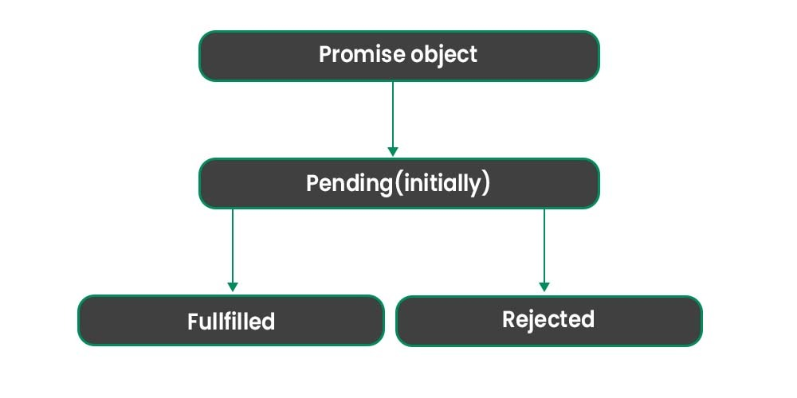

A Promise is executed by using the [**.then()**](https://www.geeksforgeeks.org/why-we-use-then-method-in-javascript/)method written after the declared promise. If we need to handle any error which is occurred then we use the [**.catch()**](https://www.geeksforgeeks.org/jquery-deferred-catch-method/)method written after promise. We also use the[**.finally()**](https://www.geeksforgeeks.org/javascript-promise-finally-method/) method if we want to just print our result irrespective of any error that occurred during promise execution.

**Declaring a Promise:** We can declare the promise by using the following syntax.

* Javascript

|  |
| --- |
| let promise =  **new** Promise((resolve , reject)=>{                  resolve('Hello JavaScript !');  }); |

As you can see in the above syntax, there is a callback function that is passed inside a promise object which takes two methods as an argument. First, one is [**resolve()**](https://www.geeksforgeeks.org/javascript-promise-resolve-method/) which is responsible for the successful completion of whatever text or anything executable is passed inside it.

The second one is [**reject()**](https://www.geeksforgeeks.org/javascript-promise-reject-method/) which is responsible for the unsuccessful completion of an operation, and we can pass on text inside it, which gets displayed along with our error.

**Executing a Promise:** We can execute the promise by using the following syntax.

**Method 1:**

* Javascript

    let promise = **new** Promise((resolve, reject) => {

      resolve("Hello JavaScript !");

    });

    promise.then((result) => console.log(result));

**Output:** It is shown above that result variable is used to console the result which is coming from the **resolve()**method.

Hello JavaScript !

**Method 2:**

* Javascript

    let promise = **new** Promise((resolve, reject) => {

      resolve("Hello JavaScript !");

    });

    promise.then((result) => {

      console.log(result);

    });

**Output:** In this method, a callback function is passed inside the **.then()** method. In the callback function result, a variable is declared which is responsible for printing out the result which is coming from the **resolve()** method.

Hello JavaScript !

**Promise Chaining:** Promise Chaining is a simple concept by which we may initialize another promise inside our **.then()**method and accordingly we may execute our results. The function inside then captures the value returned by the previous promise

The syntax for using promise chaining is as follows.

* HTML

<**script**>

    let promise = new Promise((resolve, reject) => {

    resolve("Hello JavaScript");

    });

    promise

    .then( function (result1){

        console.log(result1);

        return new Promise((resolve,reject) =>{

            resolve("GFG is awesome");

        })

    })

    .then((result2) => {

        console.log(result2);

    });

</**script**>

**Output:** As illustrated above, while executing the declared promise we are returning another promise inside the**.then()**and executing our results accordingly. Another then is used to capture the new promise. This is known as promise chaining. This solves the problem of [callback hell](https://www.geeksforgeeks.org/what-is-callback-hell-in-node-js/).

Hello JavaScript

GFG is awesome

**Note:** You can also declare several promises inside **.then()**and execute your results accordingly.

**FAQs – JavaScript Promise**

**How do Promises work in JavaScript?**

*Promises use then() and catch() methods to handle asynchronous results, allowing chaining of operations.*

**What are the states of a Promise?**

*Promises have three states: pending (initial state), fulfilled (successful completion), and rejected (failure).*

**How do you create a Promise in JavaScript?**

*Promises are created using the new Promise() constructor, which takes an executor function with resolve and reject parameters*

**What is Promise chaining?**

*Promise chaining is the practice of sequentially executing asynchronous operations using multiple then() calls on a Promise.*

**Can Promises be canceled in JavaScript?**

*Promises cannot be canceled natively, but techniques like using an external flag or a custom implementation can simulate cancellation.*

* 1. [JS Proxy](https://www.geeksforgeeks.org/javascript-proxy-handler/)

[**JavaScript**](https://www.geeksforgeeks.org/introduction-to-javascript/)**Proxy**is an object which intercepts another object and resists the fundamental operations on it. This object is mostly used when we want to hide information about one object from unauthorized access. A Proxy consists of two parts which are its target and handler. A target is a JavaScript object on which the proxy is applied and the handler object contains the function to intercept any other operation on it.

**Syntax:**

const prox = new Proxy(tar, handle)

**Parameters:**This object accepts two parameters.

* **tar:**It is the object on which the Proxy is to be applied
* **handle:**It is the object in which the intercept condition is defined

**Returns:**A proxy object.

**Example 1:**Here the method applies a Proxy object with an empty handler.

JavaScript

**let** details = {

name: "Raj",

Course: "DSA",

}

**const** prox = **new** Proxy(details, {})

console.log(prox.name);

console.log(prox.Course);

**Output:**

Raj

DSA

**Example 2:**Here the method applies a handler function to intercept calls on the target object.

JavaScript

**let** details = {

name: "Raj",

Course: "DSA",

}

**const** prox = **new** Proxy(details, {

get: **function**(){

**return** "unauthorized"

}

})

console.log(prox.name);

console.log(prox.Course);

**Output:**

unauthorized

unauthorized

**Example 3:** Here the method traps calls on the target object based on the condition.

JavaScript

**let** details = {

name: "Raj",

Course: "DSA",

}

**const** proxy = **new** Proxy(details, {

get: **function**(tar, prop){

**if**(prop == "Course"){

**return** **undefined**;

}

**return** tar[prop];

}

});

console.log(proxy.name);

console.log(proxy.Course);

**Output:**

Raj

undefined

**Example 4:**This example uses Proxy methods to delete properties.

JavaScript

**const** courseDetail = {

name: "DSA",

time: "6 months",

status: "Ongoing",

}

**const** handler = {

deleteProperty(target, prop) {

**if** (prop **in** target) {

**delete** target[prop];

console.log(`Removed: **${**prop**}**`);

}

}

};

**const** pro = **new** Proxy(courseDetail, handler);

console.log(pro.name);

**delete** pro.name

console.log(pro.name);

**Output:**

DSA

Removed: name

undefined

**JavaScript Proxy/Handler – FAQs**

**What is a Proxy in JavaScript?**

*A Proxy is a built-in object that allows you to create a custom behavior for fundamental operations on another object (called the target object). Proxies enable you to intercept and define custom behavior for operations such as property lookup, assignment, enumeration, function invocation, etc.*

**What is a Handler in JavaScript?**

*A Handler is an object that contains traps. Traps are methods that provide property access. These traps are methods that define the behavior of the proxy when an operation is performed on it.*

**How do you create a Proxy?**

*You can create a Proxy by using the new Proxy() constructor, which takes two arguments: the target object and the handler object.*

**How does the get trap work?**

*The get trap intercepts property access on the target object. It takes three arguments: the target object, the property name, and the receiver (typically the proxy itself).*

**How does the set trap work?**

*The set trap intercepts property assignment on the target object. It takes four arguments: the target object, the property name, the value to be assigned, and the receiver (typically the proxy itself).*

* 1. [JS Reflect](https://www.geeksforgeeks.org/javascript-reflect/)

JavaScript Reflect is a built-in object that gives access to other elements for interceptable operations. This object can be used to check whether an object has a particular property or to change or add new properties to an existing object. This object cannot be explicitly created using the new keyword and we cannot call it a function. Reflect has a set of static functions to perform operations.

**Syntax:**

Reflect.staticFunc()

**Parameters:**This object does not have fix parameters, it depends upon the static function being used with it

**Return Type:**The return values depend on the function being used.

**Example 1:**This example uses Reflect method to check and add properties in a particular object.

* Javascript

**var** details = {

    name: "Raj",

    course: "DSA",

    website: "geeksforgeeks.org",

}

console.log(Reflect.has(details, "course"))

Reflect.set(details, "Rating", "5");

console.log(details)

**Output:**

true

{name: 'Raj', course: 'DSA', website: 'geeksforgeeks.org', Rating: '5'}

**Example 2:**This example uses Reflect functions to construct a new object.

* Javascript

class Details {

    constructor(name, course) {

**this**.name = name;

**this**.course = course;

    }

    get fullDetails() {

**return** `${**this**.name} ${**this**.course}`;

    }

}

**var** person = ["Shobhit", "DSA"]

**var** enroll = Reflect.construct(

    Details,

    person

);

console.log(enroll **instanceof** Details);

console.log(enroll);

**Output:**

true

Details {name: 'Shobhit', course: 'DSA'}

**Example 3:**This example uses Reflect methods to freeze an array so that new elements cannot be added to it.

* Javascript

**var** arr = [];

Reflect.set(arr, 0, "Hello");

Reflect.set(arr, 1, "Welcome");

Reflect.set(arr, 2, "to");

Reflect.set(arr, 3, "GeeksforGeeks");

console.log(arr);

console.log(Reflect.isExtensible(arr))

Reflect.preventExtensions(arr);

Reflect.set(arr, 4, "DSA");

console.log(arr)

**Output:**Using the preventExtensions method new properties cannot be added to the array. This helps to freeze the array

(4) ['Hello', 'Welcome', 'to', 'GeeksforGeeks']

true

(4) ['Hello', 'Welcome', 'to', 'GeeksforGeeks']

* 1. [JS WeakMap](https://www.geeksforgeeks.org/javascript-weakmap/)

A **WeakMap in JavaScript** is a collection where keys can only be objects or non-registered symbols. It allows values of any type and doesn’t prevent the keys from being garbage collected, making its values eligible for garbage collection when their keys are collected.

**Syntax**

new WeakMap()  
new WeakMap(iter)

**Parameter:**It has only one optional parameter.

* **iter:**It is an iterable JavaScript object that implements the @@iterator method. It contains two elements where the first is key and the second is value.

**Example 1:**In this example The myGeeks function creates a WeakMap looseMap, sets objects as keys with names, assigns values, and checks if it has a specific key. Outputs the map and checks for presence of Ram.

JavaScript

**function** myGeeks() {

**let** looseMap = **new** WeakMap();

**let** Ram = {name};

**let** Raj = {name};

**let** Rahul = {name};

looseMap.set(Ram, "Ram");

looseMap.set(Raj, "Raj");

looseMap.set(Rahul, "Rahul");

console.log(looseMap);

console.log(looseMap.has(Ram))

}

myGeeks();

**Output:**

WeakMap {{…} => 'Raj', {…} => 'Rahul', {…} => 'Ram'}  
true

**Example 2:**In this example, we creates a WeakMap looseMap, sets an object Ram as a key with a value, nullifies Ram, and logs looseMap at different intervals.

JavaScript

**let** looseMap = **new** WeakMap();

**let** Ram = { name };

looseMap.set(Ram, "Ram");

console.log(looseMap);

Ram = **null**;

console.log(looseMap)

setTimeout(**function** () {

console.log(looseMap);

}, 300)

**Output:**As the reference is removed from the memory so the value in looseMap are garbage collected

WeakMap {{…} => 'Ram'}  
WeakMap {{…} => 'Ram'}  
WeakMap {}

**JavaScript WeakMap – FAQs**

**What is a WeakMap in JavaScript?**

*A WeakMap is a collection of key/value pairs where the keys are objects and the values can be arbitrary values. The primary feature of a WeakMap is that it holds “weak” references to the keys, meaning that if there are no other references to the key object, it can be garbage collected.*

**How do you create a WeakMap?**

*You can create a WeakMap using the WeakMap constructor.*

**What are the main differences between Map and WeakMap?**

* *Key Type: Map keys can be of any type, while WeakMap keys must be objects.*
* *Garbage Collection: WeakMap holds weak references to keys, allowing them to be garbage collected, whereas Map holds strong references.*
* *Iterability: Map is iterable, meaning you can loop through its entries. WeakMap is not iterable, and you cannot get a list of its keys or values.*

**How do you set and get values in a WeakMap?**

*To set a value in a WeakMap, you use the set method, and to get a value, you use the get method.*

**Can you use primitive values as keys in a WeakMap?**

*No, WeakMap keys must be objects. Using a primitive value (like a string, number, or boolean) will result in a TypeError.*

**How do you check if a WeakMap contains a specific key?**

*You can use the has method to check if a WeakMap contains a specific key.*

* 1. [JS WeakSet](https://www.geeksforgeeks.org/javascript-weakset/)

[**JavaScript**](https://www.geeksforgeeks.org/introduction-to-javascript/)**WeakSet** is used to store a collection of objects. It adapts the same properties of that of a set i.e. does not store duplicates. The major difference of a WeakSet with a set is that a WeakSet is a collection of objects and not values of some particular type.

**Syntax:**

new WeakSet(object)

**Parameters:** Here parameter “object” is an iterable object. All the elements of the iterable object are added to the WeakSet.

**Return type:**It returns a weakset object.

**Example 1:**In this example, we will create a weakSet object and add an element to it, then we will check if the element exists in the weakSet. We will use [has() method](https://www.geeksforgeeks.org/javascript-weakset-has-method/)and [add() method](https://www.geeksforgeeks.org/javascript-weakset-add-with-examples/)

javascript

**function** gfg() {

**let** weakSetObject = **new** WeakSet();

**let** objectOne = {};

*// add(value)*

weakSetObject.add(objectOne);

console.log("objectOne added");

*// has(value)*

console.log("WeakSet has objectOne : " +

weakSetObject.has(objectOne));

}

gfg();

**Output:**

objectOne added  
true

**Example 2:**In this example, we will see the working of weakSet functions also we will delete data using the [delete() method.](https://www.geeksforgeeks.org/javascript-weakset-delete-with-example/)

javascript

**let** weakSetObject = **new** WeakSet();

**let** objectOne = {};

**let** objectTwo = {};

*// add(value)*

weakSetObject.add(objectOne);

console.log("objectOne added");

weakSetObject.add(objectTwo);

console.log("objectTwo added");

*// has(value)*

console.log("WeakSet has objectTwo : " +

weakSetObject.has(objectTwo));

*// delete(value)*

weakSetObject.**delete**(objectTwo);

console.log("objectTwo deleted");

console.log("WeakSet has objectTwo : " +

weakSetObject.has(objectTwo));

**Output:**

objectOne added   
objectTwo added   
WeakSet has objectTwo : true  
objectTwo deleted  
WeakSet has objectTwo : false

**JavaScript WeakSet – FAQs**

**What is a WeakSet in JavaScript?**

*A WeakSet is a collection of objects, where each object can only appear once. It holds “weak” references to the objects, meaning if there are no other references to an object, it can be garbage collected.*

**How do you create a WeakSet?**

*You create a WeakSet using the WeakSet constructor.*

**What are the main differences between Set and WeakSet?**

* *Element Type: Set can contain any type of values (objects, primitives), whereas WeakSet can only contain objects.*
* *Garbage Collection: WeakSet holds weak references to its objects, allowing them to be garbage collected, while Set holds strong references.*
* *Iterability: Set is iterable, so you can loop through its elements. WeakSet is not iterable and does not have methods to retrieve its elements.*

**How do you add and check for objects in a WeakSet?**

*To add an object to a WeakSet, use the add method. To check if an object is in a WeakSet, use the has method.*

**Can you use primitive values in a WeakSet?**

*No, WeakSet can only contain objects. Adding a primitive value will result in a TypeError.*

**How do you remove an object from a WeakSet?**

*You can use the delete method to remove an object from a WeakSet.*

1. [JavaScript Functions](https://www.geeksforgeeks.org/javascript/#javascript-functions) : Functions in JavaScript are reusable blocks of code that perform a specific task.
   1. [JS Functions](https://www.geeksforgeeks.org/functions-in-javascript/)

A function in JavaScript is a reusable block of code that performs a specific task. You define it once, and then you can run (or “call”) it whenever you need that task done in your program.

*A JavaScript function runs when it is “called” by some part of your code.*

**Syntax**: The basic syntax to create a function in JavaScript is shown below.

function functionName(Parameter1, Parameter2, ...)

{

// Function body

}

To create a function in JavaScript, we have to first use the **keyword *function***, separated by the name of the function and parameters within parenthesis. The part of the function inside the curly braces**{}** is the body of the function.

*In javascript, functions can be used in the same way as variables for assignments, or calculations.*

**Why Functions?**

* Functions can be used multiple times, reducing redundancy.
* Break down complex problems into manageable pieces.
* Manage complexity by hiding implementation details.
* Can call themselves to solve problems recursively.

**Function Invocation**

The function code you have written will be executed whenever it is called.

* Triggered by an event (e.g., a button click by a user).
* When explicitly called from JavaScript code.
* Automatically executed, such as in self-invoking functions.

**Function Definition**

Before, using a user-defined function in JavaScript we have to create one. We can use the above syntax to create a function in JavaScript. A function definition is sometimes also termed a function declaration or function statement. Below are the rules for creating a function in JavaScript:

* Every function should begin with the keyword *function* followed by,
* A user-defined function name that should be unique,
* A list of parameters enclosed within parentheses and separated by commas,
* A list of statements composing the body of the function enclosed within curly braces {}.

**Example:**This example shows a basic declaration of a function in javascript.

JavaScript

**function** calcAddition(number1, number2) {

**return** number1 + number2;

}

console.log(calcAddition(6,9));

**Output**

15

In the above example, we have created a function named **calcAddition**,

* This function accepts two numbers as parameters and returns the addition of these two numbers.
* Accessing the function with just the function name without () will return the function object instead of the function result.

There are three ways of writing a function in JavaScript:

**Function Declaration:** It declares a function with a function keyword. The function declaration must have a function name.

**Syntax:**

function geeksforGeeks(paramA, paramB) {

// Set of statements

}

**Function Expression**

It is similar to a function declaration without the function name.[Function expressions](https://www.geeksforgeeks.org/javascript-function-expression) can be stored in a variable assignment.

**Syntax:**

let geeksforGeeks= function(paramA, paramB) {

// Set of statements

}

**Example:**This example explains the usage of the Function expression.

JavaScript

**const** square = **function** (number) {

**return** number \* number;

};

**const** x = square(4); *// x gets the value 16*

console.log(x);

**Output**

16

**Functions as Variable Values**

Functions can be used the same way as you use variables.

**Example:**

// Function to convert Fahrenheit to Celsius

function toCelsius(fahrenheit) {

return (fahrenheit - 32) \* 5/9;

}

// Using the function to convert temperature

let temperatureInFahrenheit = 77;

let temperatureInCelsius = toCelsius(temperatureInFahrenheit);

let text = "The temperature is " + temperatureInCelsius + " Celsius";

**Arrow Function:**

[**Arrow Function**](https://www.geeksforgeeks.org/es6-arrow-function) is one of the most used and efficient methods to create a function in JavaScript because of its comparatively easy implementation. It is a simplified as well as a more compact version of a regular or normal function expression or syntax.

**Syntax:**

let function\_name = (argument1, argument2 ,..) => expression

**Example:**This example describes the usage of the Arrow function.

JavaScript

**const** a = ["Hydrogen", "Helium", "Lithium", "Beryllium"];

**const** a2 = a.map(**function** (s) {

**return** s.length;

});

console.log("Normal way ", a2); *// [8, 6, 7, 9]*

**const** a3 = a.map((s) => s.length);

console.log("Using Arrow Function ", a3); *// [8, 6, 7, 9]*

**Output**

Normal way [ 8, 6, 7, 9 ]

Using Arrow Function [ 8, 6, 7, 9 ]

**Function Parameters**

Till now, we have heard a lot about function parameters but haven’t discussed them in detail. Parameters are additional information passed to a function. For example, in the above example, the task of the function *calcAddition* is to calculate the addition of two numbers. These two numbers on which we want to perform the addition operation are passed to this function as parameters. The parameters are passed to the function within parentheses after the function name and separated by commas. A function in JavaScript can have any number of parameters and also at the same time, a function in JavaScript cannot have a single parameter.

**Example:**In this example, we pass the argument to the function.

JavaScript

**function** multiply(a, b) {

b = **typeof** b !== "undefined" ? b : 1;

**return** a \* b;

}

console.log(multiply(69));

**Output**

69

**Calling Functions**

After defining a function, the next step is to call them to make use of the function. We can call a function by using the function name separated by the value of parameters enclosed between the parenthesis and a semicolon at the end. The below syntax shows how to call functions in JavaScript:

**Syntax:**

functionName( Value1, Value2, ..);

**Example:**Below is a sample program that illustrates the working of functions in JavaScript:

JavaScript

**function** welcomeMsg(name) {

**return** ("Hello " + name + " welcome to GeeksforGeeks");

}

*// creating a variable*

**let** nameVal = "Admin";

*// calling the function*

console.log(welcomeMsg(nameVal));

**Output**

Hello Admin welcome to GeeksforGeeks

**Return Statement**

There are some situations when we want to return some values from a function after performing some operations. In such cases, we can make use of the return statement in JavaScript. This is an optional statement and most of the time the last statement in a JavaScript function. Look at our first example with the function named as *calcAddition*. This function is calculating two numbers and then returns the result.

**Syntax:**The most basic syntax for using the return statement is:

return value;

The return statement begins with the keyword *return* separated by the value which we want to return from it. We can use an expression also instead of directly returning the value.

**Functions:**

* [Javascript | Arrow functions](https://www.geeksforgeeks.org/es6-arrow-function)
* [JavaScript | escape()](https://www.geeksforgeeks.org/javascript-escape)
* [JavaScript | unescape()](https://www.geeksforgeeks.org/javascript-unescape)
* [JavaScript | Window print()](https://www.geeksforgeeks.org/javascript-window-print-method)
* [Javascript | Window Blur() and Window Focus() Method](https://www.geeksforgeeks.org/javascript-window-blur-and-window-focus-method)
* [JavaScript | console.log()](https://www.geeksforgeeks.org/javascript-console-log-with-examples)
* [JavaScript | parseFloat()](https://www.geeksforgeeks.org/javascript-parsefloat-with-examples)
* [JavaScript | uneval()](https://www.geeksforgeeks.org/javascript-uneval-with-examples)
* [JavaScript | parseInt()](https://www.geeksforgeeks.org/javascript-parseint-with-examples)
* [JavaScript | match()](https://www.geeksforgeeks.org/javascript-match)
* [JavaScript | Date.parse()](https://www.geeksforgeeks.org/javascript-date-parse)
* [JavaScript | Replace() Method](https://www.geeksforgeeks.org/javascript-replace-method)
* [JavaScript | Map.get( )](https://www.geeksforgeeks.org/map-get-javascript)
* [JavaScript | Map.entries( )](https://www.geeksforgeeks.org/map-entries-javascript)
* [JavaScript | Map.clear( )](https://www.geeksforgeeks.org/map-clear-javascript)
* [JavaScript | Map.delete()](https://www.geeksforgeeks.org/map-delete-javascript)
* [JavaScript | Map.has( )](https://www.geeksforgeeks.org/map-has-in-javascript)

We have a Cheat Sheet on Javascript where we covered all the important topics of Javascript to check those please go through [Javascript Cheat Sheet-A Basic guide to JavaScript](https://www.geeksforgeeks.org/javascript-cheat-sheet-a-basic-guide-to-javascript).

**Functions in JavaScript – FAQs**

**What is a function in JavaScript?**

*A function is a reusable block of code designed to perform a particular task. Functions can take inputs, process them, and return a result.*

**How do you define a function?**

*Functions can be defined using function declarations or function expressions.*

**What is a function declaration?**

*A function declaration defines a function with the specified parameters and code block. The function can be called before it is defined due to hoisting.*

**What is a function expression?**

*A function expression defines a function inside an expression. The function can be anonymous and is not hoisted, so it cannot be called before it is defined.*

**What are arrow functions?**

*Arrow functions provide a shorter syntax for writing functions. They do not have their own this context and are not hoisted.*

*Example: const name = (parameters) => { // code to be executed };*

**How do you call a function?**

*You call a function by using its name followed by parentheses, which may include arguments.*

* 1. [JS Function Definitions](https://www.geeksforgeeks.org/javascript-function-definitions/)

JavaScript functions are declared using the**function** keyword, either as a declaration or expression. Declarations define named functions, while expressions assign functions to variables. Both enable code reuse and modularity.

**Syntax:**

* **Function Declarations:**

function functionName( parameters ) {

// Statements

};

* **Function Expressions:**

let variableName = function( parameter ) {

// Statements

};

* **Function Constructor:**

let FunctionName = new Function("parameter", "return parameter");

let variableName = FunctionName(values);

**Parameter:** It contains single parameter **functionName** which is mandatory and used to specify the name of function.

**Examples of JavaScript Function Definitions**

**Example:** This example we demonstrates a function declaration named GFG, which multiplies two numbers. The result is displayed in the paragraph element.

* html

<!DOCTYPE html>

<**html**>

    <**head**>

        <**title**>Function Declarations</**title**>

    </**head**>

    <**body** style="text-align: center">

        <**h2**>GeeksForGeeks</**h2**>

        <**p** id="geeks"></**p**>

        <**script**>

            let var1 = GFG(40, 3);

            document.getElementById(

                "geeks"

            ).innerHTML = var1;

            function GFG(num1, num2) {

                return num1 \* num2;

            }

        </**script**>

    </**body**>

</**html**>

**Output:**

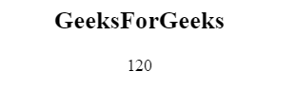

**Example 2:** This example describes a function expression assigned to var1, multiplying two numbers. The result is displayed using innerHTML.

* html

<!DOCTYPE html>

<**html**>

    <**head**>

        <**title**>Function Expressions</**title**>

    </**head**>

    <**body**>

        <**h2**>GeeksForGeeks</**h2**>

        <**p** id="geeks"></**p**>

        <**script**>

            let var1 = function (num1, num2) {

                return num1 \* num2;

            };

            document.getElementById(

                "geeks"

            ).innerHTML = var1(20, 30);

        </**script**>

    </**body**>

</**html**>

**Output:**



**Example 3:** This example describes a function expression created with the Function constructor, multiplying two numbers and displaying the result in a paragraph element.

* html

<!DOCTYPE html>

<**html**>

    <**head**>

        <**title**>Function Expressions</**title**>

    </**head**>

    <**body**>

        <**h2**>GeeksForGeeks</**h2**>

        <**p** id="geeks"></**p**>

        <**script**>

            let GFG = new Function(

                "num1",

                "num2",

                "return num1 \* num2"

            );

            document.getElementById(

                "geeks"

            ).innerHTML = GFG(25, 4);

        </**script**>

    </**body**>

</**html**>

**Output:**

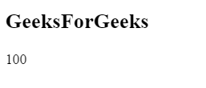

**Function Hoisting**

[Function hoisting](https://www.geeksforgeeks.org/javascript-hoisting/) moves function declarations to the top of their scope, allowing them to be used before declaration. Function expressions are not hoisted.

**Example:**In this example we define function hoisting by invoking a function before its declaration, displaying a welcome message from GeeksForGeeks.

* html

<!DOCTYPE html>

<**html**>

    <**head**>

        <**title**>Function Hoisting</**title**>

    </**head**>

    <**body** style="text-align: center">

        <**h1**>GeeksForGeeks</**h1**>

        <**script**>

            GeeksForGeeks();

            function GeeksForGeeks() {

                document.write(

                    "Welcome to GeeksForGeeks"

                );

            }

        </**script**>

    </**body**>

</**html**>

**Output:**

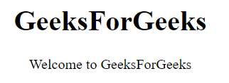

**Self-Invoking Functions**

Self-invoking functions execute automatically upon creation, without a name. Function expressions followed by () execute immediately, while function declarations cannot be invoked directly.

**Example:**In this example we define a self-invoking function that sets content in a paragraph element, showcasing its execution upon creation.

* html

<!DOCTYPE html>

<**html**>

    <**head**>

        <**title**>Function Hoisting</**title**>

    </**head**>

    <**body** style="text-align: center">

        <**h1**>GeeksForGeeks</**h1**>

        <**p** id="geeks"></**p**>

        <**script**>

            (function () {

                document.getElementById(

                    "geeks"

                ).innerHTML =

                    "GeeksForGeeks is the best way to learn";

            })();

        </**script**>

    </**body**>

</**html**>

**Output:**

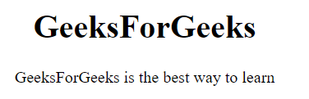

**Functions are Objects**

It can describe functions as objects and have both properties and methods.

* When define function as property of an object then it is known as method to the object.
* When design a function to create new objects then it is known as object constructor.

**Example:**In this example we demonstrates the use of the arguments object to count the number of arguments passed to a function.

* html

<!DOCTYPE html>

<**html**>

    <**head**>

        <**title**>Function Hoisting</**title**>

    </**head**>

    <**body** style="text-align: center">

        <**h1**>GeeksForGeeks</**h1**>

        <**p**>Number of arguments :</**p**>

        <**p** id="geeks"></**p**>

        <**script**>

            function GeeksForGeeks(num1, num2) {

                return arguments.length;

            }

            document.getElementById(

                "geeks"

            ).innerHTML = GeeksForGeeks(4, 3);

        </**script**>

    </**body**>

</**html**>

**Output:**

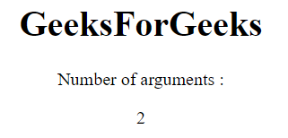

**Arrow Functions**

[Arrow functions](https://www.geeksforgeeks.org/arrow-functions-in-javascript/) simplify writing function expressions by providing a concise syntax without the need for the function keyword, return keyword, or curly brackets.

**Example:**In This example we defines an arrow function to multiply two numbers and displays the result using JavaScript.

* html

<!DOCTYPE html>

<**html**>

    <**head**>

        <**title**>Function Hoisting</**title**>

    </**head**>

    <**body** style="text-align: center">

        <**h1**>GeeksForGeeks</**h1**>

        <**p** id="geeks"></**p**>

        <**script**>

            const var1 = (num1, num2) =>

                num1 \* num2;

            document.getElementById(

                "geeks"

            ).innerHTML = var1(5, 5);

        </**script**>

    </**body**>

</**html**>

**Output:**

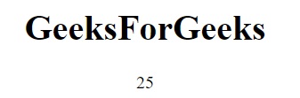

* 1. [JS Function Call](https://www.geeksforgeeks.org/javascript-function-call/)

The**call() method** is a predefined JavaScript method. It can be used to invoke (call) a method with an owner object as an argument (parameter). This allows borrowing methods from other objects, executing them within a different context, overriding the default value, and passing arguments.

**Syntax:**

call()

**Return Value:** It calls and returns a method with the owner object being the argument.

**JavaScript Function Call Examples**

**Example 1:**In this example, we defines a product() function that returns the product of two numbers. It then calls product() using call() with `this` as the context (which is typically the global object), passing 20 and 5 as arguments. It logs the result, which is 100

JavaScript

*// function that returns product of two numbers*

**function** product(a, b) {

**return** a \* b;

}

*// Calling product() function*

**let** result = product.call(**this**, 20, 5);

console.log(result);

**Output**

100

**Example 2:**This example we defines an object “employee” with a method “details” to retrieve employee details. Using call(), it invokes “details” with “emp2” as its context, passing arguments “Manager” and “4 years”, outputting the result.

JavaScript

**let** employee = {

details: **function** (designation, experience) {

**return** **this**.name

+ " "

+ **this**.id

+ designation

+ experience;

}

}

*// Objects declaration*

**let** emp1 = {

name: "A",

id: "123",

}

**let** emp2 = {

name: "B",

id: "456",

}

**let** x = employee.details.call(emp2, " Manager ", "4 years");

console.log(x);

**Output**

B 456 Manager 4 years

* 1. [JS Function Expression](https://www.geeksforgeeks.org/javascript-function-expression/)

The Javascript **Function Expression**is used to define a function inside any expression. The Function Expressionallows us to create an anonymous function that doesn’t have any function name which is the main difference between Function Expression and Function Declaration. A function expression can be used as an [IIFE (Immediately Invoked Function Expression)](https://www.geeksforgeeks.org/javascript-immediately-invoked-function-expressions-iife/)which runs as soon as it is defined. A function expression has to be stored in a variable and can be accessed using *variableName.* With the ES6 features introducing [Arrow Function](https://www.geeksforgeeks.org/arrow-functions-in-javascript/), it becomes more easier to declare function expression.

**Syntax for Function Declaration:**

function *functionName(x, y)* { *statements...* return *(z)* };

**Syntax for Function Expression (anonymous):**

let *variableName* = function*(x, y)* { *statements...* return *(z)* };

**Syntax for Function Expression (named):**

let *variableName* = function *functionName(x, y)*

{ *statements...* return *(z)* };

**Syntax for Arrow Function:**

let *variableName* = *(x, y)* => { *statements...* return *(z)* };

**Note:**

* A function expression has to be defined first before calling it or using it as a parameter.
* An arrow function must have a return statement.

The below examples illustrate the function expression in JavaScript:

**Example 1:**Code for Function Declaration.

* Javascript

**function** callAdd(x, y) {

    let z = x + y;

**return** z;

}

console.log("Addition : " + callAdd(7, 4));

**Output:**

Addition : 11

**Example 2:**CodeforFunctionExpression**(**anonymous**)**

* Javascript

let calSub = **function** (x, y) {

    let z = x - y;

**return** z;

}

console.log("Subtraction : " + calSub(7, 4));

**Output:**

Subtraction : 3

**Example 3:** CodeforFunctionExpression**(**named**)**

* Javascript

let calMul = **function** Mul(x, y) {

    let z = x \* y;

**return** z;

}

console.log("Multiplication : " + calMul(7, 4));

**Output:**

Multiplication : 28

**Example 4:** CodeforArrowFunction

* Javascript

let calDiv = (x, y) => {

    let z = x / y;

**return** z;

}

console.log("Division : " + calDiv(24, 4));

**Output:**

Division : 6

* 1. [JS Pure Functions](https://www.geeksforgeeks.org/pure-functions-in-javascript/)

A**Pure Function** is a function (a block of code) that **always returns the same result if the same arguments are passed**. It does not depend on any state or data change during a program’s execution. Rather, it only depends on its input arguments. Also, a pure function does not produce any observable side effects such as network requests or data mutation, etc.

Let’s see the below JavaScript Function:

* Javascript

**function** calculateGST(productPrice) {

**return** productPrice \* 0.05;

}

console.log(calculateGST(15))

The above function will always return the same result if we pass the same product price. In other words, its output doesn’t get affected by any other values/state changes. So we can call the “calculate GST” function a Pure Function.

**Output:**

0.75

Now, let’s see one more function below:

* Javascript

let tax = 20;

**function** calculateGST(productPrice) {

**return** productPrice \* (tax / 100) + productPrice;

}

console.log(calculateGST(15))

Pause a second and can you guess whether the above function is Pure or not?

If you guessed that it isn’t, you are right! It is not a pure function as the output is dependent on an external variable “tax”. So if the tax value is updated somehow, then we will get a different output though we pass the same productPrice as a parameter to the function.

**Output:**

18

But here we need to make an important note:

**Note:** If a pure function calls a pure function, this isn’t a side effect, and the calling function is still considered pure. (Example: using [Math.max()](https://www.geeksforgeeks.org/javascript-math-max-method/)inside a function)

Below are some side effects (but not limited to) that a function should not produce in order to be considered a pure function –

* Making an HTTP request
* Mutating data
* Printing to a screen or console
* DOM Query/Manipulation
* [Math.random()](https://www.geeksforgeeks.org/javascript-math-random-method/)
* Getting the current time
  1. [JS Function Parameters](https://www.geeksforgeeks.org/javascript-function-parameters/)

Function parameters in JavaScript act as placeholders for values that the function can accept when it’s called.

**Syntax:**

function Name(paramet1, paramet2, paramet3,...) {

// Statements

}

**Rules:**

* There is no need to specify the data type for parameters in [JavaScript function](https://www.geeksforgeeks.org/functions-in-javascript) definitions.
* It does not perform type-checking based on the passed-in [JavaScript functions](https://www.geeksforgeeks.org/functions-in-javascript).
* It does not check the number of received arguments.

**Parameters:**

* **Name:** It is used to specify the name of the function.
* **Arguments:** It is provided in the argument field of the function.

These are the types of parameters that can be used in JavaScript

* **Defaults Parameter**
* **Function Rest Parameter**
* **Arguments Object**
* **Arguments Pass by Value**
* **Objects passed by Reference**

**JavaScript Function Parameters Examples**

**1. Defaults Parameter**

Default parameters in JavaScript are utilised to set initial values for named parameters in case no value or undefined is passed when the function is called.

**Syntax:**

function Name(paramet1 = value1, paramet2 = value2 .. .) {

// statements

}

**Example:** This example uses default parameters and performs the multiplication of numbers.

JavaScript

**function** GFG(num1, num2 = 2) {

**return** num1 \* num2;

}

console.log(GFG(4));

**Output**

8

**2. Function Rest Parameter**

In JavaScript, the rest parameter syntax enables a function to accept an unlimited number of arguments, which are then gathered into an array.

**Example:** here’s an example of using the rest parameter syntax in a function

JavaScript

**function** sum(...numbers) {

**return** numbers.reduce((acc, num) => acc + num, 0);

}

console.log(sum(1, 2, 3)); *// Output: 6*

console.log(sum(1, 2, 3, 4, 5)); *// Output: 15*

console.log(sum(10)); *// Output: 10*

console.log(sum()); *// Output: 0*

**Output**

6

15

10

0

**Explanation:**The sum function accepts any number of arguments and calculates their sum using the rest parameter ...numbers

**3. Arguments Object**

The arguments object is an inherent feature in JavaScript functions. It serves as a local variable in all non-arrow functions. You can analyze the arguments passed to a function using its arguments object.

**Example:** This example uses argument objects as parameters and finds the largest of numbers.

JavaScript

**function** GFG() {

**let** i;

**let** maxnum = -**Infinity**;

**for** (i = 0; i < arguments.length; i++) {

**if** (arguments[i] > maxnum) {

maxnum = arguments[i];

}

}

**return** maxnum;

}

console.log(GFG(10, 12, 500, 5, 440, 45));

**Output**

500

**4. Arguments Pass by Value**

In a function call, the parameters are called as arguments. The pass-by value sends the value of the variable to the function. It does not send the address of the variable. If the function changes the value of arguments then it does not affect the original value.

**Example:**This example demonstrates the above-used approach.

JavaScript

*/\* Function definition \*/*

**function** GeeksForGeeks(var1, var2) {

console.log("Inside the GeeksForGeeks function");

var1 = 100;

var2 = 200;

*/\* Display the value of variable inside function \*/*

console.log("var1 =" + var1 + " var2 =" + var2);

}

var1 = 10;

var2 = 20;

*/\* The value of variable before Function call \*/*

console.log("Before function calling");

console.log("var1 =" + var1 + " var2 =" + var2);

*/\* Function call \*/*

GeeksForGeeks(var1, var2);

*/\* The value of variable after Function call \*/*

console.log("After function calling");

console.log("var1 =" + var1 + " var2 =" + var2);

**Output**

Before function calling

var1 =10 var2 =20

Inside the GeeksForGeeks function

var1 =100 var2 =200

After function calling

var1 =10 var2 =20

**Explanation:**

* Initially, var1 is assigned the value 10 and var2 is assigned the value 20.
* When the GeeksForGeeks function is called with var1 and var2 as arguments, it modifies the values of var1 and var2 to 100 and 200 respectively within its scope.
* However, outside the function, the values of var1 and var2 remain unchanged, demonstrating that JavaScript passes arguments by value, not by reference.

**5. Objects passed by Reference**

In Pass by Reference for objects, the function receives the address of the variable rather than the value itself as the argument. If we alter the value of the variable inside the function, it affects the variables outside the function as well.

**Example:** This example demonstrates the above-used approach.

JavaScript

**function** GeeksForGeeks(varObj) {

console.log("Inside GeeksForGeeks function");

varObj.a = 100;

console.log(varObj.a);

}

*// Create object*

varObj = { a: 1 };

*/\* Display value of object before function call \*/*

console.log("Before function calling");

console.log(varObj.a);

*/\* Function calling \*/*

GeeksForGeeks(varObj)

*/\* Display value of object after function call \*/*

console.log("After function calling");

console.log(varObj.a);

**Output**

Before function calling

1

Inside GeeksForGeeks function

100

After function calling

100

**Explanation:**

* Initially, an object varObj with property a set to 1 is created.
* When the GeeksForGeeks function is called with varObj as an argument, it modifies the property a of varObj to 100 within its scope.
* After the function call, the property a of varObj remains modified outside the function, demonstrating that objects are passed by reference in JavaScript.
  1. [JS Function Invocation](https://www.geeksforgeeks.org/javascript-function-invocation/)

The [JavaScript](https://www.geeksforgeeks.org/introduction-to-javascript/) **Function Invocation** is used to execute the function code and it is common to use the term “call a function” instead of “invoke a function”. The code inside a function is executed when the function is invoked.

**Syntax:**

* **Invoking a Function as a Function:**

function myFunction( var ) {

return var;

}

myFunction( value );

* **Invoking a Function as a Method:**

let myObject = {

let : value,

functionName: function () {

return this.let;

}

}

myObject.functionName();

**Parameters:** It contains two parameters as mentioned above and described below:

* **functionName:** The functionName method is a function and this function belongs to the object and myObject is the owner of the function.
* **this:** The parameter this is the object that owns the JavaScript code and in this case the value of this is myObject.

**Example 1:** This example uses function invocation to add two numbers.

* html

<!DOCTYPE html>

<**html** lang="en">

<**head**>

    <**title**>JavaScript Function Invocation</**title**>

</**head**>

<**body** style="text-align:center;">

    <**h2** style="color:green">GeeksForGeeks</**h2**>

    <**h4**>JavaScript Function Invocation</**h4**>

    <**p**>

        Function returns the addition

        of 50 and 60

    </**p**>

    <**p** id="geeks"></**p**>

    <!-- Script to add two numbers -->

    <**script**>

        function myFunction(a, b) {

            return a + b;

        }

        document.getElementById("geeks").innerHTML

            = window.myFunction(50, 60);

    </**script**>

</**body**>

</**html**>

**Output:**

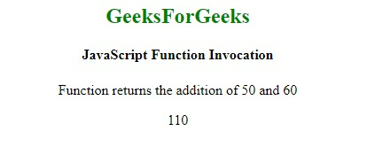

**Example 2:** This example uses function invocation to concatenate strings.

* Javascript

let myObject = {

    firstName: "Geeks",

    middleName: "for",

    lastName: "Geeks",

    fullName: **function** () {

**return** **this**.firstName + **this**.middleName

            + **this**.lastName;

    }

}

console.log(myObject.fullName());

**Output**

GeeksforGeeks

* 1. [JS Anonymous Functions](https://www.geeksforgeeks.org/javascript-anonymous-functions/)

**What are Anonymous Functions?**

An anonymous function is simply a function that does **not have a name**. Unlike named functions, which are declared with a name for easy reference, anonymous functions are usually created for specific tasks and are often assigned to variables or used as arguments for other functions.

In JavaScript, you normally use the **function keyword followed by a name** to declare a function. However, in an anonymous function, the name is **omitted**. These functions are often used in situations where you don’t need to reuse the function outside its immediate context.

**Syntax**

The below-enlightened syntax illustrates the declaration of an anonymous function using the normal declaration:

function() {

// Function Body

}

We may also declare an anonymous function using the arrow function technique which is shown below:

( () => {

// Function Body...

} )();

The below examples demonstrate anonymous functions.

**Example 1:**In this example, we define an anonymous function that prints a message to the console. The function is then stored in the *greet*variable. We can call the function by invoking *greet().*

JavaScript

<script>

**var** greet = **function** () {

console.log("Welcome to GeeksforGeeks!");

};

greet();

</script>

**Output:**

Welcome to GeeksforGeeks!

**Example 2:**In this example, we pass arguments to the anonymous function.

JavaScript

<script>

**var** greet = **function** (platform) {

console.log("Welcome to ", platform);

};

greet("GeeksforGeeks!");

</script>

**Output:**

Welcome to GeeksforGeeks!

As JavaScript supports Higher-Order Functions, we can also pass anonymous functions as parameters into another function.

**Example 3:**In this example, we pass an anonymous function as a callback function to the *[setTimeout()](https://www.geeksforgeeks.org/java-script-settimeout-setinterval-method/)*method. This executes this anonymous function 2000ms later.

JavaScript

<script>

setTimeout(**function** () {

console.log("Welcome to GeeksforGeeks!");

}, 2000);

</script>

**Output:**

Welcome to GeeksforGeeks!

**Self-Executing Anonymous Functions**

Another common use of anonymous functions is to create self-executing functions (also known as IIFE – Immediately Invoked Function Expressions). These functions run immediately after they are defined.

**Example 4:**In this example, we have created a self-executing function.

JavaScript

<script>

(**function** () {

console.log("Welcome to GeeksforGeeks!");

})();

</script>

**Output:**

Welcome to GeeksforGeeks!

**Arrow functions**

ES6 introduced a new and shorter way of declaring an anonymous function, which is known as [**Arrow Functions.**](https://www.geeksforgeeks.org/arrow-functions-in-javascript/)In an Arrow function, everything remains the same, except here we don’t need the *function*keyword also. Here, we define the function by a single parenthesis and then ‘=>’ followed by the function body.

**Example 5:**In this example, we will see the use of arrow function.

JavaScript

<script>

**var** greet = () =>

{

console.log("Welcome to GeeksforGeeks!");

}

greet();

</script>

**Output:**

Welcome to GeeksforGeeks!

If we have only a single statement in the function body, we can even remove the curly braces.

**Example 6:**In this example, we create a self-executing function.

JavaScript

<script>

**let** greet = () => console.log("Welcome to GeeksforGeeks!");

greet();

</script>

**Output:**

Welcome to Geeksforgeeks!

**Example 7:**In this example, we will declare a self-executing anonymous function (without the name itself) and will see how we may declare it as well as how we may call it in order to print the resultant value.

JavaScript

<script>

(() => {

console.log("GeeksforGeeks");

})();

</script>

**Output:**

GeeksforGeeks

* 1. [JS Arrow functions](https://www.geeksforgeeks.org/arrow-functions-in-javascript/)

ES6 introduced the Arrow functions in JavaScript which offer a more concise and readable way to write function expressions. They use the ***=>*** (arrow) syntax, which not only reduces boilerplate but also binds this lexically, making them particularly useful in certain scenarios like handling **callbacks**or working within **objects**.

**What is Arrow Function?**

An **arrow function** is essentially an anonymous function with a shorter syntax. They are often assigned to variables, making them reusable. Arrow functions are also known as **lambda functions** in some other programming languages.

**Syntax**

const gfg = () => {

console.log( "Hi Geek!" );

}

**The below examples show the working of the Arrow functions in JavaScript.**

**1. Arrow Function without Parameters**

An arrow function without parameters is defined using empty parentheses (). This is useful when you need a function that doesn’t require any arguments.

**Example:** In this example we Defines an arrow function gfg without parameters that logs “Hi from GeekforGeeks!” when called.

JavaScript

**const** gfg = () => {

console.log( "Hi from GeekforGeeks!" );

}

gfg();

**Output**

Hi from GeekforGeeks!

**2. Arrow Function with Single Parameters**

If your arrow function has a single parameter, you can omit the parentheses around it.

**Example:** In this example we defines an arrow function square with a single parameter x, returning the square of x.

JavaScript

**const** square = x => x\*x;

console.log(square(4));

*// output: 16*

**Output**

16

**3. Arrow Function with Multiple Parameters**

Arrow functions with multiple parameters, like **(param1, param2) => { }**, simplify writing concise function expressions in JavaScript, useful for functions requiring more than one argument.

**Example :**In this example we defines an arrow function gfg with parameters x, y, z, logging their sum.

JavaScript

**const** gfg = ( x, y, z ) => {

console.log( x + y + z )

}

gfg( 10, 20, 30 );

**Output**

60

**4. Arrow Function with Default Parameters**

Arrow functions support default parameters, allowing predefined values if no argument is passed, making JavaScript function definitions more flexible and concise.

**Example :** In this example we defines an arrow function gfg with parameters x, y, and a default parameter z = 30.

JavaScript

**const** gfg = ( x, y, z = 30 ) => {

console.log( x + " " + y + " " + z);

}

gfg( 10, 20 );

**Output**

10 20 30

**5. Return Object Literals**

In JavaScript, returning object literals within functions is concise: **() => ({ key: value })** returns an object { key: value }, useful for immediate object creation and returning.

**Example :**In this example we defines an arrow function makePerson with parameters firstName, lastName, returning an object.

JavaScript

**const** makePerson = (firstName, lastName) =>

({first: firstName, last: lastName});

console.log(makePerson("Pankaj", "Bind"));

**Output**

{ first: 'Pankaj', last: 'Bind' }

**Async Arrow Functions**

Arrow functions can be made asynchronous by adding the async keyword before the parameter list.

const fetchData = async () => {  
 const data = await fetch('https://api.example.com/data');  
 return data.json();  
};

**Advantages of Arrow Functions**

* **Concise Syntax:** Arrow functions reduce the amount of code needed for function expressions.
* **Lexical *this*Binding:** Arrow functions automatically bind this to the surrounding context, eliminating common issues when dealing with callbacks.
* **Improved Readability:** For shorter functions, arrow syntax can make your code more readable.

**Limitations of Arrow Functions**

* **No prototype Property:**Arrow functions do not have the prototype property, so they cannot be used as constructors.
* **Cannot be Used with *new*:** Since they lack a prototype, they cannot be used with the new keyword to create instances.
* **Cannot be Generators:**Arrow functions cannot be used as generator functions (function\*) because they do not support the yield keyword.
* **Anonymous Nature:** Debugging can be harder because arrow functions are anonymous by default.
* **No Own this, arguments, super, or new.target:** Arrow functions do not have their own bindings for these properties, which can limit their use in some cases.

**FAQs- Arrow functions in JavaScript**

**How do Arrow Functions differ from regular functions?**

*Arrow Functions have a shorter syntax, lexically bind this, and do not have their own this, arguments, super, or new.target.*

**When should I use Arrow Functions?**

*Use Arrow Functions for concise anonymous functions, especially for short callbacks or when this should lexically bind to the surrounding scope.*

**Can Arrow Functions have default parameters?**

*Yes, Arrow Functions support default parameters: (param = defaultValue) => { }.*

**Do Arrow Functions support rest parameters?**

*Yes, Arrow Functions can use rest parameters (…rest) to represent an indefinite number of arguments as an array.*

**Can Arrow Functions be used as constructors?**

*No, Arrow Functions cannot be used as constructors because they do not have their own this context.*

**How do Arrow Functions handle this?**

*Arrow Functions inherit this from the surrounding lexical context, making them useful for methods inside objects or for maintaining the context of callbacks.*

* 1. [JS Nested functions](https://www.geeksforgeeks.org/javascript-nested-functions/)

In JavaScript, Functions within another function are called “Nested function.” These nested functions have access to the variables and parameters of the outer (enclosing) function, creating a scope hierarchy. A function can have one or more inner functions.

**Syntax:**

// Outer function

function outerFunction() {

// Nested function

function nestedFunction() {

// Function logic here

}

// Call the nested function

nestedFunction();

// Rest of the outer function logic

}

// Call the outer function

outerFunction();

**Approach:**

* Write one function inside another function.
* Make a call to the inner function in the return statement of the outer function.
* Call it **fun(a)(b)** where a is a parameter to the outer and b is to the inner function.
* Finally, return the combined output from the nested function.

**Example 1:**This example uses the approach discussed above.

**Javascript**

**function** fun1(a) {

**function** fun2(b) {

**return** a + b;

    }

**return** fun2;

}

**function** GFG\_Fun() {

    console.log(fun1("A Online Computer Science Portal")

        (" GeeksforGeeks"));

}

GFG\_Fun()

**Output**

A Online Computer Science Portal GeeksforGeeks

**Example 2:** This example uses the approach discussed above, but here the nested function is created differently than the previous one.

**Javascript**

**function** fun1(a) {

    fun = **function** fun2(b) {

**return** a + b;

    }

**return** fun;

}

**function** GFG\_Fun() {

    console.log(fun1("This is ")("GeeksforGeeks"));

}

GFG\_Fun()

**Output**

This is GeeksforGeeks

* 1. [JS Function Generator](https://www.geeksforgeeks.org/javascript-function-generator/)

A generator functionuses the yield keyword to generate values, pausing execution and sending values to the caller. It retains the state to resume execution after yield, continuing immediately after the last yield run.

**Syntax :**

// An example of generator function  
function\* gen(){  
 yield 1;  
 yield 2;  
 ...  
 ...  
}

**Generator-Object :**Generator functions return a generator object. Generator objects are used either by calling the next method on the generator object or using the generator object in a “for of” loop (as shown in the above program)   
The Generator object is returned by a generating function and it conforms to both the iterable protocol and the iterator protocol.

**Example 1:** In this example, we will see the creation of basic generator object.

javascript

*// Generate Function generates three*

*// different numbers in three calls*

**function**\* fun() {

**yield** 10;

**yield** 20;

**yield** 30;

}

*// Calling the Generate Function*

**let** gen = fun();

console.log(gen.next().value);

console.log(gen.next().value);

console.log(gen.next().value);

**Output:**

10  
20  
30

**Example 2:** This example code prints infinite series of natural numbers using a simple generator.

javascript

*// Generate Function generates an*

*// infinite series of Natural Numbers*

**function**\* nextNatural() {

**let** naturalNumber = 1;

*// Infinite Generation*

**while** (**true**) {

**yield** naturalNumber++;

}

}

*// Calling the Generate Function*

**let** gen = nextNatural();

*// Loop to print the first*

*// 10 Generated number*

**for** (**let** i = 0; i < 10; i++) {

*// Generating Next Number*

console.log(gen.next().value);

}

**Output:**

1  
2  
3  
4  
5  
6  
7  
8  
9  
10

**Example 3:**This example of how to manually return from a generator.

javascript

**let** array = ['a', 'b', 'c'];

**function**\* generator(arr) {

**let** i = 0;

**while** (i < arr.length) {

**yield** arr[i++]

}

}

**const** it = generator(array);

*// We can do it.return() to finish the generator*

**Encountering yield and yield\***

* **yield:** pauses the generator execution and returns the value of the expression which is being written after the yield keyword.
* **yield\*:** it iterates over the operand and returns each value until done is true.

**Example 4:**

javascript

**const** arr = ['a', 'b', 'c'];

**function**\* generator() {

**yield** 1;

**yield**\* arr;

**yield** 2;

}

**for** (**let** value **of** generator()) {

console.log(value);

}

**Output:**

1  
a  
b  
c  
2

**Example 5:**Another way to create iterable.

javascript

**let** createOwnIterable = {

\*[Symbol.iterator]() {

**yield** 'a';

**yield** 'b';

**yield** 'c';

}

}

**for** (**let** value **of** createOwnIterable) {

console.log(value);

}

**Output:**

a  
b  
c

**Example 6:** Return from a generator function.

javascript

**function**\* generator() {

**yield** 'a';

**return** 'result';

**yield** 'b';

}

**let** it = generator();

console.log(JSON.stringify(it.next()));

*// {value: "a", done: false}*

console.log(JSON.stringify(it.next()));

*// {value: "result", done: true}*

**Output**

{"value":"a","done":false}

{"value":"result","done":true}

**Example 7:** How to throw an exception from the generator.

javascript

**function**\* generator() {

**throw** **new** **Error**('Error Occurred');

}

**const** it = generator();

it.next();

*// Uncaught Error: Error Occurred*

**Output:**

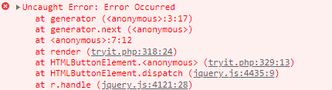

**Example 8:** Calling a generator from another generator.

javascript

**function**\* firstGenerator() {

**yield** 2;

**yield** 3;

}

**function**\* secondGenerator() {

**yield** 1;

**yield**\* firstGenerator();

**yield** 4;

}

**for** (**let** value **of** secondGenerator()) {

console.log(value)

}

**Output:**

1  
2  
3  
4

**Limitation of Generators:** You can’t yield inside a callback in a generator.

**Example 9:** In this example, we will try to give yield inside a generator function.

javascript

**function**\* generator() {

['a', 'b', 'c'].forEach(value => **yield** value)

*// This will give syntax error*

}

**Output:**

SyntaxError: missing ) after argument list

**Example 10:** Using async generators (for api call).

javascript

**const** firstPromise = () => {

**return** **new** Promise((resolve, reject) => {

setTimeout(() => resolve(1), 5000)

})

}

**const** secondPromise = () => {

**return** **new** Promise((resolve, reject) => {

setTimeout(() => resolve(2), 3000)

})

}

**async** **function**\* generator() {

**const** firstPromiseResult = **await** firstPromise();

**yield** firstPromiseResult;

**const** secondPromiseResult = **await** secondPromise();

**yield** secondPromiseResult;

}

**let** it = generator();

**for** **await** (**let** value **of** it) {

console.log(value);

}

**Output:**

(after 5 seconds)  
1   
(after 3 seconds)  
2

**Advantages of generators:** They are memory efficient as lazy evaluation takes place, i.e, delays the evaluation of an expression until its value is needed.**JavaScript use-case (generators)**

* Writing generators in redux-saga
* JavaScript async-await (Implemented with promise and generators)

**JavaScript Function Generator – FAQs**

**What is a Generator Function in JavaScript?**

*A generator function is a special type of function that can pause its execution and resume later. They are defined using the function\* syntax and use the yield keyword to yield values.*

**How do you create a Generator Function?**

*You create a generator function by adding an asterisk (\*) after the function keyword and using the yield keyword to yield values.*

**How do Generator Functions work?**

*Generator functions return a generator object when called. This generator object has methods like next(), return(), and throw(). The next() method is used to resume the generator function’s execution and retrieve the next value.*

**How do you use the yield keyword?**

*The yield keyword is used to pause the execution of a generator function and return a value. When the generator’s next() method is called, the function resumes execution from where it left off, just after the yield statement.*

**How do you iterate over values from a Generator?**

*You can iterate over values from a generator using a for…of loop or the generator’s next() method.*

* 1. [JS Function binding](https://www.geeksforgeeks.org/javascript-function-binding/)

In [JavaScript](https://www.geeksforgeeks.org/introduction-to-javascript/) function binding happens using the [**Bind()** method](https://www.geeksforgeeks.org/explain-call-apply-and-bind-methods-in-javascript/). With this method, we can bind an object to a common function, so that the function gives different results when needed. otherwise, it gives the same result or gives an error while the code is executing. We use the [**Bind()** method](https://www.geeksforgeeks.org/explain-call-apply-and-bind-methods-in-javascript/) to call a function with ‘**this’** value.

**What is ‘this’?**

‘this’ refers to the object it belongs to. The exact value of ‘this’ depends on how a function is called. In a method, ‘this’ represents the object that the method was called on, while in a regular function, it typically refers to the global object (in the case of browser environments, it’s the ‘window’ object).

**Example 1:** In this example, *this* keyword binds the *name* variable to the function. It is known as default binding. *this* keyword refers to **geeks** object.

* javascript

let geeks = {

    name: "ABC",

    printFunc: **function** () {

        console.log(**this**.name);

    }

}

geeks.printFunc();

**Output**

ABC

**Example 2:**In this example, the binding of *this* is lost, so no output is produced.

* javascript

let geeks = {

    name: "ABC",

    printFunc: **function** () {

        console.log(**this**.name);

    }

}

let printFunc2 = geeks.printFunc;

printFunc2();

**Output**

undefined

**Example 3:** In this example, we are using the **bind()** method in the previous example. The **bind()** method creates a new function where **this** keyword refers to the parameter in the parenthesis. This way the **bind()** method enables calling a function with a specified **this** value.

* javascript

let geeks = {

    name: "ABC",

    printFunc: **function** () {

        console.log(**this**.name);

    }

}

let printFunc2 = geeks.printFunc.bind(geeks);

//using bind()

// bind() takes the object "geeks" as parameter//

printFunc2();

**Output**

ABC

**Example 4:** In this example, there are 3 objects, and each time we call each object by using the **bind()**method.

* javascript

//object geeks1

let geeks1 = {

    name: "ABC",

    article: "C++"

}

//object geeks2

let geeks2 = {

    name: "CDE",

    article: "JAVA"

}

//object geeks3

let geeks3 = {

    name: "IJK",

    article: "C#"

}

**function** printVal() {

    console.log(**this**.name + " contributes about " +

**this**.article + "<br>");

}

let printFunc2 = printVal.bind(geeks1);

//using bind()

// bind() takes the object "geeks1" as parameter//

printFunc2();

let printFunc3 = printVal.bind(geeks2);

printFunc3();

let printFunc4 = printVal.bind(geeks3);

printFunc4();

//uniquely defines each objects

**Output**

ABC contributes about C++<br>

CDE contributes about JAVA<br>

IJK contributes about C#<br>

* 1. [JS Async/Await Function](https://www.geeksforgeeks.org/async-await-function-in-javascript/)

Async and Await in JavaScript is used to simplify handling asynchronous operations using promises. By enabling asynchronous code to appear synchronous, they enhance code readability and make it easier to manage complex asynchronous flows.

**Async Function**

The async function allows us to write promise-based code as if it were synchronous. This ensures that the execution thread is not blocked.

* **Promise Handling**: Async functions always return a promise. If a value is returned that is not a promise, JavaScript automatically wraps it in a resolved promise.

**Async Syntax**

async function myFunction() {

  return "Hello";

}

**Example:** Here, we will see the basic use of async in JavaScript.

javascript

**const** getData = **async** () => {

**let** data = "Hello World";

**return** data;

}

getData().then(data => console.log(data));

**Output**

Hello World

**Await Keyword**

The await keyword is used to wait for a promise to resolve. It can only be used within an async block.

* **Execution Pause**: Await makes the code wait until the promise returns a result, allowing for cleaner and more manageable asynchronous code.

**Syntax**

let value = await promise;

**Example** : This example shows the basic use of the await keyword in JavaScript.

javascript

**const** getData = **async** () => {

**let** y = **await** "Hello World";

console.log(y);

}

console.log(1);

getData();

console.log(2);

**Output**

1

2

Hello World

*The****async****keyword transforms a regular JavaScript function into an asynchronous function, causing it to return a Promise.*

*The****await****keyword is used inside an async function to pause its execution and wait for a Promise to resolve before continuing.*

**Async/Await Example**

Here, we will be implementing several promises in a method, and then that method we will use for displaying our result. You can check the JS **async/await syntax** in the example.

JavaScript

**function** asynchronous\_operational\_method() {

**let** first\_promise =

**new** Promise((resolve, reject) => resolve("Hello"));

**let** second\_promise =

**new** Promise((resolve, reject) => {

setTimeout(() => {

resolve(" GeeksforGeeks..");

}, 1000);

});

**let** combined\_promise =

Promise.all([first\_promise, second\_promise]);

**return** combined\_promise;

}

**async** **function** display() {

**let** data = **await** asynchronous\_operational\_method();

console.log(data);

}

display();

**Output:**

[ 'Hello', ' GeeksforGeeks..' ]

**Explanation:**

1. **Promise Creation**:
   * Two promises are created: one resolve immediately with “Hello”, and the other resolves after 1 second with ” GeeksforGeeks..”.
2. **Combining Promises**:
   * The Promise.all() method combines both promises into a single promise, combined\_promise.
3. **Asynchronous Function**:
   * The display() function is declared as async, indicating it contains asynchronous operations.
4. **Awaiting Promise Resolution**:
   * The await keyword pauses execution until combined\_promise is resolved.
5. **Logging Result**:
   * The resolved array from combined\_promise is logged to the console.

***Note***

*To****resolve****and****reject****are predefined arguments by JavaScript.*

* *resolve function is used when an asynchronous task is completed and returns the result.*
* *reject function is used when an asynchronous task fails and returns reasons for failure.*

**Error Handling in Async/Await**

JavaScript provides predefined arguments for handling promises: resolve and reject.

* **resolve:** Used when an asynchronous task is completed successfully.
* **reject:** Used when an asynchronous task fails, providing the reason for failure.

**Example:**

JavaScript

**async** **function** fetchData() {

**try** {

**let** response = **await** fetch('https://api.example.com/data');

**let** data = **await** response.json();

console.log(data);

} **catch** (error) {

console.error('Error fetching data:', error);

}

}

**Advantages of Async and Await**

1. **Improved Readability:**Async and Await allow asynchronous code to be written in a synchronous style, making it easier to read and understand.
2. **Error Handling:**Using try/catch blocks with async/await simplifies error handling.
3. **Avoids Callback Hell:** Async and Await prevent nested callbacks and complex promise chains, making the code more linear and readable.
4. **Better Debugging:** Debugging async/await code is more intuitive since it behaves similarly to synchronous code.

**Conclusion**

Async and Await in JavaScript have revolutionized asynchronous programming by making code more readable and maintainable. By allowing asynchronous code to be written in a synchronous style, they reduce the complexity associated with callbacks and promise chaining. Understanding and using async and await effectively can significantly enhance your JavaScript programming skills, making it easier to handle asynchronous operations in your projects.

* 1. [Hoisting in JavaScript](https://www.geeksforgeeks.org/javascript-hoisting/)

**JavaScript Hoisting** is the behavior where the interpreter moves function and variable declarations to the top of their respective scope before executing the code. This allows variables to be accessed before declaration, aiding in more flexible coding practices and avoiding “undefined” errors during execution.

**What is Hoisting in JavaScript?**

Hoisting is the default behavior in JavaScript where variable and function declarations are moved to the top of their respective scopes during the compilation phase. This guarantees that regardless of where these declarations appear within a scope, they can be accessed throughout that scope.

**Features of Hoisting**

* Declarations are hoisted, not initializations.
* Allows calling functions before their declarations.
* All variable and function declarations are processed before any code execution.
* Undeclared variables are implicitly created as global variables when assigned a value.

***Note:****JavaScript only hoists declarations, not initializations.*

JavaScript allocates memory for all variables and functions defined in the program before execution.

**Sequence of variable declaration**

The following is the sequence in which variable declaration and initialization occur.

***Declaration –> Initialisation/Assignment –> Usage***

**Variable lifecycle**

let a; // Declaration  
a = 100; // Assignment  
console.log(a); // Usage

However, since JavaScript allows us to both declare and initialize our variables simultaneously, so we can declare and initialize at the same time.

let a = 100;

**Note:** Always remember that in the background the Javascript is first declaring the variable and then initializing them. It is also good to know that variable declarations are processed before any code is executed.

However, in javascript, undeclared variables do not exist until the code assigning them is executed. Therefore, assigning a value to an undeclared variable implicitly creates it as a global variable when the assignment is executed. This means that all undeclared variables are global variables.

**Different Examples of JavaScript Hoisting**

**1. Global Scope**

JavaScript

*// Hoisting*

**function** codeHoist() {

a = 10;

**let** b = 50;

}

codeHoist();

console.log(a); *// 10*

console.log(b); *// ReferenceError : b is not defined*

**Output:**

10  
ReferenceError: b is not defined

**Explanation:** In the above example, hoisting allows variables declared with var to be accessed before declaration, but not those declared with let or const. Thus, a is accessible, but b throws a ReferenceError

**Note:** There’s a difference between ReferenceError and undefined errors. An undefined error occurs when we have a variable that is either not defined or explicitly defined as type undefined. ReferenceError is thrown when trying to access a previously undeclared variable.

**2. JavaScript var hoisting**

When we talk about ES5, the variable that comes into our minds is var. Hoisting with var is somewhat different. When it is compared to let/const. Let’s make use of var and see how hoisting works.

**Example:**

JavaScript

*// var code (global)*

console.log(name); *// undefined*

**var** name = 'Mukul Latiyan';

**Output:**

ReferenceError: Cannot access 'name' before initialization

**Explanation:** In the above code example variables declared with var are hoisted but not initialized, resulting in undefined when accessed before declaration. Variables declared with let or const do not exhibit this behavior.

But the interpreter sees this differently, the above code is seen like this:

JavaScript

*// how interpreter sees the above code*

**let** name;

console.log(name); *// undefined*

name = 'Mukul Latiyan';

**Output**

undefined

**3. Function scoped variable**

Let’s look at how function-scoped variables are hoisted.

**Example:**

JavaScript

*// Function scoped*

**function** fun() {

console.log(name);

**let** name = 'Mukul Latiyan';

}

fun(); *// Undefined*

**Output:**

undefined

There is no difference here as when compared to the code where we declared the variable globally.

**Example:**We get undefined as the code seen by the interpreter.

JavaScript

**var** name;

**function** fun() {

console.log(name);

name = 'Mukul Latiyan';

}

fun(); *// undefined*

**Output**

undefined

In order to avoid this pitfall, we can make sure to **declare and assign the variable at the same time,** **before using it.**

**Example:**

JavaScript

**function** fun() {

**let** name = 'Mukul Latiyan';

console.log(name); *// Mukul Latiyan*

}

fun();

**Output**

Mukul Latiyan

**4. JavaScript hoisting with Let**

We know that variables declared with let keywords are block scoped not function scoped and hence there is no problem when it comes to hoisting.

**Example:**

JavaScript

*//let example(global)*

console.log(name);

**let** name = 'Mukul Latiyan'; *// ReferenceError: name is not defined*

**Output:**

ReferenceError: name is not defined

**Explanation:**Like before, for the var keyword, we expect the output of the log to be undefined. However, since the es6 let doesn’t take kindly on us using undeclared variables, the interpreter explicitly spits out a Reference error. This ensures that we always **declare**our variable first.

**5. JavaScript hoisting with const**

It behaves similarly to let when it comes to hoisting. A **function**as a whole can also be hoisted and we can call it before the declaration.

**Example:**

JavaScript

fun(); *// Calling before declaration*

**function** fun() { *// Declaring*

console.log("Function is hoisted");

}

**Output**

Function is hoisted

Also, if a function is used as an **expression**and we try to access it before the assignment an error will occur as only declarations are hoisted.

**Example:**

JavaScript

fun() *// Calling the expression*

**let** fun = () =>{ *// Declaring*

**let** name = 'Mukul Latiyan';

console.log(name);

}

**Output:**

ReferenceError: Cannot access 'fun' before initialization

However, if var is used in the expression instead of let we will get the following Type Error as follows.

**6. Hoisting with Functions**

**Example:**

JavaScript

fun() *// Calling the expression*

**var** fun = () =>{ *// Declaring*

**let** name = 'Mukul Latiyan';

console.log(name);

}

**Output:**

TypeError: fun is not a function

1. [JavaScript Regular Expression](https://www.geeksforgeeks.org/javascript/#javascript-regular-expression) : Regular expressions, often abbreviated as regex or regexp, are patterns used to match character combinations in strings.
   1. [JS Regular expressions](https://www.geeksforgeeks.org/javascript-regexpregular-expression/)

**A regular expression** is a character sequence defining a search pattern. It’s employed in text searches and replacements, describing what to search for within a text. Ranging from single characters to complex patterns, regular expressions enable various text operations with versatility and precision.

A regular expression can be a single character or a more complicated pattern.

**Syntax:**

/pattern/modifiers;

**Example:**

let patt = /GeeksforGeeks/i;

**Explanation :**

/GeeksforGeeks/i is a regular expression.

GeeksforGeeks is the pattern (to be used in a search).

i is a modifier (modifies the search to be Case-Insensitive).

**Regular Expression Modifiers** can be used to perform multiline searches which can also be set to case-insensitive matching:

|  |  |
| --- | --- |
| **Expressions** | **Descriptions** |
| [g](https://www.geeksforgeeks.org/javascript-regexp-g-modifier/) | Find the character globally |
| [i](https://www.geeksforgeeks.org/javascript-regexp-i-modifier/) | Find a character with case-insensitive matching |
| [m](https://www.geeksforgeeks.org/javascript-regexp-m-modifier/?ref=lbp) | Find multiline matching |

**Regular Expression Brackets**can Find characters in a specified range

|  |  |
| --- | --- |
| **Expressions** | **Description** |
| [[abc]](https://www.geeksforgeeks.org/javascript-regexp-abc-expression) | Find any of the characters inside the brackets |
| [[^abc]](https://www.geeksforgeeks.org/javascript-regexp-abc-expression-2/?ref=ml_lbp) | Find any character, not inside the brackets |
| [[0-9]](https://www.geeksforgeeks.org/javascript-regexp-0-9-expression/) | Find any of the digits between the brackets 0 to 9 |
| [[^0-9]](https://www.geeksforgeeks.org/javascript-regexp-0-9-expression-2/?ref=ml_lbp) | Find any digit not in between the brackets |
| [(x | y)](https://www.geeksforgeeks.org/javascript-regexp-xy-expression/) | Find any of the alternatives between x or y separated with | |

**Regular Expression Metacharacters** are characters with a special meaning:

|  |  |
| --- | --- |
| **Metacharacter** | **Description** |
| [\.](https://www.geeksforgeeks.org/javascript-regexp-metacharacter/?ref=lbp) | Search single characters, except line terminator or newline. |
| [\w](https://www.geeksforgeeks.org/javascript-regexp-w-metacharacter/) | Find the word character i.e. characters from a to z, A to Z, 0 to 9 |
| [\d](https://www.geeksforgeeks.org/javascript-regexp-d-metacharacter-2/) | Find a digit |
| [\D](https://www.geeksforgeeks.org/javascript-regexp-d-metacharacter-2/) | Search non-digit characters i.e all the characters except digits |
| [\s](https://www.geeksforgeeks.org/javascript-regexp-s-metacharacter/) | Find a whitespace character |
| [\S](https://www.geeksforgeeks.org/javascript-regexp-s-metacharacter-2/) | Find the non-whitespace characters. |
| [\b](https://www.geeksforgeeks.org/javascript-regexp-b-metacharacter/?ref=lbp) | Find a match at the beginning or at the end of a word |
| [\B](https://www.geeksforgeeks.org/javascript-regexp-b-metacharacter-2/) | Find a match that is not present at the beginning or end of a word. |
| [\0](https://www.geeksforgeeks.org/javascript-regexp-0-metacharacter/) | Find the NULL character. |
| [\n](https://www.geeksforgeeks.org/javascript-regexp-n-metacharacter/) | Find the newline character. |
| [\f](https://www.geeksforgeeks.org/javascript-regexp-f-metacharacter/) | Find the form feed character |
| [\r](https://www.geeksforgeeks.org/javascript-regexp-r-metacharacter/) | Find the carriage return character |
| [\t](https://www.geeksforgeeks.org/javascript-regexp-t-metacharacter/) | Find the tab character |
| [\v](https://www.geeksforgeeks.org/javascript-regexp-v-metacharacter/) | Find the vertical tab character |
| [\uxxxx](https://www.geeksforgeeks.org/javascript-regexp-uxxxx-metacharacter/) | Find the Unicode character specified by the hexadecimal number xxxxx |

**Regular Expression Quantifiers**are used to define quantitiesoccurrence

|  |  |
| --- | --- |
| **Quantifier** | **Description** |
| [n+](https://www.geeksforgeeks.org/javascript-regexp-quantifier-2/?ref=lbp) | Match any string that contains at least one n |
| [n\*](https://www.geeksforgeeks.org/javascript-regexp-quantifier-3/?ref=lbp) | Match any string that contains zero or more occurrences of n |
| [n?](https://www.geeksforgeeks.org/javascript-regexp-quantifier/) | Match any string that contains zero or one occurrence of n |
| [m{X}](https://www.geeksforgeeks.org/javascript-regexp-x-quantifier-2/?ref=lbp) | Find the match of any string that contains a sequence of m, X times |
| [m{X, Y}](https://www.geeksforgeeks.org/javascript-regexp-xy-quantifier/?ref=lbp) | Find the match of any string that contains a sequence of m, X to Y times |
| [m{X,}](https://www.geeksforgeeks.org/javascript-regexp-x-quantifier/?ref=lbp) | Find the match of any string that contains a sequence of m, at least X times |
| [m$](https://www.geeksforgeeks.org/javascript-regexp-quantifier-6/?ref=lbp) | Find the match of any string which contains m at the end of it |
| [^m](https://www.geeksforgeeks.org/javascript-regexp-quantifier-5/?ref=lbp) | Find the match of any string which contains m at the beginning of it |
| [?!m](https://www.geeksforgeeks.org/javascript-regexp-quantifier-4/?ref=lbp) | Find the match of any string which is not followed by a specific string m. |

**Regular Expression Object Properties:**

|  |  |
| --- | --- |
| **Property** | **Description** |
| [constructor](https://www.geeksforgeeks.org/javascript-regexp-constructor) | Return the function that created the RegExp object’s prototype |
| global | Specify whether the**“g”**modifier is set or not |
| [ignorecase](https://www.geeksforgeeks.org/javascript-regexp-ignorecase-property) | Specify whether the **“i”** modifier is set or not |
| [lastindex](https://www.geeksforgeeks.org/javascript-lastindex-property) | Specify the index at which to start the next match |
| [multiline](https://www.geeksforgeeks.org/javascript-multiline-property) | Specify whether the**“m”**modifier is set or not |
| source | Return the text of RegExp pattern |

**Regular Expression Object Methods:**

|  |  |
| --- | --- |
| **Method** | **Description** |
| [compile()](https://www.geeksforgeeks.org/javascript-compile-method) | Used to compile the regular expression while executing of script |
| [exec()](https://www.geeksforgeeks.org/javascript-exec-method) | Used to test for the match in a string. |
| [test()](https://www.geeksforgeeks.org/javascript-regexp-test-method) | Used to test for a match in a string |
| [toString()](https://www.geeksforgeeks.org/javascript-regexp-tostring-method) | Return the string value of the regular expression |

Below is an example of the JavaScript Regular Expressions.

**Example:**

JAVASCRIPT

**function** GFGFun() {

**let** str = "Visit geeksforGeeks";

**let** n = str.search(/GeeksforGeeks/i);

console.log(n);

}

GFGFun();

Output:

6

**Using String Methods**

In JavaScript, regular expressions are often used with the two string methods: **search()** and **replace()**.

* The [**search() method**](https://www.geeksforgeeks.org/javascript-string-search) uses an expression to search for a match and returns the position of the match.
* The [**replace() method**](https://www.geeksforgeeks.org/javascript-string-replace-method)returns a modified string where the pattern is replaced.

**Using String search() With a Regular Expression**

Use a regular expression to do a case-insensitive search for “GeeksforGeeks” in a string:

**Example:**

JAVASCRIPT

**function** myFunction() {

*// input string*

**let** str = "Visit geeksforGeeks!";

*// searching string with modifier i*

**let** n = str.search(/GeeksforGeeks/i);

console.log(n);

*// searching string without modifier i*

**let** n = str.search(/GeeksforGeeks/);

console.log(n);

}

myFunction();

**Output:**

6

-1

**Use String replace() With a Regular Expression**

Use a case-insensitive regular expression to replace gfG with GeeksforGeeks in a string:

**Example:**

JAVASCRIPT

**function** myFunction() {

*// input string*

**let** str = "Please visit gfG!";

*// replacing with modifier i*

**let** txt = str.replace(/gfg/i, "geeksforgeeks");

console.log(txt);

}

myFunction();

**Output**

Please visit geeksforgeeks!

* 1. [JS RegExp [abc] Expression](https://www.geeksforgeeks.org/javascript-regexp-abc-expression/)

The **RegExp [abc] Expression** in JavaScript is used to search any character between the brackets. The character inside the brackets can be a single character or a span of characters.

* **[A-Z]:** It is used to match any character from uppercase A to Z.
* **[a-z]:** It is used to match any character from lowercase a to z.
* **[A-z]:** It is used to match any character from uppercase A to lowercase z.
* **[abc…]:** It is used to match any character between the brackets.

**Syntax:**

/[abc]/

or

new RegExp("[abc]")

**Syntax with modifiers:**

/\[abc]/g

or

new RegExp("[abc]", "g")

**Example 1:** This example searches the characters between [A-G] i.e uppercase A to uppercase G in the whole string.

* Javascript

**function** geek() {

    let str1 = 'GEEKSFORGEEKS is the computer'

        + ' science portal for geeks.';

    let regex4 = /[A-G]/g;

    let match4 = str1.match(regex4);

    console.log('Found ' + match4.length

        + ' matches: ' + match4);

}

geek();

**Output**

Found 7 matches: G,E,E,F,G,E,E

**Example 2:** This example searches the characters between [a-g] i.e lowercase a to lowercase g in the whole string.

* Javascript

**function** geek() {

    let str1 = "GEEKSFORGEEKS is the computer"

        + " science portal for geeks.";

    let regex4 = /[a-g]/g;

    let match4 = str1.match(regex4);

    console.log("Found " + match4.length

        + " matches: " + match4)

}

geek();

**Output**

Found 12 matches: e,c,e,c,e,c,e,a,f,g,e,e

* 1. [JS RegExp S Metacharacter](https://www.geeksforgeeks.org/javascript-regexp-s-metacharacter-2/)

The **RegExp \S Metacharacter** in JavaScript is used to find the non-whitespace characters. The whitespace character can be a space/tab/new line/vertical character. It is the same as [^\t\n\r].

**Syntax:**

/\S/

or

new RegExp("\\S")

**Syntax with modifiers:**

/\S/g

or

new RegExp("\\S", "g")

**Example 1:** This example matches the non-whitespace characters.

* Javascript

**function** geek() {

    let str1 = "GeeksforGeeks @ \_123\_ $";

    let regex4 = /\S/g;

    let match4 = str1.match(regex4);

    console.log("Found " + match4.length

        + " matches: " + match4)

}

geek();

**Output**

Found 20 matches: G,e,e,k,s,f,o,r,G,e,e,k,s,@,\_,1,2,3,\_,$

**Example 2:** This example matches the non-whitespace characters.

* Javascript

**function** geek() {

    let str1 = "Geeky@128";

    let regex4 = **new** RegExp("\\S", "g");

    let match4 = str1.match(regex4);

    console.log("Found " + match4.length

        + " matches: " + match4)}

geek();

**Output**

Found 9 matches: G,e,e,k,y,@,1,2,8

* 1. [JS RegExp m Modifier](https://www.geeksforgeeks.org/javascript-regexp-m-modifier/)

The **RegExp m Modifier** in JavaScript is used to perform multiline matching. It takes the beginning and end characters (^ and $) as working when taking over multiple lines. It matches the beginning or end of each line. It is case-sensitive.

**Syntax:**

/regexp/m

or

new RegExp("regexp", "m")

**Example 1:** This example searches the word “geeksforgeeks” at the beginning of each line in a string.

* Javascript

**function** geek() {

    let str1 = "geeksforgeeks is the computer "

        + "science portal for geeks.";

    let regex4 = /^geeksforgeeks/gm;

    let match4 = str1.match(regex4);

    console.log("Found " + match4.length

        + " matches: " + match4);

}

geek();

**Output**

Found 1 matches: geeksforgeeks

**Example 2:** This example searches the word “geeksforgeeks” at the beginning of each line in a string and replaces it with “GEEKSFORGEEKS”.

* Javascript

**function** geek() {

    let str1 = "geeksforgeeks is the computer "

        + "science portal for geeks.";

    let regex4 = **new** RegExp("^geeksforgeeks", "m");

    let replace = "GEEKSFORGEEKS";

    let match4 = str1.replace(regex4, replace);

    console.log(" New string: " + match4);

}

geek();

**Output**

New string: GEEKSFORGEEKS is the computer science portal for geeks.

* 1. [JS RegExp ?! Quantifier](https://www.geeksforgeeks.org/javascript-regexp-quantifier-4/)

The **RegExp ?!m Quantifier** in JavaScript is used to find the match of any string which is not followed by a specific string m.

**Syntax:**

/?!m/

or

new RegExp("?!m")

**Syntax with modifiers:**

/\?!m/g

or

new RegExp("?!m", "g")

**Example 1:** This example matches the words ‘Geeks’ not followed by 123 in the whole string.

* Javascript

**function** geek() {

    let str1 = "Geeks for 123 Geeks@";

    let regex4 = /Geeks(?!123)/g;

    let match4 = str1.match(regex4);

    console.log("Found " + match4.length

        + " matches: " + match4);

}

geek();

**Output**

Found 2 matches: Geeks,Geeks

**Example 2:** This example replaces the word ‘128’ with ‘#’.

* Javascript

**function** geek() {

    let str1 = "@128Geek128";

    let regex4 = **new** RegExp("128(?!ee)", "gi");

    let replace = "#";

    let match4 = str1.replace(regex4, replace);

    console.log(" New string: " + match4);

}

geek();

**Output**

New string: @#Geek#

* 1. [JS RegExp {X,Y} Quantifier](https://www.geeksforgeeks.org/javascript-regexp-xy-quantifier/)

JavaScript RegExp {X,Y} QuantifierThe **RegExp m{X, Y} Quantifier** in JavaScript is used to find the match of any string that contains a sequence of m, X to Y times where X, Y must be numbered.

**Syntax:**

/m{X, Y}/

or

new RegExp("m{X, Y}")

**Syntax with modifiers:**

/\m{X, Y}/g

or

new RegExp("m{X}", "g")

**Example 1:** This example matches the presence of the word between [a-g] of length 3 to 4 in the whole string.

* Javascript

**function** geek() {

    let str1 = "GeeksforGeeeeks@\_123\_$";

    let regex4 = /[a-g]{3,4}/gi;

    let match4 = str1.match(regex4);

    console.log("Found " + match4.length

        + " matches: " + match4);

}

geek();

**Output**

Found 2 matches: Gee,Geee

**Example 2:** This example replaces the word ‘ee’ or ‘eee’ with ‘$’.

* Javascript

**function** geek() {

    let str1 = "ee@128GeeeeK";

    let regex4 = **new** RegExp("e{2,3}", "gi");

    let replace = "$";

    let match4 = str1.replace(regex4, replace);

    console.log(" New string: " + match4);

}

geek();

**Output**

New string: $@128G$eK

* 1. [JS RegExp test() Method](https://www.geeksforgeeks.org/javascript-regexp-test-method/)

The **RegExp test() Method** in JavaScript is used to test for match in a string. If there is a match this method returns **true** else it returns **false**.

**Syntax:**

RegExpObject.test(str)

Where **str** is the string to be searched. This is required field.

**Example 1:** This example searches for the string “computer” in the original string.

* Javascript

**function** geek() {

    let str = "GeeksforGeeks is the computer science"

        + " portal for geeks.";

    let regex = **new** RegExp("computer",);

    let rex = regex.test(str);

    console.log(rex);

}

geek()

**Output**

true

**Example 2:** This example searches for the string “GEEK” in the original string.

* Javascript

**function** geek() {

    let str = "GeeksforGeeks is the computer science"

        + " portal for geeks.";

    let regex = **new** RegExp("GEEK",);

    let rex = regex.test(str);

    console.log(rex);

}

geek()

**Output**

false

* 1. [JS RegExp [^0-9] Expression](https://www.geeksforgeeks.org/javascript-regexp-0-9-expression-2/)

The **RegExp [^0-9] Expression** in JavaScript is used to search any digit which is not between the brackets. The character inside the brackets can be a single digit or a span of digits.

**Syntax:**

/[^0-9]/

or

new RegExp("[^0-9]")

**Syntax with modifiers:**

/[^0-9]/g

or

new RegExp("[^0-9]", "g")

**Example 1:** This example searches the digits which are not present between [0-4] in the whole string.

* Javascript

**function** geek() {

    let str1 = "123456790";

    let regex4 = /[^0-4]/g;

    let match4 = str1.match(regex4);

    console.log("Found " + match4.length

        + " matches: " + match4);

}

geek();

**Output**

Found 4 matches: 5,6,7,9

**Example 2:** This example searches the digits which are not present between [0-9] in the whole string and replaces the characters with hash(#).

* Javascript

**function** geek() {

    let str1 = "128@$%";

    let replacement = "#";

    let regex4 = **new** RegExp("[^0-9]", "g");

    let match4 = str1.replace(regex4, replacement);

    console.log("Found " + match4.length

        + " matches: " + match4);

}

geek();

**Output**

Found 6 matches: 128###

1. [JavaScript Events](https://www.geeksforgeeks.org/javascript/#javascript-events) :

Events are actions that happen in the browser, such as mouse clicks, keyboard input, or page loading. There are events in JavaScript, including event handling, event listeners, event propagation, event objects.

* 1. [JS Events](https://www.geeksforgeeks.org/javascript-events/)

**JavaScript Events** are**actions or occurrences**that happen in the browser. They can be triggered by various user interactions or by the browser itself.

Common events include mouse clicks, keyboard presses, page loads, and form submissions. Event handlers are JavaScript functions that respond to these events, allowing developers to create interactive web applications.

**Syntax:**

<HTML-element Event-Type = "Action to be performed">

**Common JavaScript Events Table**

|  |  |
| --- | --- |
| **Event Attribute** | **Description** |
| onclick | Triggered when an element is clicked. |
| onmouseover | Fired when the mouse pointer moves over an element. |
| onmouseout | Occurs when the mouse pointer leaves an element. |
| onkeydown | Fired when a key is pressed down. |
| onkeyup | Fired when a key is released. |
| onchange | Triggered when the value of an input element changes. |
| onload | Occurs when a page has finished loading. |
| onsubmit | Fired when a form is submitted. |
| onfocus | Occurs when an element gets focus. |
| onblur | Fired when an element loses focus. |

**1. JavaScript Events Examples**

**Example 1:**Here, we will display a message in the alert box when the button is clicked using onClick() event. This HTML document features a button styled to appear in the middle of the page. When clicked, the button triggers the `hiThere()` JavaScript function, which displays an alert box with the message “Hi there!”.

html

<!doctype html>

<**html**>

<**head**>

<**script**>

**function** hiThere() {

alert('Hi there!');

}

</**script**>

</**head**>

<**body**>

<**button** type="button"

onclick="hiThere()"

style="margin-left: 50%;">

Click me event

</**button**>

</**body**>

</**html**>

**Output:**



**Example 2:** Here, we will change the color by pressing UP arrow key **using onkeyup() event**. This code defines a JavaScript function `changeBackground()` that changes the background color of an input box when the up arrow key is pressed. RGB color values are incremented with each key press, cycling through colors.

html

<!doctype html>

<**html**>

<**head**>

<**script**>

**let** a=0;

**let** b=0;

**let** c=0;

**function** changeBackground() {

**let** x=document.getElementById('bg');

x.style.backgroundColor='rgb('+a+', '+b+', '+c+')';

a+=100;

b+=a+50;

c+=b+70;

**if**(a>255) a=a-b;

**if**(b>255) b=a;

**if**(c>255) c=b;

}

</**script**>

</**head**>

<**body**>

<**h4**>The input box will change color when UP arrow key is pressed</**h4**>

<**input** id="bg" onkeyup="changeBackground()" placeholder="write something" style="color:#fff">

</**body**>

</**html**>

**Output:**



**2. JavaScript Event Handlers**

**JavaScript event handlers** are functions that are executed in response to specific events occurring in the browser.

They can be attached to HTML elements using event attributes like onclick, onmouseover, etc., or added dynamically using the addEventListener() method in JavaScript.

**Example:** Here’s an example of a JavaScript event handler attached to an HTML button element using the onclick attribute. This code demonstrates an event handler attached to a button element. When the button is clicked, the `myFunction()` JavaScript function is invoked, triggering an alert box displaying “Button clicked!”.

HTML

<!DOCTYPE html>

<**html**>

<**head**>

<**title**>Event Handler Example</**title**>

</**head**>

<**body**>

<**button** onclick="myFunction()">Click me</**button**>

<**script**>

*// JavaScript function to handle the click event*

**function** myFunction() {

alert("Button clicked!");

}

</**script**>

</**body**>

</**html**>

**Output:**



* 1. [JS onclick Event](https://www.geeksforgeeks.org/html-dom-onclick-event/)

The **HTML DOM onclick event** occurs when the user clicks on an element.

There are three ways to add **onclick events**:

**Syntax:**

**In HTML:**

<element onclick="myScript">

**In JavaScript:**

object.onclick = function(){myScript};

**In JavaScript, using the addEventListener() Method:**

object.addEventListener("click", myScript);

**Example 1:** Using HTML

* html

<**center**>

    <**h2**>HTML DOM onclick Event in Html</**h2**>

    <**button** onclick="myFunction()">Click me</**button**>

    <**p** id="gfg"></**p**>

    <**script**>

        function myFunction() {

            document.getElementById(

            "gfg").innerHTML = "GeeksforGeeks";

        }

    </**script**>

</**center**>

**Output:**



**Example 2:** Using JavaScript

* html

<**center**>

    <**h2**>HTML DOM onclick Event</**h2**>

    <**p** id="gfg">Click me.</**p**>

    <**script**>

        document.getElementById("gfg").onclick = function() {

            GFGfun()

        };

        function GFGfun() {

            document.getElementById(

            "gfg").innerHTML = "YOU CLICKED ME!";

        }

    </**script**>

</**center**>

**Output:**



**Example 3:** In JavaScript, using the addEventListener() method:

* html

<**center**>

    <**h2**>HTML DOM onclick Event</**h2**>

    <**p** id="gfg">Click me.</**p**>

    <**script**>

        document.getElementById(

        "gfg").addEventListener("click", GFGfun);

        function GFGfun() {

            document.getElementById(

            "gfg").innerHTML = "YOU CLICKED ME!";

          document.getElementById(

            "gfg").style.color = 'red';

          document.getElementById(

            "gfg").style.background = 'cyan';

        }

    </**script**>

</**center**>

**Output:**



HTML DOM onclick event supports All HTML elements,

**Except:**

<base>, <bdo>, <br>, <head>, <html>, <iframe>, <meta>, <param>, <script>, <style>, and <title>

* 1. [JS dblclick Event](https://www.geeksforgeeks.org/html-dom-ondblclick-event/)

The **HTML DOM ondblclick event** occurs on a *double click by the user*. All HTML elements are supported with **ondblclick Event**, EXCEPT:

* <bdo>
* <br>
* <base>
* <head>
* <html>
* <iframe>
* <meta>
* <param>
* <script>
* <style>
* <title>.

**Syntax:** **In HTML:**

<element ondblclick="myScript">

**In JavaScript:**

object.ondblclick = function(){myScript};

**In JavaScript, using the addEventListener() method:**

object.addEventListener("dblclick", myScript);

**Example 1:** Using HTML

**HTML**

<!DOCTYPE html>

<**html**>

<**head**>

    <**title**>

          HTML DOM ondblclick Event

      </**title**>

</**head**>

<**body**>

    <**center**>

        <**h1** style="color:green">

            GeeksforGeeks

        </**h1**>

        <**h2**>HTML DOM ondblclick Event</**h2**>

        <**p** id="demo"

           ondblclick="myFunction()">

            Double-click

        </**p**>

        <**script**>

            function myFunction() {

                document.getElementById(

                    "demo").innerHTML =

                  "GeeksforGeeks";

            }

        </**script**>

    </**center**>

</**body**>

</**html**>

**Output:**



**Example:** Using JavaScript

**HTML**

<!DOCTYPE html>

<**html**>

<**head**>

    <**title**>

          HTML DOM ondblclick Event

      </**title**>

</**head**>

<**body**>

    <**center**>

        <**h1** style="color:green">

            GeeksforGeeks

        </**h1**>

        <**h2**>HTML DOM ondblclick Event</**h2**>

        <**p** id="demo">

              Double-click me.

          </**p**>

        <**script**>

            document.getElementById(

                "demo").ondblclick = function () {

                    GFGfun()

                };

            function GFGfun() {

                document.getElementById(

                    "demo").innerHTML =

                  "GeeksforGeeks";

            }

        </**script**>

    </**center**>

</**body**>

</**html**>

**Output:**



**Example:** In JavaScript, using the addEventListener() method:

**HTML**

<!DOCTYPE html>

<**html**>

<**head**>

    <**title**>

          HTML DOM ondblclick Event

      </**title**>

</**head**>

<**body**>

    <**center**>

        <**h1** style="color:green">

            GeeksforGeeks

        </**h1**>

        <**h2**>

              HTML DOM ondblclick Event

          </**h2**>

        <**p** id="demo">Double-click me.</**p**>

        <**script**>

            document.getElementById(

                "demo").addEventListener(

                    "dblclick", GFGfun);

            function GFGfun() {

                document.getElementById(

                    "demo").innerHTML =

                  "GeeksforGeeks";

            }

        </**script**>

    </**center**>

</**body**>

</**html**>

**Output:**



* 1. [JS onload Event](https://www.geeksforgeeks.org/html-dom-onload-event/)

The HTML **DOM onload event** in HTML occurs when an object has been loaded. The onload event is mostly used within the **<body>**tag, in order to run the script on the web page that will load all the content completely. The onload event can be used to check the user’s browser type and browser version and load the version of the web page based on the information. The onload event can also be used for cookies.

**Syntax:**

**In HTML:**

<element onload="scriptFile">

**In JavaScript:**

object.onload = function(){scriptFile};

**In JavaScript, using the [addEventListener() method](https://www.geeksforgeeks.org/javascript-addeventlistener-with-examples/):**

object.addEventListener("load", scriptFile);

**Example:** Using the addEventListener() method

* HTML

<!DOCTYPE html>

<**html**>

<**head**>

    <**title**>

        HTML DOM onload Event

    </**title**>

</**head**>

<**body**>

    <**img** src=

"<https://media.geeksforgeeks.org/wp-content/uploads/20211113003851/geeks-300x83.png>"

         id="imgid" alt="GFG\_logo">

    <**p** id="pid"></**p**>

    <**script**>

        document.getElementById("imgid")

        .addEventListener("load", GFGFun);

        function GFGFun() {

            document.getElementById("pid")

            .innerHTML = "Image loaded";

        }

    </**script**>

</**body**>

</**html**>

**Output:**Here, the [getElementById() method](https://www.geeksforgeeks.org/html-dom-getelementbyid-method/) will return the elements that have given an ID which is passed to the function. It can also be used to change the value of any particular element or get a particular element. The [DOM innerHTML property](https://www.geeksforgeeks.org/html-dom-innerhtml-property/) will be used to set or return the HTML content of an element.



*HTML DOM onload Event*

We have a complete list of HTML DOM methods, to check those please go through this [HTML DOM Object Complete reference](https://www.geeksforgeeks.org/html-dom-complete-reference/) article.

**Supported tags:**

* [**<body>**](https://www.geeksforgeeks.org/html-body-tag/)**:**It is used to define the main content present inside an HTML page.
* [**<frame>**](https://www.geeksforgeeks.org/html-frame-tag/)**:**It is used to divide the web browser window into multiple sections where each section can be loaded separately.
* [**<iframe>**](https://www.geeksforgeeks.org/html-iframes/)**:**It is used to define a rectangular region within the document in which the browser can display a separate document, including scrollbars and borders.
* [**<img>**](https://www.geeksforgeeks.org/html-img-tag/)**:**It is used to add images inside a webpage/website.
* [**<input type=”image”>**](https://www.geeksforgeeks.org/html-input-typeimage/)**:**It is used to specify the type of <input> element to display.
* [**<link>**](https://www.geeksforgeeks.org/html-link-tag/)**:**It is used to define a link between a document and an external resource.
* [**<script>**](https://www.geeksforgeeks.org/html-script-tag/)**:**It is used to define the client-side script.
* [**<style>**](https://www.geeksforgeeks.org/html-style-tag/#:~:text=The%20tag%20in%20HTML,ar%20part%20of%20a%20page.)**:**It is used to modify our text, viewed in the page.
  1. [JS onresize Event](https://www.geeksforgeeks.org/html-dom-onresize-event/)

The **HTML DOM onresize event** occurs on the browser window resize. Only the **<body>** tag support this event. To get the size of the window use:

* clientWidth, clientHeight
* innerWidth, innerHeight
* outerWidth, outerHeight
* offsetWidth, offsetHeight

**Supported Tags**

* [<body>](https://www.geeksforgeeks.org/html-body-tag/)

**Syntax:**

**In HTML:**

<element onresize="myScript">

**In JavaScript:**

object.onresize = function(){myScript};

**In JavaScript, using the addEventListener() method:**

object.addEventListener("resize", myScript);

**Example:** In this example, we will see the use of DOM  onresize Event.

* HTML

<!DOCTYPE html>

<**html**>

<**head**>

    <**title**>HTML DOM onresize event</**title**>

</**head**>

<**body**>

    <**h1** style="color:green">GeeksforGeeks</**h1**>

    <**h2**>HTML DOM onresize event</**h2**>

    <**p**>Resize the window</**p**>

    <**p**>Resized count: <**span** id="try">0</**span**></**p**>

    <**script**>

        window.addEventListener("resize", GFGfun);

        let c = 0;

        function GFGfun() {

            let res = c += 1;

            document.getElementById("try").innerHTML = res;

        }

    </**script**>

</**body**>

</**html**>

**Output:**



* 1. [JS onblur Event](https://www.geeksforgeeks.org/html-dom-onblur-event/)

The HTML DOM **onblur**event occurs when an object loses focus. The **onblur**event is the opposite of the [onfocus](https://www.geeksforgeeks.org/html-dom-onfocus-event/)event. The **onblur**event is mostly used with form validation code (e.g. when the user leaves a form field).

**Syntax:**

* **In HTML:**

<element onblur="myScript">

* **In JavaScript:**

object.onblur = function(){myScript};

* **In JavaScript, using the addEventListener() method:**

object.addEventListener("blur", myScript);

**Example:** In this example, we will see the onblur event using HTML. An alert popup is shown when the element loses focus

* html

<**center**>

    <**h1** style="color:green">

        GeeksforGeeks

    </**h1**>

    <**h2**>HTML DOM onblur event</**h2**> Email:

    <**input** type="email" id="email" onblur="myFunction()">

    <**script**>

        function myFunction() {

            alert("Focus lost");

        }

    </**script**>

</**center**>

**Output:**



**Example**: In this example, we will see the onblur event using Javascript. An alert popup is shown when the element loses focus

* html

<**center**>

    <**h1** style="color:green">

        GeeksforGeeks

    </**h1**>

    <**h2**>HTML DOM onblur event</**h2**>

    <**input** type="email" id="email">

    <**script**>

        document.getElementById("email").onblur = function() {

            myFunction()

        };

        function myFunction() {

            alert("Input field lost focus.");

        }

    </**script**>

</**center**>

**Output:**



**Example:** In this example, we will see the onblur event using the addEventListener() method in Javascript. An alert popup is shown when the element loses focus.

* html

<**center**>

    <**h1** style="color:green">

        GeeksforGeeks

    </**h1**>

    <**h2**>HTML DOM onblur event</**h2**>

    <**input** type="email" id="email">

    <**script**>

        document.getElementById(

        "email").addEventListener("blur", myFunction);

        function myFunction() {

            alert("Input field lost focus.");

        }

    </**script**>

</**center**>

**Output:**



* 1. [JS onchange Event](https://www.geeksforgeeks.org/html-dom-onchange-event/)

The **HTML DOM onchange event** occurs when the value of an element has been changed. It also works with radio buttons and checkboxes when the checked state has been changed. **Note:**This event is similar to the [oninput](https://www.geeksforgeeks.org/html-oninput-event-attribute/)event but the only difference is that the [oninput](https://www.geeksforgeeks.org/html-oninput-event-attribute/)event occurs immediately after the value of an element has changed, while onchange occurs when the element loses focus.

**Syntax:**

* **In HTML:**

<element onchange="myScript">

* **In JavaScript:**

object.onchange = function(){myScript};

* **In JavaScript, using the addEventListener() method:**

object.addEventListener("change", myScript);

**Example:** In this example, we will learn about the HTML DOM onchange event using HTML.

**html**

<**center**>

    <**h1** style="color:green">

        GeeksforGeeks

    </**h1**>

    <**h2**>HTML DOM onchange Event</**h2**>

    <**select** id="LangSelect" onchange="GFGfun()">

        <**option** value="c">C</**option**>

        <**option** value="java">JAVA</**option**>

        <**option** value="html">HTML</**option**>

        <**option** value="python">PYTHON</**option**>

    </**select**>

    <**p** id="demo"></**p**>

    <**script**>

        function GFGfun() {

            var x = document.getElementById("LangSelect").value;

            document.getElementById(

                "demo").innerHTML = "You selected: " + x;

        }

    </**script**>

</**center**>

**Output:**



**Example:** In this example, we will learn about the HTML DOM onchange event using Javascript.

**html**

<**center**>

    <**h1** style="color:green">

        GeeksforGeeks

    </**h1**>

    <**h2**>HTML DOM onchange Event</**h2**> Email:

    <**input** type="email" id="email">

    <**script**>

        document.getElementById(

        "email").onchange = function() {

            GFGfun()

        };

        function GFGfun() {

            var x = document.getElementById("email");

            x.value = x.value.toLowerCase();

        }

    </**script**>

</**center**>**Output:**



**Example:** In this example, we will learn about the HTML DOM onchange event using the addEventListener() method in Javascript.

**html**

<**center**>

    <**h1** style="color:green">

        GeeksforGeeks

    </**h1**>

    <**h2**>HTML DOM onchange Event</**h2**> Email:

    <**input** type="email" id="email">

    <**script**>

        document.getElementById(

            "email").addEventListener(

        "change", GFGfun);

        function GFGfun() {

            var x = document.getElementById("email");

            x.value = x.value.toLowerCase();

        }

    </**script**>

</**center**>

**Output:**



* 1. [JS Focus Event](https://www.geeksforgeeks.org/html-dom-focusevent/)

The **DOM FocusEvent** Object contains the events that are related to focus. It includes events like focus in, focus out and blur.

**Properties:**

* [**relatedTarget**](https://www.geeksforgeeks.org/html-dom-focusevent-relatedtarget-property/)**:** It returns the element related to the element that triggered a focus or blur event. This value is by default set to null due to security reasons. It is a read-only property.

**Example:** Finding out related event with the relatedTarget property.

* html

<!DOCTYPE html>

<**html**>

<**head**>

    <**title**>DOM FocusEvent</**title**>

</**head**>

<**body**>

    <**h1** style="color: green">

        GeeksForGeeks

    </**h1**>

    <**b**>DOM FocusEvent</**b**>

<**p**>

        The relatedTarget property will

        return the element that will

        return the secondary target.

    </**p**>

<**p**>Textarea with id of "text1"</**p**>

    <**textarea** id="text1"

        onfocus="getRelatedTarget()">

    </**textarea**>

<**p**>Textarea with id of "text2"</**p**>

    <**textarea** id="text2"></**textarea**>

    <**script**>

        function getRelatedTarget() {

            console.log(this.event.relatedTarget);

        }

    </**script**>

</**body**>

</**html**>

**Output:**

* **Focusing on the second textarea:**

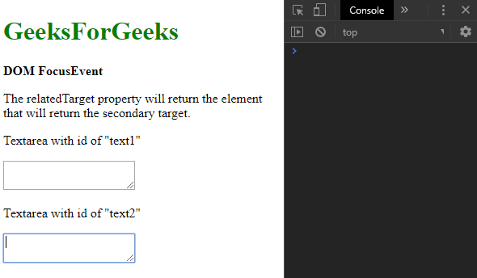

* **Refocusing the first textarea:**

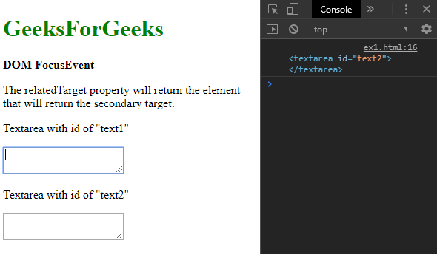

**Event Types:**

* [**onblur**](https://www.geeksforgeeks.org/html-dom-onblur-event/)**:** This event fires whenever an element loses its focus.
* [**onfocus**](https://www.geeksforgeeks.org/html-dom-onfocus-event/)**:** This event fires whenever an element gets focus.
* [**onfocusin**](https://www.geeksforgeeks.org/html-dom-onfocusin-event/)**:** This event fires whenever an event is about to get focus.
* [**onfocusout**](https://www.geeksforgeeks.org/html-dom-onfocusout-event/)**:** This event fires whenever an event is about to lose focus.

**Example:** This example implements the onfocusin event.

* html

<!DOCTYPE html>

<**html**>

<**head**>

    <**title**>DOM FocusEvent</**title**>

</**head**>

<**body**>

    <**h1** style="color: green">

        GeeksForGeeks

    </**h1**>

    <**b**>DOM FocusEvent</**b**>

<**p**>

        The onfocusin event fires whenever an

        element is about to receive focus.

    </**p**>

    <**textarea** id="text1" onfocusin="fireEvent()">

    </**textarea**>

    <**script**>

        function fireEvent() {

            console.log("The textarea was focused.");

        }

    </**script**>

</**body**>

</**html**>

**Output:**

* **Before clicking on the textarea:**

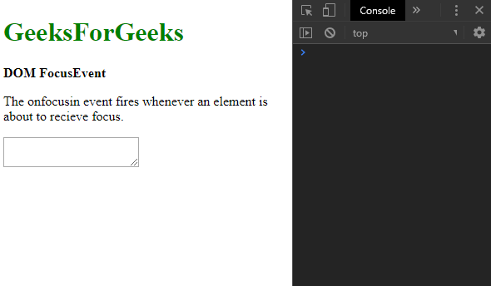

* **After clicking on the textarea:**

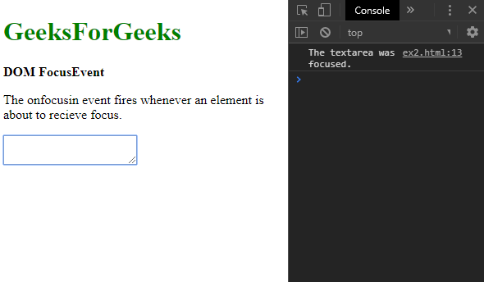

**Example:** This example implements the onfocusout event.

* html

<!DOCTYPE html>

<**html**>

<**head**>

    <**title**>DOM FocusEvent</**title**>

</**head**>

<**body**>

    <**h1** style="color: green">

        GeeksForGeeks

    </**h1**>

    <**b**>DOM FocusEvent</**b**>

<**p**>

        The onfocusout event fires whenever an

        element is about to lose focus.

    </**p**>

    <**textarea** id="text1" onfocusout="fireEvent()">

    </**textarea**>

    <**script**>

        function fireEvent() {

            console.log("The textarea was unfocused.");

        }

    </**script**>

</**body**>

</**html**>

**Output:**

* **Before clicking out of the textarea:**

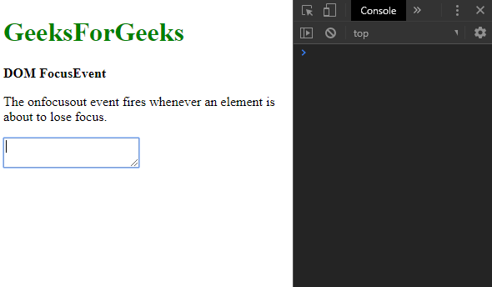

* **After clicking out of the textarea:**

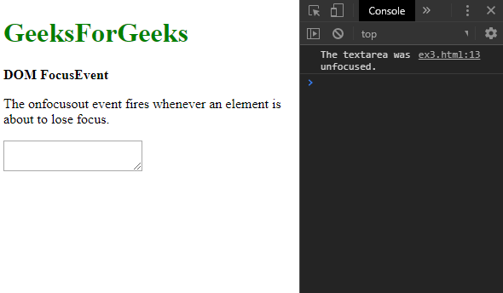

* 1. [JS Clipboard Event](https://www.geeksforgeeks.org/html-dom-clipboardevent/)

The **ClipboardEvent** refers to all the events which occur when the clipboard is modified. All the properties and methods are inherited from the ‘Event Object’. There are 3 main ClipboardEvents:

* oncopy
* oncut
* onpaste

**Return Value:**It returns an object containing the data affected by the clipboard operation.

**Clipboard Events**

**1. oncopy:**It is used to copy the content of an element.

**Syntax:**

*<input type=”text” oncopy=”function\_name()” value=”copy\_operation\_content”>*

**Example-1:** Showing oncopy event.

* HTML

<!DOCTYPE html>

<**html**>

<**body**>

    <**h1**><**center**>Geeks</**center**> </**h1**>

    <**h2**><**center**>DOM ClipboardEvent</**center**></**h2**>

    <**h4**>Copy the text from the box</**h4**>

    <**input** type="text" oncopy="clip()" value="GeeksforGeeks">

    <**p** id="gfg"></**p**>

    <**script**>

        function clip() {

            document.getElementById("gfg").innerHTML =

              "Copy Operation is performed!"

        }

    </**script**>

</**body**>

</**html**>

**Output:**

* **Before performing copy operation:**   
  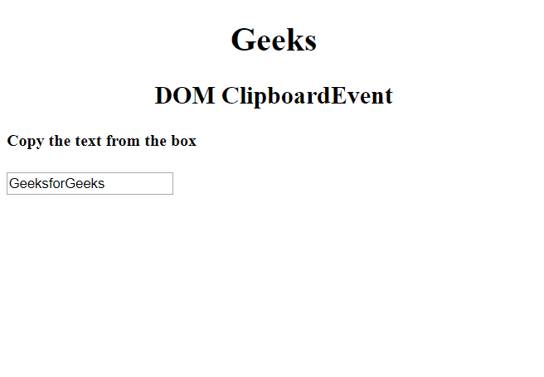
* **After performing copy operation:**   
  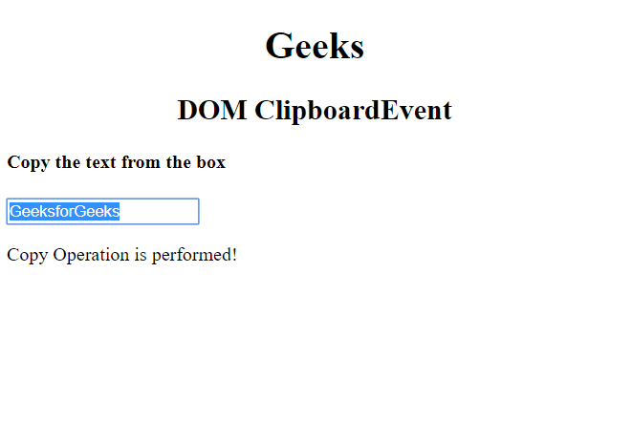

**2. oncut:**It is used to cut the content of an element.

**Syntax:**

*<input type=”text” oncut=”function\_name()” value=”cut\_operation\_content”>*

**Example-2:**Showing oncut event

* HTML

<!DOCTYPE html>

<**html**>

<**body**>

    <**h1**><**center**>Geeks</**center**> </**h1**>

    <**h2**><**center**>DOM ClipboardEvent</**center**></**h2**>

    <**h4**>Cut the text from the box</**h4**>

    <**input** type="text" oncut="clip()" value="GeeksforGeeks">

    <**p** id="gfg"></**p**>

    <**script**>

        function clip() {

            document.getElementById("gfg").innerHTML =

              "Cut Operation is performed!"

        }

    </**script**>

</**body**>

</**html**>

**Output:**

* **Before performing cut operation:**   
  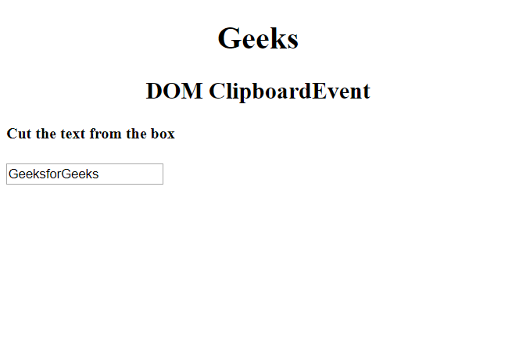
* **After performing cut operation:**   
  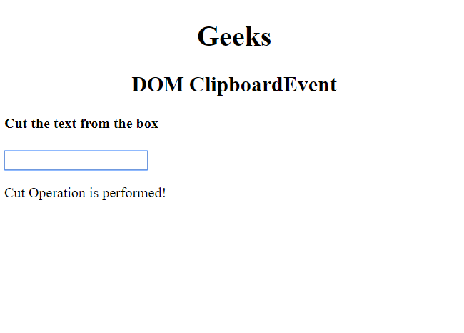

**3. onpaste:**It is used to paste content in an element.

**Syntax:**

*<input type=”text” onpaste=”function\_name()” value=”Paste\_operation\_content”>*

**Example-3:**Showing onpaste event

* HTML

<!DOCTYPE html>

<**html**>

<**body**>

    <**h1**><**center**>Geeks</**center**> </**h1**>

    <**h2**><**center**>DOM ClipboardEvent</**center**></**h2**>

    <**h4**>Paste the text in the box</**h4**>

    <**input** type="text" onpaste="clip()" value="">

    <**p** id="gfg"></**p**>

    <**script**>

        function clip() {

            document.getElementById("gfg").innerHTML =

              "Paste Operation is performed!"

        }

    </**script**>

</**body**>

</**html**>

**Output:**

* **Before performing paste operation:**   
  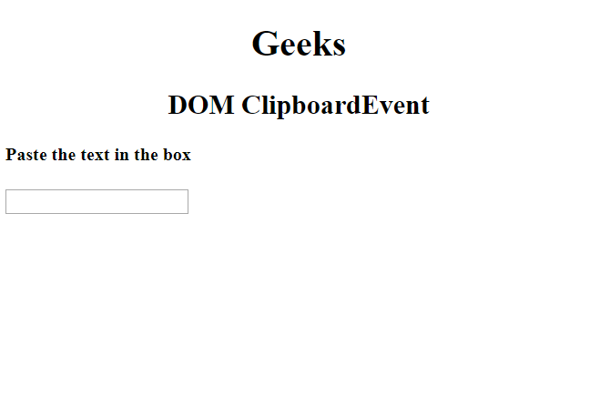
* **After performing paste operation:**   
  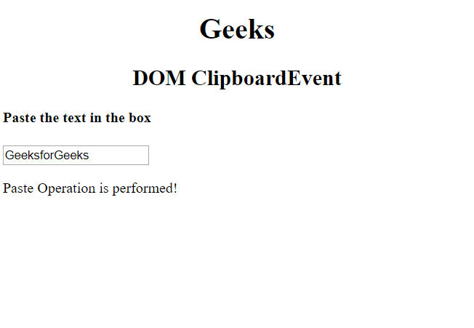
  1. [JS onscroll Event](https://www.geeksforgeeks.org/html-dom-onscroll-event/)

The **HTML DOM onscroll event** occurs when a scrollbar is used. CSS overflow is used to create a scrollbar.  
**Supported tags**

* <address>
* , <blockquote>
* , <body>
* , <caption>
* , <center>
* , <dd>
* , <dir>
* , <div>
* , <dl>
* , <dt>
* , <fieldset>
* , <form>
* , <h1>to <h6>
* , <html>
* , <li>
* , <menu>
* , <object>
* , <ol>
* , <p>
* , <pre>
* , <select>
* , <tbody>
* , <textarea>
* , <tfoot>
* , <thead>
* , <ul>

**Syntax:**

* **In HTML:**

<element onscroll="myScript">

* **In JavaScript:**

object.onscroll = function(){myScript};

* **In JavaScript, using the addEventListener() method:**

object.addEventListener("scroll", myScript);

* **Example:** Using the addEventListener() method
* html

<!DOCTYPE html>

<**html**>

<**head**>

    <**title**>

        HTML DOM onscroll Event

    </**title**>

</**head**>

<**body**>

    <**center**>

        <**h1** style="color:green">

          GeeksforGeeks

      </**h1**>

        <**h2**>HTML DOM onscroll Event</**h2**>

        <**textarea** style="width:100%" id="tID">

            HTML stands for Hyper Text Markup Language.

          It is used to design web pages using markup language.

          HTML is the combination of Hypertext and Markup language.

          Hypertext defines the link between the web pages.

          Markup language is used to define the text document

          within tag which defines the structure of web pages.

          HTML is a markup language which is used by the browser

          to manipulate text, images and other content to

          display it in required format.

        </**textarea**>

        <**p** id="try"></**p**>

    </**center**>

    <**script**>

        document.getElementById(

          "tID").addEventListener("scroll", GFGfun);

        function GFGfun() {

            document.getElementById(

              "try").innerHTML = "Textarea scrolled.";

        }

    </**script**>

</**body**>

</**html**>

* **Output:**

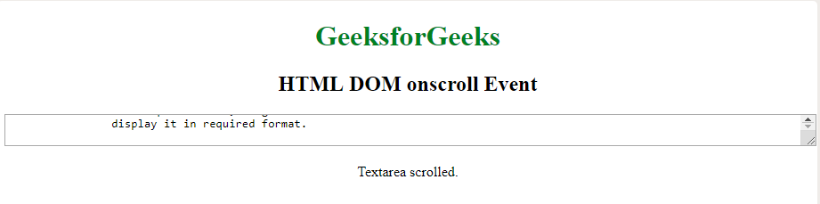

1. [JavaScript OOPs](https://www.geeksforgeeks.org/javascript/#javascript-oops)

Object-Oriented Programming (OOP) in JavaScript, a concept that enables the structure of code by modeling real-world entities as objects with properties and behaviors.

* 1. [JS Classes In JavaScript](https://www.geeksforgeeks.org/javascript-classes/)

**Classes in JavaScript** are a blueprint for creating objects, introduced in ES6. They encapsulate data and behavior by defining properties and methods, enabling object-oriented programming. Classes simplify the creation of objects and inheritance, making code more organized and reusable.

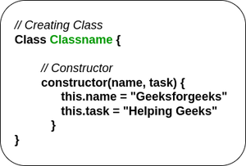

Classes are similar to functions. Here, a class keyword is used instead of a function keyword. Unlike functions classes in JavaScript are not hoisted. The constructor method is used to initialize. The class name is user-defined.

**Syntax:**

class classname {  
 constructor(parameter) {  
 this.classname = parameter;  
 }  
}

**Constructor Method**

The [constructor method in JavaScript](https://www.geeksforgeeks.org/default-constructor-in-javascript)is a special method used for initializing objects created with a class.

It’s called automatically when a new instance of the class is created. It typically assigns initial values to object properties using parameters passed to it. This ensures objects are properly initialized upon creation.

**Syntax:**

class ClassName {  
  constructor() { ... }  
  method() { ... }  
}

**Example 1:**The below example illustrates the JavaScript classes.

JavaScript

**class** emp {

**constructor**(name, age) {

**this**.name = name;

**this**.age = age;

}

}

**const** emp1 = **new** emp("Geek1", "25 years");

console.log(emp1.name);

console.log(emp1.age);

**Output**

Geek1

25 years

**Example 2:**This example demonstrates the use of constructor to create class in JavaScript.

JavaScript

**class** Person {

**constructor**(name, age) {

**this**.name = name;

**this**.age = age;

}

}

**const** person1 = **new** Person("Alice", 30);

console.log(person1.name); *// Output: Alice*

console.log(person1.age); *// Output: 30*

**const** person2 = **new** Person("Bob", 25);

console.log(person2.name); *// Output: Bob*

console.log(person2.age); *// Output: 25*

**Output**

Alice

30

Bob

25

**Example 3:** This example use class to create the object in JavaScript.

JavaScript

**class** emp {

**constructor**(name, age) {

**this**.name = name;

**this**.age = age;

}

}

**const** emp1 = **new** emp("Geek1", "25 years");

**const** emp2 = **new** emp("Geeks2", "32 years")

console.log(emp1.name + " : " + emp1.age);

console.log(emp2.name + " : " + emp2.age);

**Output**

Geek1 : 25 years

Geeks2 : 32 years

**JavaScript Classes Use-Cases**

**1.**[Classes and Objects in JavaScript](https://www.geeksforgeeks.org/classes-and-objects-in-javascript)

Classes in JavaScript provide blueprints for creating objects with similar properties and methods. Objects are instances of classes. Classes encapsulate data and behavior, promoting code reusability and organization. Objects created from classes can have unique data but share the same methods defined in the class blueprint.

**2.**[How to create a JavaScript class in ES6 ?](https://www.geeksforgeeks.org/how-to-create-a-javascript-class-in-es6)

You can create a JavaScript class by using a predefined keyword named class before the class name.

* 1. [JS class expression](https://www.geeksforgeeks.org/javascript-class-expression/)

JavaScript **class** is a type of function declared with a **class**keyword, that is used to implement an object-oriented paradigm. Constructors are used to initialize the attributes of a class.

There are 2 ways to create **a**[class](https://www.geeksforgeeks.org/es6-classes/) in JavaScript.

* **class declaration**
* **class expression**

In this article, we’ll discuss class expression to declare classes in JavaScript and how to use them.

**class expression**

The class expression is another way of creating classes in JavaScript and they can be named or unnamed. If named, the class name is used internally, but not outside of the class.

**Syntax:**

* Using named class expression:

const variable\_name = new Class\_name {  
 // class body  
}

* Using unnamed class expression:

const variable\_name = class{  
 //class body  
}

**Example 1:**Named class expression:

JavaScript

**const** Website = **class** Geek {

**constructor**(name) {

**this**.name = name;

}

websiteName() {

**return** **this**.name;

}

};

**const** x = **new** Website("GeeksforGeeks");

console.log(x.websiteName());

**Output:**

GeeksforGeeks

**Example 2:** Unnamed class expression:

JavaScript

**const** Website = **class** {

**constructor**(name) {

**this**.name = name;

}

returnName() {

**return** **this**.name;

}

};

console.log(**new** Website("GeeksforGeeks").returnName());

**Output:**

GeeksforGeeks

* 1. [JS Object Constructors](https://www.geeksforgeeks.org/javascript-object-constructors/)

[**Object**](https://www.geeksforgeeks.org/objects-in-javascript/)**:** An object is the collection of related data or functionality in the form of **key**. These functionalities usually consist of several functions and variables. All JavaScript values are objects except primitives.

**Example:**

var GFG = {

subject : "programming",

language : "JavaScript",

}

Here, *subject* and *language* are the **keys** and *programming* and *JavaScript* are the **values**. **Class:** In JavaScript, a class is a kind of function. These classes are similar to normal java classes. The classes are declared with the **class** keyword like other OOP languages. The class syntax has two components: *class declarations* and *class expressions*.

**Class declarations:**

class GFG {

constructor(A, B, C) {

this.g = A;

this.f = B;

this.gg = C;

}

}

Here class name is *GFG*.

**Class expressions:**

* javascript

class GFG {

    constructor(A, B) {

        // "this" refers to the address

        // of the keys "g" and "f"

**this**.g = A;

**this**.f = B;

    }

    print() {

        console.log(**this**.g + " " +**this**.f);

    }

}

let gg = **new** GFG("JavaScript", "Java");

gg.print();

**Output:**

JavaScript Java

[**this keyword**](https://www.geeksforgeeks.org/this-in-javascript/)**:** The **this** keyword refers to the object it belongs to, like OOPs languages C++, C#, JAVA etc. **this** keyword is used in different ways in different areas. While executing a function in JavaScript that has a reference to its current execution context, that is the reference by which the function or data member is called. See the previous example.

**Adding property to an object:** The property can be added to the object by using **dot(.)** operator or **square bracket.**,

var GFG = {

articles: 'computer science',

quantity: 3000,

};

The **GFG** has two properties “articles” and “quantity”. Now we wish to add one more property name called **subject**.

Using dot (.) operator

GFG.subject: 'JavaScript';

Using square bracket:

GFG['subject']: 'JavaScript';

Here, **subject** is the property and **‘JavaScript’** is the value of the property. **Adding a property to Constructor:** We cannot add a property to an existing constructor like adding a property to an object (see previous point), for adding a property we need to declare under the constructor.

function GFG(a, b, c) {

this.A = a;

this.B = b;

this.C = c;

this.G = "GEEK";

}

Here, we add a property name **G** with value **“GEEK”**, in this case the value **“GEEK”** is not passed as an argument. **Adding a Method to an Object:** We can add a new method to an existing object.

GFG.n = function () {

return this.A + this.B;

};

Here, the object is GFG. **Adding a Method to Constructor:**

function GFG(a, b, c) {

this.A = a;

this.B = b;

this.C = c;

this.n = function () {

return this.A + this.B;

}

}

Here, in the last line a method is added to an object.

**Constructor:** A **constructor** is a function that initializes an object. In JavaScript the constructors are more similar to normal java constructor. [**Object constructor**](https://www.geeksforgeeks.org/javascript-object-constructors/)**:** In JavaScript, there is a special constructor function known as **Object()** is used to create and initialize an object. The return value of the **Object()** constructor is assigned to a variable. The variable contains a reference to the new object. We need an object constructor to create an object *“type”* that can be used multiple times without redefining the object every time.

**Example:**

function GFG(A, B, C) {

this.g = A;

this.f = B;

this.gg = C;

}

Here, *GFG* is the constructor name and A, B, C are the arguments of the constructor.

**Instantiating an object constructor:** There are two ways to instantiate object constructor,

1. var object\_name = new Object(); or

var object\_name = new Object("java", "JavaScript", "C#");

2. var object\_name = { };

In 1st method, the object is created by using **new** keyword like normal OOP languages, and **“Java”, “JavaScript”, “C#”** are the arguments, that are passed when the constructor is invoked. In 2nd method, the object is created by using ***curly braces “{ }”***.

**Assigning properties to the objects:** There are two ways to assigning properties to the objects.

* **Using dot (.) operator:**

object\_name . properties = value;

* **Using third bracket:**

object\_name [ 'properties'] = value;

**Example 1:** This example shows object creation by using **new** keyword and assigning properties to the object using **dot(.)** operator.

* javascript

// creating object using "new" keyword

**var** gfg = **new** Object();

// Assigning properties to the object

// by using dot (.) operator

gfg.a = "JavaScript";

gfg.b = "GeeksforGeeks";

console.log("Subject: " + gfg.a);

console.log("Author: " + gfg.b );

**Output:**

Subject: JavaScript

Author: GeeksforGeeks

**Example 2:** This example shows object creation using **curly braces** and assigning properties to the object using **third bracket “[]”** operator.

* javascript

// Creating an object using "{ }" bracket

**var** gfg = { };

// Assigning properties to the object

// by using third bracket

gfg['a'] = "JavaScript";

gfg['b']= "GeeksforGeeks";

console.log("Subject: " + gfg.a);

console.log("Author: " + gfg.b );

**Output:**

Subject: JavaScript

Author: GeeksforGeeks

**Example 3:** This example shows how to use function() with object constructor.

* javascript

// Creating object

**var** gfg = **new** Object();

// Assigning properties to the object

gfg.a = "JavaScript";

gfg.b = "GeeksforGeeks";

// Use function()

gfg.c = **function** () {

**return** (gfg.a +" "+ gfg.b);

};

console.log("Subject: " + gfg.a);

console.log("Author: " + gfg.b);

// Call function with object constructor

console.log("Adding the strings: "+ gfg.c() );

**Output:**

Subject: JavaScript

Author: GeeksforGeeks

Adding the strings: JavaScript GeeksforGeeks

**Example:** Another way to create a function using function name.

* javascript

// Creating object using "{ }" bracket

**var** gfg = { };

// Assigning properties to the object

gfg.a = "JavaScript";

gfg.b = "GeeksforGeeks";

// Use function()

gfg.c = add;

// Declare function add()

**function** add() {

**return** (gfg.a +" "+ gfg.b);

};

console.log("Subject: " + gfg.a);

console.log("Author: " + gfg.b);

// Call function with object constructor

console.log("Adding the strings: "+ gfg.c());

**Output :**

Subject: JavaScript

Author: GeeksforGeeks

Adding the strings: JavaScript GeeksforGeeks

* 1. [JS Static Methods](https://www.geeksforgeeks.org/static-methods-in-javascript/)

JavaScript Static methods are defined directly on the classes, not on the instances of the class. Static methods can be of any name. A class can contain more than one static method.

***Note:******“this”****keyword is used to call a static method within any other static method in JavaScript.*

**Example 1:** The following is the code to invoke one static method.

JavaScript

**class** GeeksforGeeks {

*// static keyword is used*

*// before the function name*

**static** example1() {

*// return the string -->*

*// static method 1*

**return** "static method 1"

}

}

*// Calls the static function*

*// using className.functionName*

console.log(

GeeksforGeeks.example1());

**Output**

static method 1

**Example 2:** The following code demonstrates how to invoke more than one static method.

JavaScript

**class** GeeksforGeeks {

*// static keyword is used*

*// before the function name*

**static** example1() {

*// return the string -->*

*// static method 1*

**return** "static method 1"

}

*// Another static method*

*// with different name*

**static** example2() {

*// return the string -->*

*// static method 2*

**return** "static method 2"

}

}

*// Calls the static function using*

*// className.functionName*

console.log(GeeksforGeeks.example1());

console.log(GeeksforGeeks.example2());

**Output**

static method 1

static method 2

**Example 3:** The following example invokes more than one static method with same names.

JavaScript

**class** GeeksforGeeks {

*// static keyword is used*

*// before the function name*

**static** example1() {

*// returns static method 1*

**return** "static method 1"

}

*// Different static method*

*// with same name*

**static** example1() {

*// returns static method 2*

**return** "static method 2"

}

}

*// Calls the static function using*

*// className.functionName*

console.log(GeeksforGeeks.example1());

*// Invokes last static method in case*

*// if static function have same names*

**Output**

static method 2

**Example 4:** The following example demonstrates to invoke static method within the non static method.

JavaScript

**class** GeeksforGeeks {

*// Static keyword is used*

*// before the function name*

**static** example1() {

*// return the string -->*

*// static method 1*

**return** "static method 1"

}

*// Non static method with*

*// different name*

example2() {

*// return the string -->*

*// static method 1*

*// Calls the static function*

*// using className.functionName*

console.log(GeeksforGeeks.example1());

}

}

**let** gfg = **new** GeeksforGeeks();

gfg.example2();

**Output**

static method 1

* 1. [JS Prototype](https://www.geeksforgeeks.org/prototype-in-javascript/)

**JavaScript is a prototype-based**, automatically adds a prototype property to functions upon creation. This prototype object allows attaching methods and properties, facilitating inheritance for all objects created from the function.

**Example :** There are different ways to create an object, one of the ways is to create an object using a function constructor.

javascript

*// function constructor*

**function** Person(name, job, yearOfBirth){

**this**.name= name;

**this**.job= job;

**this**.yearOfBirth= yearOfBirth;

}

*// this will show Person's prototype property.*

console.log(Person.prototype);

**Output:-**

dcdc

In above image, you can see Person has a prototype property and that prototype property has a constructor object which again points to the Person constructor function.

**We can understand this by an Image:**

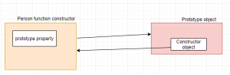

When we create an object using the above function constructor, JavaScript Engine will add dunder proto or \_\_proto\_\_ in the object which will point to the prototype’s constructor object.

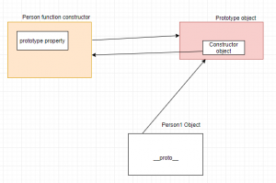

Now, we will add a method calculateAge() to the Prototype property in a Person function constructor which will inherit by the different objects. Below is the code for this:-

javascript

*// function constructor*

**function** Person(name, job, yearOfBirth) {

**this**.name = name;

**this**.job = job;

**this**.yearOfBirth = yearOfBirth;

}

Person.prototype.calculateAge = **function** () {

console.log('The current age is: ' + (2019 - **this**.yearOfBirth));

}

console.log(Person.prototype);

**Output:-**



In above image, we can see **calculateAge() method** gets added to the Prototype property. Now, we will create 2 different objects which will inherit **calculateAge() method** and remember, **When a certain method(or property) is called, it first checks inside the object but when it doesn’t find, then search moves on Object’s prototype.**

javascript

*// function constructor*

**function** Person(name, job, yearOfBirth) {

**this**.name = name;

**this**.job = job;

**this**.yearOfBirth = yearOfBirth;

}

*// adding calculateAge() method to the Prototype property*

Person.prototype.calculateAge = **function** () {

console.log('The current age is: ' + (2019 - **this**.yearOfBirth));

}

console.log(Person.prototype);

*// creating Object Person1*

**let** Person1 = **new** Person('Jenni', 'clerk', 1986);

console.log(Person1)

**let** Person2 = **new** Person('Madhu', 'Developer', 1997);

console.log(Person2)

Person1.calculateAge();

Person2.calculateAge();

**Output:-**

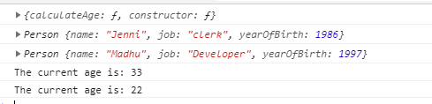

Here, we created two Objects Person1 and Person2 using constructor function Person, when we called Person1.calculateAge() and Person2.calculateAge(), First it will check whether it is present inside Person1 and Person2 object, if it is not present, it will move Person’s Prototype object and prints the current age,

**which shows Prototype property enables other objects to inherit all the properties and methods of function constructor.**

* 1. [JS Constructor Method](https://www.geeksforgeeks.org/javascript-object-prototype-constructor-property/)

The constructor property returns a reference to the object constructor function that has created the instance of an object. The value of the constructor is not a string containing the function’s name, but it is a reference to the function itself.

**Syntax:**

Object.constructor

**Return Value:**

* It is a reference to the object of the constructor.

**Example 1:** Below example illustrates how to display the constructor of an object.

JavaScript

**function** Gfg(name) {

**this**.name = name

}

**let** GeeksforGeeks = **new** Gfg('Geeks');

console.log(GeeksforGeeks.**constructor**);

**Output:**

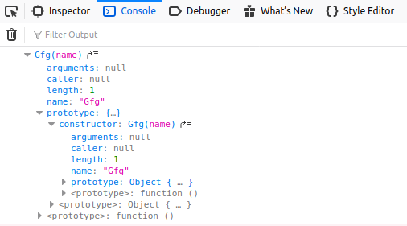

**Example 2:** Below example illustrates how to change the constructor of an object.

JavaScript

**function** Types() { }

**let** types = [

**new** Array(),

[],

**new** Boolean(),

**false**,

**new** Date(),

**new** **Error**(),

**new** Function(),

**new** RegExp(),

/(?:)/

]

**let** j = 0;

**while** (j < types.length) {

types[j].**constructor** = Types

types[j] = [types[j].**constructor**,

types[j] **instanceof** Types,

types[j].toString()]

++j;

}

console.log(types.join('\n'));

**Output:**

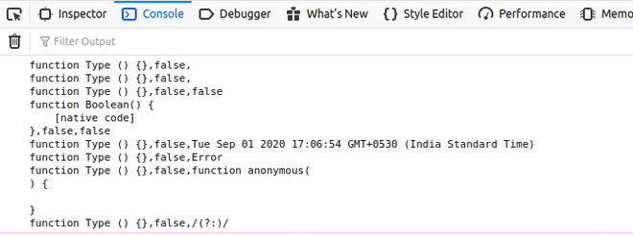

**JavaScript Object.prototype.constructor Property- FAQs**

**What is the purpose of the constructor property?**

*The constructor property is primarily used to identify and reference the constructor function of an object. It is useful for creating instances of the same type and for inheritance.*

**How does the constructor property work with inheritance?**

*In inheritance, the constructor property of the prototype can be reassigned to point to the correct constructor function for the derived class.*

**What happens if the constructor property is deleted?**

*If the constructor property is deleted from an object’s prototype, the prototype chain will be followed to find a constructor property further up the chain. This is generally not recommended as it can lead to unexpected behavior.*

**What is the most common use of the Object.prototype.constructor property?**

* *Identifying the constructor function that created an instance*
* *Creating new instances of the same type*
* *Ensuring proper reference to constructor functions in inheritance*
  1. [JS Encapsulation](https://www.geeksforgeeks.org/introduction-object-oriented-programming-javascript/#Encapsulation)

As JavaScript is widely used in Web Development, in this article we will explore some of the **Object Oriented**mechanisms supported by **JavaScript** to get the most out of it. Some of the common interview questions in JavaScript on OOPS include:

* How is Object-Oriented Programming implemented in JavaScript?
* How does it differ from other languages?
* Can you implement Inheritance in JavaScript?

and so on…

There are certain features or mechanisms which make a Language Object-Oriented like:

|  |  |  |
| --- | --- | --- |
| **OOPs Concept in JavaScript** | | |
| [**Object**](https://www.geeksforgeeks.org/objects-in-javascript/) | [**Classes**](https://www.geeksforgeeks.org/javascript-classes/) | **Encapsulation** |
| **Abstraction** | [**Inheritance**](https://www.geeksforgeeks.org/explain-prototype-inheritance-in-javascript/) | [**Polymorphism**](https://www.geeksforgeeks.org/polymorphism-in-javascript/) |

Let’s dive into the details of each one of them and see how they are implemented in JavaScript.

[**Object**](https://www.geeksforgeeks.org/objects-in-javascript/)**:** An Object is a **unique** entity that contains **properties** and **methods**. For example “a car” is a real-life Object, which has some characteristics like color, type, model, and horsepower and performs certain actions like driving. The characteristics of an Object are called Properties in Object-Oriented Programming and the actions are called methods. An Object is an **instance** of a class. Objects are everywhere in JavaScript, almost every element is an Object whether it is a function, array, or string.

**Note:** A Method in javascript is a property of an object whose value is a function.

The object can be created in two ways in JavaScript:

* **Object Literal**
* **Object Constructor**

**Example:**Using an Object Literal.

* Javascript

// Defining object

let person = {

    first\_name: 'Mukul',

    last\_name: 'Latiyan',

    //method

    getFunction: **function** () {

**return** (`The name of the person is

          ${person.first\_name} ${person.last\_name}`)

    },

    //object within object

    phone\_number: {

        mobile: '12345',

        landline: '6789'

    }

}

console.log(person.getFunction());

console.log(person.phone\_number.landline);

**Output:**

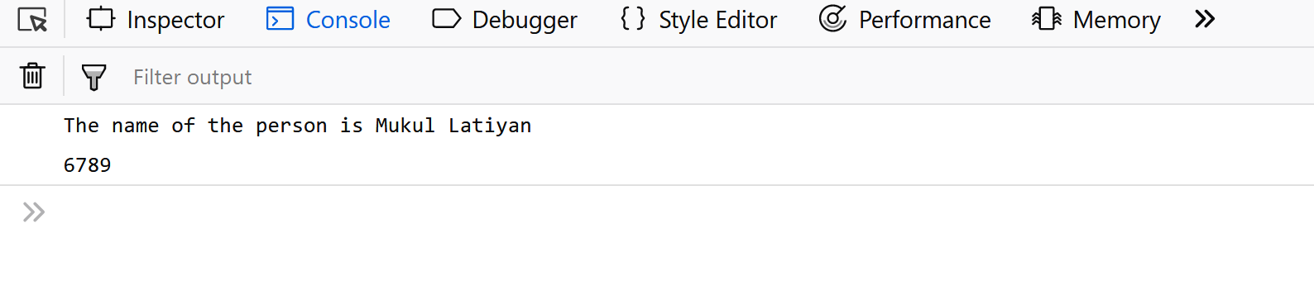**Example:**Using an Object Constructor.

* Javascript

// Using a constructor

**function** person(first\_name, last\_name) {

**this**.first\_name = first\_name;

**this**.last\_name = last\_name;

}

// Creating new instances of person object

let person1 = **new** person('Mukul', 'Latiyan');

let person2 = **new** person('Rahul', 'Avasthi');

console.log(person1.first\_name);

console.log(`${person2.first\_name} ${person2.last\_name}`);

**Output:**

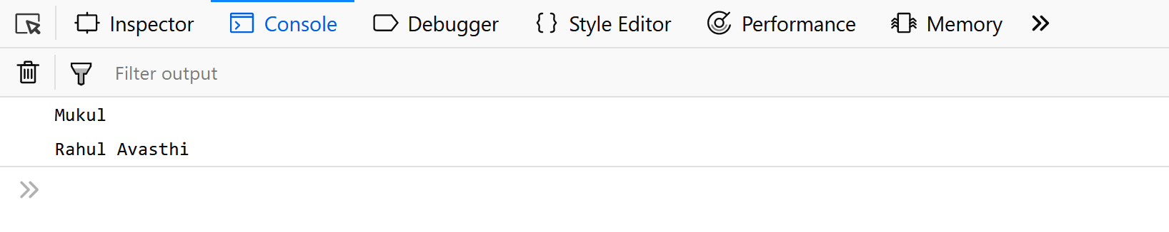**Note:** The [JavaScript Object.create() Method](https://www.geeksforgeeks.org/object-create-javascript/) creates a new object, using an existing object as the prototype of the newly created object.

**Example:**

* Javascript

// Object.create() example a

// simple object with some properties

const coder = {

    isStudying: **false**,

    printIntroduction: **function** () {

        console.log(`My name is ${**this**.name}. Am I

              studying?: ${**this**.isStudying}.`)

    }

}

// Object.create() method

const me = Object.create(coder);

// "name" is a property set on "me", but not on "coder"

me.name = 'Mukul';

// Inherited properties can be overwritten

me.isStudying = **true**;

me.printIntroduction();

**Output:**

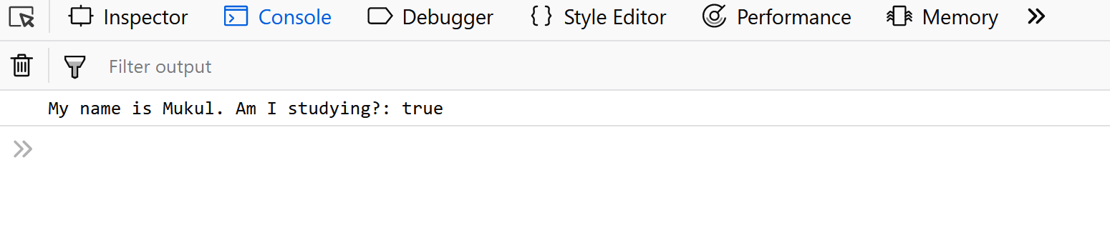

[**Classes**](https://www.geeksforgeeks.org/javascript-classes/)**:**Classes are **blueprints** of an Object. A class can have many Objects because the class is a **template** while Objects are **instances** of the class or the concrete implementation.   
Before we move further into implementation, we should know unlike other Object Oriented languages there are **no classes in JavaScript** we have only Object. To be more precise, JavaScript is a prototype-based Object Oriented Language, which means it doesn’t have classes, rather it defines behaviors using a constructor function and then reuses it using the prototype.

**Note:** Even the classes provided by ECMA2015 are objects.

*JavaScript classes, introduced in ECMAScript 2015, are primarily syntactical sugar over JavaScript’s existing prototype-based inheritance. The class syntax is not introducing a new object-oriented inheritance model to JavaScript. JavaScript classes provide a much simpler and clearer syntax to create objects and deal with inheritance.*

*-Mozilla Developer Network*

**Example:** Let’s use ES6 classes then we will look at the traditional way of defining an Object and simulate them as classes.

* Javascript

// Defining class using es6

class Vehicle {

    constructor(name, maker, engine) {

**this**.name = name;

**this**.maker = maker;

**this**.engine = engine;

    }

    getDetails() {

**return** (`The name of the bike is ${**this**.name}.`)

    }

}

// Making object with the help of the constructor

let bike1 = **new** Vehicle('Hayabusa', 'Suzuki', '1340cc');

let bike2 = **new** Vehicle('Ninja', 'Kawasaki', '998cc');

console.log(bike1.name);    // Hayabusa

console.log(bike2.maker);   // Kawasaki

console.log(bike1.getDetails());

**Output:**

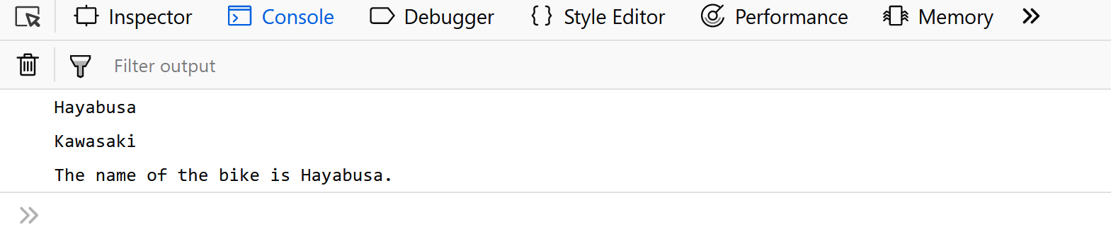

**Example**: Traditional Way of defining an Object and simulating them as classes.

* Javascript

// Defining class in a Traditional Way.

**function** Vehicle(name, maker, engine) {

**this**.name = name,

**this**.maker = maker,

**this**.engine = engine

};

Vehicle.prototype.getDetails = **function** () {

    console.log('The name of the bike is ' + **this**.name);

}

let bike1 = **new** Vehicle('Hayabusa', 'Suzuki', '1340cc');

let bike2 = **new** Vehicle('Ninja', 'Kawasaki', '998cc');

console.log(bike1.name);

console.log(bike2.maker);

console.log(bike1.getDetails());

**Output:**



As seen in the above example it is much simpler to define and reuse objects in ES6. Hence, we would be using ES6 in all of our examples.

**Abstraction:**Abstraction means displaying only essential information and hiding the details. Data abstraction refers to providing only essential information about the data to the outside world, hiding the background details or implementation.

**Encapsulation:**The process of **wrapping properties and functions**within a **single unit** is known as encapsulation.

**Example:**Let’s understand encapsulation with an example.

* Javascript

// Encapsulation example

class person {

    constructor(name, id) {

**this**.name = name;

**this**.id = id;

    }

    add\_Address(add) {

**this**.add = add;

    }

    getDetails() {

        console.log(`Name is ${**this**.name},

        Address is: ${**this**.add}`);

    }

}

let person1 = **new** person('Mukul', 21);

person1.add\_Address('Delhi');

person1.getDetails();

**Output:** In this example, we simply create a person Object using the constructor, Initialize its properties and use its functions. We are not bothered by the implementation details. We are working with an Object’s interface without considering the implementation details.

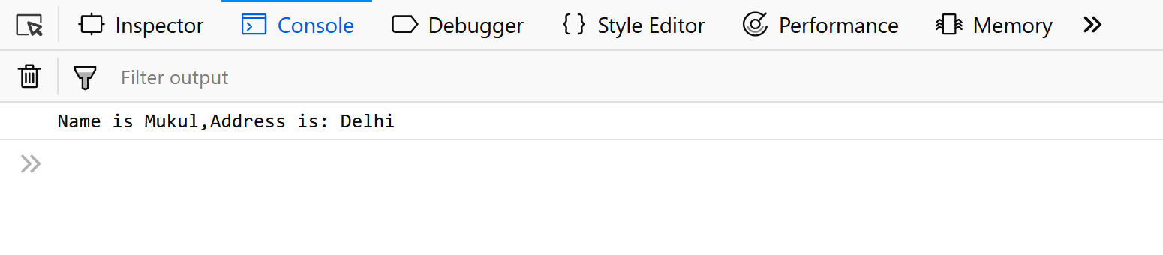Sometimes encapsulation refers to the **hiding of data** or **data Abstraction** which means representing essential features hiding the background detail. Most of the OOP languages provide access modifiers to restrict the scope of a variable, but there are no such access modifiers in JavaScript, there are certain ways by which we can restrict the scope of variables within the Class/Object.

**Example:**

* Javascript

// Abstraction example

**function** person(fname, lname) {

    let firstname = fname;

    let lastname = lname;

    let getDetails\_noaccess = **function** () {

**return** (`First name is: ${firstname} Last

            name is: ${lastname}`);

    }

**this**.getDetails\_access = **function** () {

**return** (`First name is: ${firstname}, Last

            name is: ${lastname}`);

    }

}

let person1 = **new** person('Mukul', 'Latiyan');

console.log(person1.firstname);

console.log(person1.getDetails\_noaccess);

console.log(person1.getDetails\_access());

**Output:** In this example, we try to access some property(person1.firstname) and functions(person1.getDetails\_noaccess) but it returns undefined while there is a method that we can access from the person object(person1.getDetails\_access()). By changing the way we define a function we can restrict its scope.

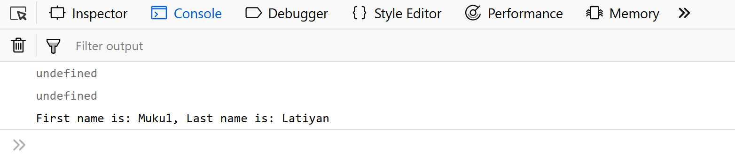

**Inheritance:**It is a concept in which some properties and methods of an Object are being used by another Object. Unlike most of the OOP languages where classes inherit classes, JavaScript Objects inherit Objects i.e. certain features (property and methods) of one object can be reused by other Objects.

**Example:**Let’s understand inheritance and polymorphism with an example.

* Javascript

// Inheritance example

class person {

    constructor(name) {

**this**.name = name;

    }

    // method to return the string

    toString() {

**return** (`Name of person: ${**this**.name}`);

    }

}

class student extends person {

    constructor(name, id) {

        // super keyword for calling the above

        // class constructor

**super**(name);

**this**.id = id;

    }

    toString() {

**return** (`${**super**.toString()},

        Student ID: ${**this**.id}`);

    }

}

let student1 = **new** student('Mukul', 22);

console.log(student1.toString());

**Output:** In this example, we define a Person Object with certain properties and methods and then we inherit the Person Object in the Student Object and use all the properties and methods of the person Object as well as define certain properties and methods for the Student Object.

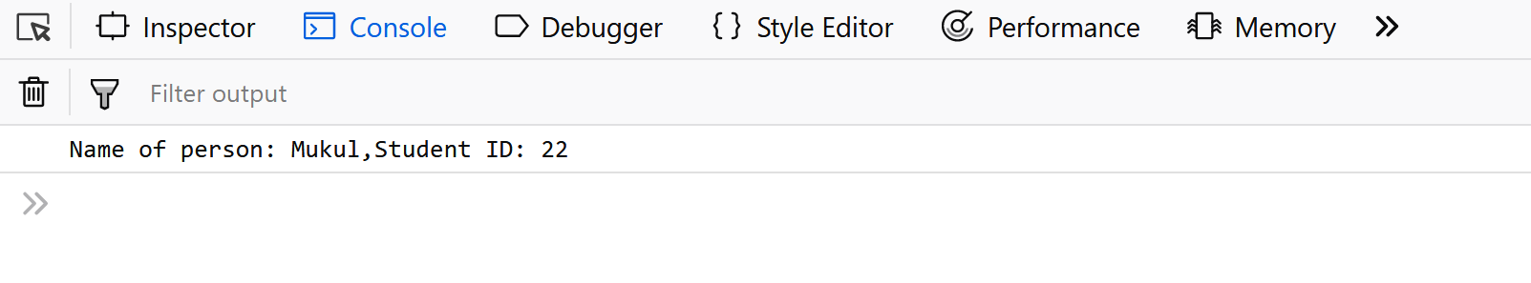**Note:** The Person and Student objects both have the same method (i.e toString()), this is called **Method Overriding**. Method Overriding allows a method in a child class to have the same name(polymorphism) and method signature as that of a parent class.

In the above code, the super keyword is used to refer to the immediate parent class’s instance variable.

[**Polymorphism:**](https://www.geeksforgeeks.org/polymorphism-in-javascript/) Polymorphism is one of the core concepts of object-oriented programming languages. Polymorphism means the same function with different signatures is called many times. In real life, for example, a boy at the same time may be a student, a class monitor, etc. So a boy can perform different operations at the same time. Polymorphism can be achieved by method overriding and method overloading

JavaScript is best known for web page development but it is also used in a variety of non-browser environments. You can learn JavaScript from the ground up by following this [JavaScript Tutorial](https://www.geeksforgeeks.org/javascript-tutorial/) and [JavaScript Examples](https://www.geeksforgeeks.org/javascript-examples/).

* 1. [JS Inheritance](https://www.geeksforgeeks.org/introduction-object-oriented-programming-javascript/#Inheritance)

As JavaScript is widely used in Web Development, in this article we will explore some of the **Object Oriented**mechanisms supported by **JavaScript** to get the most out of it. Some of the common interview questions in JavaScript on OOPS include:

* How is Object-Oriented Programming implemented in JavaScript?
* How does it differ from other languages?
* Can you implement Inheritance in JavaScript?

and so on…

There are certain features or mechanisms which make a Language Object-Oriented like:

|  |  |  |
| --- | --- | --- |
| **OOPs Concept in JavaScript** | | |
| [**Object**](https://www.geeksforgeeks.org/objects-in-javascript/) | [**Classes**](https://www.geeksforgeeks.org/javascript-classes/) | **Encapsulation** |
| **Abstraction** | [**Inheritance**](https://www.geeksforgeeks.org/explain-prototype-inheritance-in-javascript/) | [**Polymorphism**](https://www.geeksforgeeks.org/polymorphism-in-javascript/) |

Let’s dive into the details of each one of them and see how they are implemented in JavaScript.

[**Object**](https://www.geeksforgeeks.org/objects-in-javascript/)**:** An Object is a **unique** entity that contains **properties** and **methods**. For example “a car” is a real-life Object, which has some characteristics like color, type, model, and horsepower and performs certain actions like driving. The characteristics of an Object are called Properties in Object-Oriented Programming and the actions are called methods. An Object is an **instance** of a class. Objects are everywhere in JavaScript, almost every element is an Object whether it is a function, array, or string.

**Note:** A Method in javascript is a property of an object whose value is a function.

The object can be created in two ways in JavaScript:

* **Object Literal**
* **Object Constructor**

**Example:**Using an Object Literal.

* Javascript

// Defining object

let person = {

    first\_name: 'Mukul',

    last\_name: 'Latiyan',

    //method

    getFunction: **function** () {

**return** (`The name of the person is

          ${person.first\_name} ${person.last\_name}`)

    },

    //object within object

    phone\_number: {

        mobile: '12345',

        landline: '6789'

    }

}

console.log(person.getFunction());

console.log(person.phone\_number.landline);

**Output:**

**Example:**Using an Object Constructor.

* Javascript

// Using a constructor

**function** person(first\_name, last\_name) {

**this**.first\_name = first\_name;

**this**.last\_name = last\_name;

}

// Creating new instances of person object

let person1 = **new** person('Mukul', 'Latiyan');

let person2 = **new** person('Rahul', 'Avasthi');

console.log(person1.first\_name);

console.log(`${person2.first\_name} ${person2.last\_name}`);

**Output:**

**Note:** The [JavaScript Object.create() Method](https://www.geeksforgeeks.org/object-create-javascript/) creates a new object, using an existing object as the prototype of the newly created object.

**Example:**

* Javascript

// Object.create() example a

// simple object with some properties

const coder = {

    isStudying: **false**,

    printIntroduction: **function** () {

        console.log(`My name is ${**this**.name}. Am I

              studying?: ${**this**.isStudying}.`)

    }

}

// Object.create() method

const me = Object.create(coder);

// "name" is a property set on "me", but not on "coder"

me.name = 'Mukul';

// Inherited properties can be overwritten

me.isStudying = **true**;

me.printIntroduction();

**Output:**



[**Classes**](https://www.geeksforgeeks.org/javascript-classes/)**:**Classes are **blueprints** of an Object. A class can have many Objects because the class is a **template** while Objects are **instances** of the class or the concrete implementation.   
Before we move further into implementation, we should know unlike other Object Oriented languages there are **no classes in JavaScript** we have only Object. To be more precise, JavaScript is a prototype-based Object Oriented Language, which means it doesn’t have classes, rather it defines behaviors using a constructor function and then reuses it using the prototype.

**Note:** Even the classes provided by ECMA2015 are objects.

*JavaScript classes, introduced in ECMAScript 2015, are primarily syntactical sugar over JavaScript’s existing prototype-based inheritance. The class syntax is not introducing a new object-oriented inheritance model to JavaScript. JavaScript classes provide a much simpler and clearer syntax to create objects and deal with inheritance.*

*-Mozilla Developer Network*

**Example:** Let’s use ES6 classes then we will look at the traditional way of defining an Object and simulate them as classes.

* Javascript

// Defining class using es6

class Vehicle {

    constructor(name, maker, engine) {

**this**.name = name;

**this**.maker = maker;

**this**.engine = engine;

    }

    getDetails() {

**return** (`The name of the bike is ${**this**.name}.`)

    }

}

// Making object with the help of the constructor

let bike1 = **new** Vehicle('Hayabusa', 'Suzuki', '1340cc');

let bike2 = **new** Vehicle('Ninja', 'Kawasaki', '998cc');

console.log(bike1.name);    // Hayabusa

console.log(bike2.maker);   // Kawasaki

console.log(bike1.getDetails());

**Output:**



**Example**: Traditional Way of defining an Object and simulating them as classes.

* Javascript

// Defining class in a Traditional Way.

**function** Vehicle(name, maker, engine) {

**this**.name = name,

**this**.maker = maker,

**this**.engine = engine

};

Vehicle.prototype.getDetails = **function** () {

    console.log('The name of the bike is ' + **this**.name);

}

let bike1 = **new** Vehicle('Hayabusa', 'Suzuki', '1340cc');

let bike2 = **new** Vehicle('Ninja', 'Kawasaki', '998cc');

console.log(bike1.name);

console.log(bike2.maker);

console.log(bike1.getDetails());

**Output:**



As seen in the above example it is much simpler to define and reuse objects in ES6. Hence, we would be using ES6 in all of our examples.

**Abstraction:**Abstraction means displaying only essential information and hiding the details. Data abstraction refers to providing only essential information about the data to the outside world, hiding the background details or implementation.

**Encapsulation:**The process of **wrapping properties and functions**within a **single unit** is known as encapsulation.

**Example:**Let’s understand encapsulation with an example.

* Javascript

// Encapsulation example

class person {

    constructor(name, id) {

**this**.name = name;

**this**.id = id;

    }

    add\_Address(add) {

**this**.add = add;

    }

    getDetails() {

        console.log(`Name is ${**this**.name},

        Address is: ${**this**.add}`);

    }

}

let person1 = **new** person('Mukul', 21);

person1.add\_Address('Delhi');

person1.getDetails();

**Output:** In this example, we simply create a person Object using the constructor, Initialize its properties and use its functions. We are not bothered by the implementation details. We are working with an Object’s interface without considering the implementation details.

Sometimes encapsulation refers to the **hiding of data** or **data Abstraction** which means representing essential features hiding the background detail. Most of the OOP languages provide access modifiers to restrict the scope of a variable, but there are no such access modifiers in JavaScript, there are certain ways by which we can restrict the scope of variables within the Class/Object.

**Example:**

* Javascript

// Abstraction example

**function** person(fname, lname) {

    let firstname = fname;

    let lastname = lname;

    let getDetails\_noaccess = **function** () {

**return** (`First name is: ${firstname} Last

            name is: ${lastname}`);

    }

**this**.getDetails\_access = **function** () {

**return** (`First name is: ${firstname}, Last

            name is: ${lastname}`);

    }

}

let person1 = **new** person('Mukul', 'Latiyan');

console.log(person1.firstname);

console.log(person1.getDetails\_noaccess);

console.log(person1.getDetails\_access());

**Output:** In this example, we try to access some property(person1.firstname) and functions(person1.getDetails\_noaccess) but it returns undefined while there is a method that we can access from the person object(person1.getDetails\_access()). By changing the way we define a function we can restrict its scope.



**Inheritance:**It is a concept in which some properties and methods of an Object are being used by another Object. Unlike most of the OOP languages where classes inherit classes, JavaScript Objects inherit Objects i.e. certain features (property and methods) of one object can be reused by other Objects.

**Example:**Let’s understand inheritance and polymorphism with an example.

* Javascript

// Inheritance example

class person {

    constructor(name) {

**this**.name = name;

    }

    // method to return the string

    toString() {

**return** (`Name of person: ${**this**.name}`);

    }

}

class student extends person {

    constructor(name, id) {

        // super keyword for calling the above

        // class constructor

**super**(name);

**this**.id = id;

    }

    toString() {

**return** (`${**super**.toString()},

        Student ID: ${**this**.id}`);

    }

}

let student1 = **new** student('Mukul', 22);

console.log(student1.toString());

**Output:** In this example, we define a Person Object with certain properties and methods and then we inherit the Person Object in the Student Object and use all the properties and methods of the person Object as well as define certain properties and methods for the Student Object.

**Note:** The Person and Student objects both have the same method (i.e toString()), this is called **Method Overriding**. Method Overriding allows a method in a child class to have the same name(polymorphism) and method signature as that of a parent class.

In the above code, the super keyword is used to refer to the immediate parent class’s instance variable.

[**Polymorphism:**](https://www.geeksforgeeks.org/polymorphism-in-javascript/) Polymorphism is one of the core concepts of object-oriented programming languages. Polymorphism means the same function with different signatures is called many times. In real life, for example, a boy at the same time may be a student, a class monitor, etc. So a boy can perform different operations at the same time. Polymorphism can be achieved by method overriding and method overloading

JavaScript is best known for web page development but it is also used in a variety of non-browser environments. You can learn JavaScript from the ground up by following this [JavaScript Tutorial](https://www.geeksforgeeks.org/javascript-tutorial/) and [JavaScript Examples](https://www.geeksforgeeks.org/javascript-examples/).

1. [JavaScript Inheritance and Prototype Chain](https://www.geeksforgeeks.org/javascript/#javascript-inheritance-and-prototype-chain)

Inheritance allows objects to inherit properties and methods from other objects, enabling code reuse and creating hierarchical relationships between objects.

* 1. [Prototype Inheritance in JavaScript](https://www.geeksforgeeks.org/explain-prototype-inheritance-in-javascript/)

**Prototype Inheritance in JavaScript:**Following bullet points will try to analyze the basics behind Prototype Inheritance in JavaScript-

* Under the classical inheritance phenomenon, we create a new class that actually extends or reuses the properties or functions, or methods of another class that are used by several programming languages (like C, C++, Java, etc.)
* JavaScript doesn’t use classical inheritance instead it uses the phenomenon called Prototype Inheritance.
* In Prototype Inheritance, an object uses the properties or methods of another object via the prototype linkage.
* All the JavaScript objects inherit properties and methods from a prototype (like Date objects inherit properties from Date.prototype and so on).

Following pictorial representation, containing some sample values will help us to understand Prototype Inheritance in a much better and effective way-

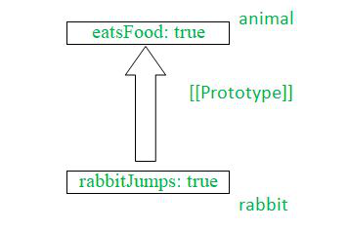

* In the above pictorial representation, we have taken an example to illustrate the Prototype Inheritance between a rabbit and another create prototype object which is an animal.
* We will set the rabbit’s prototype object as an animal prototype object wherein we will store all the values of rabbit for a purpose that if in the case in while rabbit properties are missing then JavaScript will automatically take it from animal prototype object.

Now that you have understood a brief detailed description of Prototype inheritance let us see and understand Prototype Inheritance with several following approaches-

* using \_\_proto\_\_
* Using Object.setPrototypeOf() method

**Approach 1: using \_\_proto\_\_**

In this approach, we will use **\_\_proto\_\_**, which is the special name for the internal and hidden prototype called **[[Prototype]]**. We will store all the properties of the rabbit in the animal prototype object and thereafter we may access it whenever it is required. This \_\_proto\_\_ is a bit old as well as an outdated approach that exists for some historical reasons associated with JavaScript.

**Example:**In this approach, we are using the above-explained approach.

* Javascript

let animal = {

    animalEats: **true**,

};

let rabbit = {

    rabbitJumps: **true**,

};

// Sets rabbit.[[Prototype]] = animal

rabbit.\_\_proto\_\_ = animal;

console.log(rabbit.animalEats);

console.log(rabbit.rabbitJumps);

**Output**

true

true

**Approach 2: Using**[**Object.setPrototypeOf()**](https://www.geeksforgeeks.org/javascript-object-setprototypeof-method/)**method**

In this approach, we will use the new JavaScript methods to implement JavaScript Prototype Inheritance, Here we will use **Object.setPrototypeOf()**method takes two parameters first one is the object which is to have its prototype set and the second one is the object’s new prototype. Thereafter we have declared two objects and using those two objects, we will set one of the objects as the prototype object for another object.

**Example:**In this example, we are using the above-explained approach.

* Javascript

let rabbit = {

    rabbitJumps: **true**,

};

let animal = {

    animalEats: **true**,

};

Object.setPrototypeOf(rabbit, animal);

console.log(rabbit.animalEats);

console.log(rabbit.rabbitJumps);

**Output**

true

true

* 1. [Prototype Chain in JavaScript](https://www.geeksforgeeks.org/understanding-the-prototype-chain-in-javascript/)

Here we discover what it meant and you acknowledged that it is for grouping data into “objects” with attributes. The keyword that creates these objects in many programming languages is class. You define a category with a constructor and a number of other public and personal functions. If you would like one class to inherit from another, you write simple inheritance syntax. You have created a sequence of inheritance. Until ES2015, the language didn’t implement a category. Instead, they used the prototype chain. The new ES6 “class” hides the inner workings of the prototype chain. Understanding how the prototype chain works is crucial if you would like to develop performant code while using JavaScript’s OOP paradigm. For those familiar (or not so familiar) with computing, the prototype chain may be a linked list. It’s a gross oversimplification.

**How do we initialize our chain?** All objects in JavaScript have a prototype. An object’s prototype is also considered to be an object.

* javascript

**function** Dog(name) {

**this**.name = name;

}

Because a prototype is an object, a prototype has its own prototype. In that case, the prototype of Dog.prototype is Object.prototype

* javascript

**function** Dog(name) {

**this**.name = name;

    }

    console.log(

        Object.prototype.isPrototypeOf(Dog.prototype)); // yields true

**Output:**

true

Recall the[**hasOwnProperty()**](https://www.geeksforgeeks.org/javascript-hasownproperty-method/) method.

* javascript

**function** Dog(name) {

**this**.name = name;

    }

    let duck = **new** Dog("Donald");

    console.log(duck.hasOwnProperty("name")); // yields true

**Output:**

true

The **[hasOwnProperty()](https://www.geeksforgeeks.org/javascript-hasownproperty-method/)** method is defined in *Object.prototype*, which can be accessed by *Dog.prototype*, which can then be accessed by variable “duck”. It clearly explains the prototype chain. In this prototype chain, “Dog” is the supertype for “duck”, while “duck” is the subtype. The object is a supertype for both “Dog” and “duck”. We take an Object as a supertype for all objects in JavaScript. Any object can use the **hasOwnProperty()** JavaScript method.

1. [JavaScript Memory Management](https://www.geeksforgeeks.org/javascript/#javascript-memory-management)

JavaScript uses automatic memory management, known as garbage collection, to allocate and deallocate memory dynamically.

* 1. [JS Memory Management](https://www.geeksforgeeks.org/memory-management-in-javascript/)

Memory management in JavaScript is handled automatically by the runtime environment, typically the JavaScript engine in web browsers or Node.js. JavaScript uses a garbage collector to manage memory and ensure that developers do not need to manually allocate or deallocate memory.

**Memory Life Cycle**

Irrespective of the programming language, the memory life cycle follows the following stages:

1. **Allocates the memory we need:**JavaScript allocates memory to the object created.
2. **Use the allocated memory.**
3. **Release the memory when not in use:** Once the allocated memory is released, it is used for other purposes. It is handled by a JavaScript engine.

The second stage is the same for all the languages. However, the first and last stages are implicit in high-level languages like JavaScript.

**Note:** “[Objects](https://www.geeksforgeeks.org/objects-in-javascript/)” in this context not only mean objects in JavaScript but also functions and function scopes.

**JavaScript engines have two places to store data**

* **Stack:**It is a data structure used to store static data. Static data refers to data whose size is known by the engine during compile time. In JavaScript, static data includes primitive values like strings, numbers, boolean, null, and undefined. References that point to objects and functions are also included. A fixed amount of memory is allocated for static data. This process is known as **static memory allocation.**
* **Heap:**It is used to store objects and functions in JavaScript. The engine doesn’t allocate a fixed amount of memory. Instead, it allocates more space as required.

**Overview:**

|  |  |
| --- | --- |
| **Stack** | **Heap** |
| Primitive data types and references | Objects and functions |
| Size is known at compile time | Size is known at run time |
| Fixed memory allocated | No limit for object memory |

**Example:**In the below example object ’employee’ is created in the heap and a reference to it is in the stack.

* Javascript

const employee = {

  name: 'Rajesh',

  age: 30,

};

const name="Ram"

// Allocates memory for object in heap.Values

// in object are primitive,which is why they

// are stored in stack.

**function** getname(name) {

**return** name;

}

// The function return value is given to stack after

// being evaluated in the heap

const newEmployee = employee;

// The newEmployee object will be stored in the stack and

// it will refer to the employee object in heap



**Garbage Collection**

Garbage collectors are used in releasing memory. Once the engine recognizes that a variable, object, or function is not needed anymore, it releases the memory it occupied. The main issue here is that it is very difficult to predict accurately whether a particular variable, object, or function is needed anymore or not. Some algorithms help to find the moment when they become obsolete with great precision.

**Reference-counting garbage collection**

It frees the memory allocated to the objects that have no references pointing to them. However, the problem with this algorithm is that it doesn’t understand cyclic references.

**Example:**In this example, the game and boy both reference each other. Thus, the algorithm won’t release the allocated memory. Setting them to *null*won’t make the algorithm realize that they can’t be used anymore, leading to no release of allocated memory.

* Javascript

let game = {

  name: 'cricket',

};

let boy = {

  name: 'Ram',

}

game.boy = boy;

boy.game = game;

boy = **null**;

game = **null**;

**Mark-and-sweep algorithm**

This algorithm solves the above-mentioned issue. Instead of finding references to a particular object, it detects if they are reachable from the root object.

**Note:**In JavaScript root is the [window](https://www.geeksforgeeks.org/properties-of-window-object/)object while in NodeJS it is the global object.

The algorithm marks objects that are not reachable as garbage and collects (sweeps) them. Thus, it is known as Mark and Sweep algorithm. In the previous example, neither the game nor the boy object can be accessed from the root object. Thus, it is marked as garbage and collected afterwards.

* 1. [JS Garbage Collection](https://www.geeksforgeeks.org/garbage-collection-in-javascript/)

**Memory Life Cycle**

The memory life cycle is pretty much the same for any programming language, it has 3 major steps.

* Allocate the memory.
* Use the allocated memory either to read or write or both.
* Release the allocated memory when it is no longer required.

**An Overview Behind Garbage Collection**

The majority of memory management issues occur when we try to release the allocated memory. The main concern that arises is the determination of unused memory resources. In the case of low-level languages where the developer has to manually decide when the memory is no longer needed, high-level languages such as **JavaScript** use an automated form of memory management known as **Garbage Collection(GC).**

**Garbage Collection**

The below section will explain the concepts that are necessary to understand the main garbage collection algorithms and their limitations. The main concept of the algorithms designed for garbage collection is the concept of ***reference***. An object can have a reference to another object if the *previous object has access to the latter*. For example, a JavaScript object can have an implicit reference(when the reference is to its prototypes) and explicit( when the reference is to its properties values).

Below we will explain the algorithms used for Garbage Collection.

**Reference-counting garbage collection:**

This algorithm is considered to be the most basic kind of garbage collection algorithm. What these algorithms do is that rather than determining whether any resource is important or not it scans the memory to determine if an object has any other objects referring to it. An object with **zero** references is considered to be **garbage** or “collectible”.

**Example:**

JavaScript

*// Declare an object*

**let** object\_1 = {

object\_2: {

object\_3: 7

}

};

*// In this example, create two objects One object is referred by another*

*// as one of its properties. Currently, none can be garbage collected*

*// The "object\_4" variable is the second thing that has a reference to the object*

**let** object\_4 = object\_1;

*// The object that was originally in "object\_1" has a unique reference*

*// embodied by the "object\_4" variable*

object\_1 = 1;

letar object\_5 = object\_4.object\_2;

*// The object that was in "object\_1" has now zero references to it. It can be*

*// garbage-collected. However its "object\_2" property is still referenced by the*

*// "object\_5" variable, so it cannot be freed.*

object\_4 = "Geeks For Geeks";

*// Now the "object\_2" property has no references to it and hence it can*

*// be garbage collected.*

object\_5 = **null**;

**Obstructions: Circular references:**

Limitations arise when it comes to circular references. A circular reference occurs when two objects are created with properties that refer each other, thus creating a cycle. The reference-counting algorithm fails to reclaim the these memory resources as each object has at least one reference pointing to them which prevents both the objects from being marked for garbage collection. Circular references are one of the major cause for memory leaks.

**Example:**Below example shows an instance of said case.

JavaScript

**function** Demo() {

**let** one = {};

**let** two = {};

*// one reference to two*

one.object = two;

*// two reference to one*

two.object = one;

**return** 'circular';

}

Demo();

**Mark-and-sweep-algorithm**

This algorithm modifies the problem statement from the “object being no longer needed” to the object being “unreachable”. This algorithm demands a prerequisite of the knowledge of **roots** which are a set of objects. In JavaScript, a root is a global object. On a regular basis, the garbage collector starts from these roots and finds all the objects that are referenced from these roots, then all objects referenced from these, etc. Starting from the roots, the garbage collector will find all the objects that are reachable and mark all the non-reachable objects.

**Cycles are no longer problem**

After the function call returns, the two objects are no longer referenced by any resource that is reachable from the root or global object. Hence, these will be marked as **unreachable**by the garbage collector and have their allocated memory reclaimed.

**Limitations:**

The only limitation that can be found is that it is not possible to explicitly or programmatically trigger garbage collector in JavaScript.  
Hence if there are cases when it would be convenient to manually program when to release memory, there are no provisions in JavaScript to trigger such an event.

1. [JavaScript Promises](https://www.geeksforgeeks.org/javascript/#javascript-promises)
   1. [JS Promise](https://www.geeksforgeeks.org/javascript-promise/) Discussed already
   2. [JS Promise Chaining](https://www.geeksforgeeks.org/javascript-promise-chaining/) Discussed Already
   3. [JS Errors Throw and Try to Catch](https://www.geeksforgeeks.org/javascript-errors-throw-and-try-to-catch/)

In JavaScript, errors can be thrown using the throw statement to indicate an exceptional condition. The try block is used to wrap code that might throw an error, and the catch block handles the error, preventing the program from crashing and allowing graceful error management.

But all errors can be solved and to do so we use five statements that will now be explained.

* The **try** statement lets you test a block of code to check for errors.
* The **catch** statement lets you handle the error if any are present.
* The **throw** statement lets you make your own errors.
* The **finally** statement lets you execute code after try and catch.    
  The **finally**block runs regardless of the result of the try-catch block.

Below are examples, that illustrate the JavaScript Errors Throw and Try to Catch:

**Example 1:**

JavaScript

**try** {

dadalert("Welcome Fellow Geek!");

}

**catch** (err) {

console.log(err);

}

**Output:** In the above code, we make use of ‘dadalert’ which is not a reserved keyword and is neither defined hence we get the error.  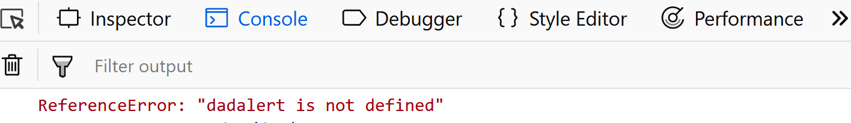**Example 2:**

JavaScript

**function** geekFunc() {

**let** a = 10;

**try** {

console.log("Value of variable a is : " + a);

}

**catch** (e) {

console.log("Error: " + e.description);

}

}

geekFunc();

**Output:** In the above code, our catch block will not run as there’s no error in the above code and hence we get the output ‘Value of variable a is: 10’.

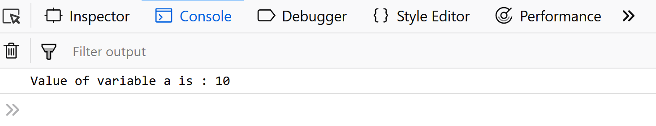

**Try and Catch Block**

The **try** statement allows you to check whether a specific block of code contains an error or not. The **catch** statement allows you to display the error if any are found in the try block.

try {  
 Try Block to check for errors.  
}  
catch(err) {  
 Catch Block to display errors.  
}

**Example:** In this example, we will see the usage of try-catch block in javascript.

JavaScript

**try** {

dadalert("Welcome Fellow Geek!");

}

**catch** (err) {

console.log(err);

}

**Output:**



**Javascript Throws Block The `*throw*` Statement**

When any error occurs, JavaScript will stop and generate an error message. The throw statement lets you create your own custom error. Technically you can throw your custom exception (throw an error). The exception can be a JavaScript Number, String, Boolean, or Object. By using throw together with try and catch, you can easily control the program flow and generate custom error messages.

**Example:** In this example, we will see how a throw statement is used to throw an error in javascript.

JavaScript

**try** {

**throw** **new** **Error**('Yeah... Sorry');

}

**catch** (e) {

console.log(e);

}

**Output:**

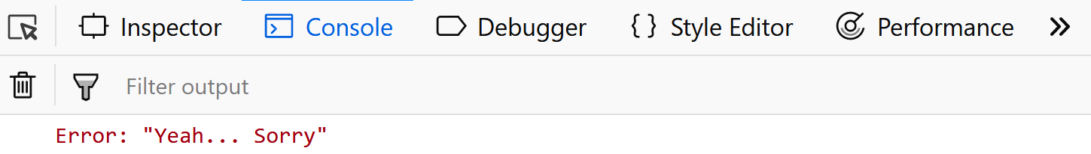

**The finally Block**

The finally Statement runs unconditionally after the execution of the try/catch block. Its syntax is

JavaScript

**try** {

Try Block to check **for** errors.

}

**catch**(err) {

Catch Block to display errors.

}

**finally** {

Finally Block executes regardless **of** the **try** / catch result.

}

**Example:**In this example, we will learn about the final statement of Javascript.

JavaScript

**try** {

console.log('try');

} **catch** (e) {

console.log('catch');

} **finally** {

console.log('finally');

}

**Output:** The Finally Block can also override the message of the catch block so be careful while using it.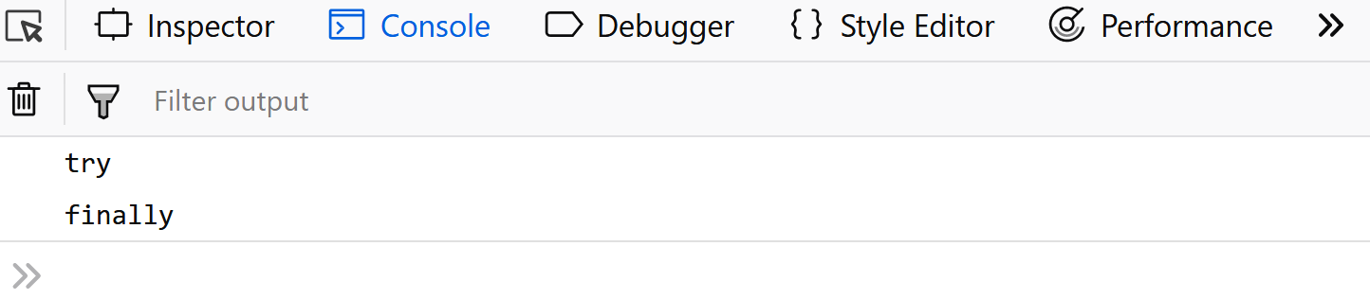

* 1. [JS Class compositions in JavaScript](https://www.geeksforgeeks.org/what-are-the-class-compositions-in-javascript/)

Composition helps in creating large & complex functions by combining small functions. For example, you can build a wall with the help of small bricks. The example of brick may be treated as a function, and composition is all about how we are combining those bricks to make a wall. The Class composition provides us with an easy way of composing, including the benefits of composition with Object-Oriented Programming.

You can compose *classes* and *objects*. A class may be considered as a “blueprint” for an object, which is an entity that has relevant functions and data (methods and state). It can be used to create many objects depending on the need.

Properties will be added to objects without using inheritance by using the **mixin** concept. Different objects’ properties are mixed into a single object, so the object has all the object’s properties and methods. In other words, a **mixin** is a way that gives methods that implement a certain behavior. It is used to add the behavior of other classes.

**Note:** The **mixin** technique defines some part of behavior, which consists of a factory function that takes a *superclass* as its argument and returns the respective subclass.

**Example:** Create a mixin class and by using it develop a “Human” class example.

* javascript

// Create a mixin class

const MixFood = superclass => class extends superclass {

    eating(food) {

        console.log(`Eating ${food}`);

    }

    excrete() {

        console.log("Going to excrete");

    }

};

// Develop the "Child" example by

// enhancing the "Human" class

class Human {

    constructor(name) {

**this**.name = name

    }

}

class Child extends MixFood(Human) {

    constructor(...args) {

**super**(...args)

    }

    cry() {

        console.log("Woff woff!")

    }

    lunch(food) {

**this**.eating(food);

**this**.excrete();

    }

}

const john = **new** Child("jack");

john.lunch("biscuits");

**Output:**

Eating biscuits

Going to excrete

1. [JavaScript Iterators and generators](https://www.geeksforgeeks.org/javascript/#javascript-iterators-and-generators)

Iterators are objects that define a sequence and provide a standard way to access its elements one at a time, while generators are functions that can pause and resume their execution to produce a sequence of values lazily.

* 1. [JS Iterator](https://www.geeksforgeeks.org/javascript-iterator/)

Javascript **Iterator**is an object or pattern that allows us to traverse over a list or collection. Iterators define the sequences and implement the iterator protocol that returns an object by using a [**next() method**](https://www.geeksforgeeks.org/javascript-generator-prototype-next-method/) that contains the value and is done. The value contains the next value of the iterator sequence and the done is the boolean value true or false if the last value of the sequence has been consumed then it’s true else false.

We can check if any entity is by default iterable or not We can check its prototype and can see if it is having a method **Symbol(Symbol.iterator)** or not.

In **Array.prototype** you will find **Symbol(Symbol.iterator): ƒ values() method**. The array is by default iterable. Also, String, Map & Set are built-in iterables because their prototype objects all have a **Symbol.iterator()** method.

**Example:** This example uses the symbol.iterator approach to iterate over the array.

* javascript

    const array = ['a', 'b', 'c'];

    const it = array[Symbol.iterator]();

    // and on this iterator method we have ‘next’ method

    console.log(JSON.stringify(it.next()));

    //{ value: "a", done: false }

    console.log(JSON.stringify(it.next()));

    //{ value: "b", done: false }

    console.log(JSON.stringify(it.next()));

    //{ value: "c", done: false }

    console.log(JSON.stringify(it.next()));

    /\* Actual it.next() will be { value: undefined,

    done: true } but here you will get

    {done: true} output because of JSON.stringify

    as it omits undefined values\*/

**Output:**

{"value":"a","done":false}

{"value":"b","done":false}

{"value":"c","done":false}

{"done":true}

Using **[for.of loop](https://www.geeksforgeeks.org/javascript-for-of-loop/)**, we can iterate over any entity (for eg: an object) which follows iterable protocol. The **for.of loop** is going to pull out the value that gets a return by calling the **next() method** each time.

**Example:** This example uses a for..of loop to iterate over the array.

* javascript

    const array = ['a', 'b', 'c'];

    const it = array[Symbol.iterator]()

**for** (let value of it) {console.log(value)}

**Output:**

a

b

c

**Iterable protocol:** The object must define a method with ‘Symbol.iterator’ the key which returns an object that itself follows iterator protocol. The object must define the ‘next’ method which returns an object having two properties ‘value’ and ‘done’

**Syntax:**

{value: 'item value', done: boolean}

**Error scenario:**

var newIt = arr[Symbol.iterator]

newIt()

//Because it does not properly bind

Uncaught TypeError: Cannot convert undefined or null to object

//How we can fix this

//var newIt = arr[Symbol.iterator].bind(arr);

newIt()

Array Iterator { }

**Create our own iterable object:**

* javascript

**var** iterable = {

    i: 0,

    [Symbol.iterator]() {

**var** that = **this**;

**return** {

        next() {

**if** (that.i < 5) {

**return** { value: that.i++, done: **false** }

            } **else** {

**return** { value: undefined, done: **true** }

            }

        }

        }

    }

    }

**for**(let value of iterable){console.log(value)}

**Output:**

0

1

2

3

4

* 1. [JS Function Generator](https://www.geeksforgeeks.org/javascript-function-generator/)

A generator functionuses the yield keyword to generate values, pausing execution and sending values to the caller. It retains the state to resume execution after yield, continuing immediately after the last yield run.

**Syntax :**

// An example of generator function  
function\* gen(){  
 yield 1;  
 yield 2;  
 ...  
 ...  
}

**Generator-Object :**Generator functions return a generator object. Generator objects are used either by calling the next method on the generator object or using the generator object in a “for of” loop (as shown in the above program)   
The Generator object is returned by a generating function and it conforms to both the iterable protocol and the iterator protocol.

**Example 1:** In this example, we will see the creation of basic generator object.

javascript

*// Generate Function generates three*

*// different numbers in three calls*

**function**\* fun() {

**yield** 10;

**yield** 20;

**yield** 30;

}

*// Calling the Generate Function*

**let** gen = fun();

console.log(gen.next().value);

console.log(gen.next().value);

console.log(gen.next().value);

**Output:**

10  
20  
30

**Example 2:** This example code prints infinite series of natural numbers using a simple generator.

javascript

*// Generate Function generates an*

*// infinite series of Natural Numbers*

**function**\* nextNatural() {

**let** naturalNumber = 1;

*// Infinite Generation*

**while** (**true**) {

**yield** naturalNumber++;

}

}

*// Calling the Generate Function*

**let** gen = nextNatural();

*// Loop to print the first*

*// 10 Generated number*

**for** (**let** i = 0; i < 10; i++) {

*// Generating Next Number*

console.log(gen.next().value);

}

**Output:**

1  
2  
3  
4  
5  
6  
7  
8  
9  
10

**Example 3:**This example of how to manually return from a generator.

javascript

**let** array = ['a', 'b', 'c'];

**function**\* generator(arr) {

**let** i = 0;

**while** (i < arr.length) {

**yield** arr[i++]

}

}

**const** it = generator(array);

*// We can do it.return() to finish the generator*

**Encountering yield and yield\***

* **yield:** pauses the generator execution and returns the value of the expression which is being written after the yield keyword.
* **yield\*:** it iterates over the operand and returns each value until done is true.

**Example 4:**

javascript

**const** arr = ['a', 'b', 'c'];

**function**\* generator() {

**yield** 1;

**yield**\* arr;

**yield** 2;

}

**for** (**let** value **of** generator()) {

console.log(value);

}

**Output:**

1  
a  
b  
c  
2

**Example 5:**Another way to create iterable.

javascript

**let** createOwnIterable = {

\*[Symbol.iterator]() {

**yield** 'a';

**yield** 'b';

**yield** 'c';

}

}

**for** (**let** value **of** createOwnIterable) {

console.log(value);

}

**Output:**

a  
b  
c

**Example 6:** Return from a generator function.

javascript

**function**\* generator() {

**yield** 'a';

**return** 'result';

**yield** 'b';

}

**let** it = generator();

console.log(JSON.stringify(it.next()));

*// {value: "a", done: false}*

console.log(JSON.stringify(it.next()));

*// {value: "result", done: true}*

**Output**

{"value":"a","done":false}

{"value":"result","done":true}

**Example 7:** How to throw an exception from the generator.

javascript

**function**\* generator() {

**throw** **new** **Error**('Error Occurred');

}

**const** it = generator();

it.next();

*// Uncaught Error: Error Occurred*

**Output:**



**Example 8:** Calling a generator from another generator.

javascript

**function**\* firstGenerator() {

**yield** 2;

**yield** 3;

}

**function**\* secondGenerator() {

**yield** 1;

**yield**\* firstGenerator();

**yield** 4;

}

**for** (**let** value **of** secondGenerator()) {

console.log(value)

}

**Output:**

1  
2  
3  
4

**Limitation of Generators:** You can’t yield inside a callback in a generator.

**Example 9:** In this example, we will try to give yield inside a generator function.

javascript

**function**\* generator() {

['a', 'b', 'c'].forEach(value => **yield** value)

*// This will give syntax error*

}

**Output:**

SyntaxError: missing ) after argument list

**Example 10:** Using async generators (for api call).

javascript

**const** firstPromise = () => {

**return** **new** Promise((resolve, reject) => {

setTimeout(() => resolve(1), 5000)

})

}

**const** secondPromise = () => {

**return** **new** Promise((resolve, reject) => {

setTimeout(() => resolve(2), 3000)

})

}

**async** **function**\* generator() {

**const** firstPromiseResult = **await** firstPromise();

**yield** firstPromiseResult;

**const** secondPromiseResult = **await** secondPromise();

**yield** secondPromiseResult;

}

**let** it = generator();

**for** **await** (**let** value **of** it) {

console.log(value);

}

**Output:**

(after 5 seconds)  
1   
(after 3 seconds)  
2

**Advantages of generators:** They are memory efficient as lazy evaluation takes place, i.e, delays the evaluation of an expression until its value is needed.

**JavaScript use-case (generators)**

* Writing generators in redux-saga
* JavaScript async-await (Implemented with promise and generators)

**JavaScript Function Generator – FAQs**

**What is a Generator Function in JavaScript?**

*A generator function is a special type of function that can pause its execution and resume later. They are defined using the function\* syntax and use the yield keyword to yield values.*

**How do you create a Generator Function?**

*You create a generator function by adding an asterisk (\*) after the function keyword and using the yield keyword to yield values.*

**How do Generator Functions work?**

*Generator functions return a generator object when called. This generator object has methods like next(), return(), and throw(). The next() method is used to resume the generator function’s execution and retrieve the next value.*

**How do you use the yield keyword?**

*The yield keyword is used to pause the execution of a generator function and return a value. When the generator’s next() method is called, the function resumes execution from where it left off, just after the yield statement.*

**How do you iterate over values from a Generator?**

*You can iterate over values from a generator using a for…of loop or the generator’s next() method.*

1. [JavaScript Validations](https://www.geeksforgeeks.org/javascript/#javascript-validations)

JavaScript validations help ensure that data entered by users meets specific criteria, such as format, length, or range, before submitting it to the server.

* 1. [JS Form Validation](https://www.geeksforgeeks.org/form-validation-using-html-javascript/)

JavaScript Form Validation is a way to ensure that the data users enter into a form is correct before it gets submitted. This helps ensure that things like emails, passwords, and other important details are entered properly, making the user experience smoother and the data more accurate.

**Steps for Form Validation in JavaScript**

When we validate a form in JavaScript, we typically follow these steps:

* **Data Retrieval:**
  + The first step is to get the user’s values entered into the form fields (like name, email, password, etc.). This is done using document.forms.RegForm, which refers to the form with the name “RegForm”.
* **Data Validation:**
  + Name Validation: We check to make sure the name field isn’t empty and doesn’t contain any numbers.
  + Address Validation: We check that the address field isn’t empty.
  + Email Validation: We make sure that the email field isn’t empty and that it includes the “@” symbol.
  + Password Validation: We ensure that the password field isn’t empty and that the password is at least 6 characters long.
  + Course Selection Validation: We check that a course has been selected from a dropdown list.
* **Error Handling:**
  + If any of the checks fail, an alert message is shown to the user using window.alert, telling them what’s wrong.
  + The form focuses on the field that needs attention, helping the user easily fix the error.
* **Submission Control:**
  + If all the validation checks pass, the function returns true, meaning the form can be submitted. If not, it returns false, stopping the form from being submitted.
* **Focus Adjustment:**
  + The form automatically focuses on the first field that has an error, guiding the user to fix it.

**Example:**Here is an example of above explained approach.

HTMLCSSJavaScript

**body** {

**font-family**: Arial, **sans-serif**;

**background-color**: #f5f5f5;

}

**h1** {

**text-align**: **center**;

**color**: #333;

}

**form** {

**max-width**: 600px;

**margin**: 0 **auto**;

**padding**: 20px;

**background-color**: #fff;

**border-radius**: 8px;

**box-shadow**: 0 0 10px rgba(0, 0, 0, 0.1);

}

**input**[**type**="text"],

**input**[**type**="password"],

**select**,

**textarea** {

**width**: 100%;

**padding**: 10px;

**margin**: 5px 0;

**border**: 1px **solid** #ccc;

**border-radius**: 5px;

**box-sizing**: **border-box**;

**font-size**: 16px;

}

**select** {

**width**: 100%;

**padding**: 10px;

**margin**: 5px 0;

**border**: 1px **solid** #ccc;

**border-radius**: 5px;

**box-sizing**: **border-box**;

**font-size**: 16px;

**background-color**: #fff;

**appearance**: **none**;

-webkit-**appearance**: **none**;

-moz-**appearance**: **none**;

}

**textarea** {

**resize**: **vertical**;

}

**input**[**type**="submit"],

**input**[**type**="reset"],

**input**[**type**="checkbox"] {

**background-color**: #007bff;

**color**: #fff;

**border**: **none**;

**border-radius**: 5px;

**padding**: 10px 20px;

**cursor**: **pointer**;

**font-size**: 16px;

}

**input**[**type**="submit"]:hover,

**input**[**type**="reset"]:hover,

**input**[**type**="checkbox"]:hover {

**background-color**: #0056b3;

}

.**error-message** {

**color**: **red**;

**font-size**: 14px;

**margin-top**: 5px;

}

**Output:**



**Types of Form Validation**

* **Client-side Validation:**
  + This is done in the user’s browser before the form is submitted. It provides quick feedback to the user, helping them fix errors without sending data to the server first.
* **Server-side Validation:**
  + Even though client-side validation is useful, it’s important to check the data again on the server. This ensures that the data is correct, even if someone tries to bypass the validation in the browser.

**Various Use case**

Below are the some use cases of Form Validation in JavaScript.

**1.**[Form validation using jQuery](https://www.geeksforgeeks.org/form-validation-using-jquery)

Here, we have validated a simple form that consists of a username, password, and a confirmed password using **jQuery,**

**2.**[Number validation in JavaScript](https://www.geeksforgeeks.org/number-validation-in-javascript)

Sometimes the data entered into a text field needs to be in the right format and must be of a particular type in order to effectively use the form. For instance, Phone number, Roll number, etc are some details that must be in digits not in the alphabet.

**3.**[Password Validation Form Using JavaScript](https://www.geeksforgeeks.org/password-validation-form-using-javascript)

The password Validation form is used to check the password requirements such as the password must have at least one Uppercase, or lowercase, number, and the length of the password.

**4.**[How to validate confirm password using JavaScript ?](https://www.geeksforgeeks.org/how-to-validate-confirm-password-using-javascript)

You can validate a confirm password field using JavaScript by comparing it with the original password field.

**5.**[JavaScript Program to Validate Password using Regular Expressions](https://www.geeksforgeeks.org/javascript-program-to-validate-password-using-regular-expressions)

A [Regular Expression](https://www.geeksforgeeks.org/javascript-regexpregular-expression) is a sequence of characters that forms a search pattern. The search pattern can be used for text search and text to replace operations. A regular expression can be a single character or a more complicated pattern.

* 1. [JS Email Validation](https://www.geeksforgeeks.org/how-to-validate-email-address-using-regexp-in-javascript/)

Given an email id and the task is to validate the email id is valid or not. The validation of email is done with the help of Regular Expressions.

**Approach 1:**

* RegExp – It checks for the valid characters in the Email-Id (like, numbers, alphabets, few special characters.)
* It is allowing every special symbol in the email-id (like, !, #, $, %, ^, &, \*) symbols in the Email-Id but not allowing the second @ symbol in ID.

**Example:** This example implements the above approach.

<!DOCTYPE html>

<**html**>

<**head**>

    <**title**>

        How to validate email address

        using RegExp in JavaScript ?

    </**title**>

</**head**>

<**body** style = "text-align:center;">

    <**h1** style = "color:green;">

        GeeksForGeeks

    </**h1**>

    <**p** id = "GFG\_UP" style =

            "font-size: 15px; font-weight: bold;">

    </**p**>

    <**button** onclick = "GFG\_Fun()">

        click here

    </**button**>

    <**p** id = "GFG\_DOWN" style =

        "font-size: 24px; font-weight: bold; color: green;">

    </**p**>

    <**script**>

        var up = document.getElementById('GFG\_UP');

        var down = document.getElementById('GFG\_DOWN');

        var email = 'GeeksForGeeks@gmail.com';

        up.innerHTML = "Click on the button to check the "

                    + "validity of Email Id.<**br**>" + email;

        function isEmail(email) {

            // Regular Expression (Not accepts second @ symbol

            // before the @gmail.com and accepts everything else)

            var regexp = /^(([^<>()\[\]\\.,;:\s@"]+(\.[^<>()\[\]\\.,;:\s@"]+)\*)|(".+"))@((\[[0-9]{1,3}\.[0-9]{1,3}\.[0-9]{1,3}\.[0-9]{1,3}\])|(([a-zA-Z\-0-9]+\.)+[a-zA-Z]{2,}))$/;

            // Converting the email to lowercase

            return regexp.test(String(email).toLowerCase());

        }

        function GFG\_Fun() {

            down.innerHTML = isEmail(email);

        }

    </**script**>

</**body**>

</**html**>

**Output:**

* **Before clicking on the button:**  
  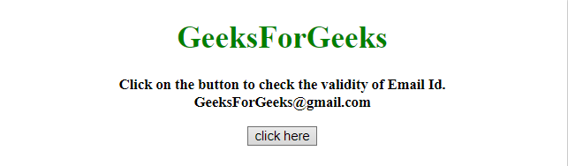
* **After clicking on the button:**  
  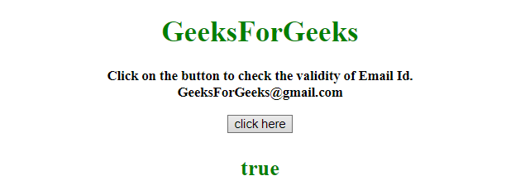

**Approach 2:**

* RegExp – It checks for the pattern like **anything@anything.anything**
* Not like the previous example, RegExp is accepting every character along with special character multiple times.

**Example 2:** This example implements the above approach.

<!DOCTYPE HTML>

<**html**>

<**head**>

    <**title**>

        How to validate email address

        using RegExp in JavaScript ?

    </**title**>

</**head**>

<**body** style = "text-align:center;">

    <**h1** style = "color:green;">

        GeeksForGeeks

    </**h1**>

    <**p** id = "GFG\_UP" style =

            "font-size: 15px; font-weight: bold;">

    </**p**>

    <**button** onclick = "GFG\_Fun()">

        click here

    </**button**>

    <**p** id = "GFG\_DOWN" style =

        "font-size: 24px; font-weight: bold; color: green;">

    </**p**>

    <**script**>

        var up = document.getElementById('GFG\_UP');

        var down = document.getElementById('GFG\_DOWN');

        var email = 'Gee%E^%ksForGeeks@gmail.com';

        up.innerHTML = "Click on the button to check the "

                +   "validity of Email Id.<**br**>" + email;

        function isEmail(email) {

            // Regular Expression (Accepts every special

            // character along with @ symbol)

            var regexp = /\S+@\S+\.\S+/;

            // Converting the email to lowercase

            return regexp.test(String(email).toLowerCase());

        }

        function GFG\_Fun() {

            down.innerHTML = isEmail(email);

        }

    </**script**>

</**body**>

</**html**>

**Output:**

* **Before clicking on the button:**  
  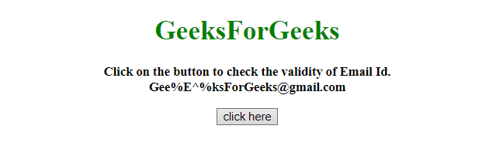
* **After clicking on the button:**  
  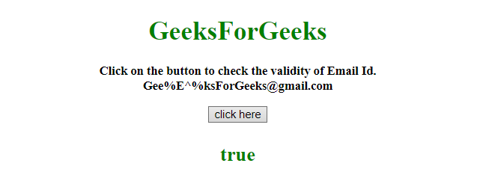

1. [JavaScript Exception Handling](https://www.geeksforgeeks.org/javascript/#javascript-exception-handling)

Exception handling is crucial for ensuring the reliability and stability of JavaScript applications by handling errors effectively.

* 1. [JS Exception Handling](https://www.geeksforgeeks.org/javascript-error-and-exceptional-handling-with-examples/)

An error is an action that is inaccurate or incorrect. There are three types of errors in programming which are discussed below:

* Syntax error
* Logical error
* Runtime error

**Syntax error:** According to computer science, a syntax error is an error in the syntax of a sequence of characters or tokens that is intended to be written in a particular programming language or it is also a compile-time error if the syntax is not correct then it will give an error message.

**Example:**

* HTML

<**script** type="text/javascript">

    // An runtime error here

    window.printme();

</**script**>

As the syntax is not correct of the JavaScript it will affect only the thread that is under this JavaScript and the rest of the code in other threads gets executed as nothing in them depends on the code containing the error.

**Logical error:** It is the most difficult error to be traced as it is the error on the logical part of the coding or logical error is a bug in a program that causes it to operate incorrectly and terminate abnormally (or crash).

**Runtime Error:** A runtime error is an error that occurs during the running of the program, also known as the exception. In the example that is given below the syntax is correct, but at runtime, it is trying to call a method that does not exist.

**Example:**

* Javascript

    // An runtime error here

    window.printme();

As in runtime errors, there are exceptions and these exceptions can be handled with the help of the try-and-catch method

**try-catch method**

JavaScript uses the try catch and finally to handle the exception and it also uses the throw operator to handle the exception. try have the main code to run and in the catch block if any error is thrown by try block will be caught and the catch block will execute. Finally block will always occur even if an error is thrown

**Note:-** We can create our own errors using throw but error thrown can only be

String, Number, Boolean, or an object

**Syntax:**

* Javascript

**try** {

            // Here the main Code runs

            [**break**;]

    }

**catch** ( exception e ){

        // The code will run when there is an exception

        [**break**;]

    }

**Example 1:**

* HTML

<!DOCTYPE html>

<**html** lang="en">

<**head**>

    <**title**>Document</**title**>

</**head**>

<**body**>

    <**p** id="gfg">

        Click the GfG button to see the result:

    </**p**>

    <**form**>

        <**input** type="button" value="Click GfG" onclick="First();" />

    </**form**>

    <**script** type="text/javascript">

        function First() {

            let a = 123

            let b = 145

            try {

                document.getElementById('gfg').innerHTML +=

                    '<**br**> Division of ' + a + ' by ' + b + ' = ' + a / b

            }

            catch (e) {

                alert(e.description)

            }

        }

    </**script**>

</**body**>

</**html**>

**Output:**



**Example 2:**  In this example, use the finally method which will always execute unconditionally after the try/catch.

* HTML

<!DOCTYPE html>

<**html** lang="en">

<**head**>

    <**title**>Document</**title**>

</**head**>

<**body**>

    <**script**>

        function First() {

            let a = 123;

            let b = 0;

            try {

                if (b == 0) {

                    throw "Do not divide by zero";

                }

            }

            catch (e) {

                document.getElementById('gfg').innerHTML +=

                      "<**br**>" + e + "<**br**>";

            }

            finally {

                document.getElementById('gfg').innerHTML +=

                      "  Finally block will always execute!";

            }

        }

    </**script**>

    <**p** id="gfg">Click the GfG button to see the result:</**p**>

    <**form**>

        <**input** type="button" value="Click GfG" onclick="First()" />

    </**form**>

</**body**>

</**html**>

**Output:**



* 1. [JS try-catch Statement](https://www.geeksforgeeks.org/javascript-errors-throw-and-try-to-catch/)

In JavaScript, errors can be thrown using the throw statement to indicate an exceptional condition. The try block is used to wrap code that might throw an error, and the catch block handles the error, preventing the program from crashing and allowing graceful error management.

But all errors can be solved and to do so we use five statements that will now be explained.

* The **try** statement lets you test a block of code to check for errors.
* The **catch** statement lets you handle the error if any are present.
* The **throw** statement lets you make your own errors.
* The **finally** statement lets you execute code after try and catch.    
  The **finally**block runs regardless of the result of the try-catch block.

Below are examples, that illustrate the JavaScript Errors Throw and Try to Catch:

**Example 1:**

JavaScript

**try** {

dadalert("Welcome Fellow Geek!");

}

**catch** (err) {

console.log(err);

}

**Output:** In the above code, we make use of ‘dadalert’ which is not a reserved keyword and is neither defined hence we get the error.  **Example 2:**

JavaScript

**function** geekFunc() {

**let** a = 10;

**try** {

console.log("Value of variable a is : " + a);

}

**catch** (e) {

console.log("Error: " + e.description);

}

}

geekFunc();

**Output:** In the above code, our catch block will not run as there’s no error in the above code and hence we get the output ‘Value of variable a is: 10’.



**Try and Catch Block**

The **try** statement allows you to check whether a specific block of code contains an error or not. The **catch** statement allows you to display the error if any are found in the try block.

try {  
 Try Block to check for errors.  
}  
catch(err) {  
 Catch Block to display errors.  
}

**Example:** In this example, we will see the usage of try-catch block in javascript.

JavaScript

**try** {

dadalert("Welcome Fellow Geek!");

}

**catch** (err) {

console.log(err);

}

**Output:**



**Javascript Throws Block The `*throw*` Statement**

When any error occurs, JavaScript will stop and generate an error message. The throw statement lets you create your own custom error. Technically you can throw your custom exception (throw an error). The exception can be a JavaScript Number, String, Boolean, or Object. By using throw together with try and catch, you can easily control the program flow and generate custom error messages.

**Example:** In this example, we will see how a throw statement is used to throw an error in javascript.

JavaScript

**try** {

**throw** **new** **Error**('Yeah... Sorry');

}

**catch** (e) {

console.log(e);

}

**Output:**



**The finally Block**

The finally Statement runs unconditionally after the execution of the try/catch block. Its syntax is

JavaScript

**try** {

Try Block to check **for** errors.

}

**catch**(err) {

Catch Block to display errors.

}

**finally** {

Finally Block executes regardless **of** the **try** / catch result.

}

**Example:**In this example, we will learn about the final statement of Javascript.

JavaScript

**try** {

console.log('try');

} **catch** (e) {

console.log('catch');

} **finally** {

console.log('finally');

}

**Output:** The Finally Block can also override the message of the catch block so be careful while using it.

* 1. [JS Promises](https://www.geeksforgeeks.org/javascript-promises/)
  2. [JS async/await](https://www.geeksforgeeks.org/async-await-function-in-javascript/)

1. [JavaScript Global Objects](https://www.geeksforgeeks.org/javascript/#javascript-global-objects)
   1. [JS encodeURI(), encodeURIComponent() and decodeURIComponent() Method](https://www.geeksforgeeks.org/javascript-encodeuri-decodeuri-and-its-components-functions/)
   2. [JS eval() Method](https://www.geeksforgeeks.org/javascript-eval-function/)

The **eval() method** in JavaScript evaluates or executes its argument. If the argument is an expression, it evaluates the expression. If it’s one or more JavaScript statements, eval() executes the statements.

***Note:***

***eval()****: This function was used to evaluate a string as JavaScript code, but it is now considered deprecated because it can introduce security vulnerabilities and is often unnecessary.*

**Example**

Input : eval(new String('2 + 2'));

Output: returns a String object containing "2 + 2"

Input : eval(new String('4 + 4'));

Output: returns a String object containing "4 + 4"

**eval() Function Syntax**

eval(string);

**eval() Function Parameters**

This function accepts a single parameter as mentioned above and described below:

* **String:** A string representing a [JavaScript expression](https://www.geeksforgeeks.org/javascript-expressions-complete-reference/), statement, or sequence of statements. The expression can include variables and properties of existing objects.

**Return Value of eval() Function**

The completion value of evaluating the given code is returned by using **eval()**. If the completion value is empty, **undefined** is returned.

**Direct and indirect eval**

**Direct eval**: It’s called by the eval identifier directly.

**Indirect eval**: It’s invoked via another property, such as window.eval() or when using setTimeout, setInterval, or the Function constructor.

**Direct and indirect eval Example:**

Here’s an example demonstrating both direct and indirect eval() functions in JavaScript:

* Javascript

// Direct eval

let directEvalResult = eval("2 + 2");

console.log("Direct eval result:", directEvalResult);

// Indirect eval

let indirectEval = "eval";

let indirectEvalResult = window[indirectEval]("3 + 3");

console.log("Indirect eval result:", indirectEvalResult);

**Output:**

Direct eval result: 4

Indirect eval result: 6

**Explanation:**

In the direct eval() call, the expression "2 + 2" is directly evaluated, resulting in 4. In the indirect eval(), the expression "3 + 3" is evaluated after accessing the eval function through the window object, also resulting in 6.

**eval() Function Example:**

Below is an example of eval().

* Javascript

// JavaScript to illustrate eval() function

**function** func() {

    // Original string

    let a = 4;

    let b = 4;

    // Finding the multiplication

    let value = eval(**new** String(a \* b));

    console.log(value);

}

// Driver code

func();

**Output**

[String: '16']

**Explanation:**

The `func` function defines variables `a` and `b`, both set to `4`. It then uses `eval()` to evaluate the multiplication expression of `a` and `b`, converting the result to a string. The output will be `16`, as `4 \* 4 = 16`. This demonstrates using `eval()` for dynamic code execution.

**eval() Function Example:**

Below is an example of eval().

* Javascript

// JavaScript to illustrate eval() function

**function** func() {

    // Original string

    let a = 2;

    let b = 2;

    // Finding the sum

    let value = eval(**new** String(a + b));

    console.log(value);

}

// Driver Code

func();

**Output**

[String: '4']

**Explanation:**

The func function defines variables a and b, both set to 2. It then uses eval() to evaluate the summation expression of a and b, converting the result to a string. The output will be 4, as 2 + 2 = 4. This demonstrates using eval() for dynamic code execution.

**eval() Function Example:**

Below is an example of eval().

* Javascript

// JavaScript to illustrate eval() function

**function** func() {

    // Original string

    let a

    let b

    // Finding the Summation

    let value = eval(**new** String(a + b));

    console.log(value);

}

// Driver code

func();

**Output**

[String: 'NaN']

**Explanation:**

The func function defines two variables a and b. Then, it uses eval() to evaluate the summation expression of a and b. However, there’s a mistake as a and b are undefined, resulting in a runtime error. This code illustrates using eval() for dynamic code execution.

**DO NOT USE eval()**

1. **Security Risk:** Evaluated code poses security vulnerabilities.
2. **Performance Impact:** Slows down execution due to runtime parsing.
3. **Readability:** Decreases code readability and maintainability.
4. **Strict Mode Compatibility:** Not allowed in strict mode.
5. **Alternatives:** Safer alternatives are available for dynamic code execution.
   1. [JS globalThis Property](https://www.geeksforgeeks.org/javascript-this-keyword/)
   2. [JS Global property](https://www.geeksforgeeks.org/javascript-global-variables/)
   3. [JS Infinity](https://www.geeksforgeeks.org/javascript-infinity-property/)
   4. [JS Undefined vs Undeclared](https://www.geeksforgeeks.org/differences-between-undeclared-and-undefined-variables-in-javascript/)

**What are Variables?**

In a programming language, the variables are used to store some kind of information & every programming language contains different kinds of procedures and techniques to create these variables and access them. In JavaScript, there exists the execution context, which is nothing but a little separate section in which the variables get memory and the code is executed.

The execution of the program takes place in two-phase:

* **Memory Allocation Phase:** All variables declared inside the program get memory in the heap area, and the JavaScript engine assigns the value undefined to all of these variables.
* **Thread Execution Phase:**The code written inside the JavaScript file is being executed line by line. Also, when the js encounter the line of code in which we are assigning some kind of value to a variable, then the value, which is undefined of variable, is being replaced by the actual value which was assigned by the programmer.

**Now, we will understand how the variables get allocated in the memory & how the JavaScript executes these variables if it is encountered in the line of code.**

**1. Undefined variable:**

The variables which are written in the code but haven’t been assigned any value yet are called undefined.

**Syntax:**

let x;  
console.log(x);

For instance, in this case, the variable x will remain undefined till the assignment.

**Explanation:**The execution of the program will be as follows:

* **In the memory Allocation phase:**JavaScript will scan all the variables and functions in the code. Here, we have only variable x in the entire code. So, it will get space in memory, and undefined will be assigned to each variable(only x in our case).
* **In the code execution phase:** In the first line of code, *console.log(x)* is written. Now JavaScript will search for this variable in memory and it will be found, but as the JavaScript engine hasn’t encountered any line on which the programmer is assigning some value to x. Hence undefined will be printed. Later, in the next line, (x=5), the undefined will be replaced by 5.

**Example:**

JavaScript

<script>

**let** x;

console.log(x);

x = 5; *// Now, variable is no longer undefined.*

console.log(x);

</script>

**Output:**



**2. Undeclared variable:**

The variables which don’t exist in the memory heap area, ie., not written inside the code, are called undeclared.

**Syntax:**

console.log(y); // y will be considered as undeclared

For instance, in this case, the variable y is not declared in the code ie., in the memory allocation phase, no space was allocated which has been named y. So it will be considered as undeclared.

**Example:**

JavaScript

<script>

**let** x;

console.log(y); *// y will be undeclared*

x = x\*2;

</script>

**Explanation:**The execution of the program will be as follows:

* **In the memory allocation phase:**All variables and functions (only x in our case) will get space in memory.
* **In the thread of execution:** Javascript will encounter the first line of *console.log(y).* Now, it will search y in memory space but y will not be found. Hence, it will be considered undeclared.

**Output:**



**Difference between undeclared and undefined variables:**

|  |  |  |
| --- | --- | --- |
| **S.No.** | **Undeclared** | **Undefined** |
| **1.** | These are the variables that do not exist in the memory heap. | These variables are the ones that do exist in memory, but nothing is being assigned to them explicitly by the programmer. |
| **2.** | The variables are considered to be undeclared because of programmer does not write them with var, let, or const. | The variables are considered to be undefined because it is assigned by JavaScript to them. |
| **3.** | If we try to access them in the code execution phase, then JavaScript will throw a Reference error. | If we try to access these variables, we’ll get the undefined as value. |

**Practical Illustration:**

In the memory allocation phase, the variable *a*will get memory, and javascript will assign undefined to it. You can see the situation in the first breakpoint where we have stopped our program at the first line of code.

Video Player

00:00

00:10

After then, the code execution phase will start with the first line of the *console.log*, undefined will be printed. Later the value of a will be replaced by 5, you can observe this on the second breakpoint. And finally, when the code will try to access some kind of variable(*b*in our case) that doesn’t exist in memory it will throw a Reference error because it was undeclared by the programmer.

HTML

<**script**>

console.log(a); *// a will be undefined here*

**var** a = 5;

console.log(a); *// a will be 5 here*

console.log(b); *// b will be undeclared here*

</**script**>

**Output:**

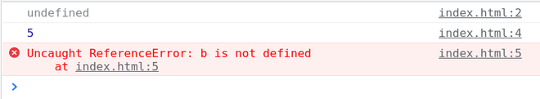

1. [JavaScript Miscellaneous](https://www.geeksforgeeks.org/javascript/#javascript-miscellaneous)
   1. [JS this Keyword](https://www.geeksforgeeks.org/this-in-javascript/)

**What is this ?**

In JavaScript, this keyword refers to the current object in context. Its value depends on how it’s used: in methods, it refers to the object; in global scope, it refers to the global object.

**Note:** this is not a variable. It is a keyword. You cannot change the value of this.

**The this keyword refers to different objects depending on how it is used**

* When used within a method of an object, this points to that object.
* When used by itself, this points to the global object.
* Within a function, this typically points to the global object.
* In a function under strict mode, this becomes undefined.
* During an event, this points to the element that triggered the event.
* Methods such as call(), apply(), and bind() can reassign this to any desired object.

**JavaScript this Keyword Examples**

**1. Using this in a Method**

In the context of an object method in JavaScript, the this keyword refers to the object itself, allowing access to its properties and methods within the method’s scope. It facilitates interaction with the object’s data and behavior, providing a way to access and manipulate its state.

**Example:** In this example we defines a person object with name, age, and a greet method. When person.greet() is called, it prints a greeting message with the person’s name and age.

JavaScript

**const** person = {

name: 'John',

age: 30,

greet() {

console.log('Hello, my name is ' +

**this**.name + ' and I am '

+ **this**.age +

' years old.');

}

};

person.greet();

**Output**

Hello, my name is John and I am 30 years old.

**2. Using this in a Function**

In a JavaScript function, the behavior of the this keyword varies depending on how the function is invoked.

**Syntax:**

function exampleFunction() {  
 console.log(this); // Refers to the current execution context  
}

**Example:**In this example we defines a greet function and two objects, person and anotherPerson. It then calls greet, person.sayHello, and greet with anotherPerson context using call.

JavaScript

**function** greet() {

console.log('Hello, my name is ' + **this**.name);

}

**const** person = {

name: 'John',

sayHello: greet

};

**const** anotherPerson = {

name: 'Alice'

};

greet();

person.sayHello();

greet.call(anotherPerson);

**Output**

Hello, my name is undefined

Hello, my name is John

Hello, my name is Alice

**3. Using this alone**

When used alone in JavaScript, outside of any specific context, the behavior of the this keyword depends on whether the code is running in strict mode or not.

**Example:**In non-strict mode, this refers to the global object. In strict mode, this is undefined outside functions or objects,

JavaScript

console.log(**this**);

**Output**

{}

**4. Implicit Binding**

When we call a function as a method of the object **this**keyword refers to the calling object

**Example:**In this example, we defines a person object with name, age, and a greet method. When person.greet() is called, it returns and prints a greeting message with the person’s name and age.

JavaScript

**const** person = {

name: "ram",

age: 22,

greet: **function** () {

**return** `Hello **${this**.name**}**, you are **${this**.age**}** years old`

}

}

console.log(person.greet());

**Output**

Hello ram, you are 22 years old

**Output:**Here **this**keyword is referring to the person object so it can access name and age values.

**5. Explicit Binding**

When we explicitly bind this keyword using the [call()](https://www.geeksforgeeks.org/explain-call-and-apply-methods-in-javascript/), [bind()](https://www.geeksforgeeks.org/javascript-function-prototype-bind-method/), or [apply()](https://www.geeksforgeeks.org/explain-call-and-apply-methods-in-javascript/) method then this keyword default reference is changed to the object called using the above-specified methods.

**Example:**In this example, we will see the explicit binding of this keyword.

JavaScript

**function** ageVerify(){

**if**(**this**.age> 18){

console.log("Yes you can drive");

} **else** {

console.log("No you cannot drive");

}

}

**const** per1 = {age: 21};

**const** per2 = {age: 16};

ageVerify.call(per1);

ageVerify.call(per2);

**Output**

Yes you can drive

No you cannot drive

**6. Default Binding**

When this keyword is used in global scope this is set to window object.

**Example:**This example shows the Default binding.

JavaScript

**const** age = 22;

**function** verifyAge (){

**return** **this**.age;

}

console.log(verifyAge());

**Output**

undefined

**7. Arrow Function Binding**

When this is used in the arrow function then this has lexical scope so without the function keyword this is unable to refer to the object in the outer scope.

**Example:**This example shows the arrow function binding.

JavaScript

**const** person = {

name: "ram",

age: 22,

greet : () =>{

**return** `Hello , you are **${this**.age**}** years old`

}

}

console.log(person.greet());

**Output**

Hello , you are undefined years old

**The precedence order of this keyword is**

* [**JavaScript bind() Method**](https://www.geeksforgeeks.org/javascript-function-prototype-bind-method/)
* [**JavaScript call() and apply() Method**](https://www.geeksforgeeks.org/explain-call-and-apply-methods-in-javascript/)
* [**JavaScript Object Method**](https://www.geeksforgeeks.org/javascript-object-methods/)
* [**JavaScript Global Scope**](https://www.geeksforgeeks.org/understanding-variable-scopes-in-javascript/#:~:text=of%20variable%20scopes%3A-,Global%20Scope,-%3A%20Variables%20declared)

The this keyword in JavaScript dynamically refers to the object executing a function or method. Its context varies: in methods, it points to the object itself; in the global scope, to the global object (like window); in strict mode, to undefined; and can be reassigned with call(), apply(), or bind().

**JavaScript this Keyword-FAQs**

**How does this behave in global scope vs. function scope?**

*In the global scope, this refers to the global object (e.g., window in browsers). Inside a function, this also refers to the global object, unless in strict mode where it is undefined.*

**How does this work inside an object method?**

*Inside an object method, this refers to the object that owns the method.*

**What happens to this in event handlers?**

*In an event handler, this refers to the DOM element that received the event.*

**What is the value of this in an arrow function?**

*In an arrow function, this is lexically bound, meaning it inherits this from the surrounding scope where the arrow function was defined.*

**How does this behave in a constructor function?**

*In a constructor function, this refers to the new object being created by the constructor.*

* 1. [JS Strict Mode](https://www.geeksforgeeks.org/strict-mode-javascript/)

The **“use strict”**directive, introduced in ECMAScript version 5, is a literal expression rather than a statement and is ignored by earlier JavaScript versions. Its purpose is to enforce strict mode, ensuring the code is executed with stricter parsing and error handling. In strict mode, you cannot use undeclared variables, among other enforced rules. Using “use strict”; eliminates silent errors, enhances performance, disables unsafe features, and makes code more secure and easier to debug.

**The benefits of Using strict**

Strict mode makes several changes to normal JavaScript semantics.

* **Eliminates Silent Errors:** Converts JavaScript silent errors into throw errors, making debugging easier.
* **Optimization:** Helps JavaScript engines perform optimizations, potentially making strict mode code run faster than non-strict code.
* **Future-Proofing:**Prohibits syntax likely to be defined in future ECMAScript versions.
* **Prevents Unsafe Actions:**Throws errors when relatively “unsafe” actions are taken, such as accessing the global object.
* **Disables Confusing Features:**Disables features that are confusing or poorly designed.
* **Security:** Makes it easier to write “secure” JavaScript

**How to Use Strict Mode**

Strict mode can be used in two ways, remember strict mode doesn’t work with block statements enclosed in {} braces.

* **Global Scope:**Applies to the entire script.
* **Function Scope:** Applies to individual functions.

**Using Strict Mode for the Entire Script**

To invoke strict mode for an entire script, put the exact statement “use strict”; (or ‘use strict’;) before any other statements.

// Whole-script strict mode syntax

'use strict';

let v = "strict mode script!";

Enable strict mode on a function-by-function basis to avoid issues when concatenating strict and non-strict scripts, ensuring compatibility and preventing unintended strict mode application in the entire script.

**Using Strict Mode for a Function**

Likewise, to invoke strict mode for a function, put the exact statement “use strict”; (or ‘use strict’;) in the function’s body before any other statements.

function strict() {

// Function-level strict mode syntax

'use strict';

function nested() { return 'Javascript on GeeksforGeeks'; }

return "strict mode function! " + nested();

}

function notStrict() { return "non strict function"; }

**Examples of using Strict mode**

**Example: Mistyping a Variable Name**

In strict mode, assigning a value (3.14) to an undeclared variable (x) without prior declaration throws an error.

JavaScript

*// Using a variable, without declaring it, is not allowed:*

'use strict';

x = 3.14; *// will throw an error*

**Output:**

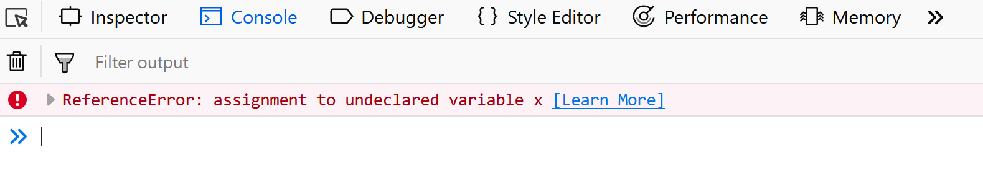

**Example: Using a Variable Without Declaring It**

In strict mode, assigning a value to an undeclared variable (x) as an object ({p1:10, p2:20}) without prior declaration throws an error.

JavaScript

*// Objects are variables too.*

*// Using an object, without declaring it, is not allowed:*

'use strict';

*// Will throw an error*

x = { p1: 10, p2: 20 };

**Output:**



**Example: Deleting a Variable or Object**

In strict mode, attempting to delete a variable (delete x;) or function (delete x; where x is a function) declaration throws an error.

JavaScript

'use strict';

**let** x = 3.14;

*// Deleting a function is also not allowed*

'use strict';

**function** x(p1, p2) {};

*// Will throw an error*

**delete** x;

**Output:**

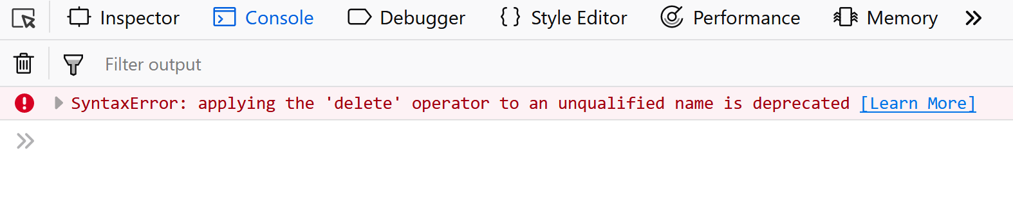

**Example: Duplicating a Parameter Name**

Using ‘use strict’;, defining a function with duplicate parameter names (p1, p1) causes an error due to parameter name duplication being disallowed in strict mode functions

JavaScript

'use strict';

*// Will throw an error*

**function** x(p1, p1) {};

**Output:**

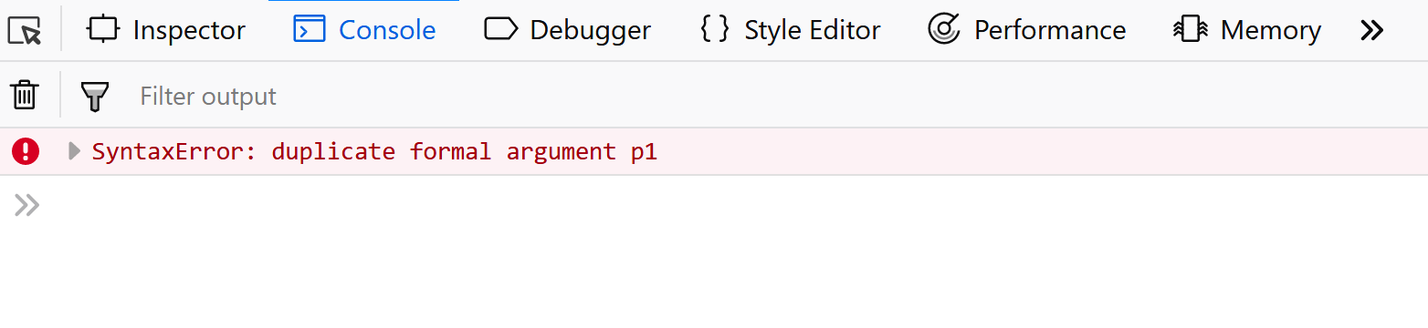

**Example: Octal Numeric Literals**

Here we Using ‘use strict’;, 010 is interpreted as an invalid octal literal because octal literals (starting with 0) are not allowed in strict mode, causing an error when assigning to variable x.

JavaScript

'use strict';

*// Will throw an error*

**let** x = 010;

**Output:**

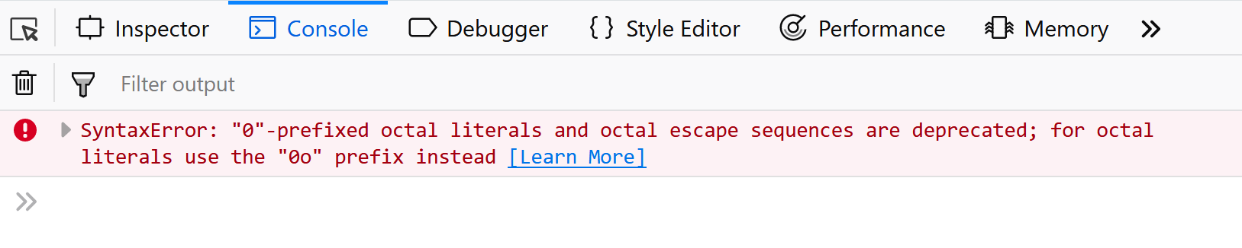

**Example: Escape Characters**

Here we Using ‘use strict’;, \010 is interpreted as an invalid octal literal, causing an error when trying to assign it to variable x.

JavaScript

'use strict';

*// Will throw an error*

**let** x = \010;

**Output:**

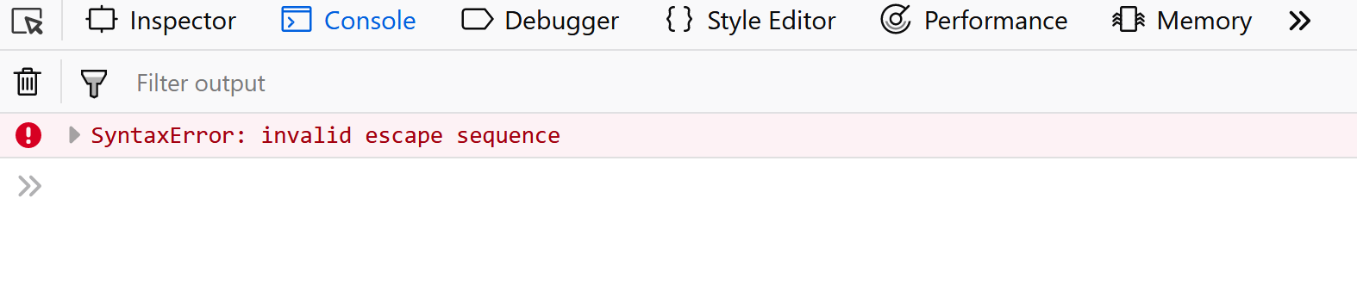

**Example: Writing to a Read-Only Property**

Using ‘use strict’; and defining obj.x as non-writable (writable:false) throws an error when attempting to assign 3.14 to obj.x, violating its non-writable property definition.

JavaScript

'use strict';

**let** obj = {};

Object.defineProperty(obj, "x", {value:0, writable:**false**});

*// Will throw an error*

obj.x = 3.14;

**Output:**

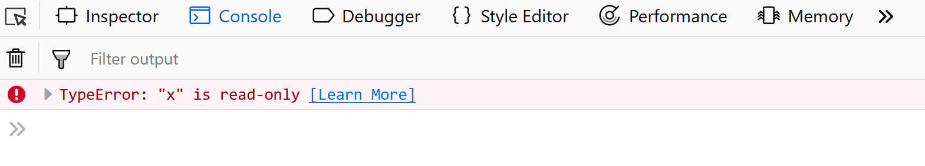

**Example: Writing to a Get-Only Property**

Using ‘use strict’; disallows assigning values to read-only properties like obj.x with a getter, causing an error in the code trying to assign 3.14 to obj.x.

JavaScript

'use strict';

**let** obj = {get x() {**return** 0} };

*// Will throw an error*

obj.x = 3.14;

**Output:**

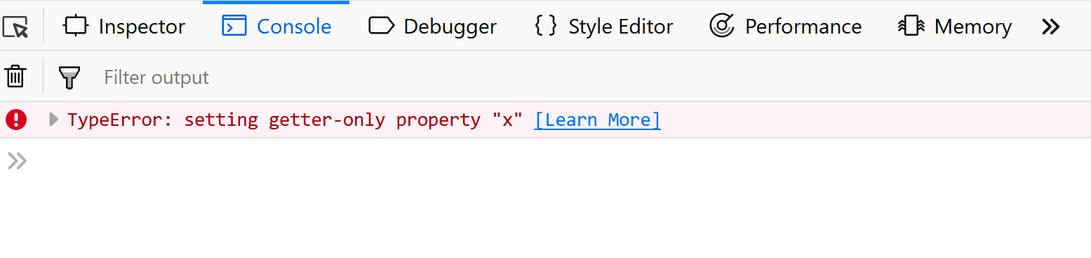

**Example: Deleting an Undeletable Property**

Using ‘use strict’; prohibits deleting properties of built-in objects like Object.prototype, which causes an error in the code snippet attempting to delete Object.prototype.

JavaScript

'use strict';

*// Will throw an error*

**delete** Object.prototype;

**Output:**

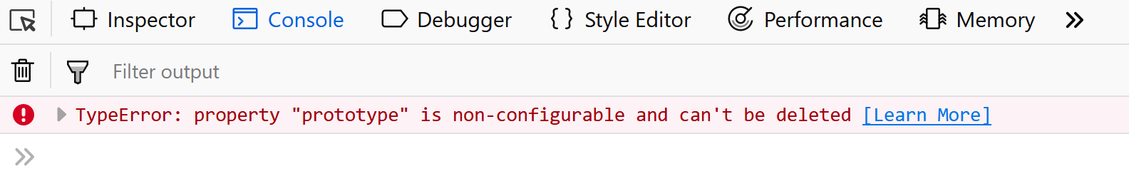

**Example: Using “eval” as a Variable**

Using ‘use strict’; prevents using eval as a variable name, causing an error. The code snippet demonstrates this by attempting to assign a value to eval.

JavaScript

'use strict';

*// Will throw an error*

**let** eval = 3.14;

**Output:**

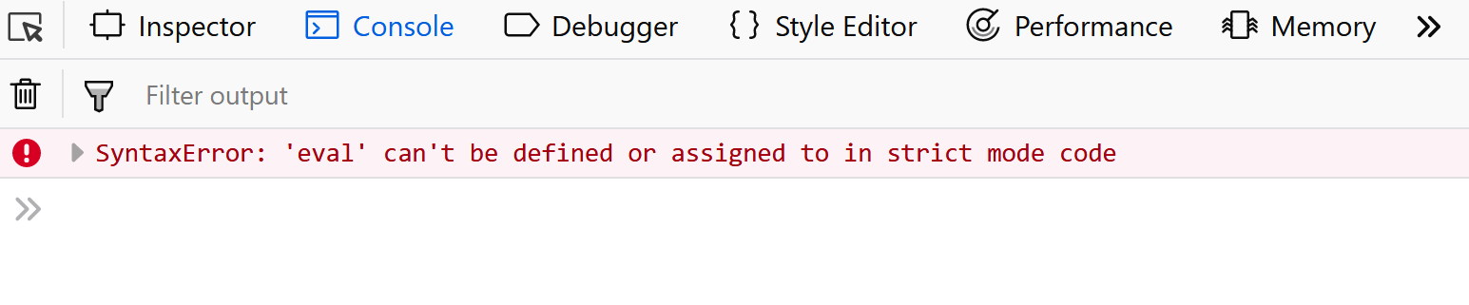

**Example: Using “arguments” as a Variable**

Using ‘use strict’; disallows using arguments as a variable name, causing an error. The code snippet demonstrates this by attempting to assign a value to arguments.

JavaScript

'use strict';

*// Will throw an error*

**let** arguments = 3.14;

**Output:**

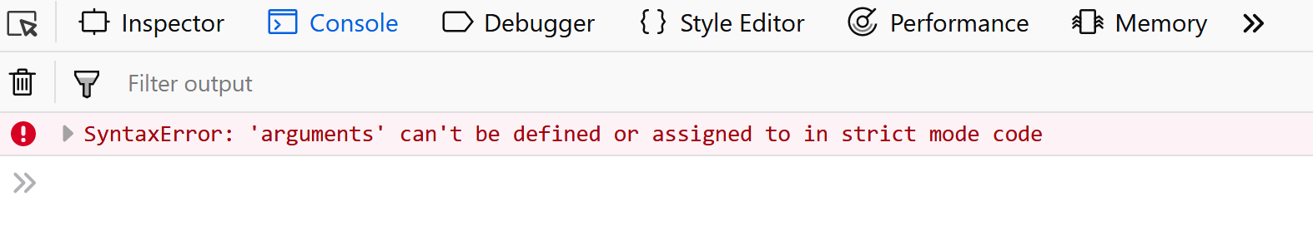

**Example: The with Statement**

Using ‘use strict’; prevents with statements, causing an error if used. The code snippet demonstrates this by attempting a with statement, which throws an error.

JavaScript

'use strict';

*// Will throw an error*

**with** (Math){x = cos(2)};

**Output:**

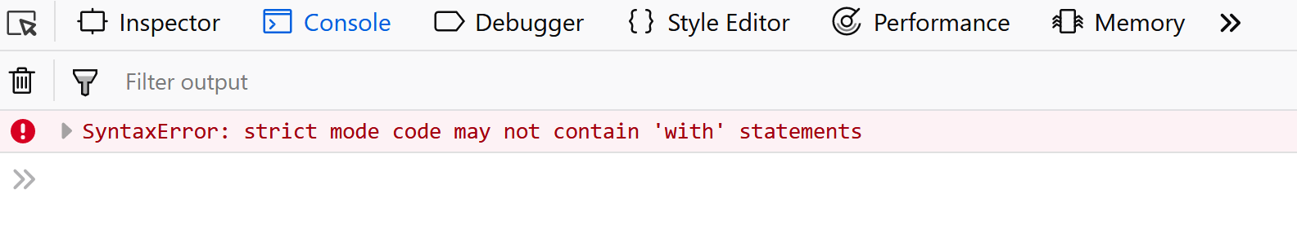

**Note:** In function calls like f(), this value was the global object. In strict mode, it is now undefined. In normal JavaScript, a developer will not receive any error feedback assigning values to non-writable properties.

**Conclusion**

Strict mode in JavaScript, introduced in ECMAScript version 5, enforces stricter parsing and error handling. It eliminates silent errors, enhances performance, disables unsafe features, and future-proofs code. Using “use strict” ensures more secure, optimized, and debuggable JavaScript code.

* 1. [JS setTimeOut() and setInterval() Method](https://www.geeksforgeeks.org/java-script-settimeout-setinterval-method/)

JavaScript **SetTimeout**and **SetInterval**are the only native function in JavaScript that is used to run code asynchronously, it means allowing the function to be executed immediately, there is no need to wait for the current execution completion, it will be for further execution.

**JavaScript setTimeout() Method**

This method executes a function, after waiting a specified number of milliseconds.

**Syntax:**

window.setTimeout(function, milliseconds);

**Parameter:**

* **function:**thefirst parameter is a function to be executed
* **milliseconds:** which indicates the number of milliseconds before the execution takes place.

**Example:** If, we want an alert box to pop up, 2 seconds after the user presses the click me button.

* HTML

<!DOCTYPE html>

<**html** lang="en">

<**head**>

    <**meta** charset="UTF-8">

    <**meta** name="viewport">

    <**title**>Document</**title**>

</**head**>

<**body**>

    <**button** onclick="setTimeout(gfg, 2000);">

        Press me

    </**button**>

    <**script**>

        function gfg() {

            alert('Welcome to GeeksforGeeks');

        }

    </**script**>

</**body**>

</**html**>

**Output:** As soon as the user presses the “press me” button, after a pause of 2 seconds this message alert box will pop up.



We can even stop the execution of the **setTimeout()** function by using a method called as **[clearTimeout()](https://www.geeksforgeeks.org/javascript-cleartimeout-clearinterval-method/)**.

**Syntax:**

window.clearTimeout(value);

**Parameter:**

* **value:**The function whose execution is to be stopped.

The **clearTimeout()**method should only be used if the function has not been executed. Let us see an example below

**Example:**In this example, we will use a **setTimeout()** function and stop its execution using the **clearTimeout()** function before the execution of the **setTimeout()**.

* HTML

<!DOCTYPE html>

<**html** lang="en">

<**head**>

    <**meta** charset="UTF-8">

    <**meta** name="viewport">

    <**title**>Document</**title**>

</**head**>

<**body**>

    <**p**>Press the stop button

        before the alert is shown</**p**>

    <**button** onclick="val = setTimeout(gfg, 2000);">

        Press me

    </**button**>

    <**button** onclick="clearTimeout(val);">

        Stop Execution</**button**>

    <**script**>

        function gfg() {

            alert('Welcome to GeeksforGeeks');

        }

    </**script**>

</**body**>

</**html**>

**Output:**Here if we click the stop execution button before the alert is shown, the execution of the alert is stopped.



**JavaScript setInterval() Method**

The setInterval() method repeats a given function at every given time interval.

**Syntax:**

window.setInterval(function, milliseconds);

**Parameter:** There are two parameters that accepted by this method

* **function:** the first parameter is the function to be executed
* **milliseconds:**indicates the length of the time interval between each execution.

**Example**: In this example, we are using setInterval() method.

* HTML

<!DOCTYPE html>

<**html** lang="en">

<**head**>

    <**meta** charset="UTF-8">

    <**meta** name="viewport">

    <**title**>Document</**title**>

</**head**>

<**body**>

    <**p** id="GFG"></**p**>

    <**script**>

        let myVar = setInterval(myTimer, 1000);

        function myTimer() {

            document.getElementById("GFG")

                .innerHTML += "<**p**>Hi</**p**>";

        }

    </**script**>

</**body**>

</**html**>

**Output:**After every second a new “hi” message will be displayed.



Since the **setInterval()** method executes the function infinitely hence there is a method called as **[clearInterval()](https://www.geeksforgeeks.org/javascript-cleartimeout-clearinterval-method/)** to stop the execution of the **setInterval()**.

**Syntax:**

window.clearInterval(value);

**Parameter:**

* **value:**The function whose execution is to be stopped.

**Example:**In this example, we will first execute a **setInterval()** function and then stop its execution by using the **clearInterval()**function.

* HTML

<!DOCTYPE html>

<**html** lang="en">

<**head**>

    <**meta** charset="UTF-8">

    <**meta** name="viewport">

    <**title**>Document</**title**>

</**head**>

<**body**>

    <**p** id="GFG"></**p**>

    <**button** onclick="clearInterval(myVar)">

        Stop Execution</**button**>

    <**script**>

        let myVar = setInterval(myTimer, 1000);

        function myTimer() {

            document.getElementById("GFG")

                .innerHTML += "<**p**>Hi</**p**>";

        }

    </**script**>

</**body**>

</**html**>

**Output:**When the stop button is clicked the execution is stopped.



* 1. [JS typeOf Operator](https://www.geeksforgeeks.org/javascript-typeof-operator/)

The**JavaScript typeof operator** returns the data type of a variable or expression. It’s a unary operator placed before its operand and returns a string indicating the data type, such as “number”, “string”, “boolean”, “object”, “undefined”, “function”, or “symbol”. It’s commonly used to dynamically determine the type of data being processed, facilitating conditional logic and type checking in JavaScript programs.

**Syntax:**

typeof operand

// OR

typeof (operand)

**Primitive Data Types**

Primitive data types in JavaScript are basic data types that represent single values. They include:

|  |  |
| --- | --- |
| **Data Type** | **Description** |
| Number | Represents numeric values like integers and floating-point numbers. |
| String | Represents textual data enclosed within single quotes (”) or double quotes (“”). |
| Boolean | Represents true or false values. |
| Undefined | Represents a variable that has been declared but has not been assigned a value. |
| Null | Represents the intentional absence of any object value. |
| Symbol | Represents a unique and immutable data type used as the key of an object’s property. |
| BigInt | Represents large integers beyond the limit of the Number type. |

**Example 1:**Below example show the results of typeof operator for premitive data types.

JavaScript

*// Define variables with different primitive data types*

**const** num = 10;

**const** str = "Hello";

**const** bool = **true**;

**const** undef = **undefined**;

**const** nul = **null**;

**const** sym = Symbol("symbol");

**const** bigInt = 9007199254740991n;

*// Use typeof operator to determine the data type*

console.log(**typeof** num); *// Output: "number"*

console.log(**typeof** str); *// Output: "string"*

console.log(**typeof** bool); *// Output: "boolean"*

console.log(**typeof** undef); *// Output: "undefined"*

console.log(**typeof** nul); *// Output: "object" (typeof null is an oddity,*

*// it returns "object")*

console.log(**typeof** sym); *// Output: "symbol"*

console.log(**typeof** bigInt);*// Output: "bigint"*

**Output**

number

string

boolean

undefined

object

symbol

bigint

**Example 2:** This example uses ‘===’ (strict equality comparison operator) which compare value and type both and then return true or false.

javascript

*//Number*

console.log(**typeof** 25 === 'number');

console.log(**typeof** 3.14 === 'number');

console.log(**typeof** (69) === 'number');

*// log base 10*

console.log(**typeof** Math.LN10 === 'number');

console.log(**typeof** **Infinity** === 'number');

*// Despite being "Not-A-Number"*

console.log(**typeof** **NaN** === 'number');

*// Wrapping in Number() function*

console.log(**typeof** Number('100') === 'number');

**Explanation:**In the first console.log(), the js starts compiling from left to right and it first calculates the type of 25 which is ‘number’, and then compares it with ‘number’ and then finally returns true or false accordingly.

**Output**

true

true

true

true

true

true

true

**Example 3:**This example compares the function datatype using the typeof operator.

javascript

*// function*

console.log(**typeof** **function** () { } === 'function');

*//classes too are objects*

console.log(**typeof** **class** C { } === 'function');

console.log(**typeof** Math.sin === 'function');

**Output**

true

true

true

* 1. [JS Debugging](https://www.geeksforgeeks.org/debugging-in-javascript/)

**Debugging in JavaScript** refers to the process of identifying and fixing errors or bugs in code. It involves using various tools like browser consoles, debuggers, and logging techniques to analyze runtime behavior, trace program flow, and resolve issues efficiently.

**Table of Content**

* [Using debugger keyword](https://www.geeksforgeeks.org/debugging-in-javascript/#using-debugger-keyword)
* [Use of console.log() method](https://www.geeksforgeeks.org/debugging-in-javascript/#use-of-consolelog-method)

**Using debugger keyword**

The [debugger keyword](https://www.geeksforgeeks.org/what-is-the-use-of-debugger-keyword-in-javascript/) is used in the code to force stop the execution of the code at a breaking point and calls the debugging function. The debugger function is executed if any debugging is needed at all else no action is performed.

**Example:** Let’s see the JavaScript program on debugging:

HTML

<!DOCTYPE html>

<**html** lang="en">

<**head**>

<**title**>Debugging in Javascript</**title**>

</**head**>

<**body**>

<**h4**>

Debugging demonstrations using Debugger keyword

</**h4**>

The solution of 20 \* 5 is:

<**p** id="test"></**p**>

<**p**>

If the debugger is turned on the code stops

execution at the start of the debugger

</**p**>

<**script**>

**const** x = 20;

**const** y = 5;

**const** z = x \* y;

**debugger**;

document.getElementById("test").innerHTML = z;

</**script**>

</**body**>

</**html**>

**Output:**

Video Player

00:00

00:05

Previously implementing debuggers was tough but with time and with the advent of modern browsers, various built-in debuggers came into implementation. As previously mentioned the setting up of breakpoints breaks the line of code and flows the control to another area from where it is called. This can be done in the debugging window of the browser. Also setting up of breakpoints in javascript acts similar to the breakpoints in Java where the execution of the code stops and examination of the values is performed by the browser. One can resume the flow control after the examination is done. The debugging can be turned on or off depending upon the user’s convenience. This all can be done through the “Console” of the debugger menu.

**Use of console.log() method**

Using [console.log(](https://www.geeksforgeeks.org/javascript-console-log-method/)) for debugging in JavaScript involves strategically placing logging statements throughout the code to output variable values, object properties, or custom messages to the console. This helps developers inspect the state of their program and identify potential issues during runtime execution.

**Example:**Let’s see the JavaScript program using console.log().

HTML

<!DOCTYPE html>

<**html** lang="en">

<**head**>

<**title**>Debugging in Javascript</**title**>

</**head**>

<**body**>

<**h3**>

GeeksforGeeks

</**h3**>

<**h4**>Hello Geek</**h4**>

<**p**>

1. To view the result activate debugging of your

browser(preferred the latest) by pressing F12 <**br**>

2. Select "Console" in the debugger menu.

</**p**>

<**script**>

x = "Where do you work?"

y = "I work at GeeksforGeeks"

console.log(x);

console.log(y);

</**script**>

</**body**>

</**html**>

**Output:**

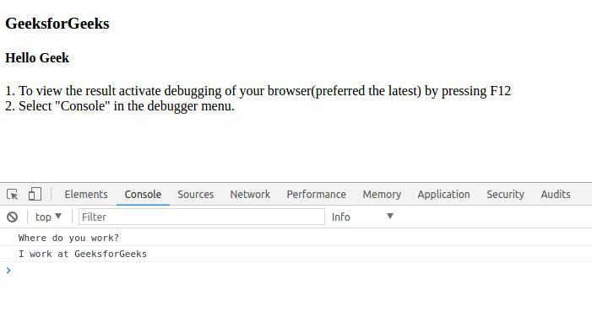

**Setting Break Points:** The console.log() is a good way to debug errors but setting breakpoints is a faster, more efficient, and better method. In this method, Breakpoints are set in code which stops the execution of code at that point so that the values of variables can be examined at that time. Here are some advantages of using Breakpoints over the console.log() method:

* In the console.log() method user has to understand the code and manually put console.log() at points in the code. But in the breakpoints method, we can set breakpoints through the Developer tool anywhere in the code without even knowing it.
* In the console.log() method we have to manually print values of different variables but at a certain breakpoint, all the values of all variables are displayed automatically in the Developers tool. Enter the Developers tool section by pressing F12 key and go to sources. In the source section, select a javascript file and set breakpoints by either selecting from the provided list like DOM breakpoints or Event listener breakpoints which stop the execution of code whenever an event occurs

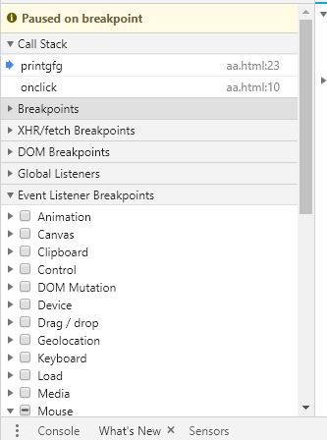  
OR set a breakpoint by simply clicking the line number shown in the code. In the following image, a breakpoint is set at line 23. (The code used is the same as the above example)

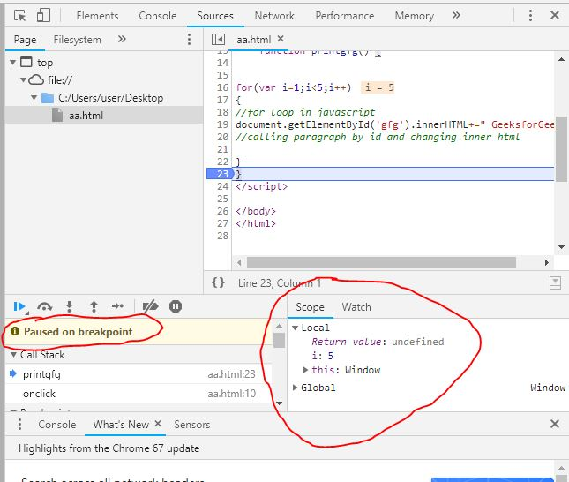

As shown in the image, the code stopped at line 23 and showed all the values of variables in the code at that point in time. Since we can see the value of I was initially 1 and at the breakpoint, it is 5. Hence GeeksForGeeks was printed 5-1=4 times.

* 1. [JS Local Storage](https://www.geeksforgeeks.org/javascript-localstorage/)

**JavaScript localStorage** is a web storage feature that allows you to store key-value pairs in a browser. Data persists even after the browser is closed, providing a method to save and retrieve data across sessions, enhancing user experience by maintaining state and preferences.

**Syntax**

ourStorage = window.localStorage;

The above will return a *storage* object which can be used to access the current origin’s local storage space.

**Properties and Methods of localStorage**

|  |  |
| --- | --- |
| **Method** | **Description** |
| setItem(key, value) | Stores key/value pair |
| getItem(key) | Returns the value in front of the key |
| key(index) | Gets the key at a given index |
| length | Returns the number of stored items (data) |
| removeItem(key) | Removes the given key with its value |
| clear() | Deletes everything from the storage |

**Key Features of localStorage**

* **Origin-Bound Storage:**Data is stored per domain and is not shared across different origins.
* **Persistent Storage:** Data remains intact even if the browser is closed or the operating system is rebooted. It will be available until manually cleared.
* **Storage Limit:**The storage limit for localStorage is 5MB, which is greater than the 4MB limit for cookies.
* **No Automatic Transmission:** Unlike cookies, localStorage data is not sent with every HTTP request, making it a more efficient option for client-side storage.

**Example: Using localStorage**

This example demonstrates using localStorage to store, update, retrieve, and delete key/value pairs in the browser. It shows setting items, updating them, retrieving data by key, checking stored items count, and clearing the storage.

HTML

<!DOCTYPE html>

<**html** lang="en">

<**head**>

<**meta** charset="UTF-8">

<**meta** http-equiv="X-UA-Compatible"

content="IE=edge">

<**meta** name="viewport"

content="width=device-width,

initial-scale=1.0">

<**title**>JavaScript localStorage</**title**>

<**style**>

**div** {

**width**: 300px;

**height**: 200px;

**padding**: 20px;

**border**: 2px **solid** **black**;

**background-color**: **green**;

**color**: **white**;

**margin**: **auto**;

**text-align**: **center**;

**font-size**: 1.5rem;

}

.**box** {

**box-sizing**: **border-box**;

}

</**style**>

</**head**>

<**body**>

<**div** class="box">GeeksforGeeks</**div**>

<**script**>

*// Saving data as key/value pair*

localStorage.setItem("name", "GeeksforGeeks");

localStorage.setItem("color", "green");

*// Updating data*

localStorage.setItem("name", "GeeksforGeeks(GfG)");

localStorage.setItem("color", "Blue");

*// Get the data by key*

**let** name = localStorage.getItem("name");

console.log("This is - ", name);

**let** color = localStorage.getItem("color");

console.log("Value of color is - ", color);

*// Get key on a given position*

**let** key1 = localStorage.key(1);

console.log(key1);

*// Get number of stored items*

**let** items = localStorage.length;

console.log("Total number of items is ", items);

*// Remove key with its value*

localStorage.removeItem("color");

*// Delete everything*

localStorage.clear();

</**script**>

</**body**>

</**html**>

**Output:**

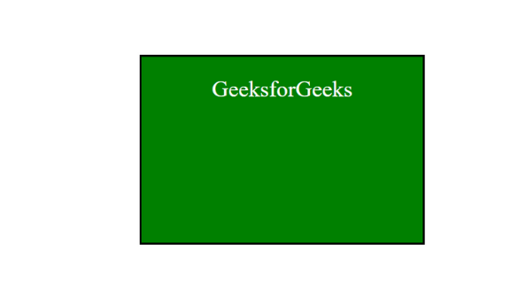

**Viewing localStorage Data**

To view the data stored in the browser’s localStorage:

* Open your web page in the browser.
* Right-click and select “Inspect” or press Ctrl+Shift+I (Windows) or Cmd+Option+I (Mac).
* Go to the “Application” tab.
* In the left-hand menu, under “Storage,” select “Local Storage.”
* Saving data as key/value pair

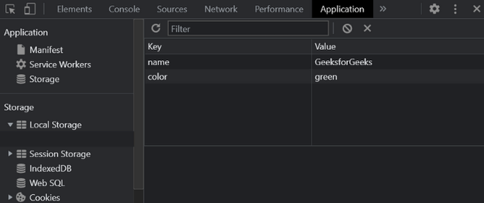

**Updating data**

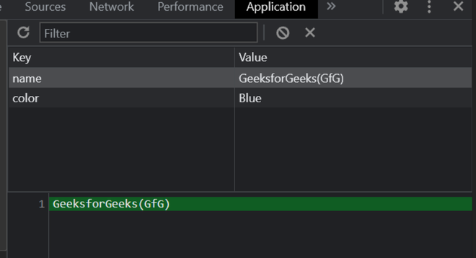

**Get data, index of a key, and number of stored items**

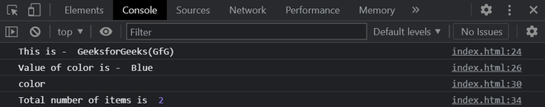

**Remove a key with its value**

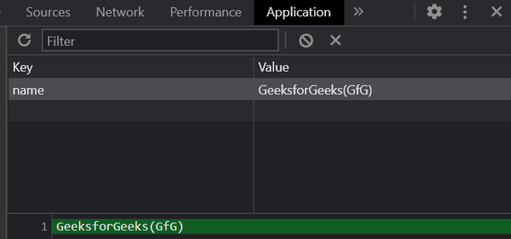

**Delete everything in storage**

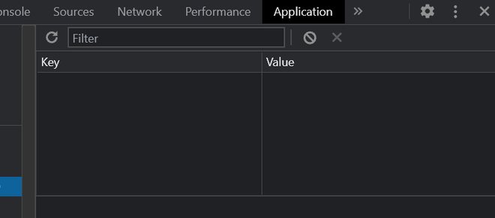

**Conclusion**

localStorage is an effective tool for storing data persistently within the browser. It provides methods to easily set, retrieve, and manage data, ensuring it remains available across sessions until explicitly cleared. By understanding and utilizing localStorage, developers can enhance the user experience by maintaining state and preferences across browsing sessions.

**JavaScript localStorage- FAQs**

**1. Can localStorage store objects?**

*Yes, but you need to serialize the object to a string using JSON.stringify() before storing, and deserialize it using JSON.parse() when retrieving.*

**2. How is localStorage different from sessionStorage?**

*localStorage retains data even after the browser is closed and reopened, whereas sessionStorage only keeps data for the duration of the page session (until the browser tab or window is closed).*

**3. Can localStorage be shared across different domains?**

*No, localStorage is domain-specific. Data stored in localStorage is only accessible from the same domain that stored it, ensuring data privacy and security between different websites.*

**4. Is localStorage secure for sensitive data?**

*No, localStorage is not secure for storing sensitive data such as passwords or personal information. Data stored in localStorage can be accessed by any script running on the same domain, including potential malicious scripts.*

**5. How can I clear all data from localStorage?**

*To clear all data from localStorage, use the clear() method*

*localStorage.clear();*

* 1. [JS Callback](https://www.geeksforgeeks.org/javascript-callbacks/)

**What are Callbacks?**

A callback is a function that is passed as an argument to another function and is executed after the completion of that main function. **In simple terms**, a callback function is called at the end of a task to either deliver results or perform an action. You pass this callback function to the main function, and once the main function completes, it invokes the callback to proceed with the **next steps**.

**Why use Callbacks?**

Callbacks are used for managing the outcomes of asynchronous tasks without blocking the program’s execution. Asynchronous tasks, like network requests or database queries, take time to finish. If these tasks were synchronous, the program would halt until they were done, resulting in a sluggish user experience.

With callbacks, though, you can keep the program running while these tasks happen in the background. When the task finishes, the callback function handles the result. This ensures the program stays responsive, enhancing the user experience.

**Important Points to Know About Callbacks**

**1. Asynchronous programming:**

Callbacks are used to handle the results of asynchronous operations, which means that the operation does not block the execution of the rest of the program. Instead, the program continues to run and the callback function is executed when the operation is complete.

**2. Non-blocking:**

Callbacks allow for non-blocking programming, which means that the program does not stop and wait for an operation to complete before continuing to execute. This is important for improving the performance and responsiveness of applications.

**3. Higher-order functions:**

A higher-order function is a function that takes one or more functions as arguments, or returns a function as a result. The main Function in the examples above is a higher-order function because it takes a callback function as an argument.

**4. Anonymous functions:**

Anonymous functions are functions that are not named and are often used as callbacks. The function passed to setTimeout in the first code example is an anonymous function.

**5. Closure:**

A closure is a function that has access to variables in its outer scope, even after the outer function has returned. This allows the callback function to access variables and information from the main function, even after the main function has completed its execution.

**Real-Life Examples**

**1. Loading images on a website**

When you load a website, images can take a while to load, especially if they’re large. If images were loaded synchronously, the website would freeze and wait for each image to load before continuing. With callbacks, you can load the images asynchronously, which means that the website continues to load while the images are being loaded in the background.

**2. Handling form submissions**

When a user submits a form, it takes time to process the data and send it to the server. If the form submission was executed synchronously, the user would have to wait for the data to be processed and sent before the form can be submitted. With callbacks, you can handle the form submission asynchronously, which means that the user can continue to interact with the form while the data is being processed and sent in the background.

**Example Code: Basic Callback Function**

JavaScript

**function** mainFunction(callback) {

console.log("Performing operation...");

*// Use setTimeout to simulate an asynchronous operation*

setTimeout(**function**() {

callback("Operation complete");

}, 1000);

}

*// Define the callback function*

**function** callbackFunction(result) {

console.log("Result: " + result);

}

*// Call the main function with the callback function*

mainFunction(callbackFunction);

**Output**

Performing operation...

Result: Operation complete

**Explanation:**

* We first define a mainFunction that takes a callback as an argument.
* The mainFunction uses setTimeout to simulate an asynchronous operation. The setTimeout function takes two arguments: a callback function and a delay time in milliseconds.
* The setTimeout function calls the callback function with the result of the operation after the specified delay time.
* We then define a callbackFunction that logs the result of the operation.
* Finally, we call the mainFunction with the callbackFunction as its argument.

**Example Code: Callback with Array.forEach() Method**

javascript

**let** numbers = [1, 2, 3, 4, 5];

**function** mainFunction(callback) {

console.log("Performing operation...");

numbers.forEach(callback);

}

**function** callbackFunction(number) {

console.log("Result: " + number);

}

mainFunction(callbackFunction);

**Output**

Performing operation...

Result: 1

Result: 2

Result: 3

Result: 4

Result: 5

**Explanation:**

* We first define an array of numbers numbers.
* We then define a mainFunction that takes a callback as an argument.
* The mainFunction uses Array.forEach to loop through the numbers array and call the callback function for each element in the array.
* We then define a callbackFunction that logs each number in the numbers array.
* Finally, we call the mainFunction with the callbackFunction as its argument.  
  In conclusion, callbacks are an important aspect of JavaScript programming and are used to handle the results of asynchronous operations in a non-blocking manner. With the help of these examples, you should have a better understanding of how to use callbacks in your own projects.
  1. [JS Closures](https://www.geeksforgeeks.org/closure-in-javascript/)

**Closures in JavaScript** are functions that retain access to variables from their containing scope even after the parent function has finished executing. They’re useful for maintaining private data, creating modular code, and implementing callback functions with persistent state.

**What is a Closure?**

A **closure** is the combination of a function bundled together (enclosed) with references to its surrounding state (the lexical environment). When you create a closure, you gain access to an outer function’s scope from an inner function. Closures are automatically created every time a function is defined in JavaScript.

**Lexical Scoping**

Lexical scoping refers to how a parser resolves variable names when functions are nested. The location where a variable is declared within the source code determines where that variable is available. Nested functions have access to variables declared in their outer scope. Consider the following example:

**Example:** This example shows the basic use of closure.

JavaScript

**function** foo() {

**let** b = 1;

**function** inner() {

**return** b;

}

**return** inner;

}

**let** get\_func\_inner = foo();

console.log(get\_func\_inner());

console.log(get\_func\_inner());

console.log(get\_func\_inner());

**Output**

1

1

1

**Output:**We can access the variable **b**which is defined in**the function foo()** through **function inner()** as the later preserves the scope chain of the enclosing function at the time of execution of the enclosing function i.e. the inner function knows the value of **b** through its scope chain.   
This is closure in action that is inner function can have access to the outer function variables as well as all the global variables.



*Closure in JavaScript*

***Note:****Closure is the concept of function + lexical environment in which function it was created. so every function declared within another function then it has access to the scope chain of the outer function and the variables created within the scope of the outer function will not get destroyed.*

**Creating Closures**

Now let’s look at another example.

**Example 1: Basic Closure.**

JavaScript

**function** foo(outer\_arg) {

**function** inner(inner\_arg) {

**return** outer\_arg + inner\_arg;

}

**return** inner;

}

**let** get\_func\_inner = foo(5);

console.log(get\_func\_inner(4));

console.log(get\_func\_inner(3));

**Output**

9

8

In the above example we used a parameter function rather than a default one. Not even when we are done with the execution of **foo(5)** we can access the **outer\_arg**variable from the inner function. And on the execution of the inner function produce the summation of **outer\_arg** and **inner\_arg** as desired.

Now let’s see an example of closure within a loop.   
In this example, we would store an anonymous function at every index of an array.

**Example 2:**

JavaScript

*// Outer function*

**function** outer() {

**let** arr = [];

**let** i;

**for** (i = 0; i < 4; i++) {

*// storing anonymous function*

arr[i] = **function** () { **return** i; }

}

*// returning the array.*

**return** arr;

}

**let** get\_arr = outer();

console.log(get\_arr[0]());

console.log(get\_arr[1]());

console.log(get\_arr[2]());

console.log(get\_arr[3]());

**Output**

4

4

4

4

Did you guess the right answer? In the above code, we have created four closures that point to the variable i which is the local variable to the function outer.**Closure doesn’t remember the value** of the variable it only **points** to the variable or stores the **reference** of the variable and hence, returns the current value. In the above code when we try to update the value it gets reflected all because the closure stores the reference.

Let’s see the correct way to write the above code so as to get different values of i at different indexes.

**Example 3:**

JavaScript

*// Outer function*

**function** outer() {

**function** create\_Closure(val) {

**return** **function** () {

**return** val;

}

}

**let** arr = [];

**let** i;

**for** (i = 0; i < 4; i++) {

arr[i] = create\_Closure(i);

}

**return** arr;

}

**let** get\_arr = outer();

console.log(get\_arr[0]());

console.log(get\_arr[1]());

console.log(get\_arr[2]());

console.log(get\_arr[3]());

**Output**

0

1

2

3

In the above code we are updating the argument of the function create\_Closure with every call. Hence, we get different values of i at different indexes.

***Note:****It may be slightly difficult to get the concept of closure at once but try experimenting with closure in different scenarios like for creating getter/setter, callbacks, and so on.*

**Common Use Cases**

Closures are useful in various scenarios:

* **Maintaining State**: Closures help maintain state between events in event-driven JavaScript.
* **Private Variables**: You can create private variables by enclosing them within a closure.
* **Callbacks and Asynchronous Code**: Closures are essential for handling callbacks and asynchronous operations.
  1. [JS defer](https://www.geeksforgeeks.org/html-defer-attribute/)

The [**HTML**](https://www.geeksforgeeks.org/html-tutorial/)**defer attribute** is a boolean attribute that is used to specify that the script is executed when the page has finished parsing. This attribute only works with external scripts.

**Applicable:**

<[script](https://www.geeksforgeeks.org/html-script-defer-attribute/?ref=rp)>

**Example:** In this example, we illustrate the use of the defer attribute in a <script> tag. It ensures the external JavaScript file my\_script.js loads after the HTML document has been fully parsed.

html

<!DOCTYPE html>

<**html**>

<**head**>

<**title**>

HTML defer Attribute

</**title**>

</**head**>

<**body** style="text-align:center;">

<**h1** style="color:green">

GeeksForGeeks

</**h1**>

<**h2**>

HTML defer Attribute

</**h2**>

<**script** id="myGeeks"

type="text/javascript"

src="my\_script.js"

defer>

</**script**>

<**br**>

<**button** type="button"

onclick="myFunction()">

Submit

</**button**>

</**body**>

</**html**>

**External script:** *my\_script.js*

javascript

**function** myFunction() {

alert("Script works");

}

**Output:**



* 1. [JS scope](https://www.geeksforgeeks.org/understanding-variable-scopes-in-javascript/)

In JavaScript, there are two types of variable scopes:

1. **Global Scope:**Variables declared Globally (outside of any function) have Global Scope and Global variables can be accessed from anywhere in a program. Similar to function scope variables declared with var, let and const are quite similar when declared outside a block.Scope outside the outermost function attached to the window.
2. **Local Scope:**Variables declared inside a function become local to the function. Local variables are created when a function starts and deleted when the function is executed. Local variables have Function Scope which means that they can only be accessed from within the function. Inside the function being executed.

**Below examples illustrate the JavaScript Variable Scope:**

**Example 1:**We have a global variable defined in the first line in the global scope. Then we have a local variable defined inside the function fun().

* javascript

    let globalLet = "This is a global variable";

**function** fun() {

      let localLet = "This is a local variable";

      console.log(globalLet); // This is a global variable

      console.log(localLet);   // This is a local variable

    }

    fun();

**Output:** When we execute the function fun(), the output shows that both global, as well as local variables, are accessible inside the function as we are able to console.log them. This shows that inside the function we have access to both global variables (declared outside the function) and local variables (declared inside the function).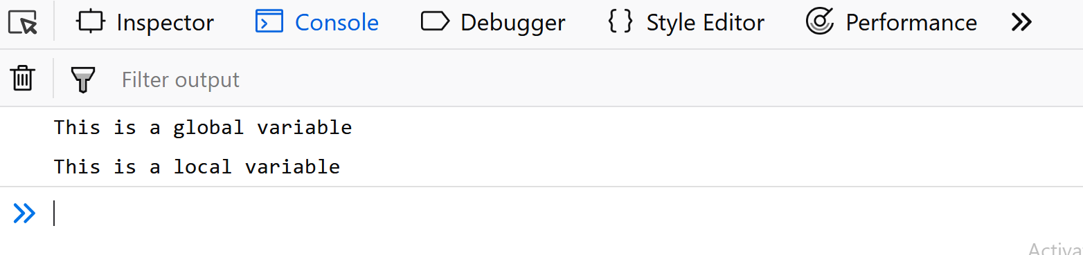**Example:**Let’s move the console.log statements outside the function and put them just after calling the function.

* javascript

    let globalLet = "This is a global variable"

**function** fun() {

      let localLet ="This is a local variable"

    }

    fun();

      console.log(globalLet); // This is a global variable

      console.log(localLet); // localLet is not defined

**Output:** We are still able to see the value of the global variable, but for local variable console.log throws an error. This is because now the console.log statements are present in global scope where they have access to global variables but cannot access the local variables.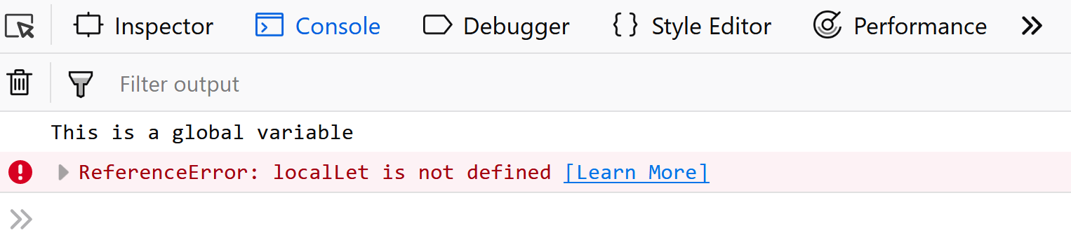**Word of caution:** Whenever you are declaring variables, always use the prefix let. If you don’t use the let keyword, then the variables are by default created in the global scope. For instance, in the above example.

**Example:**let’s just remove the keyword let before the declaration of localLet.

* javascript

    let globalLet = "This is a global variable";;

**function** fun() {

       localLet = "This is a local variable";

    }

    fun();

      console.log(globalLet); // This is a global variable

      console.log(localLet); // This is a local variable

**Output:** We are now able to console.log the local variable as well because the localLet was created in the global scope as we missed the keyword let while declaring it. What really happened is that as we didn’t use the let keyword, JavaScript first searched the localLet in local scope, then in the global scope. As there was no existing global variable by that name, so it created a new global variable.**Example:**One of the most asked questions in interviews is the scenario where the global as well as local variable has the same name. Let’s see what happens then.

* javascript

    let globalLet = "This is a global variable"

**function** fun() {

      let globalLet = "This is a local variable"

    }

    fun();

    console.log(globalLet); // This is a global variable

**Output:** In this example, we have declared a local as well as global variable “globalLet”. What matters here is the scope in which we are accessing it. In this example, we are accessing it in global scope, so it will output the global variable as a local variable is not present in its scope.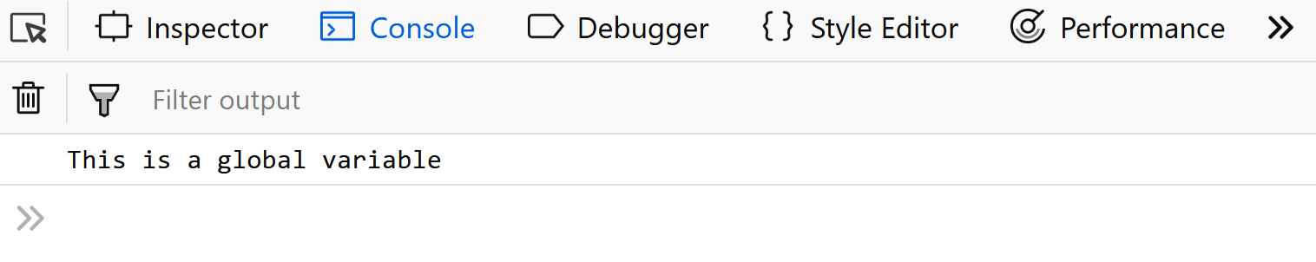**Example:** Let’s move the console.log statement inside the function fun().

* javascript

    let globalLet = "This is a global variable";

**function** fun() {

      let globalLet = "This is a local variable";

      console.log(globalLet); // This is a local variable

    }

    fun();

**Output:** Inside the function fun(), both the local as well as global variables are accessible. But when we console.log the variable globalLet, firstly JavaScript tries to find a local variable in the current scope. It finds the local variable and outputs it. Otherwise, it would have to search for the variable “globalLet” in the outer scope (which in this case is global scope).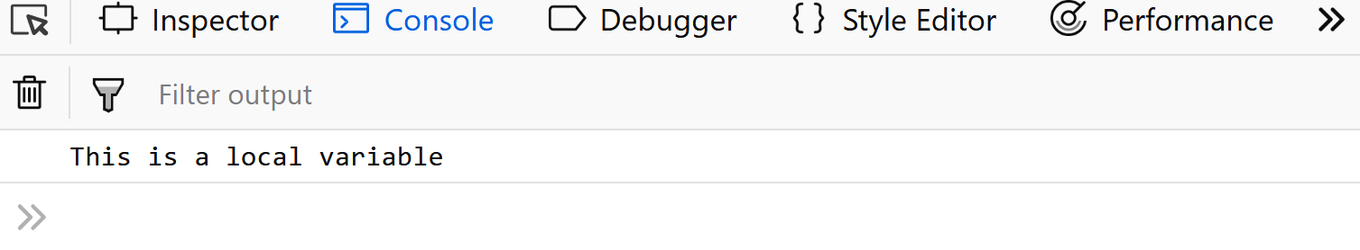**Example:**What if we want to access the global variable instead of the local one here? Well, the window object comes to our rescue. All the global variables declared using the “var” keyword or without using any keyword are attached to the window object and thus we can access the global variable name as shown in the example below.

* javascript

    let globalLet = "This is a global variable";

**function** fun() {

      let globalLet = "This is a local variable";

      console.log(window.globalLet); // This is a global variable

    }

    fun();

**Output:****Example:**After discussing scopes in JavaScript, guessing the output of the below code fragments should be a cakewalk.

* javascript

**function** fun(){

**function** fun2(){

             i = 100;

        }

        fun2();

        console.log(i); // 100

    }

    fun();

**Output:** In this example, as we didn’t use the keyword let, the variable “i” was assumed to be declared in the global scope, and thus the output was 100.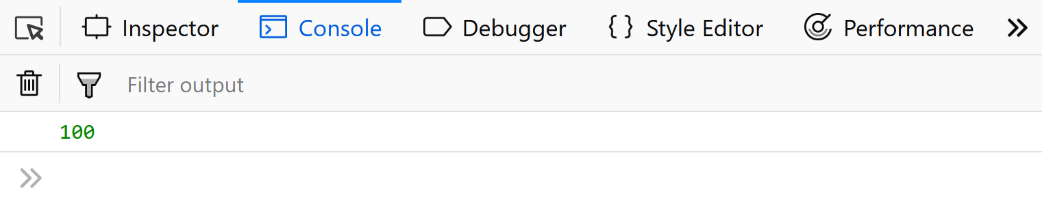**Example:**

* javascript

**function** fun(){

**function** fun2(){

            let i = 100;

        }

        fun2();

        console.log(i); // i is not defined

    }

    fun();

**Output:** In this example, “i” became a local variable and thus was not accessible outside the scope of that function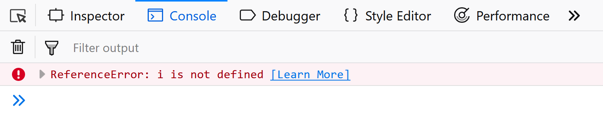In the first example, as we didn’t use the keyword let, the variable “i” was assumed to be declared in the global scope, and thus the output was 100. In the second example, “i” became a local variable and thus was not accessible outside the scope of that function.

**Example:**

* javascript

**function** fun(){

**if**(**true**){

            let i = 100;

        }

        console.log(i); // i is not defined

    }

    fun();

**Output:**After ES2015, we started using let instead of var for declaring variables, and also now the if block is also counted as a block scope, hence in the above example we get an error instead of the value 100. In earlier versions If we change the let to var we will get 100 as output as “**if..else**” block was not considered a block scope earlier, only functions were considered block scope.

Also, the **const**keyword has the same scope as the let keyword and is also a block scope.

* 1. [JS Void](https://www.geeksforgeeks.org/what-is-void-and-when-to-use-void-type-in-javascript/)

The **void keyword** in JavaScript, is used to evaluate an expression which does not return any value. The **void operator** is an unary operator that accepts the single operand, which may be of any type. The importance of the **void keyword** come into role when we just need to evaluate an expression instead of returning its value. It means, by using it, we can prevent the browser from displaying the result of the execution of the expression.

**Syntax**:

void expression

void(expression)

The **void operator** has an [operator precedence](https://www.geeksforgeeks.org/operator-precedence-in-javascript/) ie., the priority will be given to operators while parsing a statement that has more than one operator performing operations in it. Here, we have used the parenthesis, to express the purpose of the expression, according to its precedence.

For instance, consider the below example:

void (10 == '10') // undefined

void 10 == '10' // false

For the 1st case, when the number is compared with string, inside the parenthesis with the void keyword, it returns undefined whereas in the 2nd case, when the expression is evaluates directly with the void keyword, it returns false.

**Example:**This example describes the returning undefined value.

* HTML

<**script**>

       function foo() {

           return void 0;

       }

       console.log(foo());

</**script**>

**Output:**

undefined

[**void 0**](https://www.geeksforgeeks.org/what-does-javascriptvoid0-mean/) can be used as a placeholder URL that represents an onclick event is tied to the link to perform the actual action. The void 0is also commonly used in code downsizing, as it is a way of writing undefined.

There are 3 instances where the void operator can be used:

**Active Javascript URLs:**The ***javascript:*** is referred to as the pseudo URL, when we provide it as a value of *“href”* in an anchor tag, the browser evaluates the expression that follows the “:” symbol. On the other hand, the expression that follows the “:” is usually used as a referenced path.

The void operator is most commonly used in managing the **javascript:** URL (s) because it allows the browser to show the end result of the evaluation of the expression rather than the returned value of the evaluated expression on the client side.

**Example**: In this example, the link changes the color of the background to green without returning any value to the browser.

* HTML

<!DOCTYPE html>

<**html**>

<**head**>

    <**title**>Using Void in URLs</**title**>

</**head**>

<**body**>

    <**a** href=

"javascript:void(document.body.style.backgroundColor='#32CD32');">

        Click here to change the background color.

    </**a**>

</**body**>

</**html**>

**Output:**



**Inactive Javascript URLs:**In some cases, it is not required by a link to navigate anywhere or do anything. To achieve it, we combine the pseudo URL (*javascript:*) with **void(**0**)** as a value of an href, it tells the browser to return/do nothing when that link is clicked.

**Example:**This example explains the generating the inactive Javascript URL.

* HTML

<**html**>

<**head**>

      <**title**>Creating Inactive URL</**title**>

</**head**>

<**body**>

    <**pre**>

        Syntax to make Inactive Javascript URLs:

        <**a** href="javascript:void(0)">Click here to do nothing.</**a**>

    </**pre**>

</**body**>

</**html**>

**Output:**The link will be recognized by the browser but the link doesn’t react at all. When 0 is passed to void as an argument, it does nothing or returns nothing. Here “Click here and do nothing” link doesn’t do anything at all, as depicted in the output.



**Suppression of Arrow Functions:**[Arrow functions](https://www.geeksforgeeks.org/arrow-functions-in-javascript/?ref=gcse) provide a braceless syntax to return the value of an expression. To ensure that the return value of the function expression (when it is of no use) doesn’t affect the code in any way, it can be passed into a void operator.

**Example:**This example explains the returning the value of an expression.

* HTML

<**html**>

<**head**>

    <**title**>Returning the value of an expression</**title**>

</**head**>

<**body**>

    <**h3**>Here we see how we can return undefined value on purpose:</**h3**>

    <**script**>

        function someOtherFunction(num) {

            return num + 1

        }

        const toReturnUndefined = () => void someOtherFunction(1);

        console.log(toReturnUndefined());

    </**script**>

</**body**>

</**html**>

**Output:**

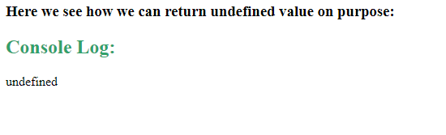

**Returning Undefined Value on Purpose:**We can [convert](https://www.geeksforgeeks.org/javascript-type-conversion/) any variable’s value to an undefined type.

* HTML

<**html**>

<**head**>

    <**title**>Returning Undefined Value on Purpose</**title**>

</**head**>

<**body**>

    <**h3**>Click the following to Return the Undefined Value:</**h3**>

    <**input** type="button"

           value="Click Me"

           onclick="genUValue();" />

    <**script**>

        function genUValue() {

            var g, f, h;

            g = void(f = 13, h = 19);

            document.write('g = ' + g);

        }

    </**script**>

</**body**>

</**html**>

**Output:**



**Immediately Invoked Function Expression:**An [Immediately Invoked Function Expression](https://www.geeksforgeeks.org/javascript-immediately-invoked-function-expressions-iife/)(IIFE) is a type of [Javascript function](https://www.geeksforgeeks.org/functions-in-javascript/) which gets executed as soon as it gets defined. They are very useful because they don’t affect the global object and the remote variable declarations very easily. We can use the **void operator**to create IIFEs. It will force the function to be treated as an expression rather than a declaration.

**Example:**

* HTML

<**html**>

<**head**>

    <**title**>Creating a IIFE Using the Void operator</**title**>

</**head**>

<**body**>

    <**h3**>Here we are creating a IIFE Using the Void operator:</**h3**>

  <**script**>

        void function iife() {

            console.log("IIFE is made with void operator");

        }();

        iife();

  </**script**>

</**body**>

</**html**>

**Output:**

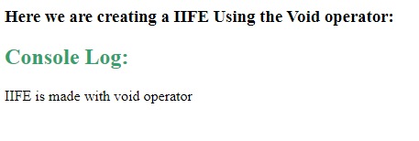

1. [JavaScript Practice Quiz](https://www.geeksforgeeks.org/javascript/#javascript-practice-quiz)

**Question 1**

Inside which HTML element do we put the JavaScript?

* <javascript>
* <js>
* <src>
* <script>

**Question 2**

Where is the correct place to insert a JavaScript?

* Both the head section and the body section are correct
* The head section
* The body section
* None of the above

**Question 3**

Is it necessary for the external script file to contain a <script> tag?

* Yes
* No
* Depends on the type of include
* None of the above

**Question 4**

What is the correct syntax for referring to an external script called \'gfg.js\'?

* <script name="gfg.js">
* <script href="gfg.js">
* <script src="gfg.js">
* None of these

**Question 5**

How many ways are there with which we can declare a variable in javascript?

* Only one
* Three
* Infinitely many
* None of the above

**Question 6**

Is a variable named \'apple\' same as \'Apple\' in javascript?

* Yes
* No
* Only when we use \'strict\'
* None of the above

**Question 7**

Which of the following variable names are correct according to javascript? (Multiple Choices may be correct)

* let 1name;
* let #name;
* let \_name;
* let $\_name;

**Question 8**

What will be the output of the following code?

< script >

document.write( typeof( '1' + 2) );

</ script >

* 'boolean'
* 'string'
* 'number'
* None of the above

**Question 9**

What will be the output of the following code?

< script>

let ans = 6 / "3";

document.write ( typeof ans );

< /script>

* None of the above
* 'number'
* 'integer'
* 'string'

**Question 10**

What is the correct JavaScript syntax to change the content of the HTML element below?

Javascript

<p id="demo">May the code be **with** you.</p>

* document.getElementById("demo").innerHTML = "Hola!";
* document.getElement("p").innerHTML = "Hola!";
* #demo.innerHTML = "Hola!";
* document.getElementByName("p").innerHTML = "Hola!";

**Question 11**

What is the correct precedence of the operator in javascript

* () [] . ++
* ++ . [] ()
* . ++ [] ()
* () ++ . [

**Question 12**

What will be the output of the following code snippet let gfg = ”GeeksforGeeks” console.log(gfg.charAt(4))

* o
* f
* k
* s

**Question 13**

What will be the output of the following code snippet let gfg=”GeeksforGeeks” console.log(gfg.indexOf(‘G’))

* 8
* 0
* -1
* 2

**Question 14**

Which of the following represent falsy values in javascript

* false
* \' \'
* undefined
* All of the above

**Question 15**

Which of the following represent truthy values in javascript

* true
* {}
* []
* All of the above

**Question 16**

What will be the output of the following code snippet let data=’false’; data?console.log(‘first statement’):console.log(‘second statement’);

* first statement
* Second statement
* Can’t say
* None of the above

**Question 17**

The advantages of using strict mode in javascript are

* Strict mode eliminates some JavaScript silent errors by changing them to throw errors.
* It disables features that are confusing or poorly thought out.
* Strict mode makes it easier to write “secure” JavaScript.
* All of the above

**Question 18**

What is the type of variable data declared below const data=[ ]?

* Number
* Object
* String
* None of the above

**Question 19**

Which of the following represents loops in javascript

* for
* while
* forEach
* All of the above

**Question 20**

An object is an unordered collection of \_\_\_\_\_\_\_.

* values
* names
* Properties
* All of the above

**Question 21**

Which of the following method can also be used to create objects in javascript

* new keyword
* object.create()
* create.object()
* Both a and b

**Question 22**

Which of the following is a reference to another object from which properties are inherited

* Object’s prototype
* Object’s characteristics
* Object’s class
* All of the above

**Question 23**

What is the role of continue keyword inside a loop

* Restart the loop
* Break out of the loop
* Ignore the rest of the statements below it and continue the loop
* None of the above

**Question 24**

What is the role of break keyword inside a loop

* Restart the loop
* Move out of the loop
* Ignore the rest of the statements below it and continue the loop
* None of the above

**Question 25**

What will be the output of the following code snippet let data=7 while(data>=0) { if(data<=5) { data--; continue; } console.log(data); data--; }

* 7 6 5 4 3 2 1 0
* 7 6 5
* 7 6
* 0 1 2 3 4 5

**Question 26**

What will be the output for the following code snippet for(let i=1; ;i++) { Let data= i\*5; console.log(data) if(data>=30) break; }

* Infinite loop
* 5 10 15 20 25 30
* 5 10 15 20 25
* 5 10 15 20 25 30 35

**Question 27**

The code snippet described below represents const {name,value,id}= data

* Destructuring in an object
* Destructuring in an array
* Can be both destructuring in array or object
* None of the above

**Question 28**

The code snippet described below represents const [value1,value2,value3]= data

* Destructuring in an object
* Destructuring in an array
* Can be both destructuring in array or object
* None of the above

**Question 29**

What is the function of spread(...) operator in javascript

* Allows an iterable to be expanded to be expanded in places where 0 or more arguments/key-value pairs are expected
* Make spaces in the beginning of a sentence
* Create substring of a string
* All of the above

**Question 30**

Which of the two operator have the same syntax of writing

* Increment and spread operator
* Spread operator and rest parameter
* Rest parameter and increment operator
* None of the above

**Question 31**

Which data structure in javascript is used to maintain only unique values out of the given data

* Set
* array
* strings
* All of the above

**Question 32**

Which data structure is used to maintain a key-value pair in javascript

* set
* array
* Map
* strings

**Question 33**

What will be the output of the following code snippet const arr=[1,2,3,4,5] console.log(...arr)

* [1 2 3 4 5]
* ...[1 2 3 4 5]
* 1 2 3 4 5
* ...1 2 3 4 5

**Question 34**

What will be the output of the following code?

const firstName='Rishi'

lastName='Raj'

console.log(`hello ${firstName}, nice to meet you`);

* hello ${firstName}, nice to meet you
* hello Rishi, nice to meet you
* hello Raj, nice to meet you
* None of the above

**Question 35**

What will be the output of the following code snippet const str1=’Geeksfor’ const str2=’Geeks’ const str3=str1.concat(str2) console.log(str3)

* GeeksforGeeks
* GeeksGeeksfor
* undefined
* None of the above

**Question 36**

What will be the output of the following code snippet const str1=’GeeksforGeeks’ const str2=str1.slice(2,5) console.log(str2)

* eks
* eksf
* Geek
* Geeksf

**Question 37**

Which of the following is the correct syntax for array declaration

* const arr={1,2,3,4}
* const arr=[1,2,3,4]
* Both a and b
* None of the above

**Question 38**

Which method is used to insert a new element at the end of an array

* unshift()
* push()
* pop()
* None of the above

**Question 39**

Which of the following is the pop() method does?

* Display the first element
* Decrements length by 1
* Increments length by 1
* None of the mentioned

**Question 40**

Which function of an Array object calls a function for each element in the array?

* forEach()
* every()
* forEvery()
* each()

**Question 41**

What will be the output of the following code const arr=[1,2,3,4,5,6] console.log(arr.pop())

* 1
* 2
* 1 2 3 4 5
* 6

**Question 42**

What will be the output of the following code const arr=[‘arun’,’rishi’,’shivam’,’raj’] console.log(arr.sort())

* [‘arun’, ’raj’, ’rishi’, ’shivam’]
* [’raj’, ‘arun’, ’rishi’, ’shivam’]
* [’rishi’, ’shivam’, ‘arun’, ’raj’]
* [‘arun’, ’rishi’, ’raj’, ’shivam’]

**Question 43**

What will be the output of the following code const arr=[1,2,3,4,5,6] console.log(arr.slice(1,3))

* [2, 3]
* [2, 3, 4]
* [2]
* [1, 2]

**Question 44**

What will be the output of the following code const arr=[1,2,3,3,3,4,5,6] const arr2=arr.filter((data)=>{return data!==3}) console.log(arr2.length)

* 8
* 5
* 6
* 3

**Question 45**

What will be the output of the following code const arr=new Set([1,2,2,3,3,4,4,4,4,5,6]) console.log(arr)

* [1,2,3]
* [1,2,3,4,5,6]
* [5,6]
* None of the above

**Question 46**

What is the function of findIndex() method

* Returns the index of all the element that passes the condition
* Returns the index of the last element that passes the condition
* Returns the index of the first element that passes the condition
* None of the above

**Question 47**

Which of the following are specific to first-class functions

* Functions are treated as simply values
* Stores functions in variables and properties
* Returns functions from functions
* All of the above

**Question 48**

Which of the following are specific to higher class functions

* A function that receives another function and returns a new function or both
* Stores functions in variables and properties
* Returns functions from functions
* All of the above

**Question 49**

What is the function of the bind method

* bind an object to a common function, so that the function gives different result when its need
* Bind two different objects into one
* Both a and b
* None of the above

**Question 50**

What will be the output of the following code:

let geeks = {   
   name : "ABC",   
   printFunc: function() {   
       console.log(this.name);  
   }   
}

let printFunc2 = geeks.printFunc;

printFunc2();

* No output
* ABC
* Can’t say
* None of the above

**Question 51**

What will be the output of the following code:

let geeks = {   
   name : "ABC",   
   printFunc: function() {   
       console.log(this.name);  
   }   
}

let printFunc2 = geeks.printFunc;

printFunc2();

* No output
* ABC
* Can’t say
* None of the above

**Question 52**

What will be the output of the following code:

var geeks = {   
   name : "ABC",   
   printFunc: function(){   
       console.log(this.name);  
   }   
}

var printFunc2 = geeks.printFunc.bind(geeks);

* No output
* ABC
* Can’t say
* None of the above

**Question 53**

What will be th output of the following code //object geeks1 var geeks1 = { name : "ABC", article: "C++" } //object geeks2 var geeks2 = { name : "CDE", article: "JAVA" } //object geeks3 var geeks3 = { name : "IJK", article: "C#" } function printVal(){ document.write(this.name+" contributes about "+this.article+"<br>"); } var printFunc2= printVal.bind(geeks1); //using bind() // bind() takes the object "geeks1" as parameter// printFunc2(); var printFunc3= printVal.bind(geeks2); printFunc3(); var printFunc4= printVal.bind(geeks3); printFunc4(); //uniquely defines each objects

* ABC contributes about C++ CDE contributes about JAVA IJK contributes about C#
* ABC contributes about C++ No output IJK contributes about C#
* ABC contributes about C++ CDE contributes about JAVA No output
* None of the above

**Question 54**

What does IIFE stands for in javascript

* Invoked Immediately Functions Expressions
* Immediately Invoked Functions Expressions
* Both a and b
* None of the above

**Question 55**

Which of the following is true about IIFE’s

* IIFEs have their own scope i.e. the variables you declare in the Function Expression will not be available outside the function.
* Similar to other functions IIFEs can also be named or anonymous, but even if an IIFE does have a name it is impossible to refer/invoke it.
* IIFEs can also have parameters
* All of the above

**Question 56**

The correct syntax of IIFE is

* (function (){ // Function Logic Here. })();
* function (){ // Function Logic Here. }();
* function (){ // Function Logic Here. }
* All of the above

**Question 57**

Which of the following are important features of javascript

* dynamic
* Single threaded
* Garbage collection
* All of the above

**Question 58**

What does high level mean in the context of javascript

* Developers don\'t need to manage resources manually. Everything happens Automatically
* The mechanism in js automatically removes unnecessary things from the memory
* Functions are simply treated as variables
* None of the above

**Question 59**

What does Garbage-collection mean in the context of javascript

* Developers don\'t need to manage resources manually. Everything happens manually
* The mechanism in js which automatically removes unnecessary things from the memory
* Functions are simply treated as variables
* None of the above

**Question 60**

What is the javascript engine

* A program that runs the javascript code
* A program that finds bugs in the javascript code
* Both a and b
* None of the above

**Question 61**

In js callstack refers to which of the following

* Place where code is executed using execution context
* Where objects are stored
* Both a and b
* None of the above

**Question 62**

In js heap refers to which of the following

* Place where code is executed using execution context
* Where objects are stored
* Both a and b
* None of the above

**Question 63**

What is a compilation?

* Source code is converted to machine code and then to binary code after which the file is executed by the computer
* Running through the source code line by line and executing each line one by one
* Both a and b
* None of the above

**Question 64**

What is Interpretation?

* Source code is converted to machine code and then to binary code after which the file is executed by the computer
* Running through the source code line by line and executing each line one by one
* Both a and b
* None of the above

**Question 65**

What is Interpretation?

* Source code is converted to machine code and then to binary code after which the file is executed by the computer
* Running through the source code line by line and executing each line one by one
* Both a and b
* None of the above

**Question 66**

Which method is used by js to read the code

* Compilation
* Interpretation
* The mix of compilation and interpretation
* None of the above

**Question 67**

Which of the following is true w.r.t. variables

* Variables declared with let and const can’t be hoisted
* Variables declared with var can be hoisted
* Both a and b
* None of the above

**Question 68**

Event handlers are a type of

* Interface
* Functions
* classes
* None of the above

**Question 69**

When is an event handler invoked by the browser

* Refreshing the browser
* First time of loading a page
* When that specified event occurs
* All of the above

**Question 70**

\_\_\_\_\_\_ specifies the property of an event

* type
* name
* value
* All of the above

**Question 71**

Events related to the browser window can be handled by

* Onclicks
* querySelector
* Window
* None of the above

**Question 72**

Event that is fired while scrolling a scrollable document element

* scroll
* window
* onClick
* None of the above

**Question 73**

How mouse drag events can be handled

* Registering onclick handler
* Registering onHover handler
* Registering mousedown handler
* None of the above

**Question 74**

Which of the following is a window event

* Focus and blur event
* Onclick events
* Both a and b
* None of the above

**Question 75**

getElementbyId is used to

* Grab a particular element by is id
* Grab a particular element by its class
* Both a and b
* None of the above

**Question 76**

OnClick event is used to handle

* Handle click events
* Handle change events
* Handle window size
* None of the above

**Question 77**

The \_\_\_\_\_\_\_\_ used to remove a binding

* UnBind()
* unBind()
* unbind()
* None of the above

JavaScript Course | Practice Quiz-2

**Question 1**

Which of the following javascript functions allows you to get user input data?

* alert
* prompt
* confirm
* None of the above

**Question 2**

Which logical operator only accepts a single operand?

* &&(AND)
* ||(OR)
* !(NOT)
* None of the above

**Question 3**

What will be the result of the following code?

Javascript

<script>

document.write( **true** && 1 && 3);

</script>

* 0
* 1
* true
* 3

**Question 4**

What will be the output of the following code?

Javascript

<script>

document.write((0 && 1) || (1 || 0));

</script>

* 0
* false
* true
* 1

**Question 5**

What will be the output of the following code?

Javascript

<script>

**let** ans = 0 / 0;

document.write(ans);

</script>

* 0
* infinity
* NaN
* None of the above

**Question 6**

What will be the output of the following code?

Javascript

<script>

**let** i = 30;

**if**( i == 10 || i > 20){

console.log(\'Hola\');

}**else** **if**( i == 5){

console.log(\'Breaking up the code\');

}**else**{

console.log(\'Adios\');

}

</script>

* Hola
* Breaking up the code
* Adios
* None of the above

**Question 7**

What will be the output of the following code?

Javascript

<script>

**let** ans = 1;

document.write( ans === \'1\');

</script>

* true
* false
* 0
* None of the above

**Question 8**

What will be the output of the following code?

Javascript

<script>

**let** age = 20;

**let** result = age>18 ? \'Great\' : \'Not so great\';

document.write(result);

</script>

* Great
* Not so great
* true
* None of the above

**Question 9**

What will be the output of the following code?

Javascript

<script>

**let** y = 1;

y = **typeof** x;

document.write(**typeof** y);

</script>

* string
* null
* number
* boolean

**Question 10**

What will be the output of the following code?

Javascript

<script>

**var** x = [**typeof** x, **typeof** y][1];

document.write(**typeof** **typeof** x);

</script>

* undefined
* string
* number
* boolean

JavaScript Course | Practice Quiz-3

**Question 1**

What will be the output of the following code?

JavaScript

<script>

**let** result = 0;

**for** (**let** i = 0; i < 5; i++) {

result += i;

}

document.write(result);

</script>

* 5
* 0
* 10
* None of the above

**Question 2**

True or false: All keys in an object are strings.

* True
* False
* Depends on the Object type
* None of the above

**Question 3**

Given a collection of artists and lists of their songs, would you store the artist-song-list pairs in an Object or an Array?

* Object
* Array
* Function
* None of the above

**Question 4**

What will be the output of the following code?

JavaScript

<script>

**if** (5) {

document.write("I like peanuts");

}

</script>

* I like peanuts
* undefined
* nothing will be printed
* None of the above

**Question 5**

What will be the output of the following code?

JavaScript

<script>

**let** bar = 1;

foo = {};

foo: {

bar : 2;

baz : ++bar;

};

document.write(foo.baz + foo.bar + bar);

</script>

* NaN
* 5
* 4
* 1

**Question 6**

What will be the output of the following code?

< script>

document.write( 10 > 9 > 8 === true );

</ script>

* true
* false
* 1
* 0

**Question 7**

What will be the output of the following code?

JavaScript

<script>

document.write(String(\'Hello\') == \'Hello\');

</script>

* true
* false
* 1
* 0

**Question 8**

What will be the output of the following code?

JavaScript

<script>

document.write(( **true** + **false** ) > 2 + **true** );

</script>

* true
* false
* 1
* 0

**Question 9**

What will be the output of the following code?

JavaScript

<script>

document.write(Number(\'1\') - 1 == 0);

</script>

* true
* false
* 1
* None of the above

**Question 10**

What will be the output of the following code?

JavaScript

<script>

document.write(**NaN** == **NaN**);

</script>

* true
* false
* 1
* 0

1. [JavaScript Interview Questions](https://www.geeksforgeeks.org/javascript/#javascript-interview-questions)

**JavaScript Interview Questions for Freshers**

Let’s discuss some common questions that you should prepare for the interviews. These questions will be helpful in clearing the interviews specially for the frontend development role.

**1. What are the differences between Java and JavaScript?**

JavaScript is a client-side scripting language and Java is object Oriented Programming language. Both of them are totally different from each other.

* [**JavaScript**](https://www.geeksforgeeks.org/javascript-tutorial/)**:** It is a light-weighted programming language (“scripting language”) for developing interactive web pages. It can insert dynamic text into the HTML elements. JavaScript is also known as the browser’s language.
* [**Java**](https://www.geeksforgeeks.org/java/)**:** Java is one of the most popular programming languages. It is an object-oriented programming language and has a virtual machine platform that allows you to create compiled programs that run on nearly every platform. Java promised, “Write Once, Run Anywhere”.

**2. What are JavaScript Data Types?**

There are three major Data types in JavaScript.

* Primitive
  + [Numbers](https://www.geeksforgeeks.org/javascript-numbers/)
  + [Strings](https://www.geeksforgeeks.org/javascript-string/)
  + [Boolean](https://www.geeksforgeeks.org/javascript-boolean/)
  + [Symbol](https://www.geeksforgeeks.org/javascript-symbol-method/)
* Trivial
  + [Undefined](https://www.geeksforgeeks.org/undefined-in-javascript/)
  + [Null](https://www.geeksforgeeks.org/null-in-javascript/)
* Composite
  + [Objects](https://www.geeksforgeeks.org/objects-in-javascript/)
  + [Functions](https://www.geeksforgeeks.org/functions-in-javascript/)
  + [Arrays](https://www.geeksforgeeks.org/arrays-in-javascript/)

**3. Which symbol is used for comments in JavaScript?**

Comments prevent the execution of statements. Comments are ignored while the compiler executes the code. There are two type of symbols to represent comments in JavaScript:

* **Double slash:** It is known as a single-line comment.

// Single line comment

* **Slash with Asterisk:** It is known as a multi-line comment.

/\*

Multi-line comments

...

\*/

**4. What would be the result of 3+2+”7″?**

 Here, 3 and 2 behave like an integer, and “7” behaves like a string. So 3 plus 2 will be 5. Then the output will be 5+”7″ = 57.

**5. What is the use of the isNaN function?**

 The number isNan function determines whether the passed value is NaN (Not a number) and is of the type “Number”. In JavaScript, the value NaN is considered a type of number. It returns true if the argument is not a number, else it returns false.

**6. Which is faster in JavaScript and ASP script?**

JavaScript is faster compared to ASP Script. JavaScript is a client-side scripting language and does not depend on the server to execute. The ASP script is a server-side scripting language always dependable on the server.

**7. What is negative infinity?**

 The negative infinity is a constant value represents the lowest available value. It means that no other number is lesser than this value. It can be generate using a self-made function or by an arithmetic operation. JavaScript shows the NEGATIVE\_INFINITY value as -Infinity.

**8. Is it possible to break JavaScript Code into several lines?**

 Yes, it is possible to break the JavaScript code into several lines in a string statement. It can be broken by using the **backslash n ‘\n’**.   
For example:

console.log("A Online Computer Science Portal\n for Geeks")

The code-breaking line is avoid by JavaScript which is not preferable.

let gfg= 10, GFG = 5,

Geeks =

gfg + GFG;

**9. Which company developed JavaScript?**

Netscape developed JavaScript and was created by Brenden Eich in the year of 1995.

**10. What are undeclared and undefined variables?**

* [**Undefined**](https://www.geeksforgeeks.org/undefined-in-javascript/)**:** It occurs when a variable is declare but not assign any value. Undefined is not a keyword.
* [**Undeclared**](https://www.geeksforgeeks.org/what-are-undeclared-and-undefined-variables-in-javascript/)**:** It occurs when we try to access any variable which is not initialize or declare earlier using the var or const keyword. If we use [‘typeof’ operator](https://www.geeksforgeeks.org/javascript-typeof-operator/)to get the value of an undeclare variable, we will face the runtime error with the return value as “undefined”. The scope of the undeclare variables is always global.

**11. Write a JavaScript code for adding new elements dynamically.**

html

<!DOCTYPE html>

<**html** lang="en">

<**head**>

<**title**>Document</**title**>

</**head**>

<**body**>

<**button** onclick="create()">

Click Here!

</**button**>

<**script**>

**function** create() {

**let** geeks = document.createElement('geeks');

geeks.textContent = "Geeksforgeeks";

geeks.setAttribute('class', 'note');

document.body.appendChild(geeks);

}

</**script**>

</**body**>

</**html**>

**Output:**

Video Player

00:00

00:03

**12. What are global variables? How are these variables declared, and what are the problems associated with them?**

 In contrast, global variables are the variables that define outside of functions. These variables have a global scope, so they can be used by any function without passing them to the function as parameters.

**Example:**

javascript

**let** petName = "Rocky"; *// Global Variable*

myFunction();

**function** myFunction() {

console.log("Inside myFunction - Type of petName:", **typeof** petName);

console.log("Inside myFunction - petName:", petName);

}

console.log("Outside myFunction - Type of petName:", **typeof** petName);

console.log("Outside myFunction - petName:", petName);

**Output**

Inside myFunction - Type of petName: string

Inside myFunction - petName: Rocky

Outside myFunction - Type of petName: string

Outside myFunction - petName: Rocky

It is difficult to debug and test the code that relies on global variables.

**13. What do you mean by NULL in JavaScript?**

 The NULL value represents that no value or no object. It is known as empty value/object.

**14. How to delete property-specific values?**

The [**delete keyword**](https://www.geeksforgeeks.org/javascript-delete-operator/)deletes the whole property and all the values at once like

let gfg={Course: "DSA", Duration:30};

delete gfg.Course;

**15. What is a prompt box?**

 The prompt box is a dialog box with an optional message prompting the user to input some text. It is often used if the user wants to input a value before entering a page. It returns a string containing the text entered by the user, or null.

**16. What is the ‘this’ keyword in JavaScript?**

 Functions in JavaScript are essential objects. Like objects, it can be assign to variables, pass to other functions, and return from functions. And much like objects, they have their own properties. ‘this’ stores the current execution context of the JavaScript program. Thus, when it use inside a function, the value of ‘this’ will change depending on how the function is defined, how it is invoked, and the default execution context.

**17. Explain the working of timers in JavaScript. Also elucidate the drawbacks of using the timer, if any.**

The timer executes some specific code at a specific time or any small amount of code in repetition to do that you need to use the functions **[setTimout](https://www.geeksforgeeks.org/java-script-settimeout-setinterval-method/" \t "_blank)**[,](https://www.geeksforgeeks.org/java-script-settimeout-setinterval-method/" \t "_blank)**[setInterval,](https://www.geeksforgeeks.org/java-script-settimeout-setinterval-method/" \t "_blank)**and **[clearInterval](https://www.geeksforgeeks.org/javascript-cleartimeout-clearinterval-method/" \t "_blank)**. If the JavaScript code sets the timer to 2 minutes and when the times are up then the page displays an alert message “times up”. The **setTimeout()** method calls a function or evaluates an expression after a specified number of milliseconds.

**18. What is the difference between ViewState and SessionState?**

* **ViewState:** It is specific to a single page in a session.
* **SessionState:** It is user specific that can access all the data on the web pages.

**19. How to submit a form using JavaScript?**

You can use **[document.form[0].submit()](https://www.geeksforgeeks.org/html-dom-form-submit-method/" \t "_blank)**method to submit the form in JavaScript.

**20. Does JavaScript support automatic type conversion?**

Yes, JavaScript supports automatic type conversion.

**JavaScript Intermediate Interview Questions**

**21. What are all the looping structures in JavaScript ?**

* [**while loop**](https://www.geeksforgeeks.org/javascript-while-loop/)**:** A while loop is a control flow statement that allows code to be executed repeatedly based on a given Boolean condition. The while loop can be thought of as a repeating if statement.
* [**for loop**](https://www.geeksforgeeks.org/javascript-for-loop/)**:** A for loop provides a concise way of writing the loop structure. Unlike a while loop, for statement consumes the initialization, condition and increment/decrement in one line thereby providing a shorter, easy to debug structure of looping.
* [**do while**](https://www.geeksforgeeks.org/javascript-do-while-loop/)**:** A do-while loop is similar to while loop with the only difference that it checks the condition after executing the statements, and therefore is an example of Exit Control Loop.

**22. How can the style/class of an element be changed?**

To change the style/class of an element there are two possible ways. We use [document.getElementByID method](https://www.geeksforgeeks.org/html-dom-getelementbyid-method/" \t "_blank)

document.getElementById("myText").style.fontSize = "16px;

document.getElementById("myText").className = "class";

**23. Explain how to read and write a file using JavaScript?**

* The **[readFile()](https://www.geeksforgeeks.org/javascript-program-to-read-text-file/" \t "_blank)** functions is used for reading operation.

readFile( Path, Options, Callback)

* The **[writeFile()](https://www.geeksforgeeks.org/javascript-program-to-write-data-in-a-text-file/" \t "_blank)** functions is used for writing operation.

writeFile( Path, Data, Callback)

**24. What is called Variable typing in JavaScript ?**

The **variable typing** is the type of variable used to store a number and using that same variable to assign a “string”.

Geeks = 42;

Geeks = "GeeksforGeeks";

**25. How to convert the string of any base to integer in JavaScript?**

In JavaScript, parseInt() function is used to convert the string to an integer. This function returns an integer of base which is specified in second argument of parseInt() function. The parseInt() function returns Nan (not a number) when the string doesn’t contain number.

**26. Explain how to detect the operating system on the client machine?**

To detect the operating system on the client machine, one can simply use navigator.appVersion or navigator.userAgent property. The Navigator appVersion property is a read-only property and it returns the string that represents the version information of the browser.

**27. What are the types of Pop up boxes available in JavaScript?**

There are three types of pop boxes available in JavaScript.

* [**Alert**](https://www.geeksforgeeks.org/html-window-alert-method/)
* [**Confirm**](https://www.geeksforgeeks.org/javascript-window-confirm-method/)
* [**Prompt**](https://www.geeksforgeeks.org/javascript-window-prompt-method/)

**28. What is the difference between an alert box and a confirmation box?**

An alert box will display only one button which is the OK button. It is used to inform the user about the agreement has to agree. But a Confirmation box displays two buttons OK and cancel, where the user can decide to agree or not.

**29. What is the disadvantage of using innerHTML in JavaScript?**

There are lots of disadvantages of using the [innerHTML](https://www.geeksforgeeks.org/html-dom-innerhtml-property/" \t "_blank) in JavaScript as the content will replace everywhere. If you use += like “innerHTML = innerHTML + ‘html’” still the old content is replaced by HTML. It preserves event handlers attached to any DOM elements.

**30. What is the use of void(0) ?**

The [void(0)](https://www.geeksforgeeks.org/what-does-javascriptvoid0-mean/)is used to call another method without refreshing the page during the calling time parameter “zero” will be passed.

*For further reading, check out our dedicated article on*[***Intermediate Javascript Interview Questions***](https://www.geeksforgeeks.org/javascript-interview-questions-and-answers-set-2/)*. Inside, you’ll discover over 20 questions with detailed answers.*

**JavaScript Interview Questions for Experienced**

**31. What is the ‘Strict’ mode in JavaScript and how can it be enabled?**

Strict Mode is a new feature in ECMAScript 5 that allows you to place a program or a function in a “strict” operating context. This strict context prevents certain actions from being taken and throws more exceptions. The statement “use strict” instructs the browser to use the Strict mode, which is a reduced and safer feature set of JavaScript.

**32. How to get the status of a CheckBox?**

The DOM Input Checkbox Property is used to set or return the checked status of a checkbox field. This property is used to reflect the HTML Checked attribute.

document.getElementById("GFG").checked;

If the CheckBox is checked then it returns True.

**33. How to explain closures in JavaScript and when to use it?**

The closure is created when a child functions to keep the environment of the parent’s scope even after the parent’s function has already executed. The Closure is a locally declared variable related to a function. The closure will provide better control over the code when using them.

JavaScript

*// Explanation of closure*

**function** foo() {

**let** b = 1;

**function** inner() {

**return** b;

}

**return** inner;

}

**let** get\_func\_inner = foo();

console.log(get\_func\_inner());

console.log(get\_func\_inner());

console.log(get\_func\_inner());

**Output**

1

1

1

**34. What is the difference between call() and apply() methods ?**

Both methods are used in a different situation

* **call() Method:** It calls the method, taking the owner object as argument. The keyword this refers to the ‘owner’ of the function or the object it belongs to. We can call a method that can be used on different objects.
* **apply() Method:** The apply() method is used to write methods, which can be used on different objects. It is different from the function call() because it takes arguments as an array.

**35. How to target a particular frame from a hyperlink in JavaScript ?**

This can be done by using the **target** attribute in the hyperlink. Like

<a href="/geeksforgeeks.htm" target="newframe">New Page</a>

**36. Write the errors shown in JavaScript?**

There are three different types of errors in JavaScript.

* **Syntax error:** A syntax error is an error in the syntax of a sequence of characters or tokens that are intended to be written in a particular programming language.
* **Logical error:** It is the most difficult error to be traced as it is the error on the logical part of the coding or logical error is a bug in a program that causes to operate incorrectly and terminate abnormally.
* **Runtime Error:** A runtime error is an error that occurs during the running of the program, also known as an exception.

**37. What is the difference between JavaScript and Jscript?**

**JavaScript**

* It is a scripting language developed by Netscape.
* It is used to design client and server-side applications.
* It is completely independent of Java language.

**Jscript**

* It is a scripting language developed by Microsoft.
* It is used to design active online content for the word wide Web.

**38. What does *var myArray = [[]];* statement declares?**

In JavaScript, this statement is used to declare a two-dimensional array.

**39. How many ways an HTML element can be accessed in JavaScript code?**

There are four possible ways to access HTML elements in JavaScript which are:

* [**getElementById() Method:**](https://www.geeksforgeeks.org/html-dom-getelementbyid-method/) It is used to get the element by its id name.
* [**getElementsByClass() Method:**](https://www.geeksforgeeks.org/html-dom-getelementsbyclassname-method/) It is used to get all the elements that have the given classname.
* [**getElementsByTagName() Method:**](https://www.geeksforgeeks.org/html-dom-getelementsbytagname-method/) It is used to get all the elements that have the given tag name.
* [**querySelector() Method:**](https://www.geeksforgeeks.org/html-dom-queryselector-method/) This function takes CSS style selector and returns the first selected element.

**40. What is the difference between innerHTML & innerText?**

The innerText property sets or returns the text content as plain text of the specified node, and all its descendants whereas the innerHTML property sets or returns the plain text or HTML contents in the elements. Unlike innerText, inner HTML lets you work with HTML rich text and doesn’t automatically encode and decode text.

**41. What is an event bubbling in JavaScript?**

Consider a situation an element is present inside another element and both of them handle an event. When an event occurs in bubbling, the innermost element handles the event first, then the outer, and so on.

*For further reading, check out our dedicated article on*[***Advanced Javascript Interview Questions***](https://www.geeksforgeeks.org/javascript-interview-questions-and-answers-set-3/)*. Inside, you’ll discover 20+ questions with detailed answers.*

**JavaScript Interview Questions – FAQs**

**What are the primitive data types in JavaScript?**

*There are six: number, string, boolean, null, undefined, and symbol.*

**How do you explain ‘hoisting’ in JavaScript?**

*Variable declarations are hoisted to the top of their scope, allowing access before their actual definition.*

**What’s the difference between ‘===’ and ‘==’?**

*=== checks for strict equality (value and type), while == performs type coercion before comparison.*

**How can you loop through the elements of an array?**

*Use a for loop or a forEach method to iterate over each item in the array.*

**1.**[What are all the looping structures in JavaScript ?](https://www.geeksforgeeks.org/loops-in-javascript)

* [**while loop**](https://www.geeksforgeeks.org/javascript-while-loop)**:** A while loop is a control flow statement that allows code to be executed repeatedly based on a given Boolean condition. The while loop can be thought of as a repeating if statement.
* [**for loop**](https://www.geeksforgeeks.org/javascript-for-loop)**:** A for loop provides a concise way of writing the loop structure. Unlike a while loop, for statement consumes the initialization, condition and increment/decrement in one line thereby providing a shorter, easy to debug structure of looping.
* [**do while**](https://www.geeksforgeeks.org/javascript-do-while-loop)**:** A do-while loop is similar to while loop with the only difference that it checks the condition after executing the statements, and therefore is an example of Exit Control Loop.

**2. How can the style/class of an element be changed?**

To change the style/class of an element there are two possible ways. We use [document.getElementByID method](https://www.geeksforgeeks.org/html-dom-getelementbyid-method" \t "_blank)

document.getElementById("myText").style.fontSize = "16px;

document.getElementById("myText").className = "class";

**3. Explain how to read and write a file using JavaScript?**

* The **[readFile()](https://www.geeksforgeeks.org/javascript-program-to-read-text-file" \t "_blank)** functions is used for reading operation.

readFile( Path, Options, Callback)

* The **[writeFile()](https://www.geeksforgeeks.org/javascript-program-to-write-data-in-a-text-file" \t "_blank)** functions is used for writing operation.

writeFile( Path, Data, Callback)

**4. What is called Variable typing in JavaScript ?**

The **variable typing** is the type of variable used to store a number and using that same variable to assign a “string”.

Geeks = 42;  
Geeks = "GeeksforGeeks";

**5.**[How to convert the string of any base to integer in JavaScript?](https://www.geeksforgeeks.org/convert-a-string-to-an-integer-in-javascript)

In JavaScript, parseInt() function is used to convert the string to an integer. This function returns an integer of base which is specified in second argument of parseInt() function. The parseInt() function returns Nan (not a number) when the string doesn’t contain number.

**6.**[Explain how to detect the operating system on the client machine?](https://www.geeksforgeeks.org/how-to-detect-operating-system-on-the-client-machine-using-javascript)

To detect the operating system on the client machine, one can simply use navigator.appVersion or navigator.userAgent property. The Navigator appVersion property is a read-only property and it returns the string that represents the version information of the browser.

**7.**[What are the types of Pop up boxes available in JavaScript?](https://www.geeksforgeeks.org/what-are-the-types-of-popup-box-available-in-javascript)

There are three types of pop boxes available in JavaScript.

* [Alert](https://www.geeksforgeeks.org/html-window-alert-method)
* [Confirm](https://www.geeksforgeeks.org/javascript-window-confirm-method)
* [Prompt](https://www.geeksforgeeks.org/javascript-window-prompt-method)

**8.**[What is the difference between an alert box and a confirmation box?](https://www.geeksforgeeks.org/what-are-the-types-of-popup-box-available-in-javascript)

An alert box will display only one button which is the OK button. It is used to inform the user about the agreement has to agree. But a Confirmation box displays two buttons OK and cancel, where the user can decide to agree or not.

**9. What is the disadvantage of using**[innerHTML](https://www.geeksforgeeks.org/html-dom-innerhtml-property" \t "_blank)**in JavaScript?**

There are lots of disadvantages of using the innerHTML in JavaScript as the content will replace everywhere. If you use += like “innerHTML = innerHTML + ‘html'” still the old content is replaced by HTML. It preserves event handlers attached to any DOM elements.

**10.**[What is the use of void(0) ?](https://www.geeksforgeeks.org/what-does-javascriptvoid0-mean)

The void(0) is used to call another method without refreshing the page during the calling time parameter “zero” will be passed.

**11.**[What are JavaScript Cookies ?](https://www.geeksforgeeks.org/es6-cookies)

Cookies are small files that are stored on a user’s computer. They are used to hold a modest amount of data specific to a particular client and website and can be accessed either by the web server or by the client’s computer. When cookies were invented, they were basically little documents containing information about you and your preferences. For instance, when you select the language in which you want to view your website, the website would save the information in a document called a cookie on your computer, and the next time when you visit the website, it would be able to read a cookie saved earlier.

**12.**[How to create a cookie using JavaScript?](https://www.geeksforgeeks.org/how-to-create-cookie-with-the-help-of-javascript)

To create a cookie by using JavaScript you just need to assign a string value to the [document.cookie object.](https://www.geeksforgeeks.org/html-dom-cookie-property" \t "_blank)

document.cookie = "key1 = value1; key2 = value2; expires = date";

**13. How to read a cookie using JavaScript?**

The value of the **[document.cookie](https://www.geeksforgeeks.org/html-dom-cookie-property" \t "_blank)**is used to create a cookie. Whenever you want to access the cookie you can use the string. The **document.cookie** string keep a list of **name = value** pairs separated by semicolons, where **name**is the *name of a cookie* and the **value**is its *string value*.

**14. How to delete a cookie using JavaScript?**

Deleting a cookie is much easier than creating or reading a cookie, you just need to set the expires = “past time” and make sure one thing defines the right cookie path unless few will not allow you to delete the cookie.

**15. What are escape characters and escape() function?**

* [**Escape character:**](https://www.geeksforgeeks.org/how-to-use-escape-characters-to-correctly-log-quotes-in-a-string-using-javascript) This character is required when you want to work with some special characters like single and double quotes, apostrophes, and ampersands. All the special character plays an important role in JavaScript, to ignore that or to print that special character, you can use the escape character **backslash “\”**. It will normally ignore and behave like a normal character.

// Need escape character  
document.write("GeeksforGeeks: A Computer Science Portal "for Geeks" ")  
document.write("GeeksforGeeks: A Computer Science Portal \"for Geeks\" ")

* [**escape() function:**](https://www.geeksforgeeks.org/javascript-escape) The escape() function takes a string as a parameter and encodes it so that it can be transmitted to any computer in any network which supports ASCII characters.

**16. Whether JavaScript has a concept-level scope?**

JavaScript is not concept-level scope, the variables declared inside any function have scope inside the function.

**17. How generic objects can be created in JavaScript?**

To create a generic object in JavaScript use:

var I = new object();

**18.**[Which keywords are used to handle exceptions?](https://www.geeksforgeeks.org/javascript-errors-throw-and-try-to-catch)

When executing JavaScript code, errors will almost definitely occur. These errors can occur due to the fault from the programmer’s side due to the wrong input or even if there is a problem with the logic of the program. But all errors can be solved by using the below commands.

* The **try** statement lets you test a block of code to check for errors.
* The **catch** statement lets you handle the error if any are present.
* The **throw** statement lets you make your own errors.

**19.**[What is the use of the blur function?](https://www.geeksforgeeks.org/jquery-blur-with-examples)

It is used to remove focus from the selected element. This method starts the blur event or it can be attached to a function to run when a blur event occurs.

**20.**[What is the unshift method in JavaScript?](https://www.geeksforgeeks.org/javascript-array-prototype-unshift-function)

It is used to insert elements in the front of an array. It is like a [**push**](https://www.geeksforgeeks.org/javascript-array-prototype-push-function) method that inserts elements at the beginning of the array.

**1.**[**What is the ‘Strict’ mode in JavaScript and how can it be enabled?**](https://www.geeksforgeeks.org/strict-mode-javascript)

Strict Mode is a new feature in ECMAScript 5 that allows you to place a program or a function in a “strict” operating context. This strict context prevents certain actions from being taken and throws more exceptions. The statement “use strict” instructs the browser to use the Strict mode, which is a reduced and safer feature set of JavaScript.

**2.**[**How to get the status of a CheckBox?**](https://www.geeksforgeeks.org/html-dom-input-checkbox-checked-property)

The DOM Input Checkbox Property is used to set or return the checked status of a checkbox field. This property is used to reflect the HTML Checked attribute.

document.getElementById("GFG").checked;

If the CheckBox is checked then it returns True.

**3.**[**How to explain closures in JavaScript and when to use it?**](https://www.geeksforgeeks.org/closure-in-javascript)

The closure is created when a child functions to keep the environment of the parent’s scope even after the parent’s function has already executed. The Closure is a locally declared variable related to a function. The closure will provide better control over the code when using them.

javascript

*// Explanation of closure*

**function** foo() {

**let** b = 1;

**function** inner() {

**return** b;

}

**return** inner;

}

**let** get\_func\_inner = foo();

console.log(get\_func\_inner());

console.log(get\_func\_inner());

console.log(get\_func\_inner());

**4.**[**What is the difference between call() and apply() methods ?**](https://www.geeksforgeeks.org/what-is-the-difference-between-call-and-apply-in-javascript)

Both methods are used in a different situation

* **call() Method:** It calls the method, taking the owner object as argument. The keyword this refers to the ‘owner’ of the function or the object it belongs to. We can call a method that can be used on different objects.
* **apply() Method:** The apply() method is used to write methods, which can be used on different objects. It is different from the function call() because it takes arguments as an array.

**5.**[**How to target a particular frame from a hyperlink in JavaScript ?**](https://www.geeksforgeeks.org/how-can-a-particular-frame-be-targeted-from-a-hyperlink-in-javascript)

This can be done by using the **target** attribute in the hyperlink. Like

<a href="/geeksforgeeks.htm" target="newframe">New Page</a>

**6.**[**Write the errors shown in JavaScript?**](https://www.geeksforgeeks.org/javascript-error-and-exceptional-handling-with-examples)

There are three different types of errors in JavaScript.

* **Syntax error:** A syntax error is an error in the syntax of a sequence of characters or tokens that are intended to be written in a particular programming language.
* **Logical error:** It is the most difficult error to be traced as it is the error on the logical part of the coding or logical error is a bug in a program that causes to operate incorrectly and terminate abnormally.
* **Runtime Error:** A runtime error is an error that occurs during the running of the program, also known as an exception.

**7.**[**What is the difference between JavaScript and Jscript?**](https://www.geeksforgeeks.org/whats-the-difference-between-javascript-and-jscript)

**JavaScript**

* It is a scripting language developed by Netscape.
* It is used to design client and server-side applications.
* It is completely independent of Java language.

**Jscript**

* It is a scripting language developed by Microsoft.
* It is used to design active online content for the world wide Web.

**8. What does *var myArray = [[]];* statement declares?**

In JavaScript, this statement is used to declare a two-dimensional array.

**9.**[**How many ways an HTML element can be accessed in JavaScript code?**](https://www.geeksforgeeks.org/different-ways-to-access-html-elements-using-javascript)

There are four possible ways to access HTML elements in JavaScript which are:

* [**getElementById() Method:**](https://www.geeksforgeeks.org/html-dom-getelementbyid-method) It is used to get the element by its id name.
* [**getElementsByClass() Method:**](https://www.geeksforgeeks.org/html-dom-getelementsbyclassname-method) It is used to get all the elements that have the given classname.
* [**getElementsByTagName() Method:**](https://www.geeksforgeeks.org/html-dom-getelementsbytagname-method) It is used to get all the elements that have the given tag name.
* [**querySelector() Method:**](https://www.geeksforgeeks.org/html-dom-queryselector-method) This function takes CSS style selector and returns the first selected element.

**10.**[**What is the difference between innerHTML & innerText?**](https://www.geeksforgeeks.org/difference-between-innertext-and-innerhtml)

The innerText property sets or returns the text content as plain text of the specified node, and all its descendants whereas the innerHTML property sets or returns the plain text or HTML contents in the elements. Unlike innerText, inner HTML lets you work with HTML rich text and doesn’t automatically encode and decode text.

**11.**[**What is an event bubbling in JavaScript?**](https://www.geeksforgeeks.org/html-bubbles-event-property)

Consider a situation an element is present inside another element and both of them handle an event. When an event occurs in bubbling, the innermost element handles the event first, then the outer, and so on.

**12. What will be the output of the following code?**

javascript

**let** X = { geeks: 1 };

**let** output = (**function** () {

**delete** X.geeks;

**return** X.geeks;

})();

console.log(output);

Here the delete will delete the property of the object. X is the object with the geek’s property and it is a self-invoking function that will delete the geek’s property from object X so the result will be undefined.

**13. How are JavaScript and**[**ECMA Script**](https://www.geeksforgeeks.org/introduction-to-es6)**related?**

JavaScript is the main language that has to maintain some rules and regulations which is ECMA Script, these rules also bring new features for the language JavaScript.

**14.**[**How to hide JavaScript code from old browsers that don’t support JavaScript?**](https://www.geeksforgeeks.org/how-can-javascript-codes-be-hidden-from-old-browsers-that-do-not-support-javascript)

To hide the JavaScript codes from the old browsers that don’t support JavaScript you can use

<!-- before <script> tag and another //--> after </script> tag

all the old browsers that will take that as a long comment of HTML. New browsers that support JavaScript will take that as an online comment.

**15. What will be the output of the following code?**

let output = (function(x) {  
 delete x;  
 return x;  
})(0);  
document.write(output);

The output will be 0. The delete operator is used to delete the operator of the object but the X is not the object here it is a local variable. The delete operator doesn’t affect local variables.

**16. In JavaScript, answer if the following expressions result in true or false.**

"0" == 0 // true or false ?   
"" == 0 // true or false ?   
"" == "0" // true or false ?

The result will be **True** for 1st and 2nd case and **False** for the 3rd case.

**17.**[**How to use any browser for debugging?**](https://www.geeksforgeeks.org/debugging-in-javascript)

By pressing the F12 we can trigger the debugging mode of any browser and can view the result by taping the console.

**18.**[**What is javascript Hoisting?**](https://www.geeksforgeeks.org/javascript-hoisting)

When any interpreter runs the code then all the variables are re-hoisted to the top of the original scope. This method is applicable for declaration not for the initialization of a variable. This is known as a javascript Hoisting.

**19.**[**What is the syntax of ‘Self Invoking Function’ ?**](https://www.geeksforgeeks.org/what-is-the-self-executing-function)

The syntax for Self-Invoking Function: The last bracket contains the function expression.

(function () {  
 return // body of the function  
}());

**20.**[**How to use external JavaScript file in another JavaScript file?**](https://www.geeksforgeeks.org/how-to-include-a-javascript-file-in-another-javascript-file)

You can use the below code to use external JavaScript code in another JavaScript file.

javascript

**let** script = document.createElement('script');

script.src = "external javascript file";

document.head.appendChild(script)